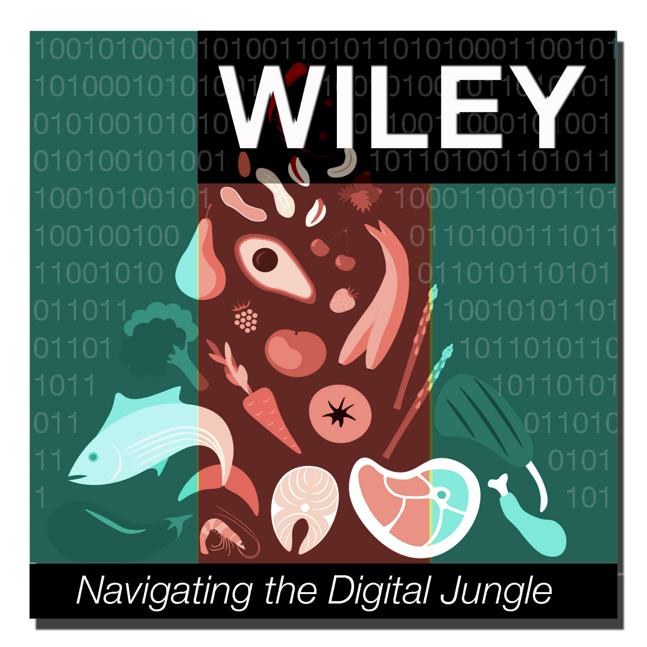

Wiley 1.0

Installation Guide

***Table of Contents***

Setup 1  
Startup 1

Shutdown 4

# Setup

# ShutdownStartup

# Shutdown Startup

# ShutdownStartup

# Startup

# ShutdownStartup

# Shutdown Startup

# ShutdownStartup

# ShutdownStartupSetup

# ShutdownStartup

# Shutdown Startup

# ShutdownStartup

1. Use URLs below to clone **Orbis180** project to your local VM

|  |  |
| --- | --- |
| **Clone Type** | **URL** |
| HTTPS | https://github.com/OrbisTechnologies/Orbis180.git |
| SSH | git@github.com:OrbisTechnologies/Orbis180.git |
| Subversion | https://github.com/OrbisTechnologies/Orbis180 |

1. Under locally cloned Orbis180 project, go to **conf** folder:

**$ cd <Orbis180>/dataIngestion/src/main/resources/conf**

1. Open **config.properties** file with an appropriate editor
   1. Add your API Key

**$ com.orbis.orbis180.rest.openFDAClient.urlAPIKey=<Your_API_Key_Goes_Here>**

* 1. Update json directory path

**$com.orbis.orbis180.rest.openFDAClient.jsonDirPath=<File_Path_To_Created_Json_file>**

1. Change to dataIngestion base folder

**$ cd ../../../../**

1. Build the dataIngestion project

**$ mvn clean install**

1. When the “Build Success” message is displayed, the WAR file is created under the target directory. Proceed to Startup.

# Startup

# ShutdownStartup

# Shutdown Startup

# ShutdownStartup

# ShutdownStartup

# ShutdownStartup

# Shutdown Startup

# ShutdownStartup

# Shutdown

# ReferencesShutdown

# ShutdownStartup

# ShutdownStartup

# Shutdown Startup

# ShutdownStartup

# ShutdownStartup

# ShutdownStartup

# Shutdown Startup

# ShutdownStartup

1. **Application Install**
2. Login to the VM hosting the Wiley Tomcat instance.
3. Execute the following command to stop Tomcat:

**$ ./<Tomcat Server>/bin/shutdown.sh**

1. Change to Tomcat server webapps folder.

**$ cd <Tomcat Server>/webapps**

1. Copy dataIngestion**.**war to webapps.

**$ cp -rp <Orbis180>/dataIngestion/target/dataIngestion.war .**

1. Copy wiley project to webapps.

**$ cp –rp <Orbis180>/wiley .**

1. Click below link to go to Sesame Framework download page

**http://sourceforge.net/projects/sesame/files/Sesame%202/**

1. Under parent folder, click on 2.8.3 and download openrdf-sesame-2.8.3-sdk.tar.gz.

**http://sourceforge.net/projects/sesame/files/Sesame%202/2.8.3/**

1. Download Sesame 2.8.3 Framework from below link to the VM and unzip the files

**$ tar –zvf openrdf-sesame-2.8.3-sdk.tar.gz**

1. Change to Tomcat server webapps folder.

**$ cd <Tomcat Server>/webapps**

1. Copy openrdf-sesame.war file to webapps

**$ cp -rp openrdf-sesame-2.8.3/war/openrdf-sesame .**

1. Copy openrdf-workbench.war file to webapp

**$ cp -rp openrdf-sesame-2.8.3/war/openrdf-workbench.war .**

1. **Configuration modification**
   1. Go to **<Tomcat Server>/dataIngestion/WEB-INF/classes/conf/config.properties**
   2. Modify configuration fields to accommodate the following values:

|  |  |  |
| --- | --- | --- |
| **Configuration Fields** | **Data field** | **Value** |
| sesame.server | URL hosting openrdf-sesame | http://<host>:<port>/openrdf-sesame |
| sesame.repository | Repository Name | openFDA-test |
| sesame.context | Graph name to use to store the triples into Sesame. | http://www.orbistechnologies.com/openFDA/context |
| sesame.baseuri | Base URI to use when creating entities within the ontology model. | http://www.orbistechnologies.com/ontologies/openFDA |
| clavin.server | Clavin server URL | http://<host>:<port>/api/v0/geotagmin |
| storage.foods.api | Class to invoke in order to parse the openFDA Food API | com.orbis.orbis180.storage.SesameFoodStore |
| storage.drugs.api | Class to invoke in order to parse the openFDA Drugs API | Not implemented yet |
| storage.devices.api | Class to invoke in order to parse the openFDA Devices API | Not implemented yet |
| storage.dblocation | Derby Database location for monitor class | /myDB |
| openFDAClient.nextRecordLimit | Read remaining document limit | 100 |
| openFDAClient.maxRecordLimit | Maximum number of document read limit | 100 |
| openFDAClient.maxNextRecordLimit | Maximum reading document limit | 5000 |
| openFDAClient.recordWritedToFile | Initialized write to file counter | 0 |
| openFDAClient.openFDAFoodUrl | openFDA base URL | https://api.fda.gov/food/enforcement.json? |
| openFDAClient.urlAPIKey | API Key to read data | Get from openFDA website |
| openFDAClient.jsonDirPath | Path to write data to file | /home/clouddev/Desktop/json_test |
| openFDAClient.minDateVal | Lower limit of the date range | 2004/01/01  (Need to be in yyyy/mm/dd format) |
| openFDAClient.maxDateVal | Higher limit of the date range | 2015/12/31  (Need to be in yyyy/mm/dd format) |
| databaseQuery.endpoint | Database query endpoint | http://54.208.5.141/openrdf-sesame/repositories/openFDA-test?query= |

c. Execute the following command to start Tomcat:

**$ ./<Tomcat Server>/bin/startup.sh**

# Shutdown

# ReferencesShutdown

# Shutdown

# ReferencesShutdown

If system maintenance and down time is needed, Wiley jobs can be shut down by turning off the Tomcat server.

**$ ./<Tomcat Server>/bin/shutdown.sh**