DIVA Analytics Alarm API Design
This document outlines the simplified architecture, data models, and workflow for the DIVA Analytics Alarm verification subsystem.

Goal
Provide external systems a clean, single-point API to evaluate if a triggered event is a True Alarm or a False Positive by executing parallel object-detection across an array of cameras on a specific timestamp.

Workflow
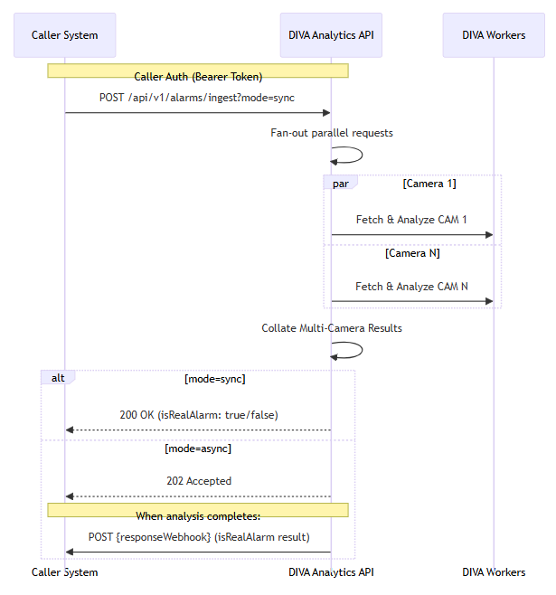

API Specification

1. Ingest Alarm Event (POST /api/v1/alarms/ingest)
Evaluates a single temporal event across multiple parallel cameras to conclusively determine if the alarm is real.

Query Parameters:
- mode (string): sync or async. Defaults to sync. If sync, the API blocks until analysis finishes. If async, the API returns 202 Accepted immediately.

Request Payload:
{
"sourceAlarmId": "ALM-GROUP-001",
"timestamp": 1774945800000,
"preRollMs": 5000,
"postRollMs": 5000,
"cameras": [
"CAM-north-gate-01",
"CAM-north-gate-02",
"CAM-north-ptz-01"
],
"responseWebhook": "https://caller-system.local/api/callbacks/diva-alarms",
"webhookToken": "eyJhbG..."
}

Response (200 OK) [When mode=sync]:
{
"analyticsAlarmId": "DIVA-GROUP-777",
"sourceAlarmId": "ALM-GROUP-001",
"status": "completed",
"isRealAlarm": true,
"confidence": 0.94,
"results": {
"detectedObjects": [
{
"type": "person",
"confidence": 0.94,
"cameraId": "CAM-north-gate-01",
"timestamp": 1774945802000,
"boundingBox": {"x": 120, "y": 45, "w": 60, "h": 180}
},
{
"type": "vehicle",
"confidence": 0.88,
"cameraId": "CAM-north-ptz-01",
"timestamp": 1774945804500,
"boundingBox": {"x": 400, "y": 300, "w": 250, "h": 140}
}
],
"videoClipUrls": {
"CAM-north-gate-01": "https://diva.local/clips/DIVA-777_CAM-north-gate-01.mp4",
"CAM-north-gate-02": "https://diva.local/clips/DIVA-777_CAM-north-gate-02.mp4",
"CAM-north-ptz-01": "https://diva.local/clips/DIVA-777_CAM-north-ptz-01.mp4"
}
}
}

Response (202 Accepted) [When mode=async]:
{
"analyticsAlarmId": "DIVA-GROUP-777",
"status": "pending",
"links": { "status": "/api/v1/alarms/DIVA-GROUP-777/status" }
}

2. Check Status (GET /api/v1/alarms/{analyticsAlarmId}/status)
Allows the caller or a UI to poll for the current processing status of an individual asynchronous analytics task.

Response (200 OK): (Returns identical schema to the synchronous 200 OK response.)

3. Webhook Callback (POST {responseWebhook})
Executed by DIVA Analytics once asynchronous processing is completed. The payload sent to the Webhook mirrors exactly the 200 OK structure from the Status route.

