MediCart - Complete Software Engineering Diagrams

1. Gantt Chart — Project Development Timeline
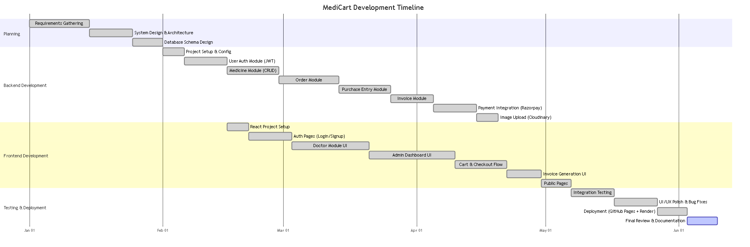

2. Data Flow Diagram — Level 0 (Context Diagram)
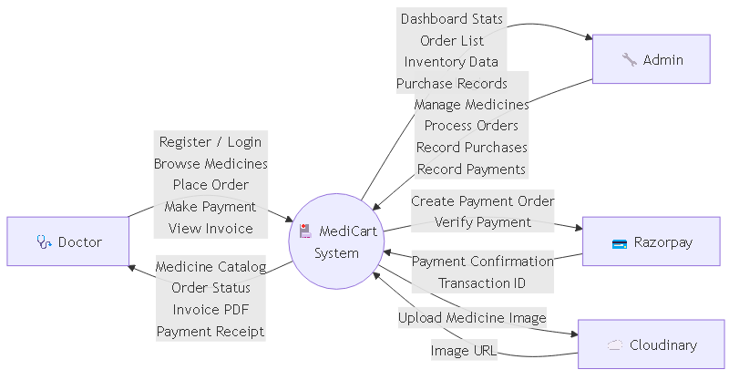

3. Data Flow Diagram — Level 1
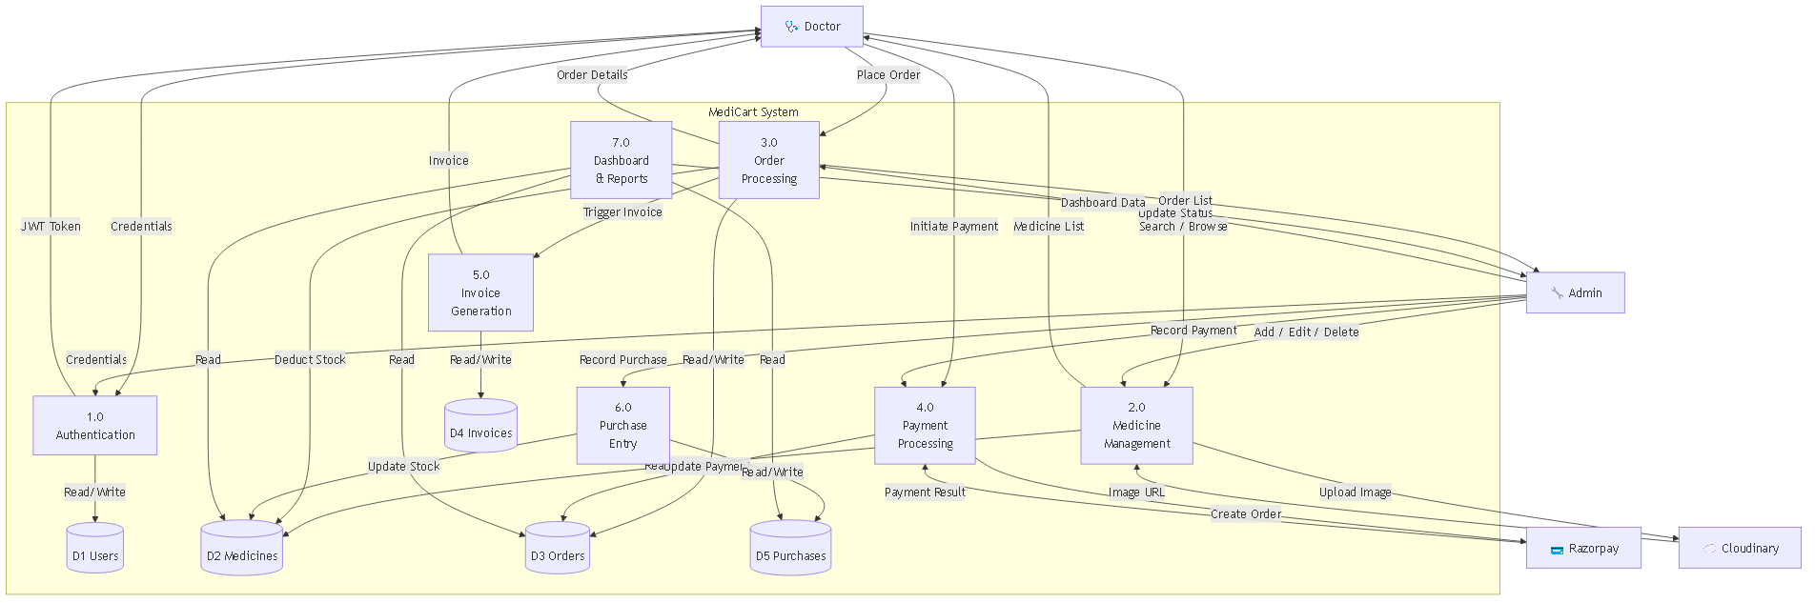

4. Use Case Diagram
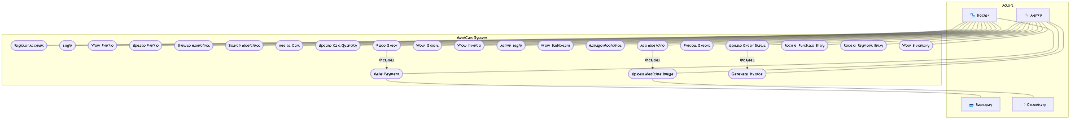

5. ER Diagram (Entity Relationship Diagram)
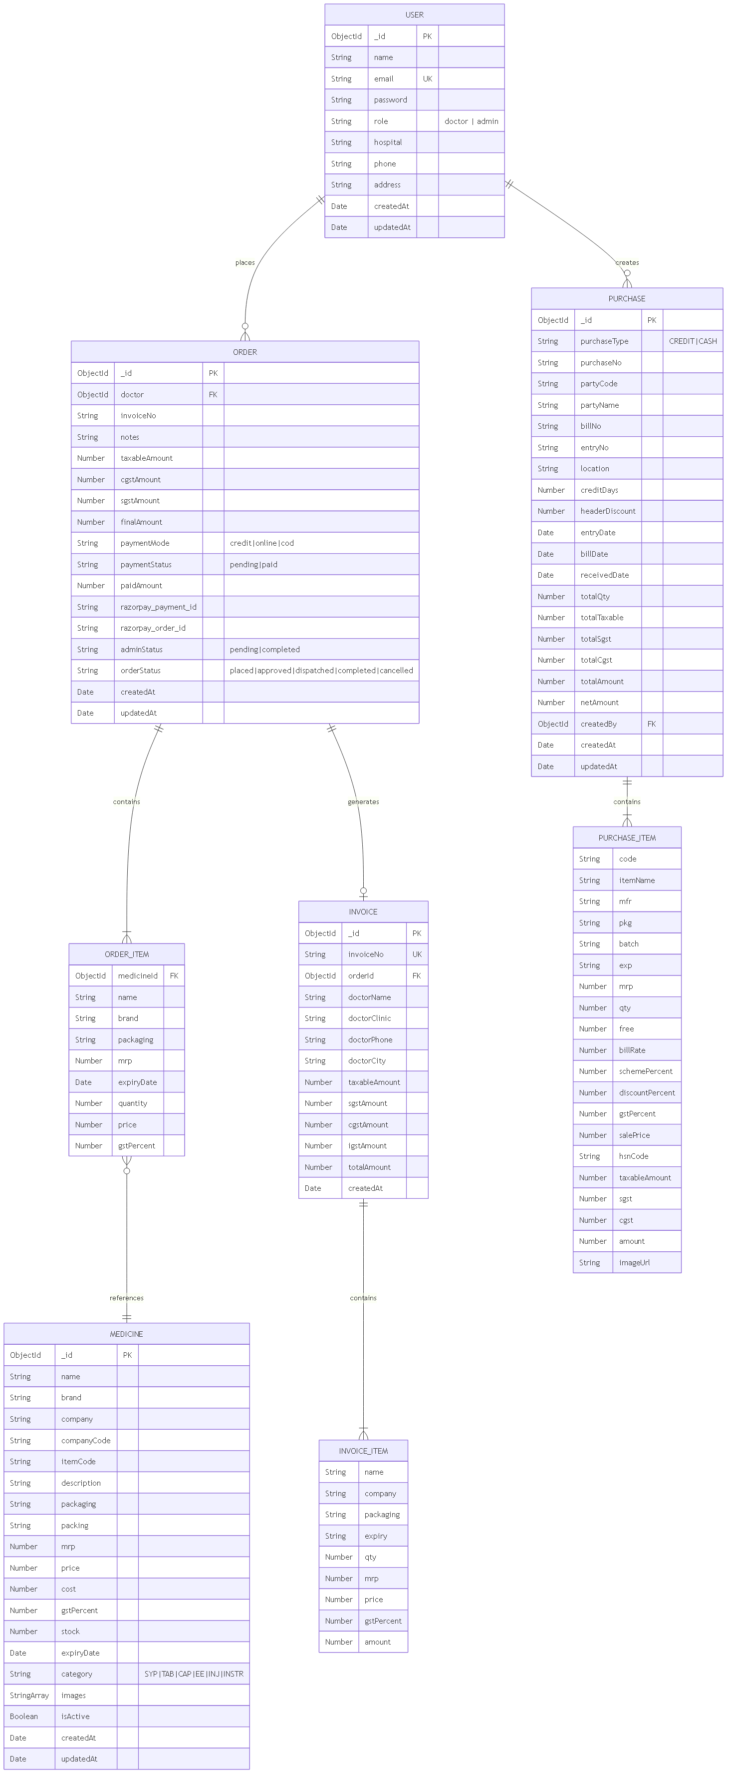

6. Database Schema Diagram
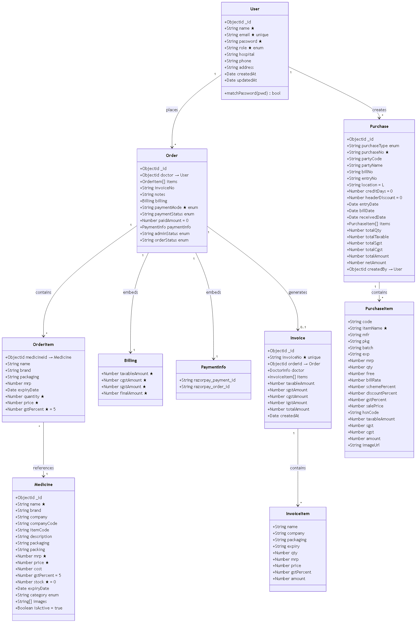

7. System Architecture Diagram
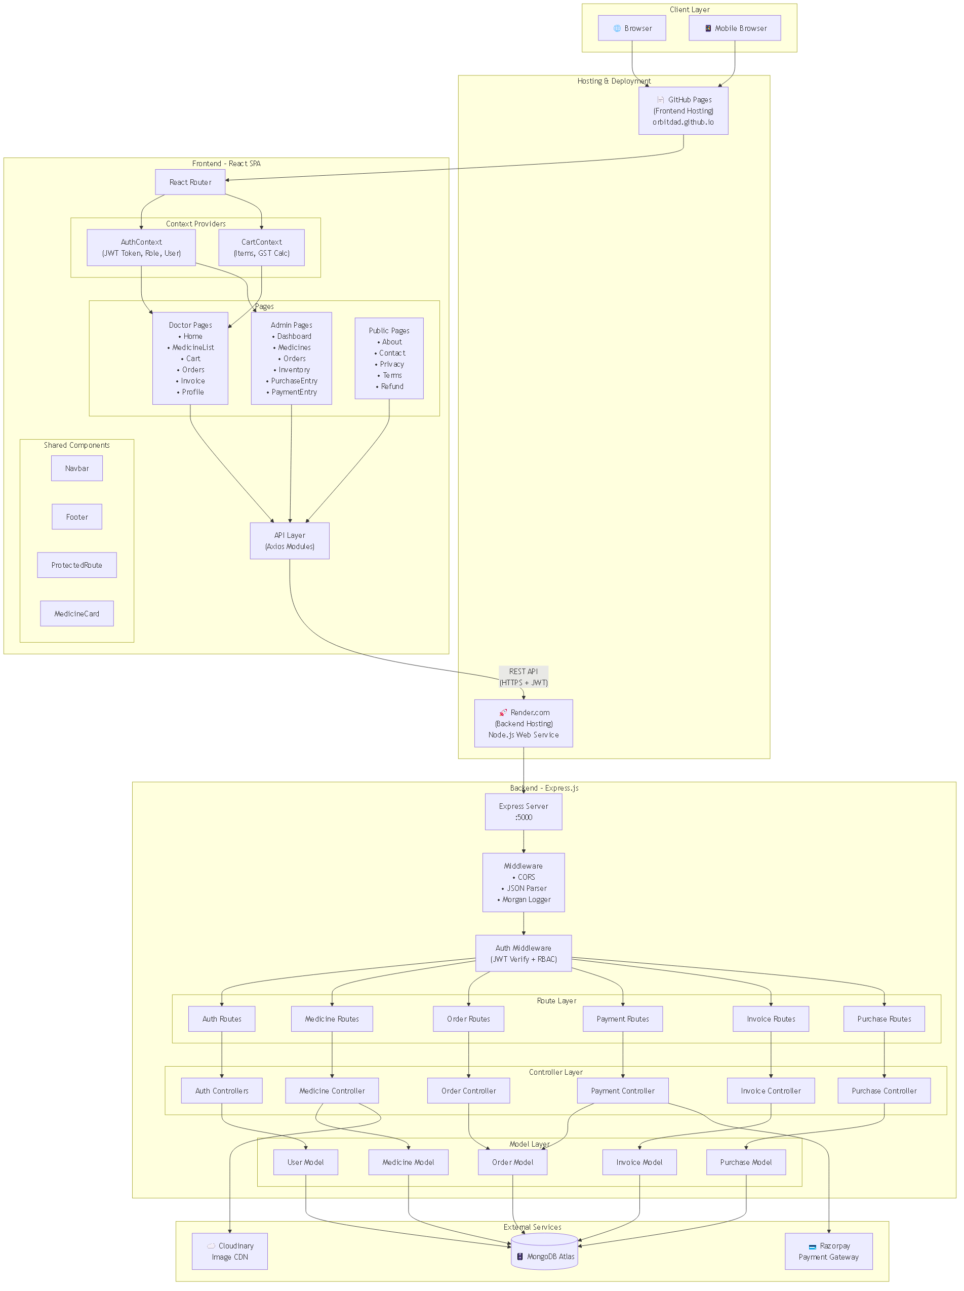

8. Activity Diagram — Doctor Order Placement Flow
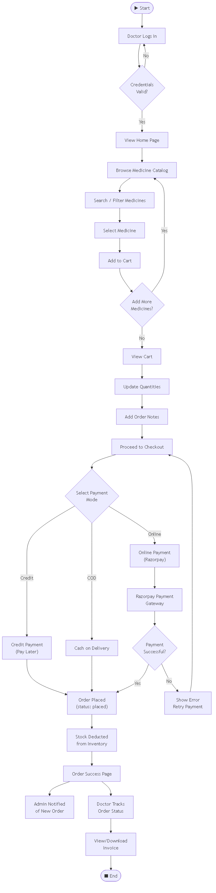

9. Sequence Diagram — Order & Payment Flow
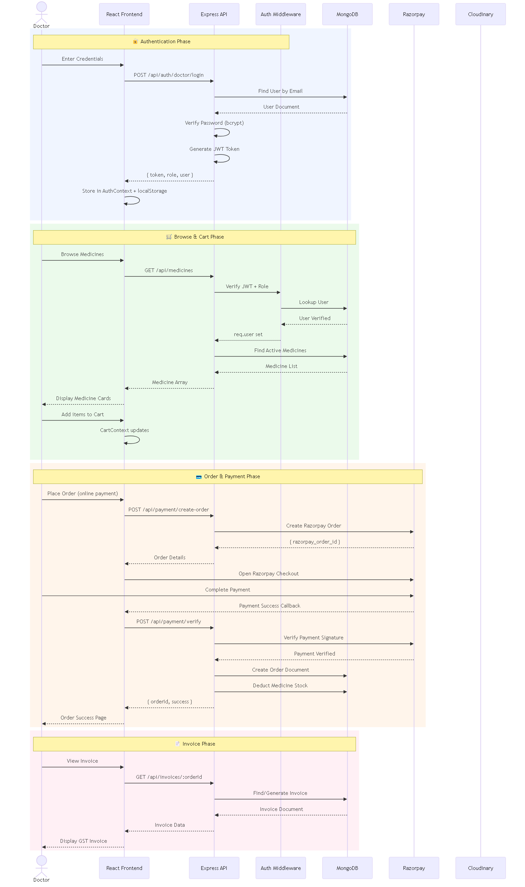

10. PERT Chart — Project Task Dependencies

11. Flowchart — Complete System Workflow
