Assignment 2

207548231 , 319081667

1.

Attached is the error where is the point at step k.

We’ve used

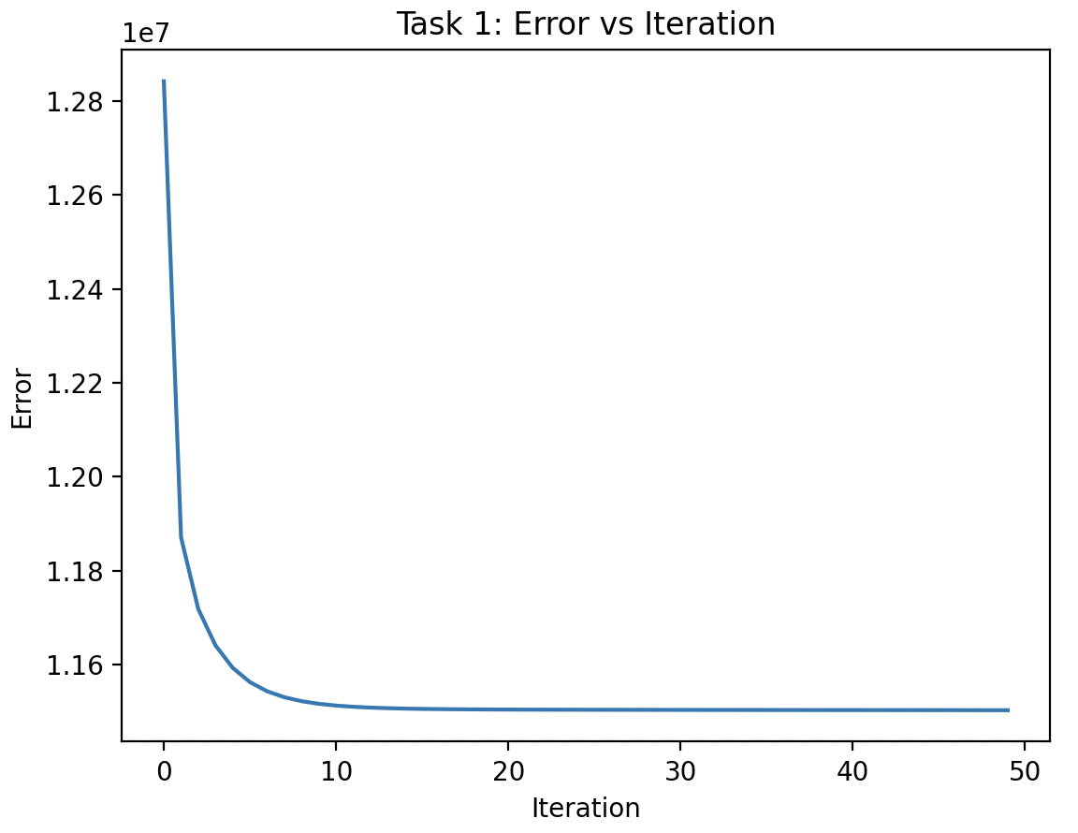

2.

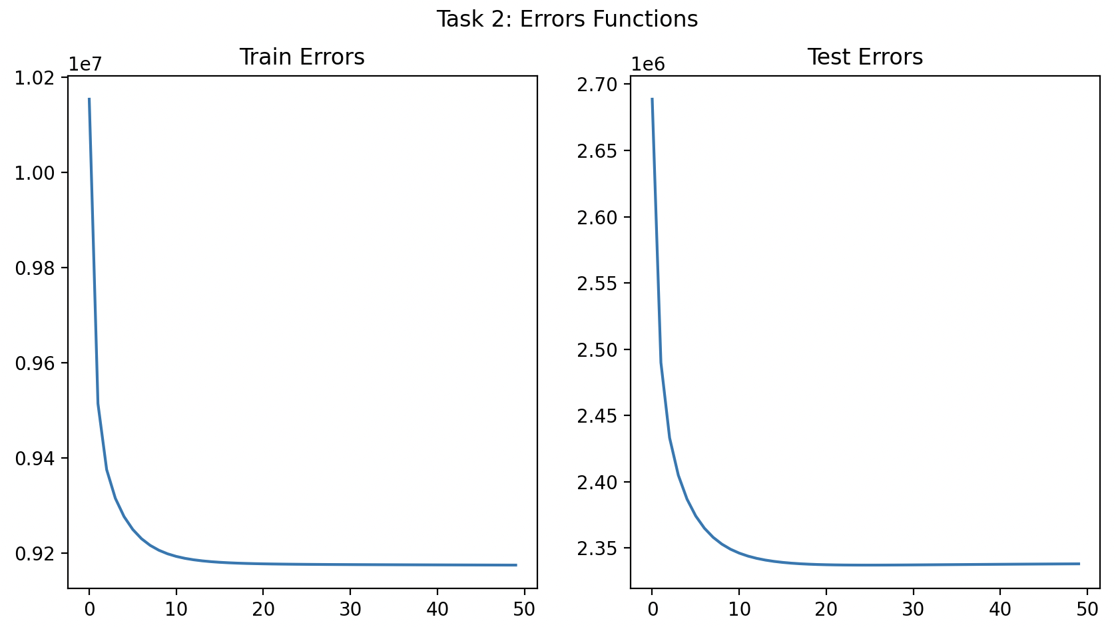

From those graphs, altough we expect – we detect no overfit, as we can see the error declines on the Test sample, and it seems doing well on the sample.

Again – we’ve used .

3.

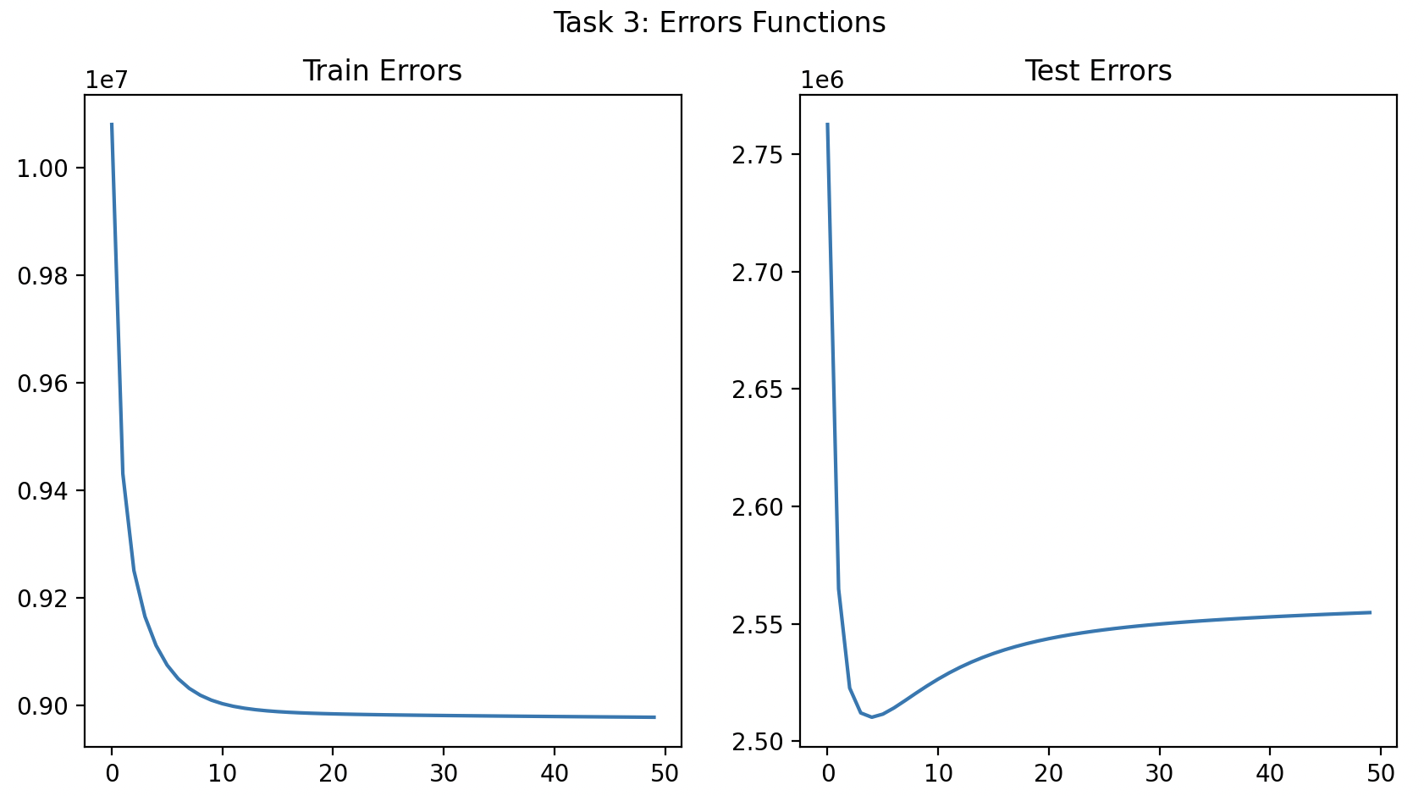

We can now observe the average of 10 iterations as asked.

We can see an overfit curve starting around iteration 4, where the train error continues dropping, and the average test error going up instead.

We might say that the minimum average error – around 4 iterations, might be the best iterations number those of hyperparameters.