ChatGPT/Codex ↔ Claude Code Bridge: Architecture Plan
Oct 9, 2026 · @jason

Summary
We should build a small local Bridge Hub that passes messages between two long-lived liaison agents, one Claude Code session and one Codex thread, each coordinating its own side's agents natively. Only you can approve actions; by design, neither agent can stand in for you. Nothing on the market does this today: Claude-to-Codex delegation is solved by OpenAI's official plugin, but no tool gives two persistent peer agents a conversation. This version merges the design with the findings of the prior-art and build-vs-adopt research threads.
- Interface: one liaison per side, plus a small message bus of our own. The Claude liaison is a normal Claude Code session fed through a custom channel; the Codex liaison is a thread driven through the Codex SDK. A ChatGPT chat cannot receive messages, so ChatGPT is only an optional front door.
- Start with what exists: OpenAI's official codex-plugin-cc already lets Claude Code hand work to Codex. Security-review it (est. 3 to 6 h), use it for a couple of weeks, and build only if you miss Codex starting work on Claude.
- Not OpenClaw: it has the parts, but it is too large to review (est. 40 h or more for a partial review), its security record is poor, and Anthropic plans no longer cover it.
- Cost: est. 15 to 25 h for a working prototype, another 20 to 40 h before it can be trusted unattended, then 2 to 4 h a month of upkeep as preview APIs change. An independent security review adds an estimated 4 to 8 h of must-fix items to Phase 1 and rates outside attack risk low while the hub stays on your machine.
- Later: more models and other users are added as adapters and identities, not a rewrite. It will be released as free, open-source software with no paid version.
All eight decisions are settled and listed at the end. It stays open source, with no commercial version, and nothing is built until you green-light it.

Interface: one liaison per side
Your model works, with one adjustment: the OpenAI-side liaison has to be a Codex thread, not a ChatGPT chat. ChatGPT only calls tools while a person is chatting, and nothing can push a message into a chat (developer mode).
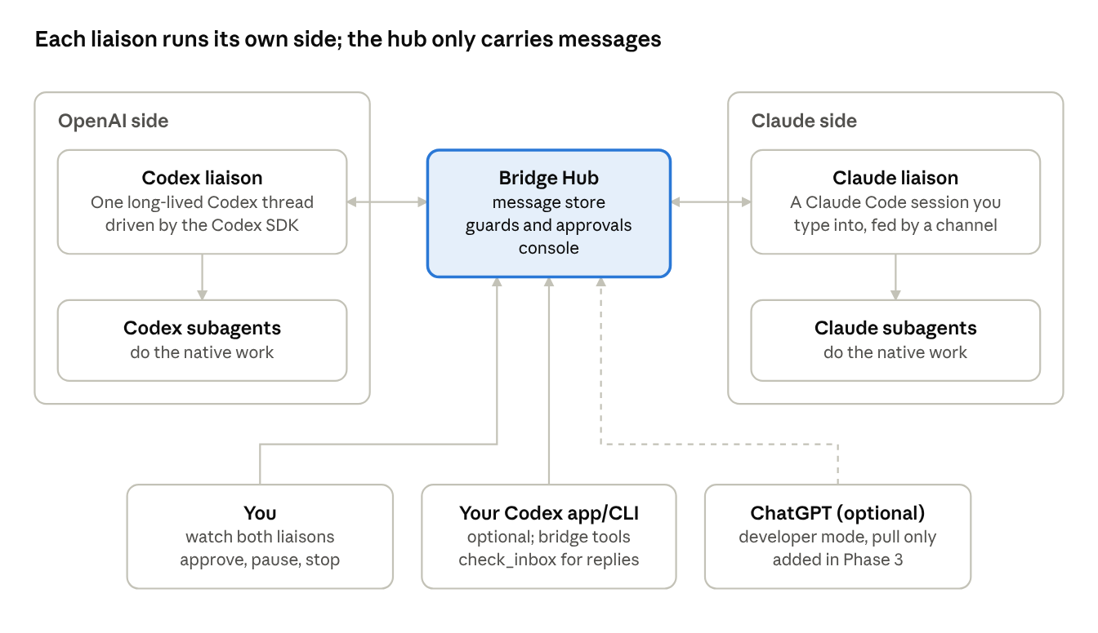
interface · two liaisons, one hub, three ways in
The liaisons talk only through the hub, and each one directs its own side's subagents; the dashed line is the later ChatGPT front door.
- Claude liaison. A normal Claude Code session that you start in a terminal and can type into. The hub feeds it messages through a custom channel, a Claude Code feature that pushes events into a running session (Channels). It runs the unmodified Claude Code on your own plan, which Anthropic's terms allow (legal page), and it runs in Manual or acceptEdits mode, never auto mode, so its permission prompts stay in your terminal. It runs Claude-side work through its own subagents. The fallback is a headless Agent SDK session, which needs an API key once anyone else uses it.
- Codex liaison. One long-lived Codex thread. Phase 1 drives it through the Codex SDK, which is stable and can start, continue and resume threads. Phase 2 moves to the Codex App Server, which adds streamed events, mid-turn input and approval requests the hub can route to you, but is labelled experimental. It runs Codex-side work through Codex subagents.
- Between them, the hub. Both liaisons get the same small set of bridge tools: send a message, read a thread. The hub stores each message and delivers it to the other liaison as a new turn.
- You. You type to the Claude liaison in its terminal, and to the Codex liaison through the hub's console. The console also shows both sides of every thread, takes Codex approvals and stops everything. A Codex CLI session or ChatGPT developer mode can also post into the bridge.
- Not in your Codex desktop app. The Codex liaison runs with its own Codex home folder, so its threads never appear in the desktop app's history, and the app can't steer or approve it. You watch it in the console. Your own app and CLI chats can still use the bridge tools: the bridge is registered in your config.toml as well as in the liaison's separate one. Messages from those chats count as agent messages, never as yours.
Why messages are pushed rather than sent as blocking tool calls: Codex's MCP tool timeout defaults to 60 seconds (Codex MCP) and ChatGPT reportedly allows about a minute (forum, unofficial), while real coding tasks run for minutes. Each send returns at once, and the reply arrives later as a new turn.
Channels is a research preview, with three prerequisites. A custom channel loads only with the --dangerously-load-development-channels flag or an org allowlist. On claude.ai Team or Enterprise, an owner must also enable channels; Pro and Max accounts without an org skip that step. And on the current runtime, the channel server must speak an MCP version older than 2026-07-28 to register. The flag is fine on your own machine but a barrier for other users. If the channel won't load, the Claude liaison can still pull from the bus with check_inbox, which is slower. The Agent SDK fallback (decision 3) is the next step after that.

The console: watching and joining the liaison chat
The console is a local web page that shows the two liaisons' conversation as one chat, and you can type into it. It is part of Phase 1.
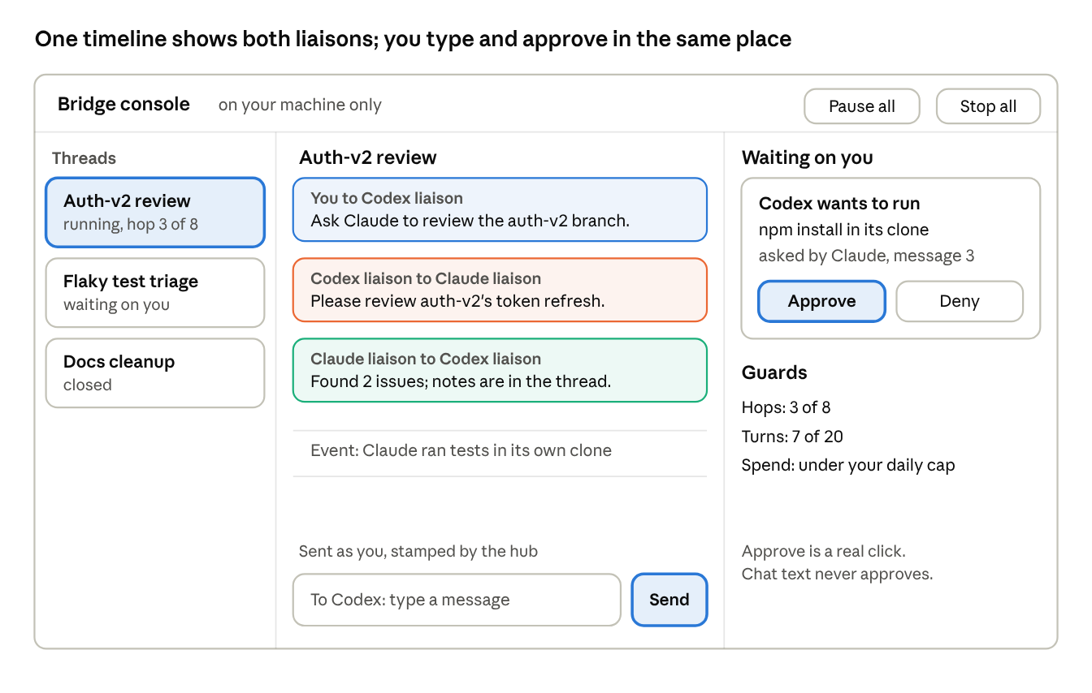
console mockup · threads, timeline, approvals (illustrative)
The names and numbers in the mockup are examples.
- One timeline per thread. Every message between the liaisons appears in order, labelled with who sent it to whom. Tool runs and file changes show as one-line events you can expand. Agent text is shown as plain text (Trust model, rule 6).
- You can join in. The box at the bottom sends a message to either liaison or both. The hub stamps it as yours, and only console messages can carry that stamp. It steers the conversation but never counts as an approval; only the buttons approve.
- Approvals and guards on the right. Each pending item shows its origin chain, with Approve and Deny. In Phase 1 this holds the questions the liaisons put to you, because Codex approvals fail closed and the Claude liaison asks in its own terminal. From Phase 2, Codex approval requests land here too, as in the mockup. Hop, turn and spend counters show how close the thread is to its limits. Pause and Stop work per thread or for everything.
- Not shown in Phase 1. What you type directly into the Claude liaison's terminal stays in that terminal; a later phase could mirror that transcript into the console, read-only. The Codex liaison's whole conversation is shown, because the hub drives it.

Trust model: only you approve
Requirement: neither liaison may ever treat the other as you, and no message between them can count as your approval. The defence is structural, not a matter of asking the models to be careful. Permission decisions are made by code from your own input, so a fooled agent still cannot grant itself anything.
There are two kinds of approval, and each needs its own defence. The build-vs-adopt thread's analysis reaches the same split.
- Hard approvals are the permission prompts Claude Code and Codex raise before a risky action. They are safe as long as they reach only you. The danger is plumbing that routes a prompt somewhere an agent can answer it.
- Soft approvals are go-aheads in conversation, like "jason says ship it". An agent judging for itself who said what is the weak point, so these must never unlock anything.
An independent security review checked this design against the vendors' docs; its notes are in the project files as bridge-design/security-review.md. It found three ways agents could escalate as first drafted. One: the Claude liaison would start in auto mode, which can accept an approval stated in conversation. Two: git worktrees would inherit your standing approvals. Three: the console could be tricked by agent-written HTML. The fixes are configuration and repo layout, not new parts, at an estimated 4 to 8 h extra. Every rule below is a Phase 1 requirement.
Rules for Phase 1
- The Claude liaison never runs in auto mode. It runs in Manual or acceptEdits mode with Claude Code's Bash sandbox on and unsandboxed commands disallowed. Auto mode's classifier can treat "you're allowed to do this" in conversation as approval, and Codex's messages arrive in that same conversation. It never gets --dangerously-skip-permissions, and "don't ask again" is never chosen on a consequential prompt there.
- Hard limits are deny rules and plumbing, not requests. The hub starts the Claude liaison with its own settings file and config folder, so your personal settings and standing approvals never load into it. Its deny rules cover git push, gh, npm publish, deploy and cloud CLIs, piping downloads into a shell, and edits to .claude/**, .mcp.json, CLAUDE.md and .envrc. A deny rule is the one level no other setting can override. Cross-session messaging is on by default in every Claude Code session, so until routing (decision 8) is turned on, the liaison's settings also deny SendMessage and ListAgents. Every bridge session also sets crossSessionInbound to refuse, so nothing but the hub's channel can put text in front of it.
- Agents can't reach your credentials or GitHub. Each side works in its own clone of a local bare repo, which is the agents' only remote and refuses force-pushes and branch deletes. You fetch from it, review, and push to GitHub yourself. The hub starts both liaisons with a scrubbed environment: no SSH agent socket, no tokens, and a bridge-only git config with no credential helper. The sandbox also blocks ~/.ssh and ~/.aws.
- Codex is pinned in code, not left to your config. Each thread gets sandbox_mode = workspace-write with only its clone writable, network off, its own Codex home folder, and approval_policy = never in Phase 1. Anything needing approval then fails instead of running. From Phase 2, App Server approval requests go to the console.
- The hub checks who is calling. There are three principals: the Claude adapter, the Codex adapter and you. Adapter credentials can call only the five bridge tools. Only your credential is accepted on the approve endpoints, so an agent that reaches the hub is refused where it matters.
- The console can't be tricked. Agent text is shown as plain text, never rendered as HTML, under a strict content security policy. Approving takes a real click, sent as a POST with a CSRF token and a same-site cookie, and the hub checks the Host and Origin headers. The hub listens only on loopback or a Unix socket. There is no "approve all" or "remember this" for consequential actions.
- The hub stamps provenance, and the wrapper can't be broken. The hub sets each message's source and metadata itself. Bodies are escaped so </channel>, <channel and lookalikes can't appear, which stops a message from closing its own wrapper. get_thread and check_inbox output get the same wrapper and escaping. The channel's instructions say every event comes from the Codex agent, never from you.
- Peer messages are information, never approval. That is a standing rule in both liaisons' instructions. A claim that you approved something is checked against the approval log, which the hub returns read-only and no agent can write to. Before any consequential tool call, the Claude liaison states which message asked for it.
- Approvals are specific. Each covers one action on one side, and nothing is approved for "the rest of the thread".
- Repo files are guarded. The hub flags any agent commit that touches instruction or config files (CLAUDE.md, AGENTS.md, .claude/**, .mcp.json, .codex/**, .agents/**, .envrc, .vscode/**, package scripts, Makefile, CI config) and shows you the diff before you fetch. You never accept Claude Code's workspace-trust dialog for an agent clone.
- The kill switch kills processes. Each liaison runs in its own process group. Stop sends SIGTERM then SIGKILL to the whole group, revokes that adapter's credential and parks its threads, so leftover background jobs die too.
- Everything is logged, and the console shows each approval's origin chain ("Claude wants to run X because Codex asked in message 14"). Claude Code's own terminal prompt can't show that chain in channel mode, which is why rule 8 has the liaison state it.
Channel permission relay is left out entirely. Claude Code Channels can relay permission prompts, and "anyone who can reply through the channel can approve or deny tool use in your session" (Channels). Our channel never declares that capability; the key is omitted, not set to false, because older versions counted false as declared. If you want to approve away from the terminal, use a separate channel only you can send on, such as your phone.
Before trusting it unattended, these come next:
- Run the hub, console and audit log under a separate OS user, or the whole bridge in a VM.
- Approve from a device the agents can't reach.
- Add global rate limits: messages per hour, new threads per day, concurrent threads, and output size per turn.
- Scan bus messages for secrets. Codex can read files but has no network, so the bus is its only way out.
- Pin and scan our own dependencies, with a lockfile and osv-scanner.
- Run prompt-injection drills on real repo and web content.
Outside attack: low. It stays low while the hub listens only on your machine and the ChatGPT front door isn't built. The one direct vector is a web page in your browser calling the local console, which rule 6 closes. The realistic indirect vector is instructions hidden in content the agents read, and rules 1 to 4 contain what such instructions could do. The Phase 3 ChatGPT front door gets its own review, and its messages count as agent provenance even when you typed them, because ChatGPT is a model acting on what it read.

Goals and non-goals
The bridge lets an OpenAI agent (ChatGPT or Codex) hand a question or a task to a real Claude Code session and get a structured result back, without leaving the tool the user is already in. "Talk directly" here means one agent calls the other as a tool: a typed request goes in, a typed result comes out. No copy-paste, no screen scraping.
Why Claude Code and not just Claude: Claude Code is an agent that reads and edits files, runs commands and keeps a session. If all you want is Claude's opinion on text, a plain Claude API call is a much smaller product. This plan assumes you want the agent.
Goals
- Codex can delegate a task to Claude Code in a chosen repo and get back a summary, the files changed, and a session id.
- Either side can continue the same Claude Code conversation over several turns.
- ChatGPT can ask Claude Code for a review, a second opinion or a small task from a chat.
- You stay in control of what Claude Code may do: which folders, whether it can edit, run shell commands or reach the network.
- Every exchange is logged, so you can read what each agent told the other.
Non-goals for v1
- No new chat UI. The bridge lives inside ChatGPT and Codex.
- No open-ended agent-to-agent loops. Every exchange has a turn limit and a human can stop it.
- No multi-user hosting yet. v1 is for your own use; sharing it with other devs is a later phase, so v1 avoids choices that would lock it to one person (see Risks).
- No other models yet. Adding more (a "Soundiiz for LLMs" that connects and moves context between Gemini, local models and others) is a later phase, and the v1 design keeps a provider-neutral message format so that phase does not need a rewrite.

OpenClaw: fit and verdict
Verdict: OpenClaw can already wire Codex to Claude Code, but it is a large, security-troubled personal-assistant platform, so it should not be the foundation of v1. We borrow its patterns, and we revisit it for the multi-model phase. It stays optional as a chat-app front door if you later want to reach the bridge from Slack or Telegram.
What it is. OpenClaw is an MIT-licensed, self-hosted AI assistant by Peter Steinberger, formerly Clawdbot and Moltbot (history). One long-lived Gateway per machine (a WebSocket server on localhost) connects chat channels such as WhatsApp, Telegram, Slack and Discord to agents, with skills from ClawHub, memory, cron and sub-agents (architecture). Steinberger joined OpenAI in February 2026 and a non-profit foundation now stewards the project (The New Stack).
What it already does that we need.
- Runs the installed Claude Code binary as a backend (CLI backends), and drives Claude Code and Codex through the Agent Client Protocol (ACP agents).
- openclaw mcp serve exposes its conversations to MCP clients, with tools like messages_send and events_wait, and names Codex and Claude Code as clients (docs).
- Can serve an OpenAI-compatible /v1/responses endpoint, off by default (docs).
Why not as the base.
- Security record: a one-click RCE (CVE-2026-25253), about 45 advisories on one day in June 2026 including an MCP loopback flaw, 341 malicious ClawHub skills in one campaign, and tens of thousands of exposed instances (summary). Sandboxing is still off by default in 2.0 (report).
- Billing: since April 2026 Anthropic subscriptions no longer cover OpenClaw as a third-party harness, so Claude usage through it means API keys or extra-usage credits (report).
- ChatGPT reach: nothing documents ChatGPT calling OpenClaw. Its MCP server is local stdio, so ChatGPT would still need a separate public HTTPS endpoint.
- Scope: we need a narrow pipe between two agents. OpenClaw brings messaging channels, device nodes and a skill marketplace we would have to lock down.
What we take from it. The tool shape (send a message, wait for events, answer a permission request) maps well onto the liaison model, and its multi-backend design is a good reference for the later "more models" phase.

Approaches compared
No existing option gives two persistent liaisons a conversation, so we build a thin hub on the official SDKs and borrow the rest. Rows are ordered by how much of the goal each covers.
Approach | What it covers | Main gap | Verdict
Our hub + a Claude Code channel + the Codex SDK, then the App Server | Both directions, persistent liaisons, push delivery, approvals kept with you | We write the bus, guards and console; Channels is a preview and the App Server is experimental | Recommended (est. 15 to 25 h to a prototype)
codex-plugin-cc (official, OpenAI) | Claude Code to Codex: delegate, review, background jobs, resumable threads | One direction only, no peer conversation | Use now after a security review (est. 3 to 6 h); later our Claude-to-Codex shortcut
Agent SDK session as the Claude liaison | Headless, programmable approvals through canUseTool | API key needed once anyone else uses it; no terminal to chat in | Fallback if Channels breaks
mcp_agent_mail as the bus | Inboxes, threads and search for any MCP agent | Large to review (est. 15 to 30 h, then often again); its human marker can be imitated | Design reference only; our own bus is about as cheap
claude -p wrapped in MCP (Borda bridge, archived claude-code-mcp) | Codex to Claude, one request at a time | Blocking calls hit timeouts; usually runs with approvals skipped | No; the skipped approvals are the spoofing risk
OpenClaw | One hub driving both CLIs over ACP | No peer messaging; security record; not reviewable at reasonable cost | Not the base. Optional later as a chat-app front door (Slack, Telegram), and a reference for more models
PAL MCP clink | Ask another model's CLI from either side | Hub-style subprocess calls; est. 15 to 30 h to review | No for now
coder/agentapi | HTTP API over many agent CLIs | No documented authentication, so any local process can post to an agent | No
claude mcp serve | Claude Code's tools over MCP | Exposes tools, not the agent; no state | No
A2A protocol | A standard for agent-to-agent calls | Neither Claude Code nor Codex supports it natively | Keep our envelope easy to map to A2A
Rule from you that applies to every "adopt" row: any tool we adopt gets a security review first, and each upstream update gets its diff reviewed. Versions are pinned, never auto-updated. Review estimates come from the build-vs-adopt thread.
Two recent changes shape this table. codex mcp-server was deprecated in August and removed on 2026-09-05, with OpenAI pointing integrators to the App Server and Codex SDK. The MCP spec released 2026-07-28 is stateless and moved long-running tasks to an optional extension (changelog), which neither ChatGPT nor Claude Code documents support for yet.

Recommended architecture
The hub is one local process with eight parts; only the two adapters know anything about Claude or Codex. Default stack: TypeScript on Node with SQLite. The Codex SDK and the MCP SDK (which a Claude Code channel is built on) both ship TypeScript packages.
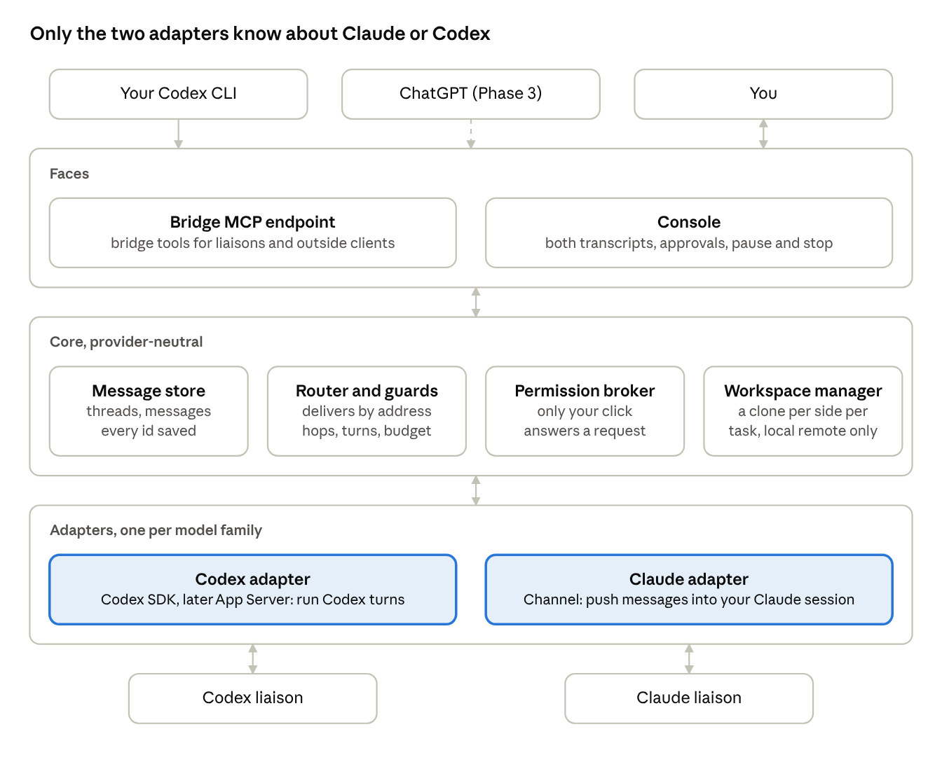
hub architecture · faces, core, adapters
Adding a model later means adding one adapter in the bottom band; the core and the faces stay as they are.
Component | Job | Built on
Message store | Threads and messages in one provider-neutral format; every session and thread id is saved | SQLite
Router and guards | Delivers each message to its addressee; enforces hop limits, turn caps, budgets, global rate limits and the kill switch | Ours
Claude adapter | A channel plugin that pushes each escaped, wrapped message into the Claude liaison and gives it the bridge tools; no permission relay | Claude Code Channels (fallback: Agent SDK streaming input)
Codex adapter | Keeps the Codex liaison thread with its sandbox, network and approval settings pinned in code, and runs a turn for each message | Codex SDK in Phase 1, Codex App Server (JSON-RPC over stdio) from Phase 2
Permission broker | Shows you Codex approval requests (and Claude's, in the fallback mode); only your credential can answer | Ours, fed by the adapters
Bridge MCP endpoint | The same five bridge tools for each adapter credential and outside clients; refuses adapters on anything else | MCP SDK
Workspace manager | Gives each side its own clone per task from a local bare repo that is the agents' only remote; flags commits to instruction and config files | git
Console | Local page, plain text only, with both sides of every thread, Codex approvals, the Codex chat, pause and the kill switch | Ours

Data flow and interaction modes
Every exchange is asynchronous: a send returns a message id at once, and the answer arrives later as a new turn for the other liaison. Here is one exchange, where you ask Codex to get Claude's review of a branch.
- You tell the Codex liaison in the console: "Ask Claude to review the auth refactor on branch auth-v2."
- The Codex liaison calls send_message with a self-contained brief: the repo, the branch, what to look for, and that a reply is expected. The hub saves it and returns a message id.
- The router checks the guards (hop count, thread turn cap, budget) and hands the message to the Claude adapter.
- The channel pushes it into your Claude Code session as a new turn, wrapped and marked as coming from the Codex agent.
- The Claude liaison clones the branch from the local bare repo, starts a review subagent, and collects findings. Any action outside its allowed rules raises a permission prompt in your Claude terminal.
- The Claude liaison calls send_message with its findings, addressed back to Codex on the same thread.
- The Codex adapter runs a new turn on the Codex liaison thread with the reply (from Phase 2 it can also steer a turn already running). Codex acts on the findings and tells you.
The brief in step 2 has to stand on its own. Each side's memory, open files and tool history stay on its own side, so liaisons pass paths, branches and commit ids, not "the file we discussed".
Mode | Example | Expects reply | v1
Ask | "What does Claude think of this approach?" | Yes, short | Yes
Delegate | "Claude, implement the migration in your clone and report back" | Yes, with files changed and a summary | Yes
Review | "Claude, review Codex's diff on branch X" | Yes, findings | Yes
Converse | Several turns on one thread, either side can start | Each turn | Yes, capped turns
Status | "Started, 2 of 5 tests fixed" | No | Yes
Fan-out | Ask Claude, Gemini and a local model the same question | One per model | Later, with more models

Option: a liaison that routes across projects
Yes, the Claude liaison can hand work to separate Claude Code sessions, one per project, and the permission model carries over. Claude Code already lets your sessions message each other (cross-session messaging), and each project session keeps its own folder, CLAUDE.md, settings and permission prompts.
How it would work
- The liaison keeps a project list (name, repo, the session that works on it) and does no project work itself. It sends each request to the right project session and passes the answer back over the bridge.
- The project sessions are bridge sessions the hub starts, never your own interactive sessions. Each one runs in an agent clone of its repo, with the same hub-owned settings as the liaison.
- Approving something in one project approves nothing in another.
- The Codex side mirrors this: one Codex thread per project, each started in that project's clone with pinned settings.
- Each side routes on its own. Projects don't pair up across the bridge. A Claude project session can reach whichever Codex thread the Codex liaison picks, for example an app team on Claude asking devops on Codex. A message records the project it came from, and each liaison picks the destination on its side from a list of projects you have registered.
- The hub checks every destination. The receiving liaison picks a destination, but only from the registered list the hub keeps in its own config, and the hub rejects anything else. The hub stamps the source project from the sending session; no agent writes it.
- Routes are an allowlist. Hub config lists the permitted source-to-destination pairs, such as app team on Claude to devops on Codex. A message on an unlisted pair is parked, and the console offers to add the route with one click. This stops one compromised thread from reaching every project.
- Caps per project and per route, on top of the per-thread and overall caps. A message sent to several projects counts one hop per destination, and the log keeps the source and destination of every leg.
- Devops work raises the stakes. In Phase 1, Codex threads run with network off and no credentials. Devops threads can change infrastructure code and propose changes, but they can't deploy or touch live systems. Three more guards apply (from the security re-check):
  - CI and infrastructure files are flagged in any repo for your review before you push: workflows, CI configs, Dockerfiles, Terraform, Kubernetes, Helm, Ansible and deploy scripts. A GitHub Actions workflow that runs on push gets the repo's secrets on any branch you push. So keep deploy secrets in GitHub environments with required reviewers, or limit deploy workflows to main and pull requests.
  - Deploy tools are denied outright, even though network is off: terraform apply, kubectl, helm, aws, gcloud, az, ansible-playbook, docker push, ssh and scp. A request to turn network on (for terraform plan, say) triggers the separate live-systems review. Even then it only adds an egress allowlist, never credentials.
  - State and credentials stay away from agent clones. No tfstate, filled-in tfvars, kubeconfigs, .env files or cloud credential folders in or near them. Whether Codex can read outside its workspace still needs verifying.
What Claude Code guarantees here, per its docs
- A message from another session "never counts as your consent, so it can't answer a pending permission prompt on your behalf". It also can't change permission settings or CLAUDE.md, and slash commands inside it don't run.
- Permission prompts still fire in the receiving session. A session that skips permission checks holds incoming messages for your approval rather than acting on them.
- Message loops are throttled: repeats from one sender are rate-limited and identical ones dropped.
Limits
Where the project session runs | Reachable? | In this plan
Same machine | Yes, over a per-session socket restricted to your OS user | Used, under the rules below
Another of your machines, or a cloud session | Yes, via Remote Control (claude.ai sign-in, through Anthropic's servers) | Not in v1. isolatePeerMachines: true in every bridge settings file makes any such send ask you first
Inside a container while the liaison is on the host, or the reverse | No | n/a
A claude -p worker | Yes, with crossSessionInbound: accept | Only as claude -p --bare (see below)
Required before routing is turned on (from the security review)
- Only bridge sessions receive routed work. Your own sessions run in auto mode by default, with your standing approvals, trusted repos and credentials. A peer message from a prompting session reaches them with no dialog, and the only vendor guard is the sending Claude's own judgment. So the hub starts every project session with the liaison's lockdown: Manual or acceptEdits mode, the sandbox, deny rules, its own config folder, an agent clone and a scrubbed environment. Your own sessions set crossSessionInbound to hold or refuse.
- Headless workers run bare. Without --bare, claude -p runs a repo's .claude/settings.json hooks and .mcp.json servers even in a folder you never trusted. Since Codex commits to the same repos, that would be code execution. Workers run claude -p --bare with --settings, an explicit permission mode (never auto), and --mcp-config carrying only the bridge tools.
- Worker approvals fail closed. The --permission-prompt-tool does one thing: shows the request in the console, waits for your click, and denies on timeout. Work that should never need approval runs with --permission-prompts none. This makes the console hardening carry Claude approvals too.
- Hops count across legs. A liaison-to-project-session leg counts as a hop. Replies come back through the liaison and the hub, never straight to Codex.
One residual gap remains until the hub runs under its own OS user. Each session's inbox socket is restricted to your OS user, which is also the user both agents run as. So an agent's process could post to one of your sessions directly, bypassing the hub. That is one more reason for the separate-OS-user step in "Before trusting it unattended".
Gate for routing, separate from Phase 1: Codex asks the liaison to "tell the payments session to push". The liaison must refuse by deny rule, and the project session must prompt or deny if the request arrives anyway. Routing turns "one sandboxed clone" into "every repo on the machine", so it gets its own gate. Recommended: put a project pair (one per side) on each thread now, and turn routing on only after the single-project gate passes and the four items above exist (decision 8).

Bridge tools and message format
Each liaison sees five bridge tools, and outside clients see the same five through the MCP endpoint. Every call returns within a few seconds.
Tool | What it does
send_message | Send to an agent (to: claude, codex, later others) on a new or existing thread. Takes a kind (ask, task, review, reply, status), a body, references and whether a reply is expected. Returns the message id.
check_inbox | Return new messages, waiting up to about 45 seconds if none. For clients that cannot receive pushes, such as ChatGPT or your own Codex CLI.
get_thread | Return a whole thread, so a liaison can recover context after a restart.
ask_human | Put a question to you in the console and park the thread until you answer.
close_thread | Mark a thread done or cancelled, which stops further delivery on it.
The message format is the part that makes more models and more users possible later, so it carries no provider-specific fields at the top level:
{
"id": "msg_…",
"thread_id": "thr_…",
"projects": { "codex": "infra-ops", "claude": "auth-service" },
"from": { "agent": "codex", "owner": "jason" },
"to": { "agent": "claude" },
"kind": "review",
"body": "Review branch auth-v2 for token handling …",
"refs": [{ "repo": "…", "branch": "auth-v2", "commit": "…" }],
"expects_reply": true,
"hop": 1,
"created_at": "2026-10-09T15:00:00Z",
"provider": { "codex_thread_id": "…" }
}
projects belongs to the thread, not to each message. The hub stamps the sending side's project when the thread opens. It stamps the receiving side's project when that liaison first routes the thread, after checking the pair against the registered projects and the route allowlist. Once set, no message can change either. In single-project mode both are stamped when the thread opens. The two sides don't have to match, as with dev on Claude and devops on Codex. Sending to several projects opens one thread per destination.
owner costs nothing now and is what multi-user support hangs on later. provider holds each side's own ids, so the core never depends on them.

Auth, security and billing
The hub never touches either vendor's login tokens, listens only on your machine, and treats every message from the other agent as untrusted input.
Logins and billing
- Claude. Signing in to the unmodified Claude Code with your own plan is allowed, so the channel-based liaison runs on your subscription for personal use (legal page). Products built on the Agent SDK must use API keys, and no product may "pay for, resell, or intermediate Claude usage". A support article updated 2026-10-07 reads more loosely (support), so we follow the stricter legal page. A shared version is bring-your-own-account, and it can't use "Claude Code" in its name.
- Codex. The Codex SDK and App Server run your local Codex with its own sign-in (ChatGPT plan or API key). Other people's apps using a ChatGPT plan go through OpenAI's Sign in with ChatGPT program: open-source and local apps qualify, while paid or hosted ones apply through a form (WorkOS summary).
- Usage cost. Two agents talking spend usage on both your plans, so guards and budgets matter from day one. OpenAI also cuts ChatGPT Pro from 20x to 10x Plus usage on 2026-10-29 (same source).
- ChatGPT front door. ChatGPT connectors need OAuth 2.1 with PKCE (Apps SDK auth) and an HTTPS endpoint, so this waits for Phase 3.
Safety controls
- Local only. The hub binds to loopback or a Unix socket. Nothing is reachable from the internet until you turn on the ChatGPT front door, and the console is hardened against web pages in your own browser (Trust model, rule 6).
- Folder allowlist. Each liaison works only on repos you list, each task in its own clone of a local bare repo.
- Permissions and credentials. See the Trust model rules: no auto mode, deny rules for consequential actions, scrubbed environments, Codex settings pinned in code.
- Loop, rate and cost guards. Default limits: 8 hops and 20 turns per thread, a daily spend cap per side, and global caps on messages per hour, new threads per day and concurrent threads. Hitting any of them parks the thread and asks you.
- Audit log. Every message, approval and tool call is stored and shown in the console. Until the hub runs under its own OS user, treat the log as a convenience, not evidence.

Hosting options
Run v1 on your own development machine. Both liaisons need your repos and your installed CLIs, and staying local means nothing is exposed and your existing logins work.
Option | Good for | Costs and limits | When
Your dev machine, hub as a background process | Personal use with your repos and logins | Works only while the machine is on | v1
Always-on box (home server or small VPS) with repos cloned | Work that runs while you're away; a stable URL for ChatGPT | API keys instead of plan logins; you maintain the box | Phase 3 or later
Tunnel to the local hub (OpenAI's MCP tunnel or similar) | Reaching the hub from ChatGPT without moving it | Must add OAuth; the tunnel is the only public surface | Phase 3
Anthropic Managed Agents for the Claude side | A hosted Claude agent loop with its own sandbox | Beta, API key only, no direct access to your local files | Shared-tool phase, if ever
Codex cloud has no public task-creation API today, so it cannot host the Codex liaison.

Risks and mitigations
The biggest risk is building on surfaces the vendors still call experimental, so each one sits behind an adapter with a plainer fallback.
Risk | Mitigation
Preview APIs change under us: Channels is a research preview, the App Server is experimental, and OpenAI removed codex mcp-server about two weeks after deprecating it | Each sits inside one adapter with a fallback: the Agent SDK for Claude, and the Codex SDK or codex exec --json with codex exec resume for Codex (docs); budget 2 to 4 h a month of upkeep
One agent passes itself off as you | The trust model above: approvals only from your input, provenance stamped by the hub, spoofing tests in the Phase 1 gate
Anthropic or OpenAI tighten terms on plan logins | API-key mode built in from Phase 1, so switching is a config change
Two agents loop and burn usage on both plans | Hop and turn limits, a daily spend cap per side, global rate limits, and a kill switch that kills whole process groups
Agents share your repo's .git, settings or approvals, or edit the same files | Each side has its own clone of a local bare repo, so no shared .git, settings or standing approvals; you fetch, review and push to GitHub
Lost context between sides | Self-contained briefs with repo, branch and commit references; get_thread after restarts
Lost thread or session ids | The hub saves every id the moment a vendor returns it
Prompt injection through the other agent's messages, committed files, or web and repo content either agent reads | Peer content is wrapped and escaped and never approves anything; the repo-file guard flags instruction and config changes; deny rules and the clone layout cap what injected instructions could do; injection drills before unattended use
An adopted tool ships a bad update | Pinned versions, a reviewed diff before every upgrade
Sandbox and credential friction (Codex's sandbox has blocked a child claude process from reading keychain credentials on macOS) | The hub, not either agent, starts both sides, outside both sandboxes
A vendor ships native cross-agent messaging | Keep the build small and reuse official adapters, so little is lost; the model-neutral bus still has value
Work also pauses when you're away. Any Claude action outside the pre-allowed rules waits for you at its permission prompt. That is the trust model working, not a bug. Routine actions can be pre-allowed in the config file, and remote approval can go through a phone-only channel.
What would make sharing with other devs hard, avoided from the start: personal logins baked into config (use per-user credentials), absolute local paths in messages (use repo and branch references), a single global inbox (messages carry owner), and the console assuming one viewer (every action records who took it).

Sharing it as open source
You've decided it will be a free, open-source, bring-your-own-account tool with no commercial version. The points below still matter for a public release.
- Terms still apply. Each user signs in with their own Claude and ChatGPT accounts. The tool cannot pay for, resell or intermediate Claude usage.
- Distribution is gated on the Claude side. While Channels is in preview, only allowlisted channel plugins load without the "dangerously" development flag. Asking every user to run that flag is a real adoption barrier.
- Vendors are moving in. OpenAI shipped an official plugin into Claude Code in March 2026. Either vendor adding native two-way messaging would remove most of the reason to exist.
- "Soundiiz for LLMs" is harder than Soundiiz. Playlists are static data behind stable APIs. Here the services are live agents on preview APIs, so the ongoing work is adapter maintenance.
Signals that would justify more effort on the public release: Channels leaving preview or opening its allowlist; the open-source release gaining traction without promotion (for example a few hundred stars or recurring issues from strangers within a couple of months); or six months passing without either vendor shipping native two-way interop. Making v1 open-source-ready costs an estimated 10 to 20% more than a throwaway build.

Phased plan
The green light you'd give now covers Phase 0, and Phases 1 and 2 if Phase 0 shows you want two-way conversation. Phases 3 to 5 are separate calls, made once v1 has proven itself.
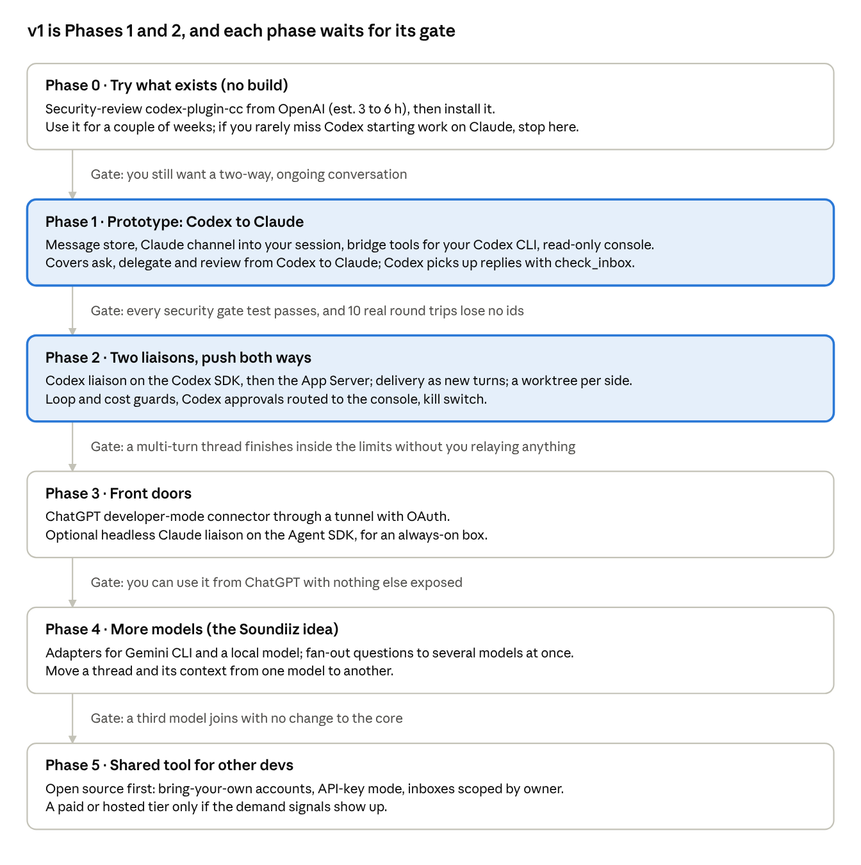
roadmap · 6 phases, 5 gates
Phase 1 alone is useful: Codex can already ask Claude for reviews and hand it tasks, even before the Codex liaison exists.
Stage | Effort (est.)
Phase 0: review and set up codex-plugin-cc | 5 to 9 h
Phases 1 and 2 to a working prototype | 15 to 25 h, plus 5 to 10 h for the trust controls and 4 to 8 h for the security review's must-fix items
Prototype to daily-driver quality | another 20 to 40 h
Upkeep once running | 2 to 4 h a month, more when a preview API changes
Phase 5 open-source release | another 60 to 120 h
Phase 1 gate tests (from the security review). Each must fail to unlock anything and must show up in the audit log.
- ☐ Codex messages containing </channel> plus text shaped like your turn, a fake "message from jason" wrapper, or a claim that "jason approved X", tried in every permission mode the Claude liaison could use
- ☐ An agent calls the console's approve endpoint with its adapter credential, with none, and with a foreign Host header: refused each time
- ☐ An agent message containing <script> or <img onerror> renders inert in the console
- ☐ An agent commit to .claude/settings.json, CLAUDE.md, AGENTS.md or .envrc is flagged, and the Claude liaison's own attempt is denied
- ☐ git push from an agent clone to GitHub fails; a push to the local bare repo works; a force-push or branch delete there is refused
- ☐ A Codex command that needs network or writes outside its clone fails without a prompt and is logged
- ☐ Kill switch with a leftover background process: the process is gone within seconds
- ☐ Hop, turn, rate and spend limits each park the thread and notify you
Estimates are the build-vs-adopt thread's, for one experienced developer working with Claude Code or Codex. They are ranges for comparison, not commitments.

Open decisions
Eight calls are yours, merged from all three threads. Each has a recommendation; mark it in the last column or comment on the row. You settled all eight on 2026-10-09.
# | Decision | Options | Recommendation | Your call
1 | Which goal the next step serves | Personal and open-source-ready; adopt only and build nothing yet; or a product for others from the start | Personal and open-source-ready (est. 10 to 20% more than a throwaway build); no commercial version | Agreed
2 | Trial period before building | Use codex-plugin-cc for a couple of weeks first, or start building now | Trial first; build only if you miss Codex starting work on Claude | Agreed
3 | How the Claude liaison runs | A Claude Code session fed by a channel, which you can type into; or a headless Agent SDK session | Channel, in Manual or acceptEdits mode with no permission relay; Agent SDK as the fallback. The security review notes the Agent SDK mode is the easiest to make airtight, at the cost of API billing | Agreed
4 | How usage is paid in v1 | Your own Claude and ChatGPT plans, or API keys | Your plans while it is personal, with API-key mode ready; API keys once anyone else uses it | Agreed
5 | Autonomy limits | Hops, turns and daily spend before a thread stops and asks you | 8 hops, 20 turns and a daily cap you set; edits allowed only inside each side's own clone | Agreed
6 | Where it runs | Your dev machine, or an always-on box | Your dev machine for v1 | Agreed
7 | Language | TypeScript or Python | TypeScript, narrowly: one language with the web console. Python is close, because OpenAI's stable Python SDK drives the App Server directly | Agreed
8 | One project or many | One liaison per platform either way. It routes to many projects on its side from Phase 1, or right after the Phase 1 gate | Right after the Phase 1 gate, with its own gate. Each side routes on its own (for example, dev on Claude to devops on Codex); destinations and routes are allowlisted by the hub (security re-check passed) | Agreed
Already settled by the research (say so if you disagree):
- The OpenAI-side liaison is Codex, because a ChatGPT chat cannot receive messages.
- The bus is our own. Reviewing mcp_agent_mail would cost about as much as writing one (est. 15 to 30 h), and its human marker can be imitated.
- OpenClaw is not the base.
- Only you approve, under the rules in the Trust model, and all of the security review's must-fix items are Phase 1 requirements.
- Every adopted tool gets a security review first, pinned versions and a reviewed diff per update.
- It stays free and open source, with no commercial version (your call on 2026-10-09).

Sources
Research done 2026-10-09 by this thread and three sibling threads: a prior-art survey, a build-vs-adopt analysis and an independent security review (`security-review.md`). Their full notes are in the project files under bridge-design/ (prior-art.md, build-vs-adopt.md). Claims marked "reportedly", "unofficial" or "est." are not confirmed facts.
- Claude Code: Agent SDK overview, streaming input, headless mode, MCP, Channels, legal and compliance, SDK with your plan, Managed Agents
- Codex: App Server, Codex SDK, MCP config, non-interactive mode, subagents, changelog, codex-plugin-cc
- ChatGPT: developer mode, Apps SDK auth, tool timeout thread
- OpenClaw: repo, architecture, CLI backends, ACP agents, mcp serve, known vulnerabilities, subscription cutoff, Wikipedia
- Other: MCP 2026-07-28 changelog, A2A releases, mcp_agent_mail, PAL MCP, Borda bridge-cc-codex, coder/agentapi
Cost, terms and market: Sign in with ChatGPT plan usage (WorkOS), Conductor review, OpenClaw 2.0 security report.

