Orchard Core Workshops

Sign-up link

https://forms.office.com/Pages/ResponsePage.aspx?id=vLlPa0hJy0a8SkTVCjbmq4YeKJYGYglHmeA2Spx2JJdUNkhUU1NSTFYwUE40VjVDTzRIUkNEWk1JRy4u

Summary

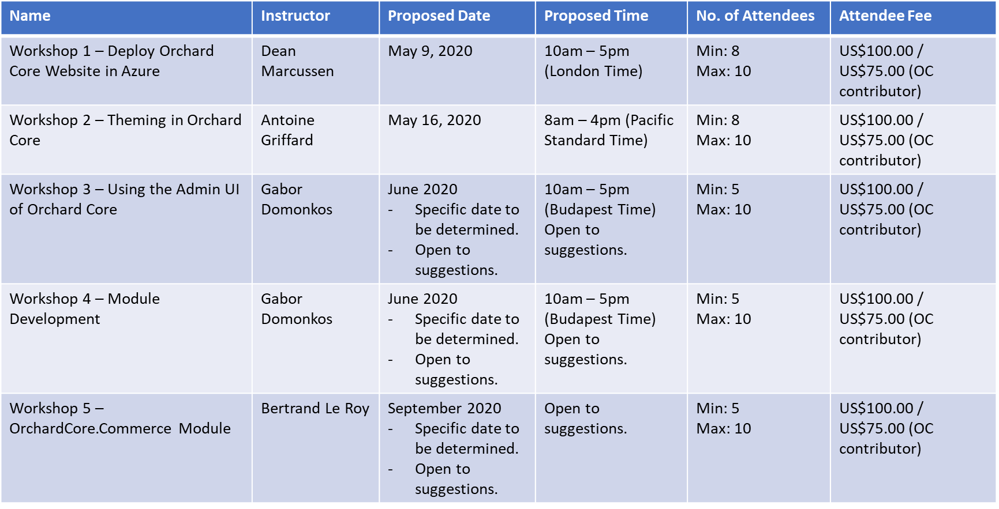

Workshop 1 – Deploy Orchard Core Website in Azure

- Set-up an OC development environment
- Deploy to Azure
  - Deployment considerations
    - App_Data folder
  - Connect to Db
    - Appsettings.json and configuration
- Enable Tenants (SaaS server, and Agency tenant)
- Enable Azure Data Protection
- Azure Pipelines / DevOps for deployment
- Azure Sql Server
- Enable Azure Blob Media Storage with Tenants
- Discuss Media Caching / ImageSharp / Image Resizing considerations
- How to add new image sizes and file formats
- Enable Azure CDN for media and resource scripts
- Enable Email (requires SendGrid, or SMTP server (registration emails)
- Enable Sitemap
- Considerations
  - Use existing OC Agency Theme to focus on functionality and not Theming
  - Attendees must have Azure accounts

Workshop 2 – Theming in Orchard Core

- Set-up an OC development environment
  - Discuss Current OC Themes and How it Works
  - Create our own theme using TheBlogTheme as a BaseTheme
- Make new content type based on BagPart
- Discuss Liquid templates vs Razor templates
- Focus on Liquid templates.
- Discuss and use Liquid shape alternates for BagPart
- Enable Search / Search Shapes
- Lucene Queries
- Enable Feedback submission form / Workflows -> Email

Workshop 3 – Using the Admin UI of Orchard Core

- Set-up an OC development environment
  - Use latest dev branch, not RC1
- Using recipes, the content of the recipes, predefined contents/themes comes with the different kind of recipes
- Content management, creating custom content types/content parts/content fields/content field editors, using the Widget stereotype (what is a widget?)
- Named content parts like the BagPart, how to use the FlowPart, adding widgets to it
- Layers, layer rules, zones
- Templating using the admin UI, where you can write Liquid and see the live preview of your changes
- How to enable/disable modules and themes
- OpenID server, OpenID application, JWT token, to use the content APIs of Orchard Core, user management, permission management (creating a custom role)
- Deployment plans, deployment step, check the structure of the Recipe.json file, here we could also mention the migrations
- Ways to add content to Orchard:
  - Using the admin UI, with built-in APIs, implementing custom APIs, importing recipe files, implementing migration steps

Workshop 4 – Module Development

- Workshop Objective
  - Add a new Orchard Core module (example: To-do lists -> work to-dos, home to-dos)
- Set-up an OC development environment
  - Use latest dev branch, not RC1
- Different ways of creating an empty module (Startup.cs file, Manifest.cs file)
- Code Generation templates (https://docs.orchardcore.net/en/dev/docs/getting-started/templates/)
- Implementing custom content parts/content types/content fields using the data migrations
- Indexing the custom parts, Yes SQL queries
- Razor views, custom Razor Tag Helpers
- Add a custom Razor Tag Helper, focus on Razor templates (.cshtml files)
- AdminControllers (add custom site settings), admin menus, controllers
- How to open pull request to contribute your module back to Orchard Core via GitHub

Workshop 5 – OrchardCore.Commerce Module

- Workshop Content To Be Discussed

