Documentation

TI-Dspire Calculator

MVC pattern with ExpressJS and NodeJS

0. Setup the NodeJS environment:
- Install Node.js (https://nodejs.org/en)
- After installation, open a terminal and type ‘node -v’ (to check the installed Node.js version) and ‘npm -v’ (to check the installed Node Package Manager version).
- Go to the project directory and run ‘npm init -y’ to create a ‘package.json’ file.
0. Setup the Express.js environment:
- In the same project folder, run ‘npm install express’.
1. Create 3 different folders: routes, models, controllers.
Routes: this is where we define whatever we wanna do with ‘x’ object.
Models: mainly for database and organizing queries eventually.
Controllers: execute the different actions and manage the data.
2. Let’s start by creating a Calculator.js router with the app.js to write the Express Application.
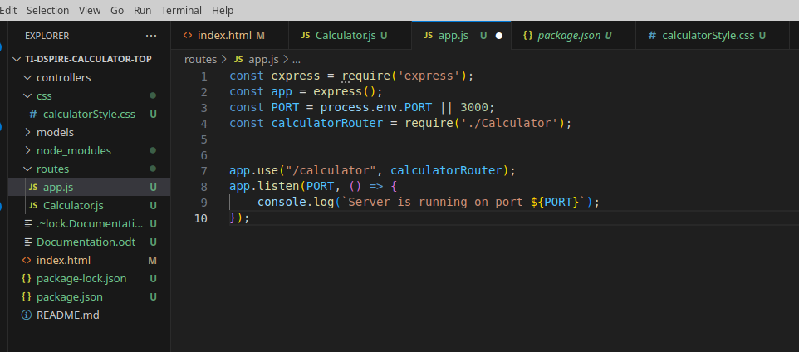

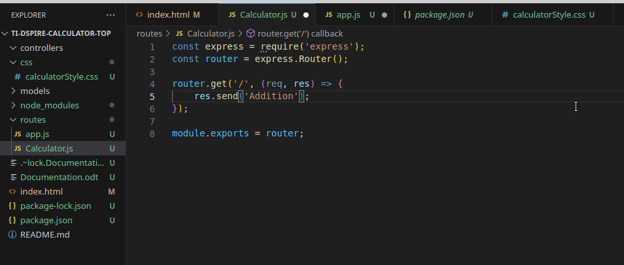

However, this is not MVC as the router is not supposed to do the get method. Now let’s create a controller.

