**Week 4 Work**

**Part 1**

Build a circuit similar to mine below. Note that you must list four sequential letters from your first or last name in sequence from top to bottom. Then, light up the output bit for each of the letters in alphabetical order. You may need to use different bits to distinguish the letters. You may be able to do it in 2 bits, and should be able to do it with less than four. The mystery circuit may or may not need all inputs, and it should consist of 3 gates.

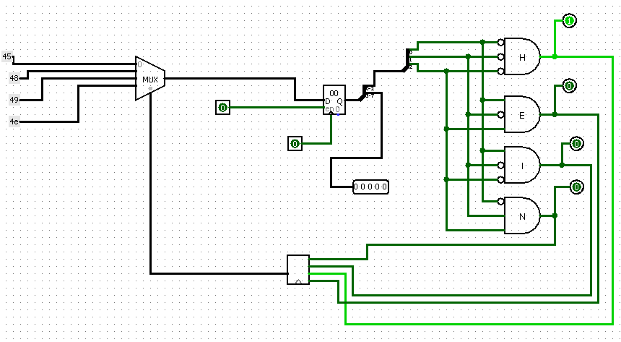

**Mystery Circuit**

**Part 2**

Write a 1 paragraph(7-10 sentences) addressing each of the following scenarios(2 paragraphs or 14-20 sentences total):

1. What if you had a sixteen bit architecture instead of 32 bits. How many registers would such a computer have? What kinds of instructions would you include/exclude? What about instruction types? How would you allocate bits?
2. What if you had a 64 bit architecture? Could you run two instructions from MIPS in parallel(at the same time)? Why or why not? What kinds of instructions could you include that you cannot include in a 32 bit architecture?