Parallel action: replace text and image

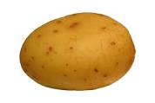

## Potatoes are Rich in Vitamins and Minerals