Parallel action: replace text and image

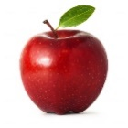

**An Apple a Day Keeps the Doctor Away.**