Parallel action: replace text and image

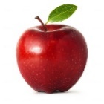

## Apples are Rich in Vitamins and Minerals