Parallel action: replace text and image

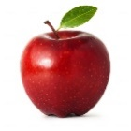

## Apples are Great for Our Teeth