STUDENT ATTENDANCE AND PERFORMANCE TRACKING SYSTEM

A Software Engineering SDLC Project

Prepared By:
[ODUEYUNGBO OREOLUWA ISREAL]
[23/13342]

Course Code & Title:
[SEN 201: INTRODUCTION TO SOFTWARE ENGINEERING]

Lecturer:
[Prof. Moses. K. Aregbesola]

Institution:
[CALEB UNIVERSITY]

CHAPTER ONE: INTRODUCTION

1.1 Background of the Study
Student attendance management is an essential academic activity in educational institutions. Traditional paper-based systems are prone to errors and inefficiencies. This project presents a no-code Student Attendance and Performance Tracking System using Microsoft Excel.

1.2 Problem Statement
Manual attendance recording leads to inaccurate data, difficulty in tracking trends, and inefficient report generation.

1.3 Aim and Objectives
The aim of this project is to design and implement a no-code attendance management system.
- Record student attendance accurately
- Automate attendance calculations
- Generate attendance summaries
- Reduce manual errors

1.4 Scope of the Study
The system focuses on attendance management for a single course using Microsoft Excel.

1.5 Significance of the Study
The system improves efficiency, accuracy, and accessibility of attendance records.

CHAPTER TWO: PLANNING AND FEASIBILITY STUDY
The project follows the System Development Life Cycle (SDLC) methodology.
Technical Feasibility: Uses readily available tools.
Economic Feasibility: No cost involved.
Operational Feasibility: Easy to use.

CHAPTER THREE: REQUIREMENTS ANALYSIS
Functional Requirements:
- Manage student records
- Record attendance
- Calculate attendance percentages
- Generate reports
Non-Functional Requirements:
- Accuracy
- Reliability
- Ease of use

CHAPTER FOUR: SYSTEM DESIGN
The system is designed as an Excel workbook containing multiple worksheets.

CHAPTER FIVE: IMPLEMENTATION
Microsoft Excel was used to implement the system using built-in formulas. 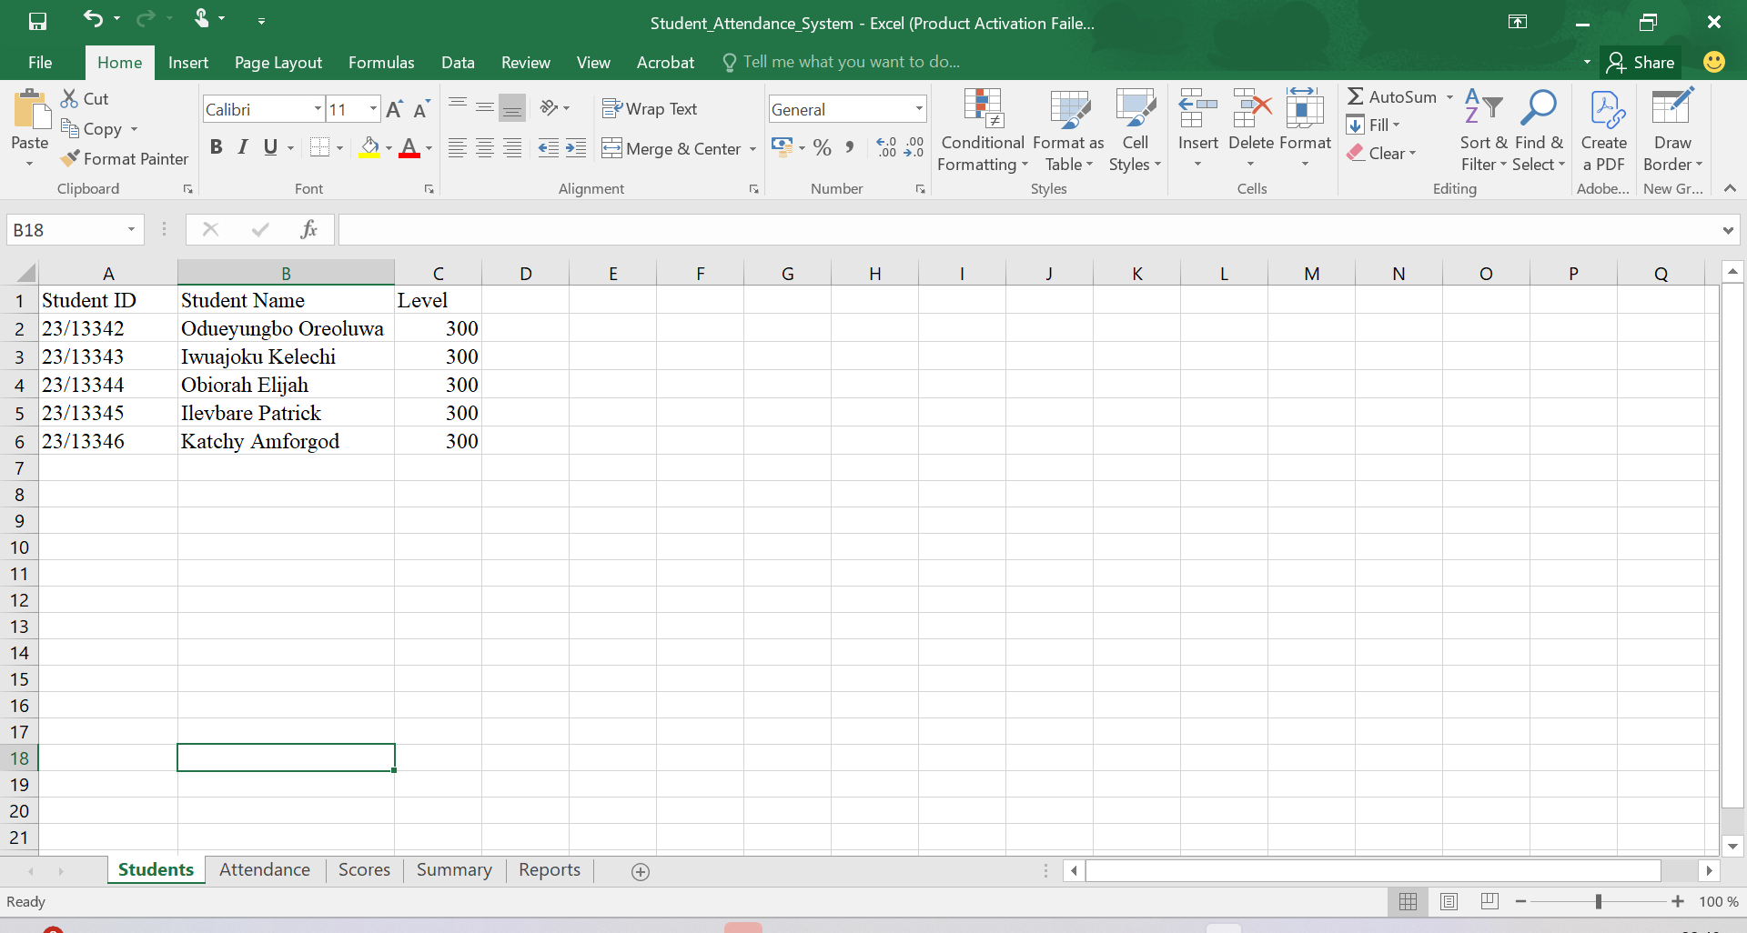
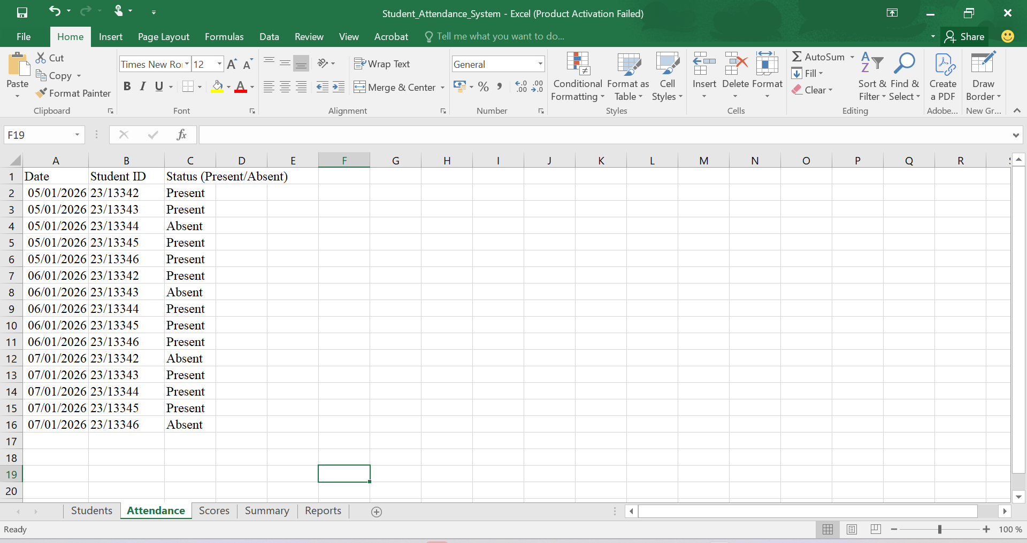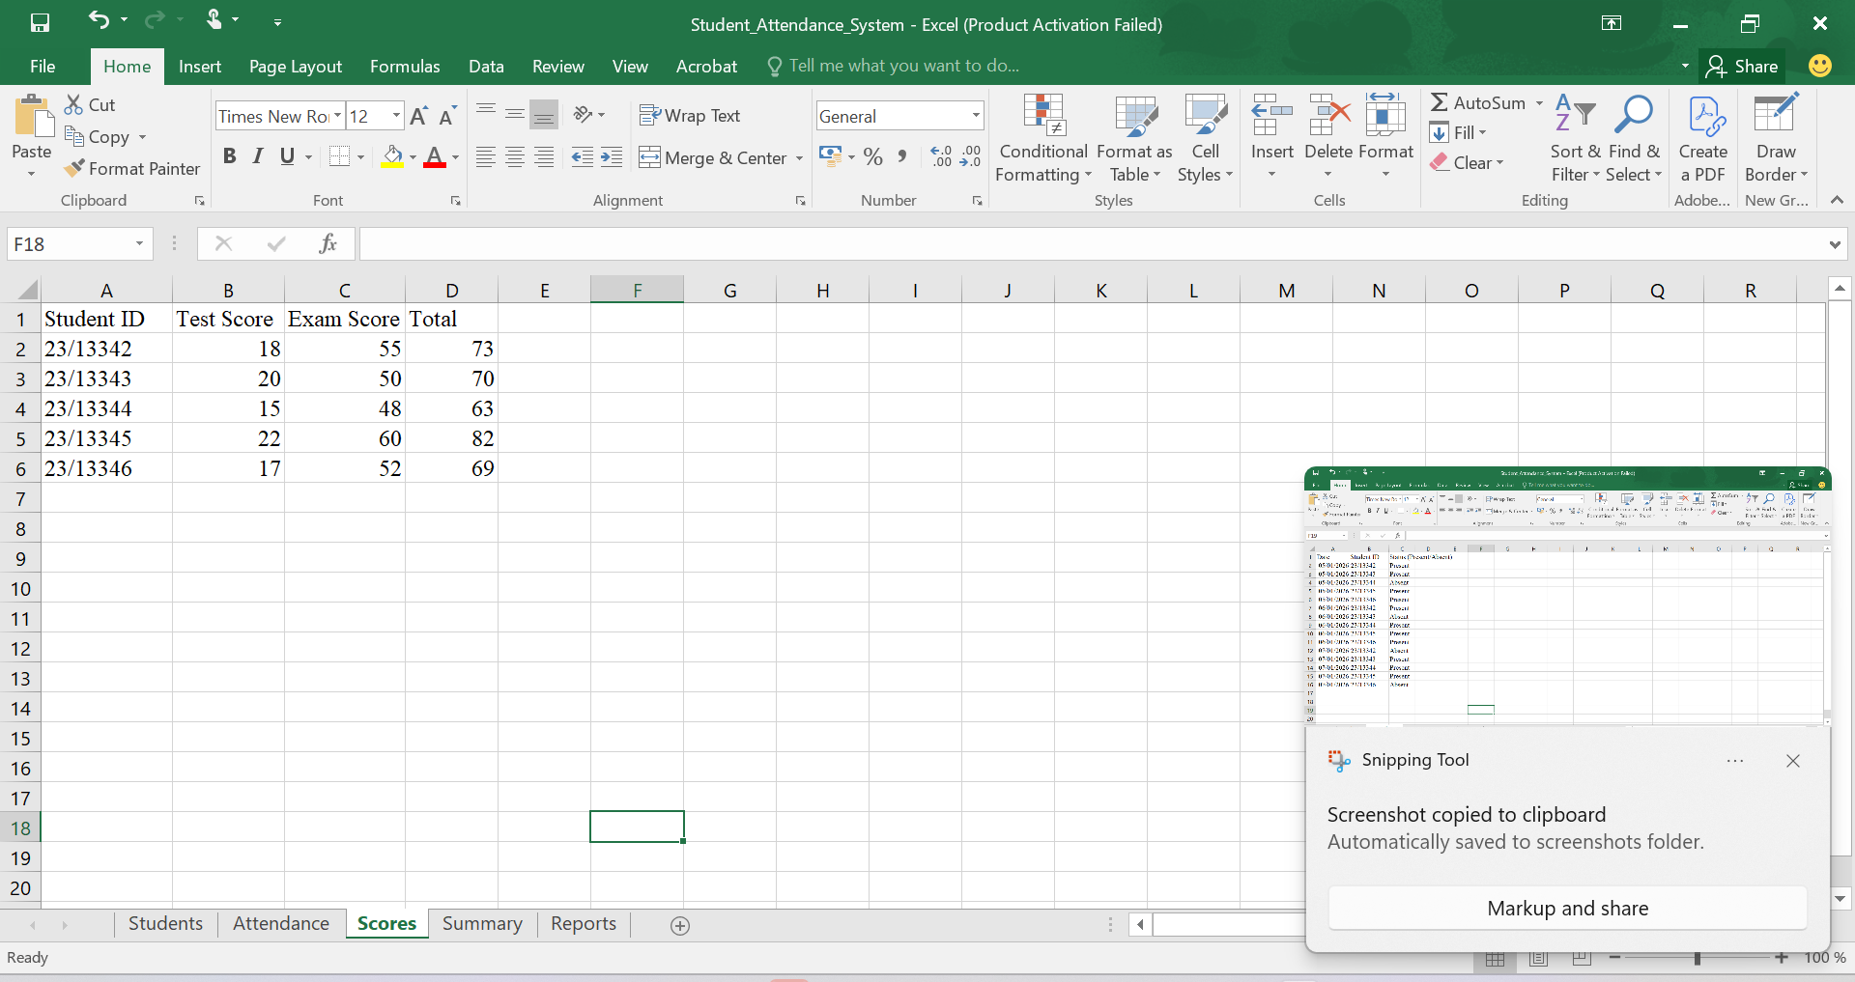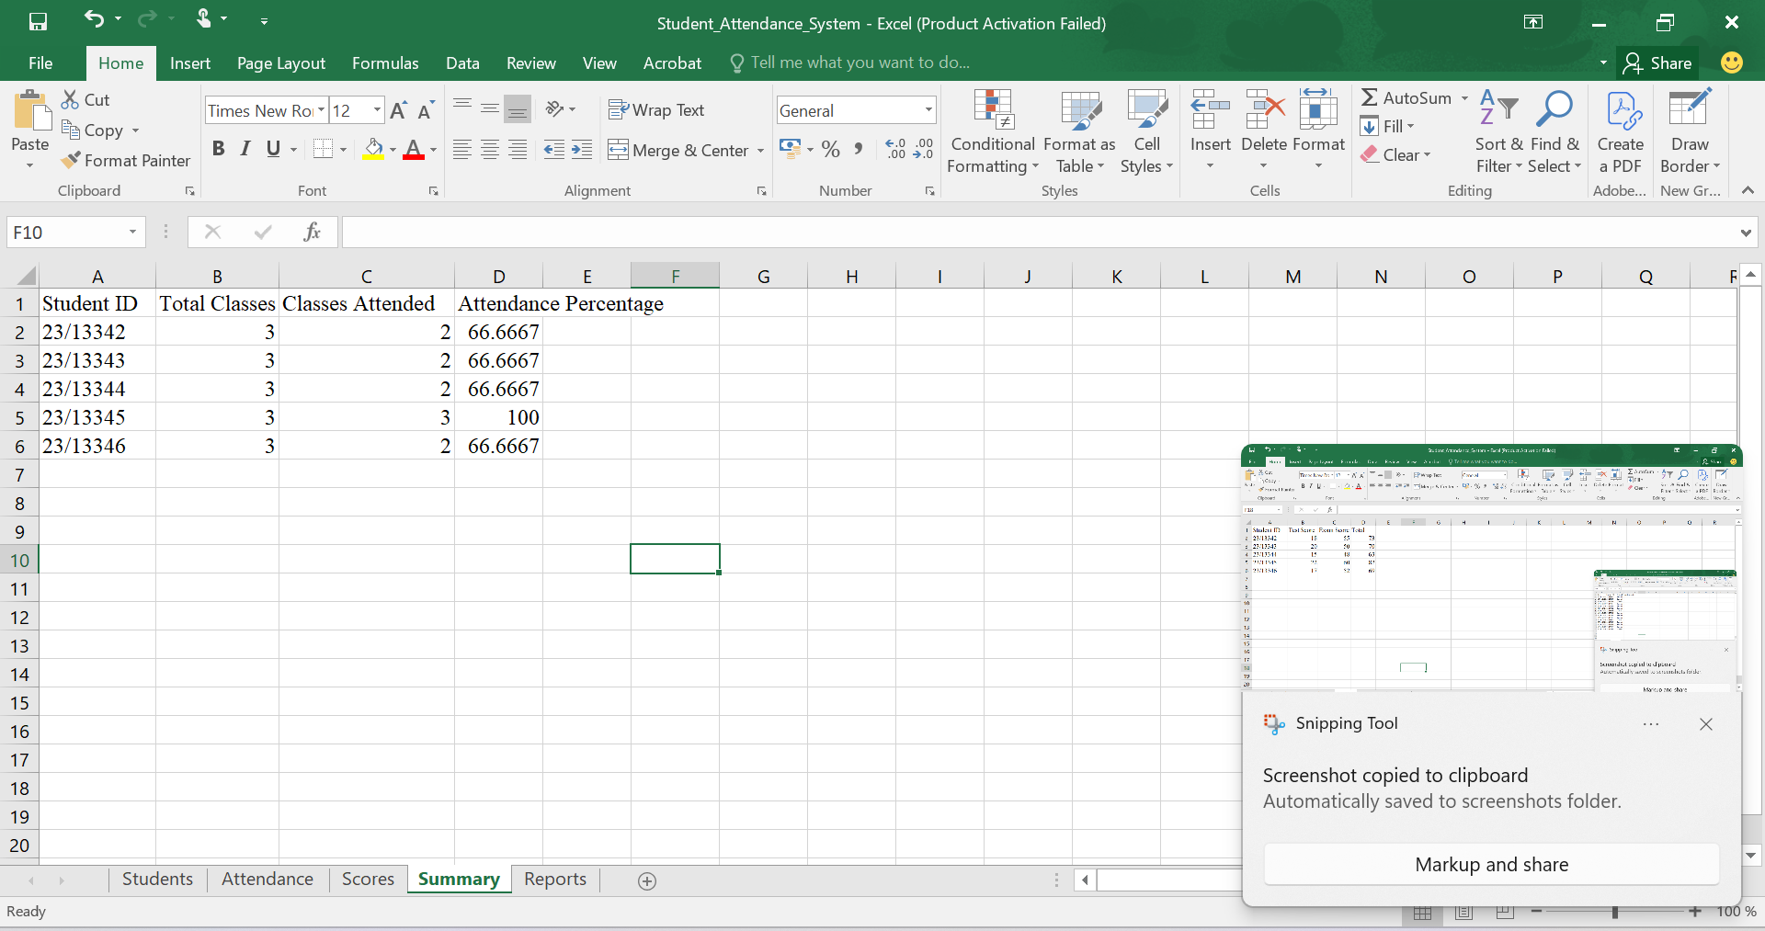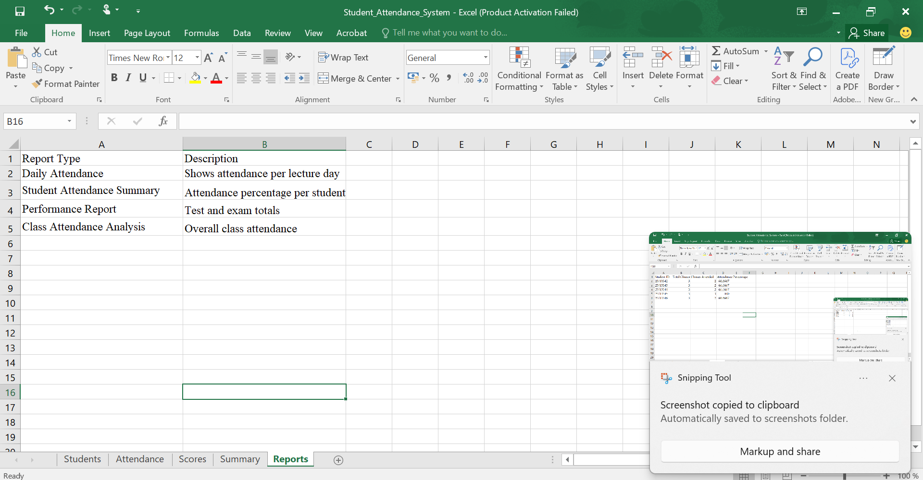
CHAPTER SIX: TESTING
Testing was conducted using sample data to verify system accuracy.

CHAPTER SEVEN: DEPLOYMENT AND MAINTENANCE
The system was deployed by copying the Excel file and maintained through regular updates.

CHAPTER EIGHT: CONCLUSION
The project successfully demonstrates SDLC implementation using a no-code approach.

