NO background, NO MFCC,43features

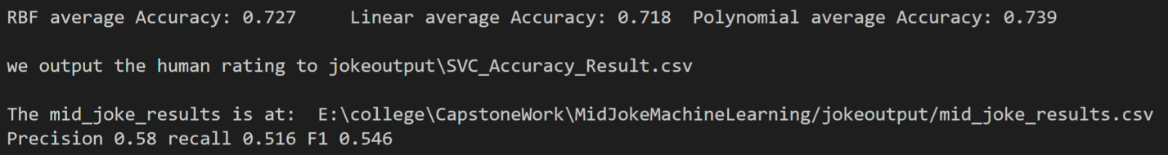

Has background, No MFCC, 43features

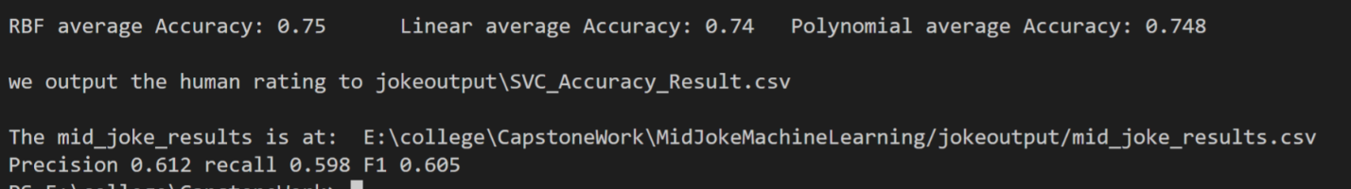

No Background, Has MFCC, 43features



Has background, has mfcc, 43features



Has both, 27 features

