

Graph Embedding by Deep Generative Graph Adversarial Networks

Submitted By:
Orel Damti 315838375
orel.damti@e.braude.ac.il

Supervisors:
Dr. Dvora Toledano-Kitai
Prof. Zeev Volkovich
This report is submitted in partial fulfilment of the requirement for the degree of MSc in Software Engineering
November 9, 2025
Table of Contents
Abstract ........................................................................................................................................................................ 4
- Introduction ............................………………………………………………………………………………4
  - Challenges in Large-Scale Network and Graph Applications………………………………….4
  - Graph Embedding for Efficient Graph Mining .......................................................................... 4
  - Limitations of Existing Link Prediction Methods ........................................................................5
- Related Work ................................................................................................................................................ 6
- Background………………………………………………………………………………………………….8
3.1 Graph Embedding…………………………………………………………………………………8
3.2 Generative Adversarial Network (GAN)…………………………………………………………8
3.2.1 Positive Sample…………………………………………………………………………...9
3.2.2 Negative Sample………………………………………………………………………….9
3.2.3 Objective Function……………………………………………………………………10
3.2.4 Training………………………………………………………………………………….11
3.3 DGGAN: Directed Graph Generative Adversarial Network………………………………….11
3.4 Link Prediction…………………………………………………………………………………...14
- Approach.......................................................................................................................................................15
4.1 Model Architecture………………………………………………………………………….……15
4.2 Evaluation Methodology…………………………………………………………………………17
4.2.1 Algorithmic Procedure…………………………………………………………………17
- Implementation Phase……………………................................................................................................. 18
5.1 Dataset…………………………………………………………………………………………….18
5.2 Hyperparameters……………………………………………………………………………….18
5.2.1 General Training Parameters………………………………………………………….18
5.2.2 Regularization and Noise Settings……………………………………………………19
5.2.3 Model Architecture Hyperparameters………………………………………………19
5.2.4 Optimizer Configuration……………………………………………………………….20
5.3 Implementation Details………………………………………………………………………….20
5.4 Performance Evaluation…………………………………………………………………………22
5.4.1 Ranking-Based Evaluation Metrics………………………………………………….23
5.4.2 Repetitive link reconstruction performance measurement…………………………23
5.4.2.1 Flowchart of the Evaluation Methodology………………………………….23
5.5 Evaluation Results……………………………………………………………………………….25
5.5.1 Link Reconstruction Performance…………………………………………………….25
5.5.1.1 Distribution of Hit Ranks…………………………………………………….25
5.5.1.2 Cumulative Hits@k...........................................................................................26
5.5.2 Repetitive LinkReconstruction Performance…………………………………………27
5.5.2.1 Hits@1................................................................................................................27
5.5.2.2 Hits@100............................................................................................................27
5.5.2.3 Mean Reciprocal Rank……………………………………………………….27
5.5.2.4 Precision@100....................................................................................................29
5.5.2.5 Metric Distribution and Analysis…………………………………………….29
5.5.2.6 raining Loss and AUC vs Epoch……………………………………………….30
5.5.2.7 ROC Curves for Link Prediction……………………………………………...31
5.5.3 Summary and Discussion of Evaluation Results……………………………………32
- Implementation: Tools and Technologies................................................................................................... 33
- Google Collab………………………………………………………………………………………………34
- Git…………………………………………………………………………………………………………34
- References…………………………………………………………………………………………………35

Abstract
The goal of this project is to apply DGGAN (Deep Generative Graph Adversarial Network) for link prediction in citation networks. Link prediction is a fundamental task in various graph-based applications, including recommendation system and social network analysis. The proposed approach utilizes DGGAN to capture the underlying structure of citation networks, enabling the generation of synthetic graphs that closely mirror real-world citation patterns. By leveraging adversarial learning, DGGAN enhances the accuracy of link prediction and maintains the structural coherence of the network, offering a robust solution for predicting future citation links.
Keywords: Graph Embedding, Link Prediction, Generative Adversarial Networks (GAN), Deep Learning,

- Introduction
This project addresses the challenge of identifying potential neighbors of a given node within a directed graph represented in a vector space.
The Deep Generative Graph Adversarial Network (DGGAN) model is introduced to address the link prediction problem in graph structures. DGGAN employs Generative Adversarial Networks (GANs) to uncover hidden relationships within the graph, enhancing prediction accuracy and network structures analysis.
Challenges in Large-Scale Network and Graph Applications
In recent years, an increasing number of applications have relied on large-scale networks and graph structures. These applications span a wide range of domains, including predicting potential membership in social networks, bioinformatics, citation networks, and website link networks. Despite their growing importance, effectively processing graph data remains a significant challenge due to the complexity and high-dimensional nature of such structures. A fundamental issue in graph analysis is graph representation, which involves encoding graphs in a manner that facilitates advanced analytical tasks such as pattern recognition, structure analysis, and link prediction while optimizing computational efficiency in both time and space. Despite ongoing research efforts, the problem of graph representation remains largely unresolved.

Graph Embedding for Efficient Graph Mining
When working with a dataset represented as a directed graph, it is often necessary to transform the graph from its original high-dimensional space into a lower-dimensional representation to enable efficient graph mining operations. This transformation process, known as graph embedding, maps nodes into a continuous vector space while preserving structures properties, such as edges and connectivity patterns. To ensure that meaningful insights can be derived from such embeddings, the directed relationships between nodes must be accurately predicted.

Limitations of Existing Link Prediction Methods
Several existing methods (e.g., HOPE [5], APP [11]) have been proposed for link prediction in directed graphs; however, they exhibit several notable limitations. A significant challenge is the lack of generalization, as many models are tailored to specific types of graphs and struggle to adapt to diverse network structures. Additionally, scalability remains a significant issue, as traditional approaches often fail to efficiently process large-scale graphs. Furthermore, these methods tend to perform poorly in edge cases, particularly when handling nodes with low in-degree or out-degree, which results in reduced prediction accuracy.
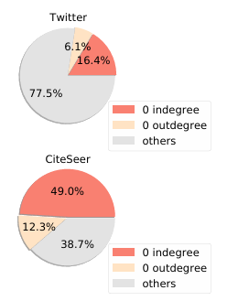
Figure 1: Statistics from the social network of Twitter and the citation network of CiteSeer.

A real-world example illustrating these limitations can be found in social networks such as Twitter, where users are represented as nodes and connections (followers and following relationships) form directed edges. Predicting relevant connections for users with no prior interactions (e.g., new accounts with zero followers or followings) presents a significant challenge. Similarly, in academic citation networks such as CiteSeer [12] (Fig.1), a considerable number of research articles lack citations or references, making it difficult to infer relationships between different research fields. This underscores the necessity of an approach capable of capturing latent structures in such scenarios.

This project describes an efficient model for capturing asymmetric relationships (directed edges) in graph structures. The model is designed to learn various features of a graph, such as node properties and the correspondence between incoming and outgoing connections). More accurate identification of asymmetric information leads to improved reliability when modeling real-world data, including social networks and citation networks.

To address these challenges, this project leverages a Generative Adversarial Network (GAN)-based model to learn graph structures through neural networks, making it scalable and adaptable to different types of graphs. The core idea is to employ neural networks along with a normal distribution to generate realistic samples and classify them through an iterative training process. Given an input node, the model generates potential source and target neighbors ensuring their consistency with the original graph structure. Through adversarial training, the model refines its predictions to output a graph that closely resembles the original, including plausible directed edges between nodes.

- Related Work

Extensive research has been conducted on developing methods for capturing directed relationships between nodes in graph embeddings. Various techniques have been proposed for learning graph representations, including matrix factorization methods, random walk-based approaches, and neural network-based models. Among these, neural network-based methods, such as Graph Convolutional Networks (GCNs) [4] and Graph Attention Networks (GATs) [9], leverage deep learning to derive node embeddings from the structural properties of a graph.
Several methods have been developed to preserve information within a graph; however, their ability to accurately predict directed edges remains limited.
One such method is High-Order Proximity preserved Embedding (HOPE) [5]. HOPE is based on the Katz index [3] and aims to predict paths and infer links between nodes. Despite its effectiveness in capturing high-order proximity, HOPE struggles with specific edge cases, particularly nodes with low in-degree or out-degree. Additionally, it relies on matrix decomposition techniques, which are computationally expensive and impractical for large graphs. Since these techniques do not effectively leverage graph sparsity, they often incur excessive memory and processing costs, restricting their applicability to large-scale networks.
Another approach, Asymmetric proximity preserving (APP) [11] employs a random walk strategy that follows outgoing arcs to generate negative samples. However, this method is also constrained by its inability to accurately predict directed edges for nodes with low connectivity, making it unsuitable for sparsely linked graphs.
Deep learning-based approaches have been increasingly utilized to address the challenge of missing edge completion in networks. For instance, Graph Convolutional Networks (GCNs) [4] apply convolutional operations to graph structures, allowing models to learn complex patterns and predict missing connections between nodes. Similarly, Graph Attention Networks (GATs) – [9] integrate attention mechanism into the learning process, enhancing the model’s ability to capture node-specific features and infer missing links in graph-structured data.
A more recent deep learning-based method, Directed Graph Generative Adversarial Network (DGGAN), builds upon these foundations. DGGAN is a generative model designed to infer missing directed edges by learning node representations in an adversarial setting. As a specific case of deep learning-based techniques, it extends the capabilities of models like GCN and GAT by incorporating directionality and adversarial learning, improving the generation of realistic directed edges, especially in sparse networks.

- Background

  - Graph Embedding
Graph Embedding [10] illustrated in Fig. 2 is a technique designed to transform nodes and edges into a graph into a vector space while preserving the essential structural and relational properties of the original graph. This transformation enables efficient processing and analysis of graph-based data, facilitating tasks such as link prediction, clustering, and anomaly detection.
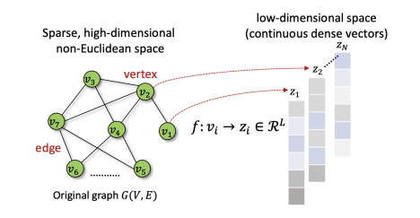
Figure 2: Schematic of graph (node) embedding.

  - Generative Adversarial Network (GAN)

A Generative Adversarial Network (GAN) [1] illustrated in Fig. 3 is a type of generative model designed to produce high-quality synthetic data. It consists of two primary components: the Generator and the Discriminator. The Generator aims to create realistic data samples based on patterns learned from real data, while the Discriminator is responsible for distinguishing between real and synthetic samples. The model undergoes an iterative adversarial training process where both components continuously improve through trial and error. This optimization process refines the weights of the neural network, ultimately enhancing the quality and reliability of the generated data.
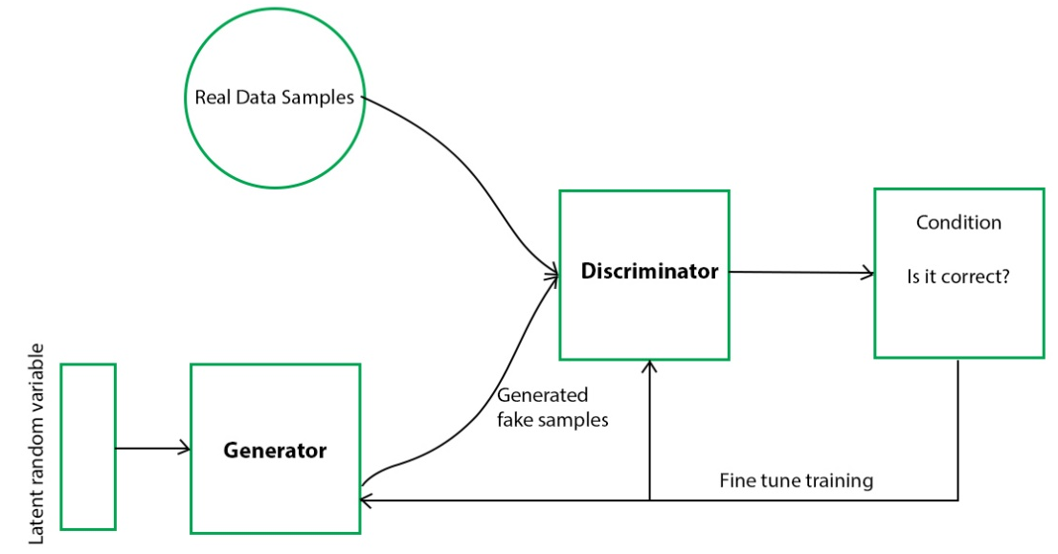
Figure 3: The basic architecture of GANs.

In the context of this project, the GAN framework is specifically adapted for directed graphs. Instead of generating generic data samples, the generators in our model propose potential source and target neighbors for each node. These suggestions aim to reconstruct missing citation links in a directed citation network. The discriminator evaluates the proposed links, distinguishing between real and synthetic citations, and thus refines the embedding quality and improves link prediction accuracy.
3.2.1 Positive Sample
Positive samples refer to data points derived from true distribution of the dataset, often referred to as ground truth. These samples represent real data and serve as a benchmark for the discriminator, which uses them to compare against synthetic (negative) samples produced by the generator. By evaluating the difference between positive and negative samples, the discriminator computes a loss function that guides the model’s learning process.
In our project, positive samples refer to actual citation links between papers in the original dataset, which serve as ground truth during the adversarial training process.
3.2.2 Negative Sample
Negative samples are artificially generated data points produced by the generator during the training process. These samples attempt to mimic real data and are evaluated against positive samples by the discriminator. The effectiveness of the generator improves as it learns to produce negative samples that become increasingly indistinguishable from positive ones, thereby reducing the discriminator's ability to differentiate between real and synthetic data.
In this project, negative samples are synthetic citation links generated by the two generators in DGGAN. These are evaluated against the real citations by the discriminator to improve its classification accuracy.
3.2.3 Objective Function
The objective function plays a crucial role in optimizing the performance of the GAN model. Its primary goal is to minimize the generator’s error while forcing the discriminator to misclassify synthetic samples as real. Mathematically this process is expressed by the following equation:
(1)
Equation (10) represents the objective function of a Generative Adversarial Network (GAN), specially used in adversarial learning for graph embedding, where: represents:
1. $\min_{θ^{G}} \max_{θ^{D}}$ ; signifies a minimax game between two neural networks:
* Generator ($G$) with parameters $θ^{G}$
* Discriminator ($D$) with parameters $θ^{D}$
The discriminator maximizes the function to distinguish real from fake samples, while the generator minimizes it to fool the discriminator.
2. $E_{x\sim P_{data\left(x\right)}}\left[\log{D\left(x;θ^{D}\right)}\right];$ is the expectation over real data $x$ sampled from the true data distribution $P_{data\left(x\right)}.$
- $D(x;θ^{D})$ represents the discriminator’s probability that $x$is real.
- The discriminator aims to maximize this term by correctly classifying real data.
3. $E_{z\sim P_{z(z)}}[log⁡(1-D\left(G\left(z;θ^{G}\right);θ^{D}\right))]$: the expectation over noise $z$ sampled from a prior distribution $P_{z(z)}$ (e.g., Gaussian or Uniform).
* The generator $G\left(z;θ^{G}\right)$ takes $z$ and generates a fake sample.
* $D\left(G\left(z;θ^{G}\right);θ^{D}\right)$ is the probability assigned by the discriminator to the fake data.
* The discriminator tries to minimize this term (maximize $1-D$), while the generator tries to minimize it (make $D$ output higher values for fake data).
This equation represents the adversarial learning process, where the generator $G$ aims to minimize the discriminator’s ability to distinguish real from generated samples, while the discriminator $D$attempts to maximize its classification accuracy. The interaction between $G$ and $D$ forms a zero-sum game, leading to an equilibrium state where the generator produces samples that are nearly indistinguishable from real data. Both $G$ and $D$ are typically implemented using Multilayer Perceptron’s (MLPs), ensuring effective learning and adaptation throughout the training process.
In our DGGAN model, this adversarial objective function governs the training process between the generators and the discriminator. The generators attempt to produce realistic citation links that resemble the ground truth, while the discriminator learns to distinguish them from real ones. This dynamic leads to improved link prediction and more robust node embeddings in the context of directed citation graphs.
3.2.4 Training
During the training process, the model optimizes its parameters (weights) within a neural network by learning relevant features from the input data. The objective is to the weights in such a way that the network can accurately represent and generate reliable data samples. The more precise the network’s weights, the more realistic and high-quality the generated samples become. The training procedure begins with the discriminator, which is first trained to distinguish between real and synthetic data by identifying errors in the random patterns generated by the generator. Once the discriminator has been sufficiently trained, attention shifts to the generator, which learns to create more convincing samples that challenge the discriminator’s ability to differentiate between real and fake data. The iterative process follows a back-and-forth approach: first the discriminator is trained, then the generator, and this alternation continues throughout the training cycle. This method ensures that both components continually improve, enabling the model to refine its predictions and overcome issues related to poor-quality or imbalanced data samples.
In the case of DGGAN, this training process involves generating candidate citation links, evaluating them through the discriminator, and iteratively improving the generators to produce increasingly realistic links. This adversarial feedback loop enables the model to learn latent structures within the citation network and accurately predict missing or potential citation edges.
3.3 DGGAN: Directed Graph Generative Adversarial Network
DGGAN (Directed Graph Generative Adversarial Network) [12] introduces a novel approach to directed graph embedding by leveraging adversarial mechanisms to overcome the limitations of existing methods. Unlike traditional approaches that learn source and target vectors separately, DGGAN deploys a unified framework with one discriminator and two generators that jointly learn each node's source and target vectors from the same underlying distribution.
For a given node, the two generators produce synthetic target and source neighbor nodes, while the discriminator attempts to distinguish whether a given neighbor node is real or artificially generated. This adversarial architecture enables the robustness of the learned embeddings, particularly for nodes with low in-degree or out-degree, as the generators reinforce each other through a shared latent representation.
Empirical evaluations demonstrate that DGGAN consistently outperforms state-of-the-art methods across various mining tasks, including link prediction, node classification, and graph reconstruction. The model's ability to effectively capture asymmetric relationships in directed graphs underscores its potential for advancing research in network analysis.
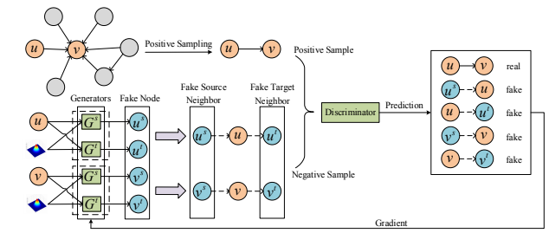
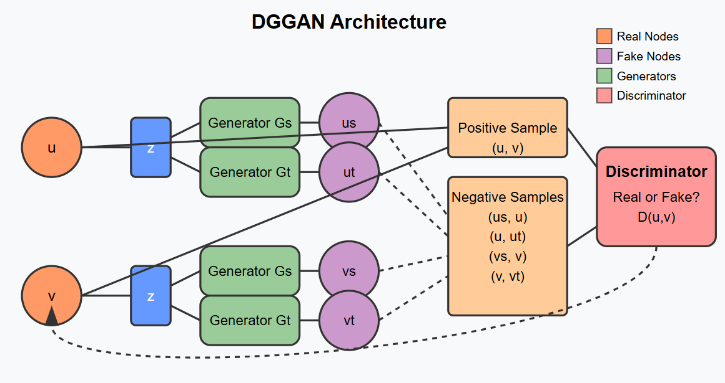
Figure 4: DGGAN Architecture.
The diagram in Fig. 4 illustrates the key components of DGGAN architecture:
- Real Nodes (orange circles): Labeled as '$u$' and '$v$', these are the actual nodes from the input directed graph.
- Latent Space (blue rectangles): Denoted by '$z$', this represents the shared underlying distribution from which fake neighbors are generated.
- Generators (green rectangles): Two types of generators are shown:
  - Generator $Gs$: Produces fake source neighbors
  - Generator $Gt$: Produces fake target neighbors. Each node has both generators working in tandem.
- Fake Nodes (purple circles): The outputs from the generators:
  - $us$: Fake source neighbor of node '$u$'.
  - $ut$: Fake target neighbor of node '$u$'.
  - $vs$: Fake source neighbor of node '$v$'v.
  - $vt$: Fake target neighbor of node '$v$'.
- Samples (orange rectangles):
  - Positive Sample: A Real node pair, $(u,v)$ from the original graph.
  - Negative Samples: Generated fake node pairs including $(us,u)$, $(u,ut)$,$(vs,v)$, and$(v,vt)$
- Discriminator (red rectangle): The discriminator attempts to distinguish between real node pairs and fake node pairs, outputting probability score $D(u,v)$, which indicates the likelihood that a node pair is real.
- Connections:
  - Solid lines show the forward process of generating fake neighbors
  - Dashed lines represent feedback during adversarial training
The architecture highlights how the two generators share the same latent space, jointly learning the source and target representations for each node. The discriminator provides feedback to improve the generators' ability to produce realistic fake neighbors. This process is particularly beneficial for nodes with low in-degree or out-degree, as the generators mutually reinforce each other. The joint learning framework enables more robust node embedding by ensuring the source and target roles are learned in conjunction.

3.4 Link Prediction
Link prediction is a task of inferring missing or future connections between nodes in a graph based on its existing structure and node features. It is a fundamental problem in graph-based machine learning with a wide range of applications, including social network analysis, biological networks, and knowledge graph completion (e.g., discovering new entity relationships).
Formally, given a graph $G=(V,E),$ where $V$ is the set of nodes and $E$ is the set of observed edges, the objective of link prediction is to estimate the likelihood of an unobserved edge $(u,v)∉E$ existing in the graph.
Traditional approaches to link prediction include similarity-based heuristics, such as Common Neighbors, the Adamic/Adar index, and the Katz index. While these methods are relatively simple and computationally efficient, they often struggle to capture complex structural patterns, especially in sparse or directed networks.
In recent years, deep learning methods, particularly Graph Neural Networks (GNNs), have gained increasing prominence for link prediction. GNN-based models, such as Graph Convolutional Networks (GCNs) and Graph Attention Networks (GATs), learn node embeddings by aggregating information from neighboring nodes. These learned embeddings can then be leveraged to predict the existence of links between node pairs using techniques such as dot-product scoring or neural classifiers.
Although link prediction is not inherently built-into GANs, it is a task that can be effectively addressed using GAN-based architecture. In this context, the GAN framework is used to generate realistic candidate links; the generator proposes potential links (edges), while the discriminator attempts to distinguish between real and generated links. This adversarial learning process i enhances the model’s ability to capture the underlying graph structure.
In this project, we employ the Directed Graph Generative Adversarial Network (DGGAN) for link prediction, leveraging its capability to model directed graphs and infer missing edges. The DGGAN framework extends the GAN paradigm to graph data by incorporating directionality into both the generation and discrimination processes, allowing it to better represent asymmetrical relationships. This makes it particularly effective for sparse, large-scale, or directional graphs, where traditional and even standard GNN-based approaches may fall short.
Link prediction [9] (Fig. 5) refers to the process of forecasting potential connections or relationships between nodes within a network or graph. It is a fundamental task in various domains, such as social network analysis, recommendation systems, and biological networks, where the goal is to predict missing or future links based on the existing structure of the graph.
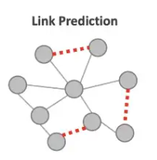

Figure 5: Link Prediction.

- Approach
The proposed model utilizes Directed Graph Generative Adversarial Networks (DGGAN) to predict missing citation links in academic networks. In such networks, a missing edge corresponds to a citation that likely exists conceptually but is absent due to incomplete or evolving bibliographic data. The suggested approach aims to reconstruct these latent links by learning meaningful structural representations and generating high-confidence citation predictions.
4.1 Model Architecture
The model architecture follows an adversarial learning process consisting of the following core components
- Graph Embedding Layer:
The model learns two distinct embedding spaces for each node:
- Source embeddings: capturing the behavior of nodes as citing entities
- Target embeddings: capturing the behavior of nodes as cited entities.
This dual embedding scheme is particularly effective for directed and sparse graphs, such as citation networks, as it allows the model to differentiate between the incoming and outgoing roles of each paper: for example, distinguishing a highly cited paper from one that frequently cites others.

The embedding process consists of:
- Discriminator Embeddings:
Two separate embedding matrices are learned for source and target roles:
- embedding_matrix[0] for source nodes
- embedding_matrix[1] for target nodes
- These embeddings are optimized to help the discriminator distinguish between real and generated citation pairs. Generator Embeddings:
Generator modules transform the learned discriminator embeddings by adding stochastic noise and applying learned linear transformations, thereby producing synthetic citation links.

- This approach effectively preserves the directional nature of citations (i, e., A cites B ≠ B cites A) and captures the structural asymmetry inherent in academic networks, where some papers are frequently cited but rarely cited others, and vice versa.Generative Process:
Two generators are employed:
  - $Gs$ (source generator): Proposes candidate source nodes for potential citation links.
  - and Gt (target generator): Proposes candidate target nodes.
Both generators sample from a shared latent space and are trained to capture citation patterns from both outgoing and incoming perspectives. This dual approach promotes diversity in the generated links and helps prevent mode collapse.
- Discriminative Process:
A single discriminator ($D$) evaluates node pairs (source, target) to determine whether they represent:
- A real citation link from the training graph, or
- A synthetic link proposed by the generators.
The discriminator thus learns to capture fine-grained structural patterns that characterize genuine citations.
- Adversarial Training Loop:
The training process is adversarial:
- The generators are optimized to produce plausible citation links that can “fool” the discriminator/
- The discriminator is trained to simultaneously improve its ability to detect artificially generated links.
Through this competitive adversarial interplay progressively, both components are iteratively improved, resulting in increasingly realistic and accurate link predictions over time.

Figure 6: DGGAN Edge Prediction Procedure.

4.2 Evaluation Methodology
To evaluate the model’s ability to predict missing citation links, we adopt a reconstruction-based evaluation strategy. Specifically, a percentage $P$% of true citation edges is removed from the original graph to simulate incomplete data. The model is then tasked with recovering these omitted links, and its performance is assessed by comparing the predicted edges to the held-out ground truth.
4.2.1 Algorithmic Procedure
Given a directed citation graph $G=\left(V,E\right)$, the following procedure is executed over $k$ independent runs to ensure statistical robustness:
  - Edge Removal: Randomly remove $P$% of the edges from the graph to simulate missing citations. The removed edges are stored as the ground truth set for evaluation.
2. Link Prediction via DGGAN: Apply the DGGAN-based link prediction procedure to the incomplete graph to generate potential missing links.
3. Performance Evaluation: Compare the predicted links to the original ground truth using the metrics Top-k, Hits@k, Mean Reciprocal Rank (MRR), Precision@k.

5. Implementation Phase
5.1 Dataset
The CORA-Full dataset is used for node classification task.
It is an extended version of the original Cora dataset, where:
- Nodes represent academic papers
- Edges represent citations relationships between papers.

Reference: https://github.com/shchur/gnn-benchmark#datasets

Dataset Statistics:
- Number of nodes: 19,793
- Number of edges: 126,842
Note: The original dataset contains 65,311 edges. However, when using DGL (Deep Graph Library), reverse edges are automatically added and duplicate edges are removed, resulting in a different total edge count.
- Number of Classes: 70
- Node feature dimension: 8,710

5.2 Hyperparameters
This section summarizes the key hyperparameters used during the training and design of the DGGAN model, including both optimization settings and architectural configurations/
5.2.1 General Training Parameters
Batch Sizes:
g_batch_size = 128 (Generator batch size)
d_batch_size = 128 (Discriminator batch size)
Learning Rates:
lr_gen = 1e-4 (Generator learning rate)
lr_dis = 1e-4 (Discriminator learning rate)
Training Epochs:
n_epoch = 100 (Total training epochs)
d_epoch = 15 (Discriminator training steps per epoch)
g_epoch = 5 (Generator training steps per epoch)

5.2.2. Regularization and Noise Settings
L2 Regularization:
lambda_gen = 1e-5 (Generator L2 regularization weight)
lambda_dis = 1e-5 (Discriminator L2 regularization weight)
Noise and Label Smoothing:
sig = 1.0 (Standard deviation for noise generation)
label_smooth = 0.0 (Label smoothing parameter)

5.2.3 Model Architecture Hyperparameters
Embedding Parameters
n_emb = 128 (Node embedding dimension)
n_node (number of nodes, determined dynamically bsed on dataset size)

Generator Architecture
Input: Concatenation of node embeddings and noise vectors Structure:
Two fully connected layers per direction (source and target)
Weight Matrices: shape [2, n_emb, n_emb] per layer
Bias Vectors: shape [2, n_emb] per layer
Activation: Leaky ReLU
Initialization: Glorot Normal
Discriminator Architecture
Input: Positive node pairs and generated (fake) embeddings
Embedding Matrix: shape [2, n_node, n_emb], representing bidirectional embeddings
Loss Components:
Positive loss (sigmoid cross-entropy)
Four negative losses accounting for distinct direction combinations (source → target, target → source, etc.)
Initialization: Glorot Normal
5.2.4 Optimizer Configuration
Generator Optimizer: Adam with lr_gen = 1e-4
Discriminator Optimizer: Adam with lr_dis = 1e-4

5.3 Implementation Details

Step 0-Data Preparation
- Represent the selected CORA citation network as a directed graph where nodes correspond to academic papers and directed edges represent citation relationships between papers.
- Preprocess data by:
- Removing isolated nodes (i.e., nodes with no incoming or outgoing edges)
- Ensuring the resulting graph weakly connected to allow meaningful embedding learning and link propagation.

Step 1-Random Edge Removal
For each iteration $i$ = 1 to $k$:
- Randomly remove $P$% of the citation edges from the graph to simulate missing links.
- Store the removed edges as the evaluation set for later comparison with predicted results.

Step 2-Link Prediction with DGGAN
- Graph Embedding: Learn low-dimensional vector representations for each node while preserving edge directionality, learning separate embeddings for source and target roles.
- Model Training:
  - Train two generators ($Gs$ and $Gt$) to generate potential citation edges from different perspectives (outgoing and incoming). Train a discriminator ($D$) to classify citation pairs as either real (from the original graph) or generated.
- Adversarial Optimization:
  - Employ adversarial training to iteratively improve both generators and the discriminator.
  - This process refines the model’s ability to distinguish realistic citation patterns and enhances its link prediction accuracy.

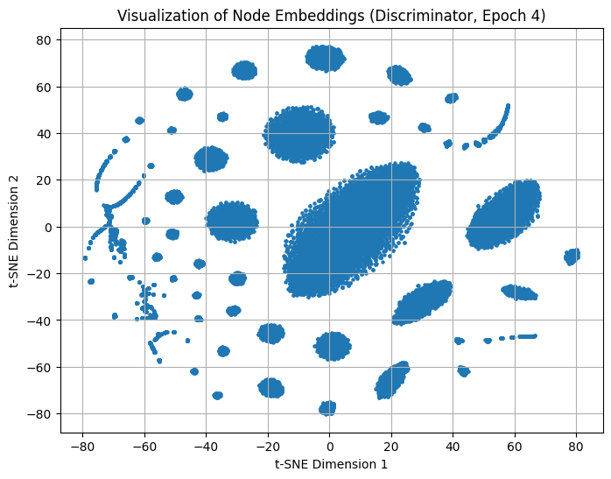
Step 3- Dimensionality Reduction (t-SNE Visualization)
Figure 7: Visualization of Node Embeddings

To qualitatively evaluate the learned embeddings, we apply t-distributed Stochastic Neighbor Embedding (t-SNE) to project the high-dimensional node representations into a two-dimensional space. The visualization reveals distinct clusters, suggesting the model effectively captures the underlying semantic and structural properties of the articles in the citation network.

Center of Gravity Analysis
Based on the spatial distribution of points, the center of gravity appears slightly right-of- center in the plot, approximately around coordinates (10-15, 10-20).
Key Structural Observations

1. Asymmetric Distribution: The embedding space exhibits an imbalance, with higher point density observed on the right side of the plot.
2. Central Dense Cluster: The most prominent cluster is positioned in the center-upper region around coordinates (0,40). This dense cluster significantly influences the overall center of gravity.
3. Scattered Outliers: Several smaller clusters and isolated nodes are distributed throughout the space, contributing secondary influences on the centroid’s position.
Dominant Factors
The central cluster around (0, 40) serves as the primary factor determining the center of gravity. The peripheral clusters and outliers exert a modest shifting effect, pulling it slightly toward the right.

5.4 Performance Evaluation
5.4.1. Ranking-Based Evaluation Metrics: To quantitatively assess the model’s ability to reconstruct missing citation links, several ranking-based metrics are employed. Rather than using binary classification accuracy, this approach measures the position of true links in the model’s list of predicted links, offering insight into the model’s confidence and discriminative capability.
- Evaluation Protocol:
Test Set Generation: Randomly remove 30% of the existing citation links from the graph. These links are excluded from training and used as the test set for evaluation.
- Prediction Task:
The model attempts to reconstruct the missing links, producing a ranked list of predicted citations for each node.
- Metrics:
- Top-k: Number oftop-ranked predictions considered for evaluation (k=100 in this study)
- Hits@k: Proportion of removed citations that appear within the top-k predictions for each source node
- Mean Reciprocal Rank (MRR): Average of the reciprocal ranks of the first correctly predicted link per source node
- Precision@k: Proportion of correct predictions among the top-k predicted citations.
Interpreting Rank Values

Low Rank (1-10): Indicates high confidence and strong model performance. The model identifies true citations as highly probable connections.

High Rank (50-100): Suggests lower model confidence; true links are ranked farther down in the prediction list.

5.4.2. Repetitive link reconstruction performance measurement
To ensure the robustness and stability of the model's performance, the link prediction procedure is repeated multiple times. Specifically, for k=5 repetitions:
- In each run, a different random 30% subset of citation links is removed.
- The DGGAN model is retrained and evaluated on each modified graph.
- Averaging the results across runs helps mitigate the effect of sampling variance and supports more reliable performance conclusions.
5.4.2.1 Flowchart of the Evaluation Methodology
This flowchart in Figure 7 outlines the complete evaluation pipeline designed to assess the link prediction capabilities of the DGGAN model. The process follows these key steps:
  - Edge Removal: A predefined percentage $P\%$ of real citation links is randomly removed from the input graph to simulate missing edges.
  - Model Training and Prediction: The DGGAN model is trained on an incomplete graph and tasked with predicting the missing citation links.
  - Evaluation: The predicted links are compared to the original (held-out) edges to measure reconstruction performance.
  - Repetition: This process is repeated $K$ times with different random removals to ensure statistically robust evaluation and reduce variance.
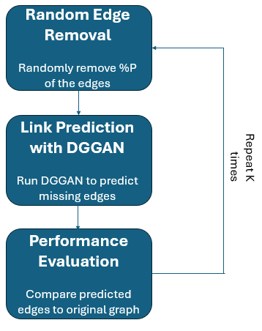
Figure 8: Flowchart Evaluation Methodology.
This approach provides a stress test for DGGAN by ensuring that it learns meaningful graph structures rather than memorizing spurious patterns.
This evaluation framework serves as a stress test for DGGAN. By forcing the model to reconstruct deliberately removed links, we assess whether it learns generalizable structural patterns in the citation network, rather than simply memorizing observed connections.

5.5. Evaluation Results:
5.5.1. Link Reconstruction Performance
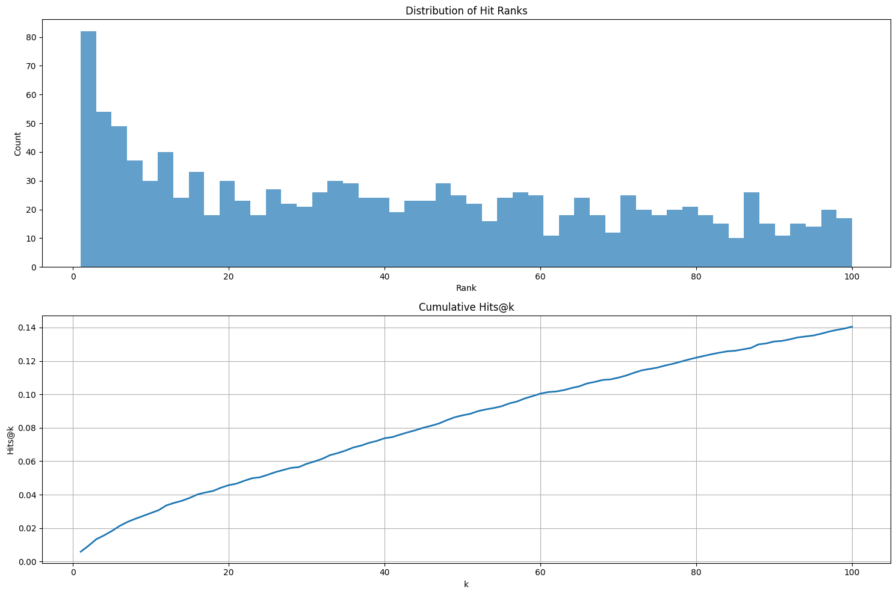
Figure 9: Distribution of hit ranks and cumulative hit ranks at which the model successfully predicted true citation links.
5.5.1.1. Distribution of Hit Ranks (upper graph):
The histogram illustrates the distribution of hit ranks, i.e., the rank positions at which the model successfully predicted true citation links. The chart reveals a clear concentration of correct predictions at low ranks, with a prominent peak at rank 1–3 (over 80 hits), followed by a rapid decline. Despite this sharp initial drop, the remainder of the distribution is non-uniform and relatively flat, with successful hits scattered across ranks 10 to 100. This long tail indicates that while the model often identifies correct links early in its ranking, a non-negligible portion of correct predictions are still assigned mid-to-low confidence ranks.

Interpretation: The model demonstrates strong predictive capability,
capturing strong structural signals for a subset of links, ranking them very highly, but struggles to clearly separate other true links from noise, leading to dispersed hits throughout the lower ranks.
5.5.1.2. Cumulative Hits@k (lower graph):
The cumulative Hits@k curve demonstrates a gradual and steady growth in recall as the prediction cutoff 𝑘 increases:
- Hits@1 ≈ 2%: Approximately 2% of removed links are ranked as the top prediction.
- Hits@20 ≈ 6%: Around 6% are recovered within the top 20 predictions
- Hits@100 ≈ 14%: Performance reaches 14% recovery at rank 100.
The curve’s smooth linear shape (with no plateaus or sharp bends) suggests the model maintains stable discriminative capability across ranking thresholds, rather than relying on a small number of high-confidence predictions followed by random output.
Interpretation: This pattern indicates that the model generalizes moderately well and does not overfit to specific link types but still leaves substantial room for improvement in precision and early recall.

5.5.2. Repetitive LinkReconstruction Performance
5.5.2.1. Hits@1
Result: 0.58%
Figure 10: First Rank Accuracy vs Iteration.
Interpretation: Only ~0.6% of the removed links were predicted as the model's top-ranked recommendation. This low value reflects limited confidence in precise, first-rank predictions, which is typical for large graphs with a vast candidate space.

5.5.2.2. Hits@100
Result: 14.32% (mean across 5 iterations)
Figure 11: Hits@100 (the percent of predicted true citation links up to Rank 100) values across five independent iterations.
Interpretation:
Figure 11 above illustrates the Hits@100 values across five independent iterations, each involving a different random 30% subset of positive links removed for evaluation. The red dashed line represents the mean value (14.32%) across all iterations.
Key Observations:
1. Stability After Initial Variance: While the first two iterations show slight variability (ranging from ~13.9% to 14.0%), the model’s performance stabilizes significantly from iteration 3 onward, reaching a narrow band around 14.58%–14.60%. The variation beyond iteration 2 remains minimal (within ±0.08%), indicating that the model converges to robust, repeatable representations once exposed to a diverse set of training-removal scenarios.
2. Effect of Random Sampling: The variation between iterations
reflects the randomness in sampling which links are removed, simulating different missing-link configurations. The observed convergence pattern suggests that once the model is tested across varied removal patterns, it adapts well and maintains performance, confirming its generalization ability.
3. Performance Plateau and Saturation: The peak values at iterations 3 and 4 (14.58% and 14.60%, respectively) represent the model’s effective performance ceiling under current training conditions. The minor decline in iteration 5 (to ~14.53%) is consistent with expected sampling fluctuations and does not indicate model degradation.
The model demonstrates strong stability in Hits@100 performance, with low variance across iterations and a well-defined performance plateau. This reinforces the reliability of the learned embeddings and the robustness of the adversarial training process
5.5.2.3. Mean Reciprocal Rank (MRR)
Result: 0.0147
Figure 12: MRR (Mean Reciprocal Rank) vs iteration.
Interpretation: The low MRR indicates that when correct predictions are made, they tend to appear in lower ranks. The model rarely places correct links near the top of the prediction list.
5.5.2.4. Precision@100
Result: 0.16%

Figure 13: Precision up to rank 100 vs iteration.

Interpretation: On average, only 0.16 out of every 100 predicted links were correct. This extremely low precision indicates a high false positive rate and suggests potential underfitting, i.e., the model lacks sufficient expressive capacity to capture the complexity of the data.
5.5.2.5. Metric Distribution and Analysis
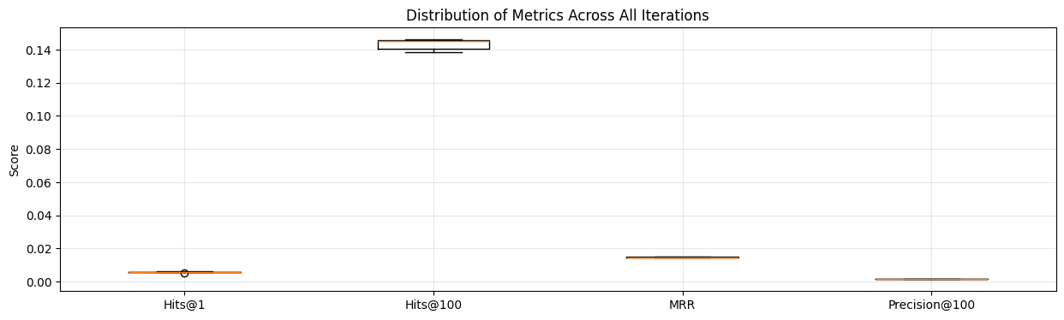
Figure 14: Distribution of Metric across all iterations.

5.5.2.6. Training Loss and AUC vs Epoch
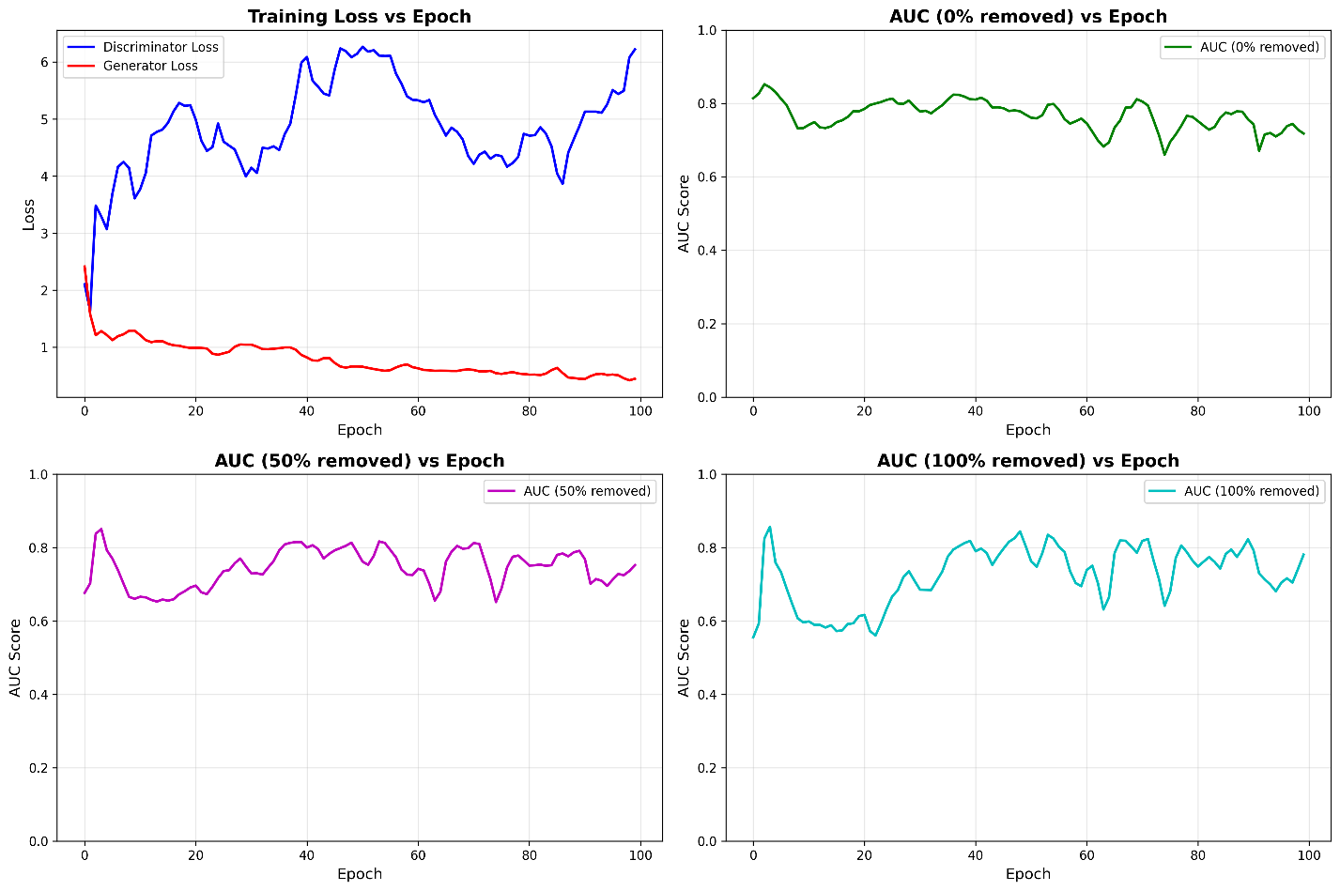
Figure 15 : Training Loss and AUC vs Epoch
• Discriminator loss rises quickly to 4–6, oscillates, ends near 6.2, suggests unstable discriminator or imbalance.
• Generator loss drops from about 2.5 to 0.5 and plateaus, indicates the generator saturates early.
• AUC, 0% removed: mostly flat around 0.74–0.78 with mild drift down after mid training.
• AUC, 50% removed: improves to about 0.78–0.82 after 30–40 epochs, shows small oscillations.
• AUC, 100% removed: climbs from about 0.55 to 0.80 by mid training, then oscillates, overall the strongest trend.
• Practical takeaways:
- Early stopping near 50–60 epochs captures most of the AUC gains.
- Add discriminator regularization, smaller learning rate, gradient penalty, or label smoothing to reduce loss oscillations.
- Track validation AUC per removal level and save the best checkpoint rather than training to epoch 100.

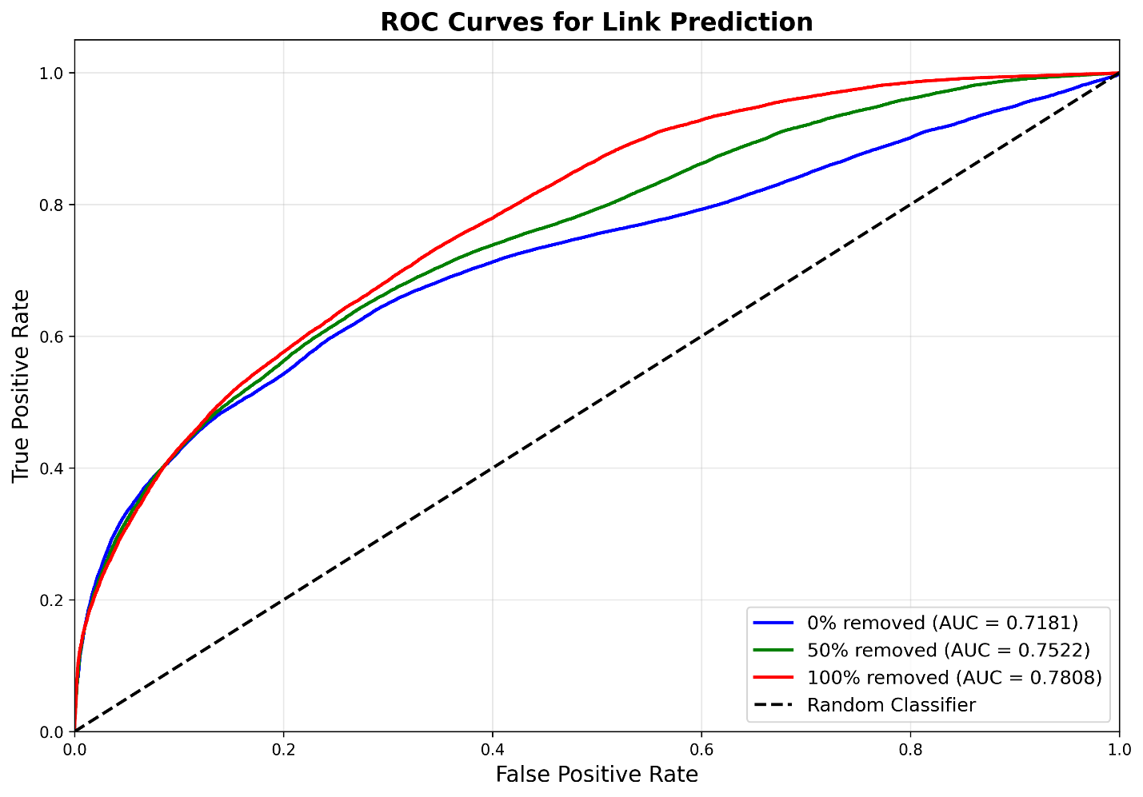
5.5.2.7. ROC Curves for Link Prediction

Figure 16: ROC Curves across Removal Levels
• Reported AUCs: 0% removed 0.7181, 50% removed 0.7522, 100% removed 0.7808.
• Higher removal levels yield higher ROC curves across most false positive rates.
• The gap is largest for mid false positive rates around 0.3–0.7, where recall improves meaningfully.
• Threshold selection: for a fixed FPR budget, the 100% removed model attains higher TPR, so calibrate thresholds separately by scenario.

5.5.3 Summary and Discussion of Evaluation Results
1. Consistency Across Iterations
- The model exhibited highly stable results across runsHits@1 varied by only ±0.04%
- Hits@100 by ±0.32%
- MRR is extremely stable, varied by (±0.0002)
This consistency suggests your model is stable and reliable, not overly sensitive to which specific edges are removed for testing.

2. Rank Distribution (Histogram Analysis)
- A peak was observed at low ranks (e.g., 82 hits within ranks 1–3), demonstrating the model's ability to assign high ranks to some true links.
- A gradual decline in hit counts was seen as ranks increased.
- A long tail existed, with correct predictions still appearing at high ranks (up to rank 100).

3. Cumulative Hits:
- Hits@1: 0.59% - Only about 0.6% of true links are ranked as the #1 prediction
- Hits@10: 2.9% - About 3% of true links appear in top 10 predictions
- Hits@50: 8.7% - About 9% of true links appear in top 50 predictions
- Hits@100: 14.0% - About 14% of true links appear in top 100 predictions
These results show incremental improvement in recall as the threshold expands, although absolute recall remains modest.
Performance Summary
Strengths:
- The model captures meaningful citation structures and consistently ranks many true links above irrelevant ones.
- The peak at low ranks indicates that true connections are prioritized over noise in many cases.
- Performance exceeds random baseline (e.g., ~1% for Hits@100 in large graphs), indicating that the model is learning useful structure
Limitations:
- Low precision and MRR suggest the model has difficulty strongly distinguishing between true and false links.
- High false positive rate in top predictions indicates a need for better regularization or a more expressive embedding space.
- Underfitting symptoms suggest architectural refinement or additional features may be necessary to improve discrimination capacity.

6. Implementation: Tools and Technologies
To implement and evaluate the proposed DGGAN-based link prediction model on citation networks, the following tools and libraries in Python will be employed. Each was selected for its efficiency and suitability in handling specific tasks within the development pipeline.
6.1 Graph Representation and Embedding
- PyTorch Geometric (PyG):
Utilized to building and training Graph Neural Networks (GNNs) such as GCN. PyG provides efficient data loaders, preprocessing functions, and a comprehensive set of GNN layers optimized for sparse graph data, making It particularly suitable for link prediction in directed citation networks.
6.2 Generative Adversarial Network (GAN) Implementation
- PyTorch:
The primary deep learning framework for implementing DGGAN architecture. It offers full flexibility in designing and training both the generator and discriminator models while seamlessly integrating with PyG for graph-based learning.
- NumPy:
Employed for numerical operations, including array manipulation, mathematical transformations, and random sampling during training.
- Scikit-learn (preprocessing):
Utilized for data normalization, dataset splitting, and training/test set preparation, ensuring consistent and clean model input.
6.4 Evaluation and Metrics
- Scikit-learn (metrics):
Provides standard evaluation metrics such as precision, recall, F1-score, ROC-AUC, and confusion matrices, essential for assessing link prediction performance.
- Matplotlib / Seaborn:
Used for visualizing evaluation results, training loss curves, and link prediction outcomes (e.g., ROC curves, precision-recall plots).
7. Google Collab
https://drive.google.com/drive/folders/1HTPzXdW1z5j9-BIC_zD-6mBg1oKU9C0y
- Git
https://github.com/OrelDamti/DGGAN2Improve.git

9. References

[1] GeeksforGeeks. (n.d.). Generative adversarial network (GAN). Retrieved from https://www.geeksforgeeks.org/generative-adversarial-network-gan/
[2] Goodfellow, I., Pouget-Abadie, J., Mirza, M., Xu, B., Warde-Farley, D., Ozair, S., Courville, A., & Bengio, Y. (2014). Generative adversarial networks. arXiv preprint. Retrieved from https://arxiv.org/abs/1406.2661
[3] Katz, L. (1953). A new status index derived from sociometric analysis. Psychometrika, 18(1), 39-43.‏ https://doi.org/10.1007/BF02289026.
[4] Lei, K., Qin, M., Bai, B., Zhang, G., & Yang, M. (2019, April). GCN-GAN: A non-linear temporal link prediction model for weighted dynamic networks. In IEEE INFOCOM 2019-IEEE Conference on Computer Communications (pp. 388-396). IEEE.‏
[5] Ou, M., Cui, P., Pei, J., Zhang, Z., & Zhu, W. (2016, August). Asymmetric transitivity preserving graph embedding. In Proceedings of the 22nd ACM SIGKDD international conference on Knowledge discovery and data mining (pp. 1105-1114).
[6] SAGAR SHARMA (2017, September). Activation Functions in Neural Networks, In Towards Data Science. https://towardsdatascience.com/activation-functions-neural-networks-1cbd9f8d91d6.
[7] Sarang Narkhede (2018, June). Understanding AUC - ROC Curve, In Towards Data Science, https://towardsdatascience.com/multilayer-perceptron-explained-with-a-real-life-example-and-python-code-sentiment-analysis-cb408ee93141
[8] Simeon Kostadinov (2019, August). Understanding backpropagation Algorithm, In Towards Data Science, https://towardsdatascience.com/understanding-backpropagation-algorithm-7bb3aa2f95fd.
[9] Tomonori Masui (2022, October). Graph Neural Networks with PyG on Node Classification, Link Prediction, and Anomaly Detection, In Towards Data Science, https://towardsdatascience.com/graph-neural-networks-with-pyg-on-node-classification-link-prediction-and-anomaly-detection-14aa38fe1275.
[10] Xu, M. (2021). Understanding graph embedding methods and their applications. SIAM Review, 63(4), 825-853.‏
[11] Zhou, C., Liu, Y., Liu, X., Liu, Z., & Gao, J. (2017, February). Scalable graph embedding for asymmetric proximity. In Proceedings of the AAAI Conference on Artificial Intelligence (Vol. 31, No. 1).‏‏
[12] Zhu, S., Li, J., Peng, H., Wang, S., & He, L. (2021, May). Adversarial directed graph embedding. In Proceedings of the AAAI Conference on Artificial Intelligence (Vol. 35, No. 5, pp. 4741-4748).
[13] https://www.geeksforgeeks.org/mini-batch-gradient-descent-in-deep-learning/

