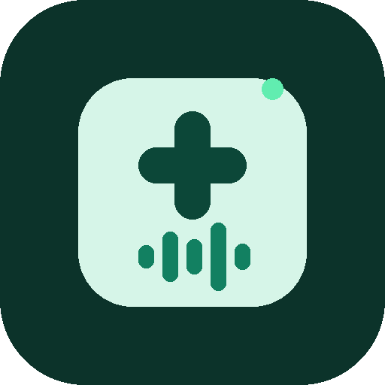 | BioClerk  BIOCLERK.COM | Offline clinical dictation  Medical transcription app for clinicians · Nigeria

BILL TO  [Customer Name]  [customer@email.com] | INVOICE
  Invoice # | INV-2026-001
  Date | 27 October 2026
  Due date | 10 November 2026
Invoice
Thank you for choosing BioClerk. Please find the details of your license purchase below.
DESCRIPTION | QTY | UNIT PRICE | AMOUNT
BioClerk desktop license | 1 | ₦0.00 | ₦0.00
Subtotal | ₦0.00
Tax | ₦0.00
Total | ₦0.00
PAYMENT NOTES
Payment instructions will be shared separately (bank transfer or Paystack). For questions about this invoice, email support.bioclerk@gmail.com.
Regards,
[Your Name]
BioClerk

contact us | support.bioclerk@gmail.com | bioclerk.com | +234 904 295 6435

