GitHub Loader

This application helps you to create a new repository under your GitHub credentials and upload it’s code to the repository that been created.

How to use:
1) Navigate 127.0.01 http://127.0.0.1:5000/login. The login screen should be opened
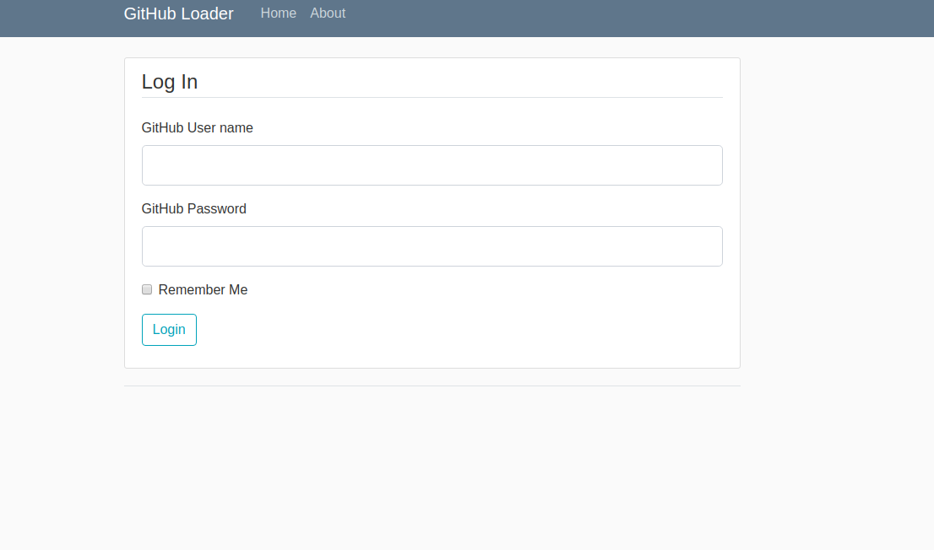
pic 1 ‘Login screen’
2) Enter your GutHub usename and password.
If username or password is incorrect you’ll get an error message

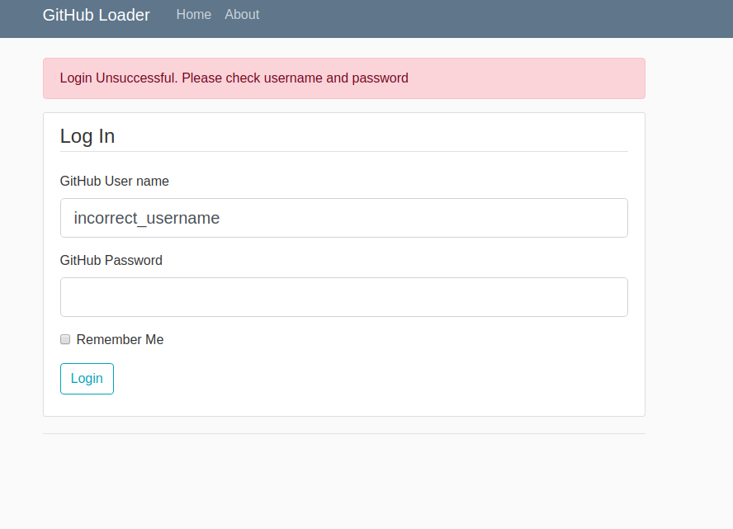

Pic. 2 The Login screen with error

If the credential is correct you'll see the Homepage.

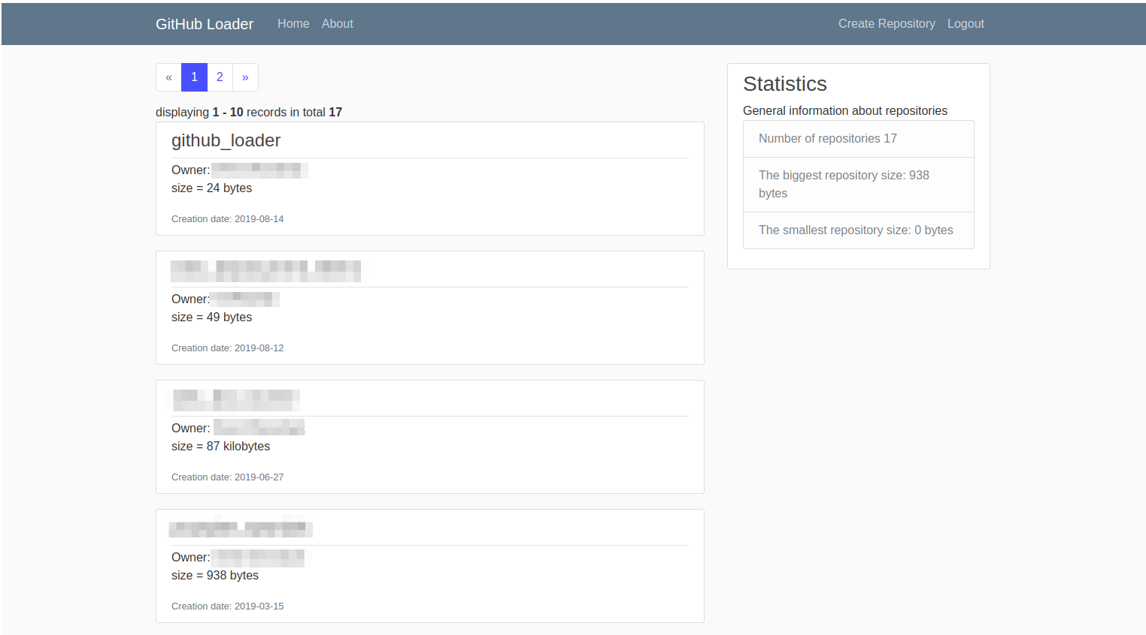
Pic 3 The Homepage

On the Homepage you’ll see a navigation menu with the following options:
* Home – current page
* About – short info about the application
* Create Repository – navigate you to create repository form
* Logout – to leave the application

In the body of the Homepage you’ll see the list of repositories from your GitHub account, The list is ordered by creation date and size in descending order. The header of the list item is repository name, below the name you can see an owner of the repository, size and creation date.

The homepage has pagination, and shows 10 items per page.

In the top right corner you can see Statistics bar with general information about your repository, it
includes number or repositories, max and min size of the repository.

3) Click the Create Repository button
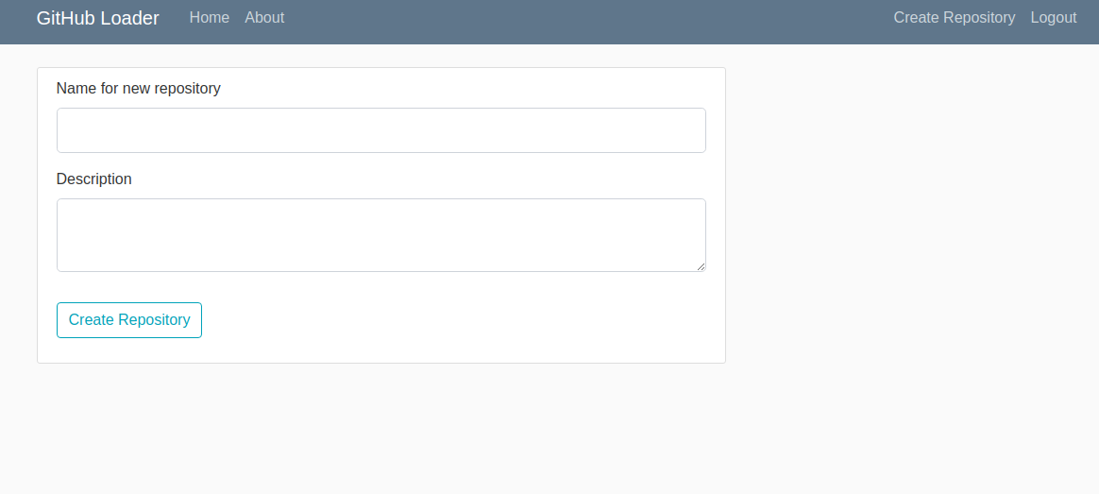

Pic. 4 The Create new repository form

The form propose you to enter a name and a description for new repository.

If the name you have entered exists in your GitHub account you’ll get an error message.
Validation works after click on the Create Repository button.
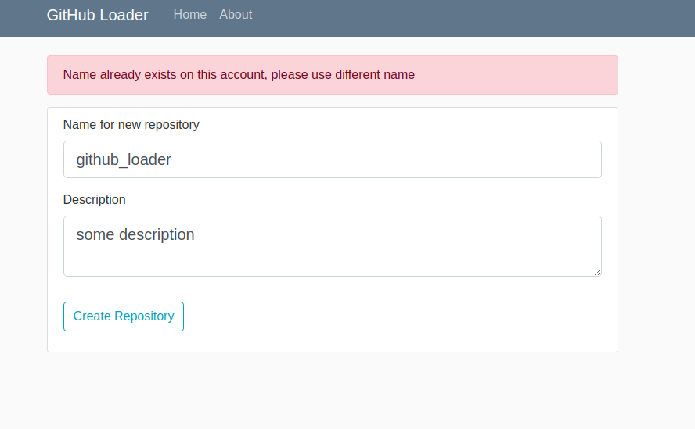
Pic 5 The Create new repository form with error message

If you leave the Description box empty, you’ll see a popup window which asks you to enter the description.

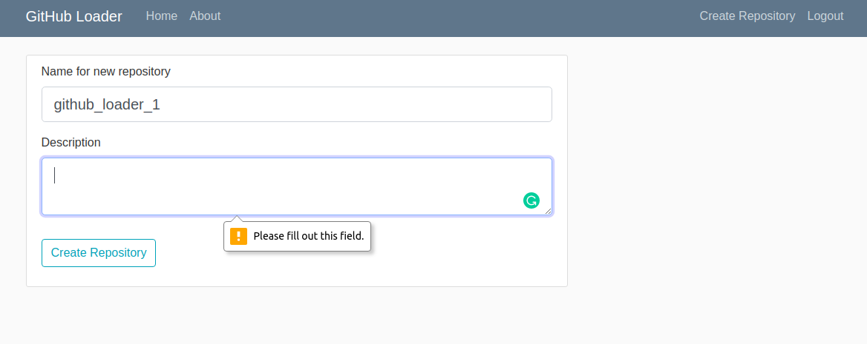
Pic6 The Create new repository form with popup

Once you enter a valid name and description and click the Create Repository button, the app will start the creation of a new repository and uploading its source code to the repository. It may take some time minutes depends on Internet connection speed and GitHub response speed

After the app finished upload, you’ll see a success message. And you can find new repository in the top of the list of repositories. Also you can see Statistics uppdated as well
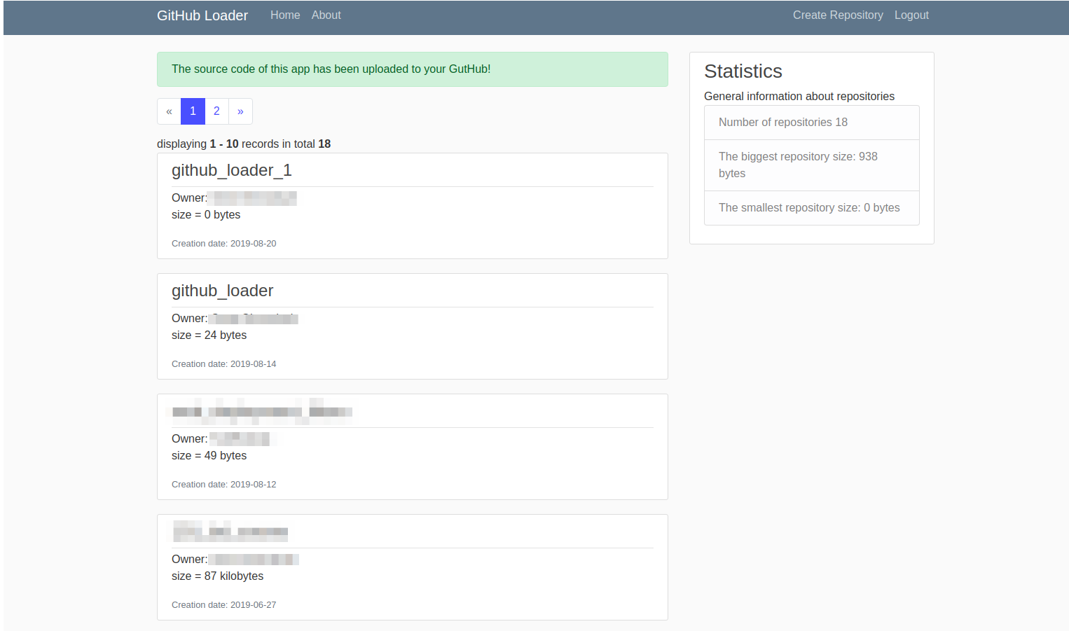

Thats it, now you can logout.

Warning: this app will gather and store your personal data (username, email) to build some statistics

