Gevorg Markarov

Assignment 2

Questions:

1. Which part of a MAC address is unique to each manufacturer?
   1. The network identifier
   2. The OUI
   3. The device identifier
   4. The physical address
2. What decimal number corresponds to the binary number 11111111?
   1. 255
   2. 256
   3. 127
   4. 11111111
3. What type of device does a computer turn to first when attempting to make contact with a host on another network?
   1. Default gateway
   2. DNS server
   3. Root server
   4. DHCP server
4. Which statement describes SMTP?
   1. SMTP is a connectionless protocol that uses UDP
   2. SMTP is a connection-based protocol that uses UDP
   3. SMTP is a connectionless protocol that uses TCP
   4. SMTP is a connection-based protocol that uses TCP
5. When your computer first joins an IPv6 network, what is the prefix of the IP address the computer first configures for itself?
   1. FE80::/10
   2. FF00::/8
   3. 2001::/64
   4. 2001::/3
6. You have just brought online a new secondary DNS server and notice your monitoring software reports a significant increase in network traffic. Which two hosts on your network are likely to be causing the increased traffic and why?
   1. The caching and primary DNS servers, because the caching server is requesting zone transfers from the primary server
   2. The secondary and primary DNS servers, because the secondary server is requesting zone transfers from the primary server
   3. The root and primary DNS servers, because the primary server is requesting zone transfers from the root server.
   4. The Web server and primary DNS server, because the Web server is requesting zone transfers from the primary DNS server.
7. Suppose you send data to the 11111111 11111111 11111111 11111111 IP address on an IPv4 network. To which device(s) are you transmitting?
   1. All devices on the Internet
   2. All devices on your local network
   3. The one device with this given IP address
   4. Because no device can have this given IP address, no devices receive the transmission
8. If you are connected to a network that uses DHCP, and you need to terminate your Windows workstation’s DHCP lease, which command would you use?
   1. ipconfig/release
   2. ipconfig/renew
   3. ifconfig/release
   4. ifconfig/new
9. What computers are the highest authorities in the Domain Name System hierarchy?
   1. Authoritative name servers
   2. Root servers
   3. Top-level domain servers
   4. Primary DNS server
10. What version of SMB can be used across Windows, UNIX, and other operating systems?
    1. SIP (Session Initiation Protocol)
    2. RDP (Remote Desktop Protocol)
    3. CIFS (Common Internet File System)
    4. MGCP (Media Gateway Control Protocol)
11. Suppose you want to change the default port for RDP as a security precaution. What port does RDP use by default, and from what range of numbers should you select a private port number?

3389, 49512, 65535

1. Which type of DNS record identifies a mail server?

MX

1. How many bits does an IPv6 address contain?

128

1. On what port is an IPv6 client listening for DHCP messages?

546

1. The second 64 bits of an autoconfigured IPv6 address may either be random or generated from the computer’s MAC address, which contains 48 bits. What standard

defines the conversion of the MAC address to the IPv6 64-bit device ID?

EUI-64

1. You issue a transmission from your workstation to the following socket on your LAN: 10.1.1.145:110. Assuming your network uses standard port designations, what Application layer protocol are you using?

POP3

1. What protocol does a network gateway use to keep track of which internal client is talking to which external Web server?

PAT

1. You are the network manager for a computer training center that allows clients to bring their own laptops to class for learning and taking notes. Clients need access to the Internet, so you have configured your network’s DHCP server to issue IP addresses automatically. What DHCP option should you modify to make sure you are not wasting addresses that were used by clients who have left for the day?

The lease duration for client computers

1. What is the range of IP addresses that might be assigned by APIPA?

169.254.0.1 - 169.254.255.254

1. While troubleshooting a network connection problem for a coworker, you discover the computer is querying a nonexistent DNS server. What command-line utility can you use to assign the correct DNS server IP address?

nslookup

1. FTP sometimes uses a random port for data transfer, but an FTP server always, unless programmed otherwise, listens to the same port for session requests from clients. What port is the FTP server listening on?

21

1. While troubleshooting a network connection problem for a coworker, you discover that the computer has a static IP address and is giving a duplicate IP address error. What command-line utility can you use to find out what other device may already be using that IP address?

ping or nslookup

1. What is the IPv4 loopback address? What is the IPv6 loopback address?

127.0.0.1 and ::1/128

1. You have just set up a new wireless network in your house, and you want to determine whether your Linux laptop has connected to it and obtained a valid IP address. What command will give you the information you need?

ifconfig -a

1. You have decided to use SNAT and PAT on your small office network. At minimum, how many IP addresses must you obtain from your ISP for all five clients in your office to be able to access servers on the Internet?

1

1. If you know that your colleague’s TCP/IP host name is JSMITH, and you need to find out his IP address, what command should you type at your shell prompt or command prompt?

nslookup jsmith or ping jsmith

1. When determining whether a local network has any NetBIOS traffic, do you use the nslookup utility in interactive mode or a packet analyzer such as Wireshark?

nslookup jsmith or ping jsmith

1. List three signaling protocols discussed in the chapter that are used for communicating multimedia data.

SIP, H.323, and MGCP

1. What version of the ping command do you use in Windows with IPv6 addresses? What version do you use on a Linux system?

ping -6 and ping6

1. When running a scan on your computer, you find that a session has been established with a host at the address 208.85.40.44:80. Which protocol is in use for this session? What command-line utility might you use to find out who the host is?

Port 80 indicates this is an HTTP session. And nslookup can identify the domain name of the host at that IP address.

Project 2.1:

Your corporation hosts a Web site at the static public IP address 92.110.30.123. A router directs this traffic to a Web server at the private IP address 192.168.11.100. However, the Web server needs a hardware upgrade and will be down for two days. Your network administrator has asked you to configure the router so that requests to the IP address 92.110.30.123 are redirected to the backup server for the Web site, which has the private IP address 192.168.11.110. The router’s inside Ethernet interface uses IP address 192.168.11.254 and its outside interface uses the IP address 92.110.30.65. Answer the following questions about the new static route you’ll be creating:

1. What is the router’s outside interface IP address?

92.110.30.65

1. What is the router’s inside interface IP address?

192.168.11.254

1. What is the Web site’s public IP address?

92.110.30.123

1. What is the private IP address of the backup Web server?

Use the example given earlier in the chapter as a template to create the NAT translation table entries for the address translation. For the subnet masks, use the default subnet mask for a Class C IP address license. Include appropriate comment lines in your table.

192.168.11.110

interface serial 0/0

ip address 92.110.30.65 255.255.255.0

ip nat outside

!--- Defines the serial 0/0 interface as the router’s NAT outside interface

!--- with an IP address of 92.110.30.65

interface ethernet 1/1

ip address 192.168.11.254 255.255.255.0

ip nat inside

!--- Defines the Ethernet 1?1 Interface as the router’s NAT inside interface

!--- with an IP address of 192.168.11.254

ip nat inside source static 192.168.11.110 92.110.30.123

!--- States that source information about the inside host will be translated

!--- so the host’s private IP address (192.168.11.110) will appear as the

!--- public IP address (92.110.30.123). Both ingoing and outgoing traffic

!--- exchanged with the public IP address will be routed to the host at the private IP

!--- address.

**Project 2-3: Manage DNS**

You have learned that clients as well as name servers store DNS information to associate names with IP addresses. In this project, you view the contents of a local DNS cache, clear it, and view it again after performing some DNS lookups. Then you change DNS servers and view the DNS cache once again.

* 1.

To view the DNS cache, open a command prompt and enter the following command: **ipconfig /displaydns**



* 2.

If this computer has been used to resolve host names with IP addresses—for example, if it has been used to retrieve mail or browse the Web—a list of locally cached resource records appears. Read the file to see what kinds of records have been saved, using the scroll bar if necessary. How many are A records and how many are a different type, such as CNAME?

20 Cname, 53 A records

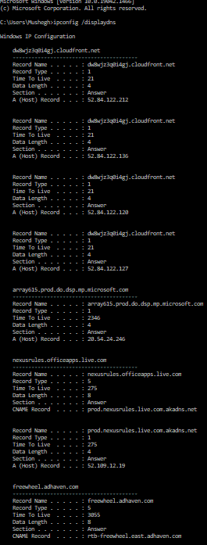

* 3.

Next clear the DNS cache with this command: **ipconfig /flushdns**

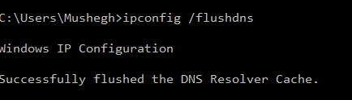

The operating system confirms that the DNS resolver cache has been flushed. One circumstance in which you might want to empty a client’s DNS cache is if the client needs to reach a host whose IP address has changed (for example, a Web site whose server was moved to a different hosting company). As long as the DNS information is locally cached, the client will continue to look for the host at the old location. Clearing the cache allows the client to retrieve the new IP address for the host.

* 4.

View the DNS cache again with the command: **ipconfig /displaydns**

Because you just emptied the DNS cache, you will receive a message that indicates that Windows could not display the DNS resolver cache. (See [Figure 2-31](javascript://).)

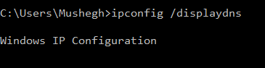

* 5.

Switch to your browser window and go to **www.cengage.com**. Next go to [www.google.com](http://www.google.com/" \t "_blank). Finally, go to [www.loc.gov](http://www.loc.gov/" \t "_blank).



* 6.

Return to the Command Prompt window and view the DNS cache once more to see a new list of resource records using this command: **ipconfig /displaydns**

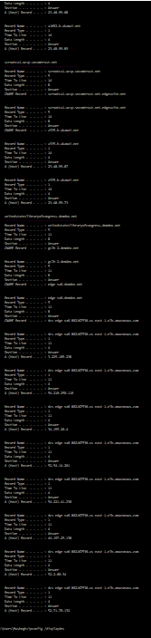

* 7.

Scroll up through the list of resource records and note how many associations were saved in your local DNS cache after visiting just three Web sites. How many hosts are identified for each site you visited? What type of record is most common? Can you think of any situations, other than wanting to reach a host that has moved to a different address, in which you might want to clear your DNS cache?

Google: A – 1 CNAME – 1

Canagage: A - 1 CNAME -2

Cloud front: A- 4

CanageSupport: A – 2 CNAME – 1

Hotjar: A- 4

Doubleclick: A – 4 CNAME – 1

The most commune type of records was A record

A reason to clear the DNS cash is privacy, so nobody can see what websites you were visiting, since deleting search history is not deleting you DNS cash