API Generator
Worldwide Sales Conference WebEx Demonstration
December 7, 2005

Introduction
The API Generator is a modeling and design demonstration project that I started to exercise some stuff I may or may not have learned in a certificate program I completed in June. In its current state of completion the 250 classes that represent and generate a combination of API, terminal type, and programming language (ATL) are approximately 60% completed. Now that you have seen some of the working classes in action I’d like to describe what contribution you can make to finish what remains and why it’s in all of our interests that you contribute.

Current project progress
There are four levels of readiness for each ATL. They are:
- Ready to test –functions are implemented and module format is ready to run. 67 of the ATL’s are in this state.
- Translation required – Typically, no work has been done on these ATL’s, but they are probably the easiest to complete because you need only copy the info from some other working ATL of the same API and either remove functions that don’t apply to the terminal type or translate the generated code from one language to another. 110 ATL’s are in this state.
- Function implementations needed – code format is complete, but not all of the functions generate. ATL’s in this category have between ten and thirty functions generating, but may have between thirty and 200 remaining to be done. There are 82 ATL’s in this state.
- Formatting required – all or nearly all functions are generating, but the code format is incomplete. That typically means that the functions all generate, but the module entry and exit points aren’t yet provided. That is usually due to the fact that I never received an instructive sample. There are 16 ATL’s in this state.
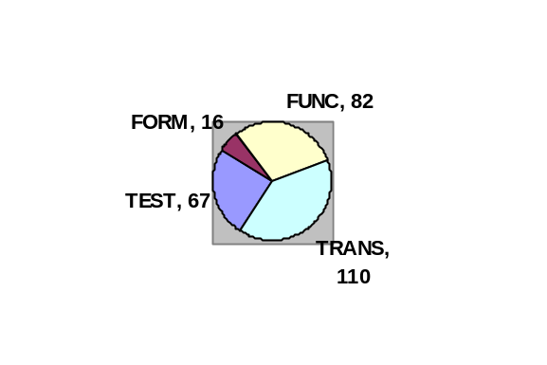
For each API besides CASL macros, DOS shell, Perforce, and Unix shell, the API
Generator currently presents at least one combination of terminal type and programming language that runs in the ready-to-test state.

Types of contributions (Demonstrations)
The following are the different ways you can contribute to the completion of the project.
- Use an ATL, and thereby test it. Runtime and documentation feedback are very important to validating every ATL. Also, if you can suggest a better code format or set of directions to make the output better or more easily used submit your suggestions. Demonstration of documentation of CAG_VHI_VBN.
- Translate a ready-to-test ATL to a different terminal type. Demonstration of CAG_RWEB_5250_JS from CAG_RWEB_VT_JS.
- Translate a ready to test ATL to a different programming language. Demonstration of CAG_RWEB_VT_VBS from CAG_RWEB_VT_JS.
- Complete the function list in a partly implemented ATL. Demonstration of ITask ScreenNativeAccess::doExecute function.

In all cases a contributor will only need to work within a single class’s header and implementation file pair to complete an ATL. All ATL classes inherit from the same base class and possess the same set of six functions. Those six functions are:
generateHeader() | The paragraph at the top of the output file that explains what environment is necessary to run the code, how to set it up, and how to run the code. Also, variable declarations are appended to this when needed by the functions generated.
appendBody() | This is the section of the code that usually starts with the module entry point. Then the function argument variables are assigned their values and functions are laid out when so-specified by the user.
declareVariable | Each variable used in the output file that will be used as a return value or a function argument is declared within this function. A boolean flag is maintained for each variable that signals whether or not the variable has been declared yet. That is to ensure that the variable is not declared multiple times and that any allocated memory is freed before the module unloads.
Finalize() | This section of code handles closing any open code blocks or subroutines. It also checks the declared variable flags to learn if it should free memory allocated for objects used in the code.
resetVariableFlags() | This section of code resets the variable flags when a module has been finalized so the variables will be declared in subsequent APIGen runs that use the same ATL.
checkDebug() | In many ATL’s a Debug option is provided in the function list that provides users with a means to trace their generated module’s runtime progress. While, in many cases it is left empty, you can choose to insert a messagebox or specify some sort of debug output that’ll be produced while the generated module runs.

Knowledge of C++ is not a requirement, as 95% of the work is simply changing existing strings.
Contributors can choose to download the entire project to build and test their own changes or simply modify and submit modified files.

Configuration & Product Management
You can access the project source from a [Source Safe || PerForce] archive on the Consulting file server. We can get the files to you if you don’t have access to the archives.
You can look in the APIGen About box for a list that shows the current state of progress for each ATL. If you will tell me what you’re going to work on then I’ll update the list with your name so someone else doesn’t take on that ATL.

Benefits of contributing
By contributing to the API Generator you’ll see long term efficiency in your own work and realize some good karma in contributing to others’. If you begin to write a project involving an ATL that is not currently implemented you’ll find that you can translate a ready to test ATL to the one in which you’re going to work in an hour or two. That time, of course, is dependent on the number of methods in your chosen API. From then on you can quickly generate the code you originally intended to write as well as in all of your subsequent projects. Meanwhile, your expertise will become available to everyone else who might be inclined to do or research work with that ATL.

Unadvertised specials
These are items that are very near test-ready, but have some simple runtime or formatting issues that require some finishing touches by somebody with the ATL expertise.
- Airlines SDK Java 3270, 5250, VT, or T27
- EAO Java 3270, 5250, or VT
- Reflection FTP C++

