INDUSTRIAL IOT ENGINEERING — MINI PROJECT REPORT
Digital Twin of a Mini Conveyor Belt
Virtual commissioning, fault diagnosis, multi-camera inspection and predictive maintenance
Submitted by
Sarthak Wage — Roll No. 16014323039
Sameer Morya — Roll No. 16014323036
Under the guidance of
Dinesh Chawde · Venkataramanan V
Department of Robotics and Artificial Intelligence
K J Somaiya School of Engineering, Somaiya Vidyavihar University, Mumbai
Academic Year 2026–27
Source code: github.com/Organic42/conveyor-digital-twin
1. INTRODUCTION
1.1 Background
Belt conveyors are the backbone of discrete manufacturing and packaging lines. Their availability is limited by a small set of recurring problems: cartons jamming against guides or each other, belt slip on a worn drive roller, failing photo-eyes, and bearing wear in the drive. Quality is limited by defective products that reach the customer because inspection sees only part of the product. In most plants these problems are discovered after throughput has already dropped.
A digital twin addresses this by keeping a live computational model of the machine alongside the real one. It differs from a dashboard in three ways: data flows in both directions (the twin can command the machine), the twin runs its own models and compares them with measurements, and it acts on the difference — diagnosing faults, predicting failures and recommending settings. In the classical classification, a digital model has no live data, a digital shadow receives data one way, and a digital twin is connected bidirectionally and model-based.
1.2 Problem statement
Design and build a digital twin of a mini inspection-and-reject conveyor that (a) mirrors the machine in real time over an industrial-style interface, (b) detects and diagnoses faults that individual sensors cannot reveal, (c) inspects every carton and rejects defects automatically, (d) predicts maintenance needs before failure, and (e) proves its own accuracy quantitatively. Because commissioning a twin on real hardware is slow and risky, the twin is developed against a physics-based virtual plant — the industrial practice known as virtual commissioning.
1.3 Objectives
- Real-time 3D mirror (25 Hz) and bidirectional PackML control of the conveyor through an OPC UA-style tag interface.
- Model-based detection and diagnosis of belt slip, jams, photo-eye failures and drive-train wear, with automatic protective action.
- Data-driven (learned) detection of faults for which no rule exists.
- Five-camera automated quality inspection with a fail-safe accept/reject decision.
- Predictive maintenance: vibration-based condition monitoring, remaining useful life (RUL) and maintenance work orders.
- Decision support — OEE, energy, SPC, what-if simulation and speed optimisation — and a validation benchmark of the twin itself.
1.4 Reference machine
The twinned machine is a 1.2 m benchtop conveyor (160 mm belt, Ø50 mm rollers) carrying 60 × 50 × 45 mm cartons at up to 0.45 m/s. Instruments follow ISA-5.1 naming (Table 1).
Tag | Device | Specification | Role in the twin
M-001 | DC gearmotor | 24 V, 60 W, i = 20:1 | Drive; current used for health index
ENC-001 | Incremental encoder | 600 PPR, ×4 quadrature | Speed; reference for slip and tracking
PE-101…401 | Diffuse photo-eyes | 24 V DC PNP at 0.15/0.55/0.84/1.12 m | Carton edges; jam/sensor diagnosis
CAM-201…205 | Area-scan cameras | Top, left, right, front 45°, back 45° | Five-face quality inspection
VT-001 | Accelerometer | 2.56 kHz, 1024-sample blocks | Bearing condition, ISO 10816, RUL
TT-001 | PT100 | Winding temperature | Thermal forecast, over-temperature trip
YV-301 | Solenoid valve + cylinder | 5/2 valve, Ø16 cylinder | Rejects cartons not confirmed good
HL-001 / ES-001 | Stack light / E-stop | R/A/G + horn / twin-channel NC | State indication / safety abort
Table 1 — Instrument list of the reference conveyor.
2. METHODOLOGY
2.1 System architecture
The system is organised in three layers mapped to the ISA-95 levels (Figure 1). The virtual plant runs in a separate Web Worker thread and behaves like the machine plus its PLC. The digital twin runs in the main thread and can reach the plant only through the plant link — a tag/method interface shaped like OPC UA. This single seam is the key design decision: replacing the worker with a real PLC or an OPC UA/MQTT gateway that exposes the same tags requires no change to the twin.
VIRTUAL PLANT — Web Worker (ISA-95 L0–1)  DC gearmotor, belt, cartons  Photo-eyes PE-101…401, encoder  VT-001 vibration, TT-001, current  PackML state machine, 20 ms scan  Reject tracking, pusher YV-301  Fault injection (7 faults) | ⇄  25 Hz tags · 1 Hz vibration | PLANT LINK (L2)  OPC UA-style address space  ISA-95 tag paths  Methods: Start, Hold,  SetSpeed, ReportInspection  Status codes (Good, Bad…) | ⇄  commands · verdicts | DIGITAL TWIN SERVICES (L2–3)  Shadow model · rule diagnosis  Learned PCA anomaly model  5-camera vision node  Vibration analysis · RUL  Alarms (ISA-18.2) · historian · replay  OEE · SPC · what-if · optimiser
HMI (ISA-101, L3): Three.js 3D twin · 2D line overview · trends · alarms · faceplates · Health / Vision / PdM / OEE / SPC / Optimise / Maintenance / Validate tabs
Figure 1 — System architecture: virtual plant, plant link and digital twin services, presented through an ISA-101 HMI.
2.2 Virtual plant model
Every 20 ms PLC scan reads inputs, runs the control program and writes outputs; the physics is then integrated in four 5 ms sub-steps. The DC motor is modelled by its armature and rotor equations:
L · di/dt = V − R·i − Kₑ·ω (1)
J · dω/dt = Kₜ·i − b·ω − T꜀ − T_load (2)
where T_load includes belt drag on the slider bed, friction of carried cartons and the higher sliding friction of cartons held by an obstruction. Winding temperature follows a first-order thermal network:
C_th · dT/dt = i²·R − (T − T_amb) / R_th (3)
A feed-forward PI controller holds the belt speed from encoder counts. The control program implements the PackML state machine (STOPPED → RESETTING → IDLE → STARTING → EXECUTE, with HOLD and ABORT paths), interlocks (E-stop, restart temperature) and encoder-based reject tracking: each carton is assigned a tracking ID at PE-201 and the pusher fires a measured encoder distance after PE-301. Seven faults can be injected without informing the twin: belt slip, zone-2 jam, photo-eye failure, bearing wear (instant or progressive), camera failure, a misaligned side guide and the upstream defect rate.
2.3 Plant link and information model
The plant publishes its process image at 25 Hz and a vibration waveform at 1 Hz. Tags follow the ISA-95 hierarchy, for example DemoPlant.Area1.Line1.Conveyor01.Drive.MotorCurrent, with OPC UA-style node IDs, data types and units. Commands are method calls (Start, Hold, SetSpeed, ReportInspection …) that return status codes such as Good or BadInvalidState, so the plant enforces its own state model exactly as a PLC would.
2.4 Twin model and rule-based diagnosis
The shadow model tracks every carton independently of the PLC: it predicts each position from encoder travel and corrects it at every photo-eye edge. Comparing the known photo-eye spacing with the encoder travel between edges estimates belt slip, which the encoder cannot measure because it sits on the drive roller. A motor model (Eq. 2 at steady state) predicts the current for the measured speed and load; the residual between measured and modelled current gives a drive-train health index. Table 2 lists the diagnostic logic.
Fault | Signature seen by the twin | Twin response
Belt slip | Transit time longer than encoder travel predicts | Slip estimate, P2 alarm, work order
Jam | ≥ 2 cartons overdue in a zone, or accumulation > 3 carton lengths | P1 alarm, automatic Hold command
Photo-eye failure | Carton appears downstream without the sensor edge | P2 alarm, line keeps running
Bearing wear | Current above model at steady speed; vibration rising | Health index, SPC, RUL, work order
Over-temperature | First-order forecast of winding temperature | Time-to-trip, safe-speed advisory
Table 2 — Rule-based fault signatures and the twin's response.
2.5 Learned anomaly model
Rules only catch faults someone anticipated. A data-driven detector therefore learns normal behaviour from ten raw signals (motor current, PWM duty, belt speed, four photo-eye occupancies and three zone transit ratios), sampled every 2 s. After 80 s of healthy running, principal component analysis keeps the components explaining 90 % of the variance. Each new sample is scored with Hotelling's T² (unusual combination inside the normal subspace) and the Q statistic (variation the model cannot explain); limits come from the χ² distribution and the training residuals, and four consecutive exceedances raise an anomaly. A contribution analysis names the signal — and therefore the asset — responsible. One model is learned per speed setpoint.
2.6 Five-camera vision inspection — basis for acceptance and rejection
Defects can occur on any carton face, so the inspection station is a tunnel of five cameras triggered together by PE-201. Each camera image (128 × 96 px) is processed with an explainable HSV colour pipeline, and the five verdicts are fused (Table 3).
Step | Rule
1. Segment carton | Cardboard colour: hue 15–50°, saturation > 0.28, value > 0.15
2. Detect defects | Inside the carton outline — red (hue < 14° or > 340°) = wrong label; blue (hue 190–265°) = ink contamination
3. Verdict per camera | DEFECT if defect pixels > 5 % of carton area; NO_READ if image dark or carton < 3 % of frame; otherwise GOOD
4. Fusion | Any DEFECT → reject; any NO_READ → reject (fail-safe); all five GOOD → accept
5. PLC action | Verdict stored with the tracking ID; pusher YV-301 fires at PE-301 for every carton not confirmed GOOD
Table 3 — Accept/reject logic of the vision tunnel.
2.7 Predictive maintenance
VT-001 is mounted on the drive-end bearing (6204 type: 8 balls, d = 7.94 mm, pitch diameter D = 33.5 mm). Each 1024-sample block is Hann-windowed, transformed with an FFT (2.5 Hz resolution) and integrated to velocity. The overall RMS velocity (10–1000 Hz) is classified on ISO 10816-1 class I zones: A ≤ 0.71, B ≤ 1.8, C ≤ 4.5 and D > 4.5 mm/s. Bearing defect frequencies follow from geometry:
BPFO = (n/2)·fᵣ·(1 − d/D) ≈ 3.05·fᵣ , BPFI = (n/2)·fᵣ·(1 + d/D) ≈ 4.95·fᵣ (4)
Outer-race wear appears as BPFO and its harmonics rising above their healthy baseline. Entering zone C marks point P (potential failure) and zone D point F (functional failure) on the P-F curve. A linear trend fitted to the last minute is extrapolated to F to give the remaining useful life with a ±2σ band; a predictive work order is raised when RUL falls below 150 s (demo-accelerated time). A cost model with Weibull wear-out (β = 2) compares reactive, time-based and predictive maintenance per bearing position.
2.8 HMI, analytics and validation
The HMI follows ISA-101: grey for normal operation, colour only for abnormal states, and shape-coded alarm priorities managed to ISA-18.2 (unacknowledged, acknowledged, returned-to-normal). It provides OEE (availability × performance × quality), energy per carton, SPC charts with Western Electric rules, a 10-minute time-travel replay, and a what-if engine that runs a private copy of the plant about 10 000× faster than real time; the optimiser sweeps 0.15–0.45 m/s with it and keeps the motor below 80 °C. Finally, a validation benchmark drives the same twin pipeline against headless plant copies with randomised faults and measures detection rate, time to detect, diagnosis accuracy and false alarms.
2.9 Tools and technologies
Layer | Technology
Language and build | TypeScript 5.6, Vite 5 with single-file packaging, Terser minification
3D visualisation | Three.js r169 (WebGL), CSS2D labels; off-screen rendering for the camera tunnel
Charts | uPlot 1.6 (trends, SPC, spectrum, P-F curve)
Concurrency | Web Worker for the virtual plant; message-based plant link
Version control | Git and GitHub (public repository, MIT licence)
Table 4 — Technology stack.
3. RESULTS
3.1 Working digital twin
The complete twin runs in a browser from a single offline HTML file (≈ 217 KB compressed). Figure 2 shows the operator screen: PackML commands, live 3D model with device tags, the camera tunnel inset, the 2D line overview with plant cartons (filled) and twin estimates (outlined), trends and alarms. The plant link sustained 25 Hz with latency below 10 ms; in a steady run at 0.30 m/s the twin's motor model matched the measured current within 0.03 A, and OEE settled at 62 % (availability 100 %, performance 67 %, quality 93 %) at 34.7 J per good carton.
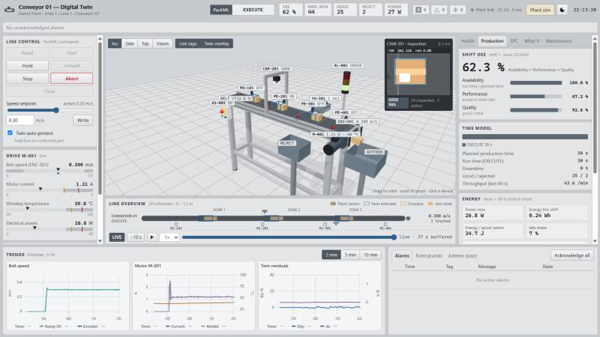
Figure 2 — Operator screen of the digital twin (light ISA-101 theme).
3.2 Fault detection and diagnosis
The validation benchmark injected each fault 20 times with random magnitude, onset time and operating speed (0.25–0.35 m/s) and observed 40 minutes of healthy running (Table 5).
Injected fault | Rules: detected | Mean time | Correct diagnosis | Learned: detected | Mean time
Belt slip 15–35 % | 20/20 | 2.5 s | 100 % | 20/20 | 8.3 s
Jam in zone 2 | 20/20 | 2.4 s | 100 % | 0/20 * | —
Photo-eye failure | 20/20 | 1.4 s | 100 % | 20/20 | 11.2 s
Bearing wear 50–100 % | 20/20 | 11.5 s | 100 % | 20/20 | 8.4 s
Guide rub (no rule exists) | 0/20 | — | — | 20/20 | 8.3 s
False alarms in 40 min healthy | 0 |  |  | 0
Table 5 — Validation benchmark (100 fault scenarios, 4.3 h of plant time simulated in 3.5 s). * The rule-based auto-protect already holds the line.
Rules are fast and name the fault precisely; the learned model is slower but catches the unmodelled guide-rub fault in every run, pointing to the zone 3 transit ratio as the cause (93–96 % contribution). The two approaches are complementary. In a separate run, the slip estimate converged to 24.7 % for an injected 25 % slip, while the encoder still reported the nominal 0.300 m/s.
3.3 Vision inspection
With the defect rate raised to 35–40 % so that many defects occur, test runs of 31–34 cartons gave zero escaped defects and zero false rejects with all five cameras. Because defects appear on any face, the top camera alone would have passed more than 80 % of the defective cartons. The five views are captured with a single GPU read-back and processed in about 12 ms per carton.
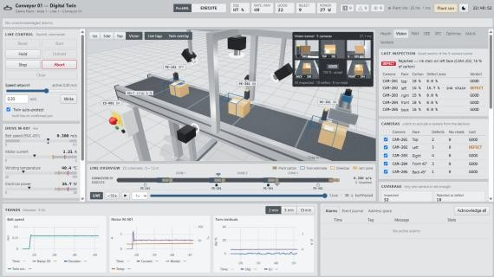
Figure 3 — Vision tunnel view: five camera thumbnails, fused verdict and per-camera results in the Vision tab.
3.4 Predictive maintenance
Table 6 shows the vibration response to bearing wear at 0.30 m/s. Healthy operation sits in zone A; the defect appears as BPFO at 116.5 Hz (3.05 × the 38.2 Hz shaft frequency) with harmonics. In a progressive-wear run the twin diagnosed an outer-race defect with BPFO at 41× its baseline, detected point P on entering zone C, predicted RUL = 1 min 40 s (band 1:28–1:54), and raised a predictive work order before failure. Completing the work order repaired the plant and the health index returned to 99 %.
Bearing wear | 0 % | 30 % | 50 % | 70 % | 85 % | 100 %
Velocity RMS (mm/s) | 0.55 | 1.39 | 2.44 | 3.74 | 4.84 | 6.03
ISO 10816 zone | A | B | C (P) | C | D (F) | D
BPFO amplitude (mm/s pk) | 0.04 | 0.97 | 2.06 | 3.45 | 4.62 | 5.94
Table 6 — Vibration severity versus bearing wear.
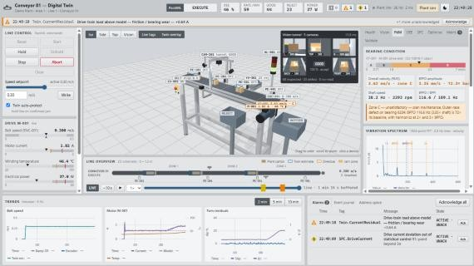
Figure 4 — PdM tab: ISO 10816 severity bar, bearing diagnosis and velocity spectrum with BPFO/BPFI markers.
The economic comparison (Table 7) uses 6000 operating hours per year, ₹ 500/min downtime, ₹ 1 200 per bearing and a 98 % detection rate taken from the benchmark.
Strategy | Jobs / year | Breakdowns / year | Annual cost
Reactive (run to failure) | 1.50 | 1.50 | ₹ 1,51,200
Preventive (replace every 2000 h) | 3.20 | 0.57 | ₹ 1,01,076
Predictive (this digital twin) | 1.67 | 0.03 | ₹ 36,473
Table 7 — Maintenance strategy cost per bearing position: predictive maintenance saves 76 % versus run-to-failure.
3.5 Optimisation and simulation speed
The what-if engine simulated 120 minutes of plant time in 0.59 s (≈ 12 000× real time). The optimiser recommended 0.39 m/s, giving +35 % throughput (≈ 4 000 good cartons/h) over the 0.30 m/s baseline, and rejected three higher speeds that would overheat the motor. With heavy bearing wear the same engine correctly predicted an over-temperature trip within 1.6 minutes at 0.42 m/s.
4. CONCLUSION
The project delivers a working digital twin of a mini conveyor that goes well beyond visualisation. It keeps physical and statistical models of the machine, diagnoses faults that no single sensor can reveal (belt slip, jam versus sensor failure, drive-train wear), protects the line automatically, inspects all five visible faces of every carton with a fail-safe decision, predicts bearing failure from vibration and plans maintenance before it happens. Most importantly, it quantifies its own performance: 100 % detection and correct diagnosis of the modelled faults, detection of an unmodelled fault by the learned model, and zero false alarms.
Because the twin communicates with the plant only through a standard tag interface, the same software can be commissioned on a real conveyor — the purpose of virtual commissioning.
Limitations
- The plant is simulated; the plant link has the OPC UA structure but is an in-browser message channel.
- Thermal and wear time constants are accelerated so that effects are visible within a demonstration.
- The bottom carton face is not inspected; this needs a camera beneath a gap between two belts.
Future scope
- OPC UA or MQTT (Unified Namespace) gateway to a physical conveyor and PLC.
- Jetson Nano edge node with real cameras and a trained defect-detection network.
- Extension from one conveyor to a multi-line plant with bottleneck analysis.
REFERENCES
[1] M. Grieves and J. Vickers, "Digital Twin: Mitigating Unpredictable, Undesirable Emergent Behavior in Complex Systems," in Transdisciplinary Perspectives on Complex Systems, Springer, 2017.
[2] ISO 10816-1, Mechanical vibration — Evaluation of machine vibration by measurements on non-rotating parts — Part 1: General guidelines.
[3] ANSI/ISA-95 (enterprise–control integration), ANSI/ISA-18.2 (alarm management), ANSI/ISA-101.01 (HMI) and ISA-TR88.00.02 (PackML).
[4] OPC Foundation, OPC Unified Architecture, IEC 62541.
[5] R. B. Randall, Vibration-based Condition Monitoring, Wiley, 2011.
[6] J. E. Jackson and G. S. Mudholkar, "Control procedures for residuals associated with principal component analysis," Technometrics, 1979.
[7] Project repository: https://github.com/Organic42/conveyor-digital-twin

