CruxIQ
Energy Risk Intelligence for Import-Dependent Economies
ET AI Hackathon 2026 · Problem Statement 2

Team: Men in Market
github.com/Organic42/team-men-in-market-et-hackathon
July 22, 2026

1. The problem, in one number
India imports roughly half of its natural gas. When a geopolitical shock hits a shipping corridor, Indian industrial buyers find out from the price — 30 days too late.
In March 2026, the Indian Gas Exchange benchmark jumped +69% month-on-month (₹971 → ₹1,644/MMBTU) as the West Asia crisis escalated. Any plant buying spot that month paid a ₹672/MMBTU premium. For a single 2 MTPA cement plant with 30% gas in its energy mix, that is roughly ₹10 crore of avoidable cost — in one month.
The information needed to see it coming was public. The GDELT news firehose showed Hormuz corridor risk escalating through February. No mid-market Indian CFO has a system that reads it.

2. What CruxIQ does
GDELT (global news, free) → LLM event extraction (Groq / Llama) → deterministic corridor scoring → 30-day BUY / HEDGE / WAIT signal → ₹-crore plant impact → WhatsApp alert to the CFO
Three design decisions:
• ₹ before risk score — the landing page leads with rupee exposure, not an abstract index. CFOs budget in crores, not in "risk units".
• LLM for reading, arithmetic for scoring — the LLM only extracts structured events from news; the score itself is a deterministic weighted formula with a click-through audit trail. No hallucinated numbers.
• Backtested, not vibes — every claim is checked against 67 months of real IGX prices with no forward-looking data leaked.

3. Proof: 5-year backtest on real IGX data
Data: our own scrape of the Indian Gas Exchange — 11,926 rows, 1,397 trading days, Dec 2020 → Jul 2026, shipped in the repo.
Metric | Result
Months evaluated | 67 (2020-12 → 2026-06)
Geopolitical big moves caught | 77.8% (of 18 geopolitics-driven ≥10% moves)
All big moves (incl. demand shocks) | 58.3%
Directional accuracy (all months) | 61.2%
False positive rate | 12.5% (RED flags followed by <5% move)

Hero case: CruxIQ's scoring flags Hormuz RED in February 2026 — one month before the +69% spike. A plant that locked 30-day forward supply on that signal avoided the entire ₹672/MMBTU premium.

4. The product — 9 screens
All screenshots are the live app in the dark "Terminal" theme. A one-click toggle switches to a light "Boardroom" theme for CFO presentations.

F1 · Risk Command Center
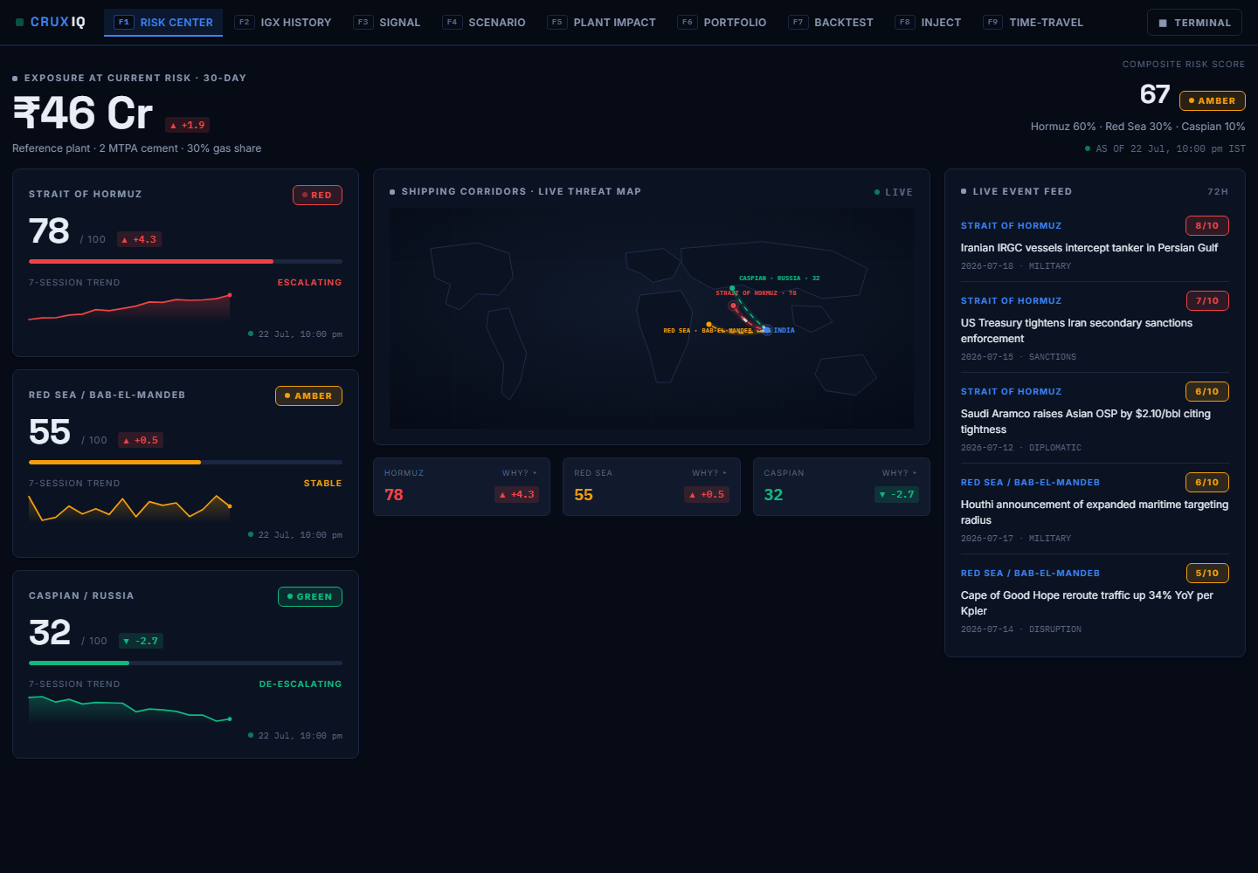
Rupee exposure first (live from the plant-impact engine), composite risk second. Three corridor metric cards, live threat map, 72-hour event feed. Every corridor tile has a "WHY?" link opening the full data-lineage audit trail.

F2 · IGX Price History
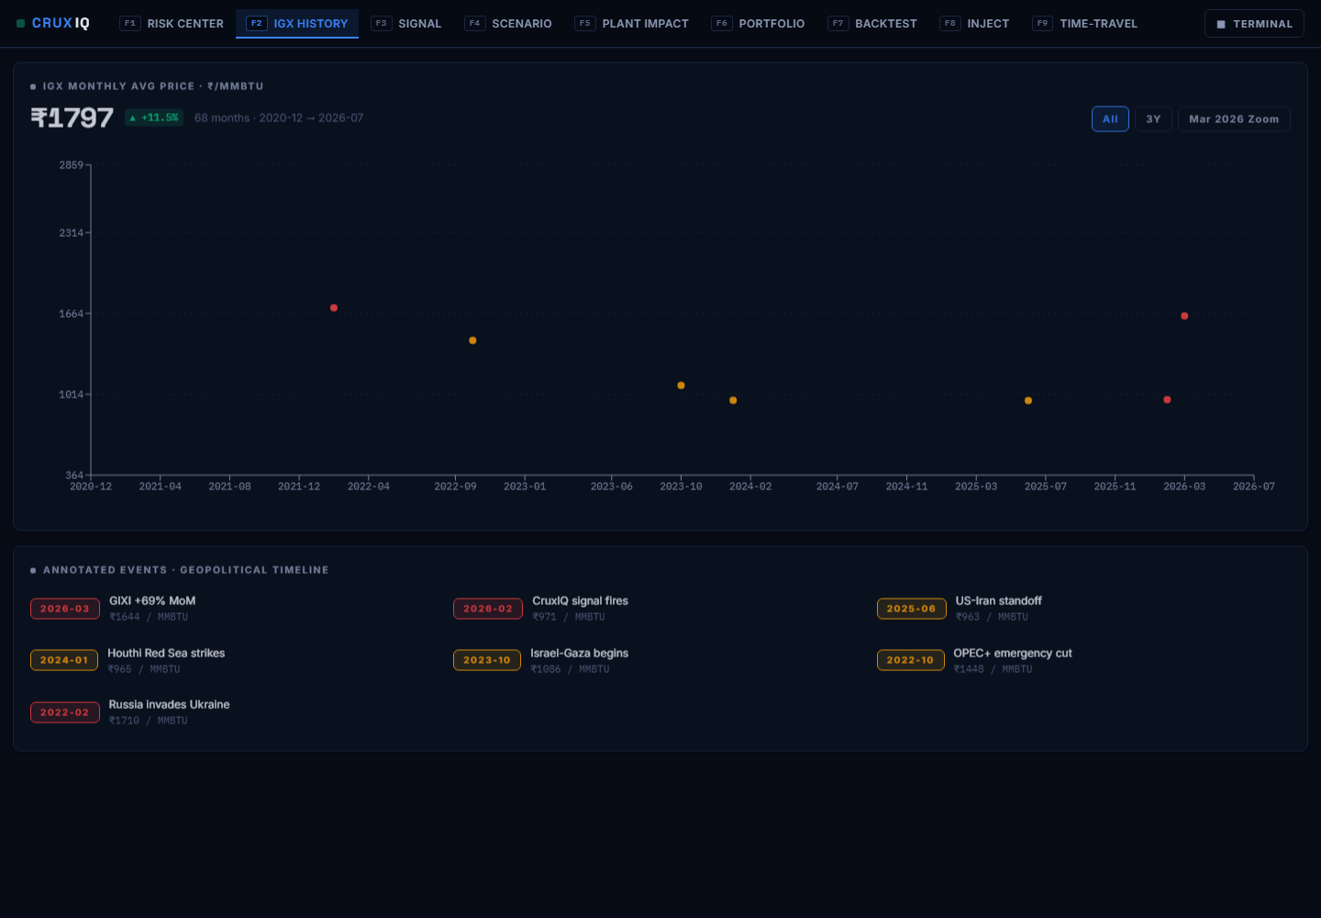
Five and a half years of real IGX prices with geopolitical event markers — including the point where CruxIQ's signal fires ahead of the March 2026 spike.

F3 · 30-Day Signal + WhatsApp delivery
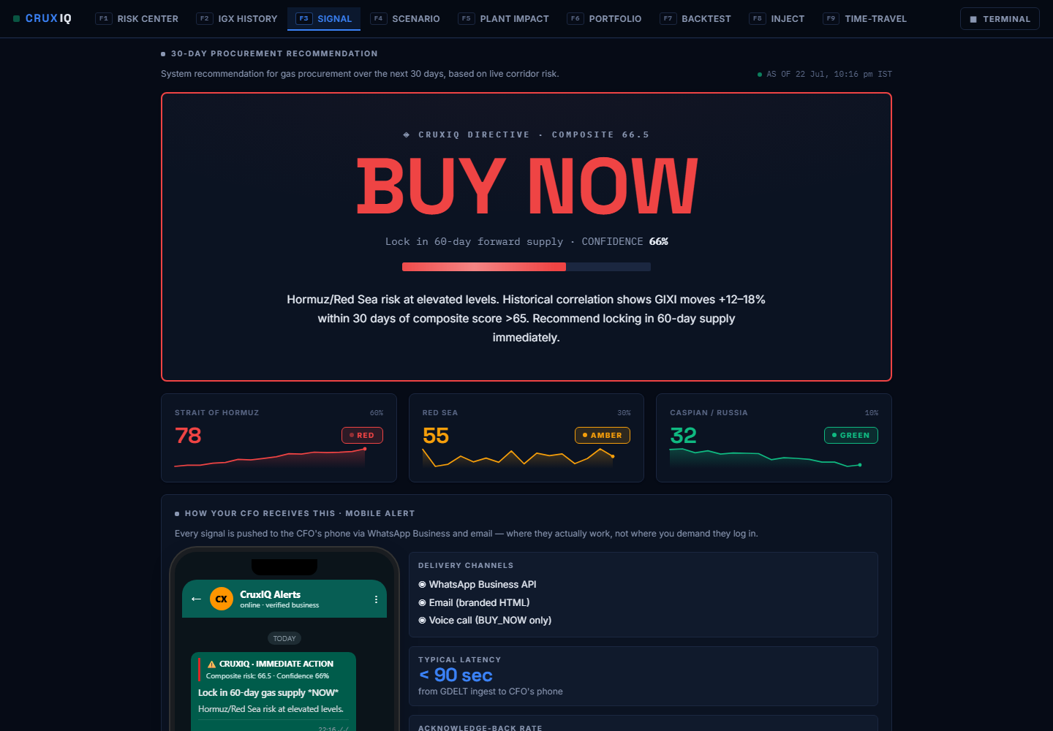
The single actionable output: BUY NOW / PARTIAL HEDGE / WAIT with confidence and rationale. Below it, the WhatsApp Business alert the CFO receives, rendered live from the same signal (latency under 90 seconds).

F4 · Scenario Simulator
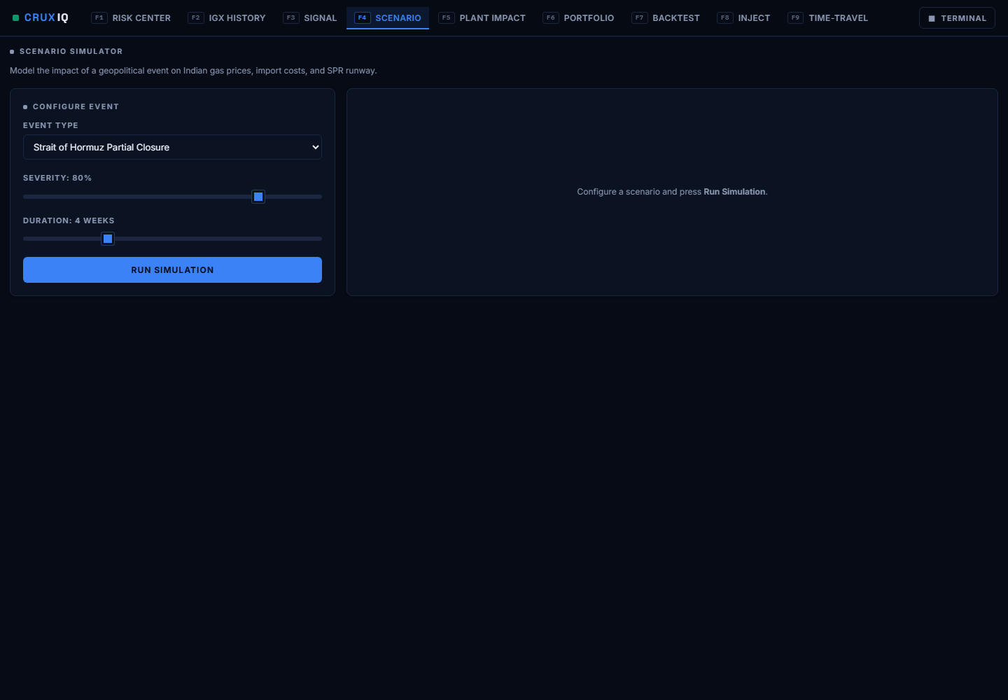
"What if Hormuz partially closes for 4 weeks at 80% severity?" — models the price path, import cost delta, and strategic-reserve runway using the same calibration constants the backtest validates.

F5 · Plant Impact Calculator
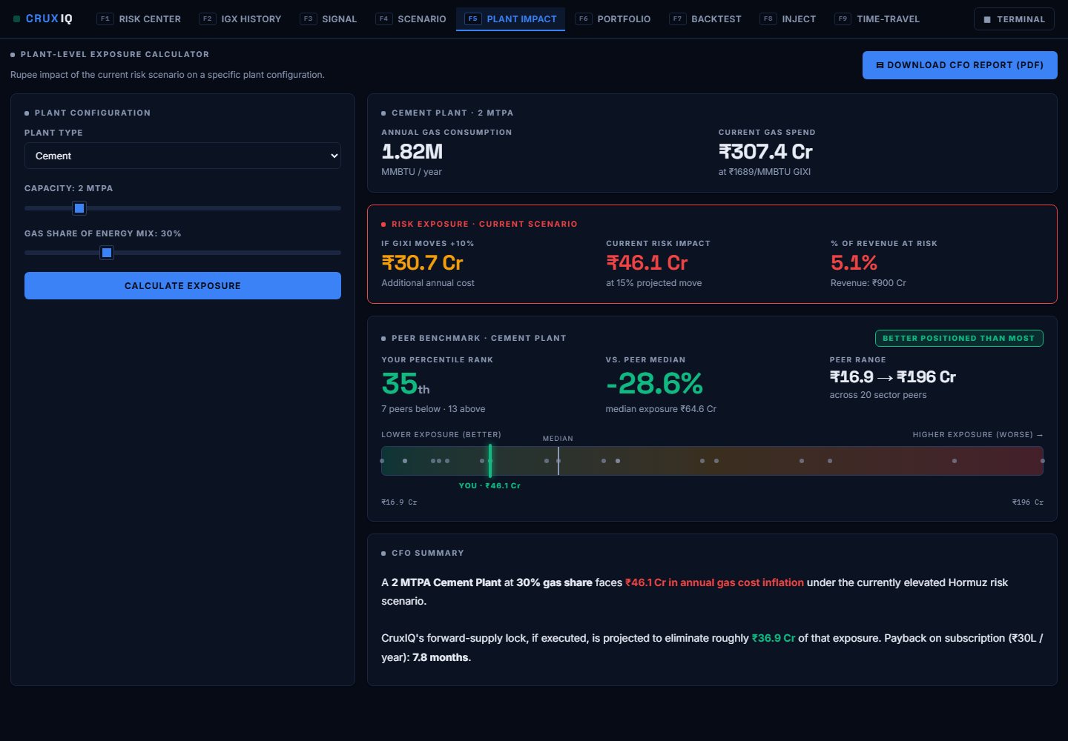
Plant type + capacity + gas share → rupee exposure, projected savings from a forward lock, payback. Includes peer benchmarking against an anonymised sector cohort and one-click CFO PDF export.

F6 · Portfolio View
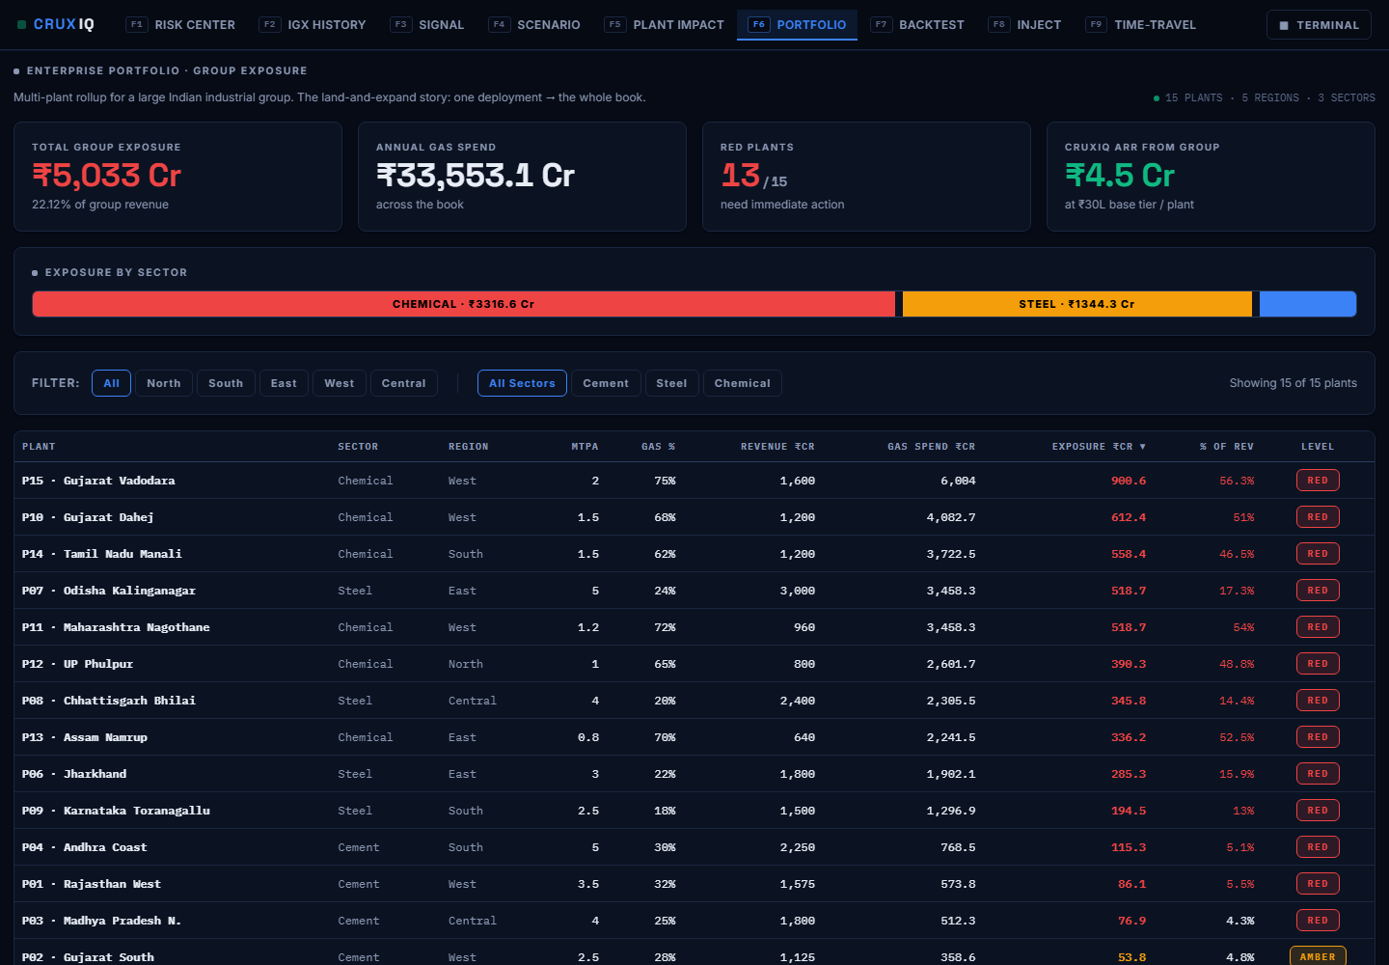
The enterprise story: a 15-plant industrial group — ₹5,033 Cr aggregate exposure, 13 plants RED — sortable and filterable by region and sector.

F7 · Backtest Report
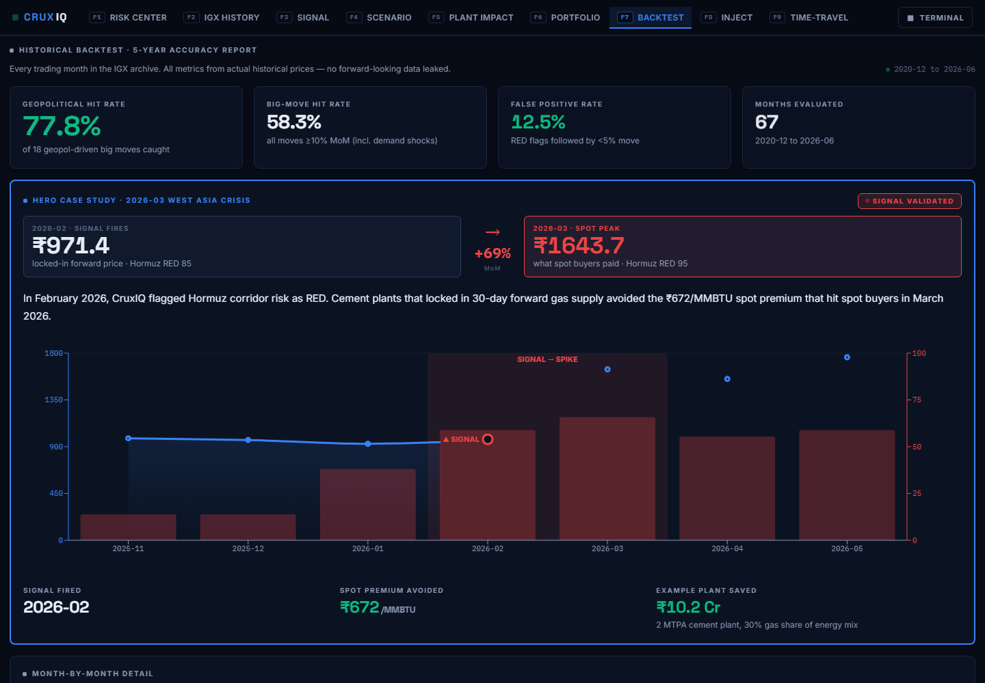
The full 67-month accuracy report with the March 2026 hero case study, month-by-month detail, and honest misses.

F8 · Event Injector
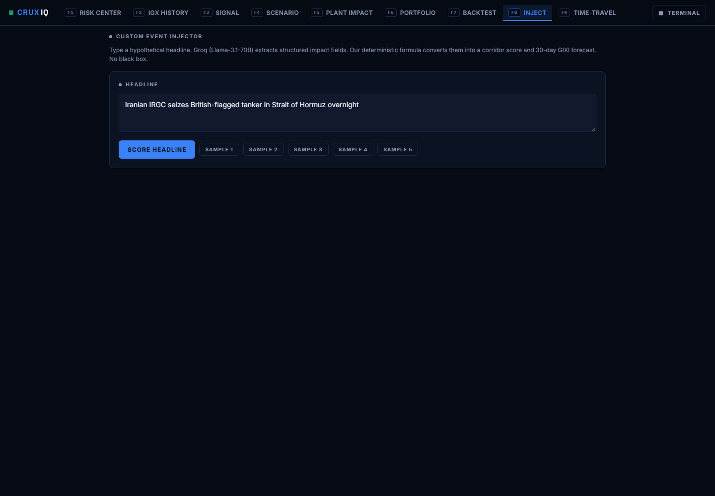
Live-demo tool for judges: inject a hypothetical event and watch scores, signal, and WhatsApp alert update end-to-end.

F9 · Time-Travel
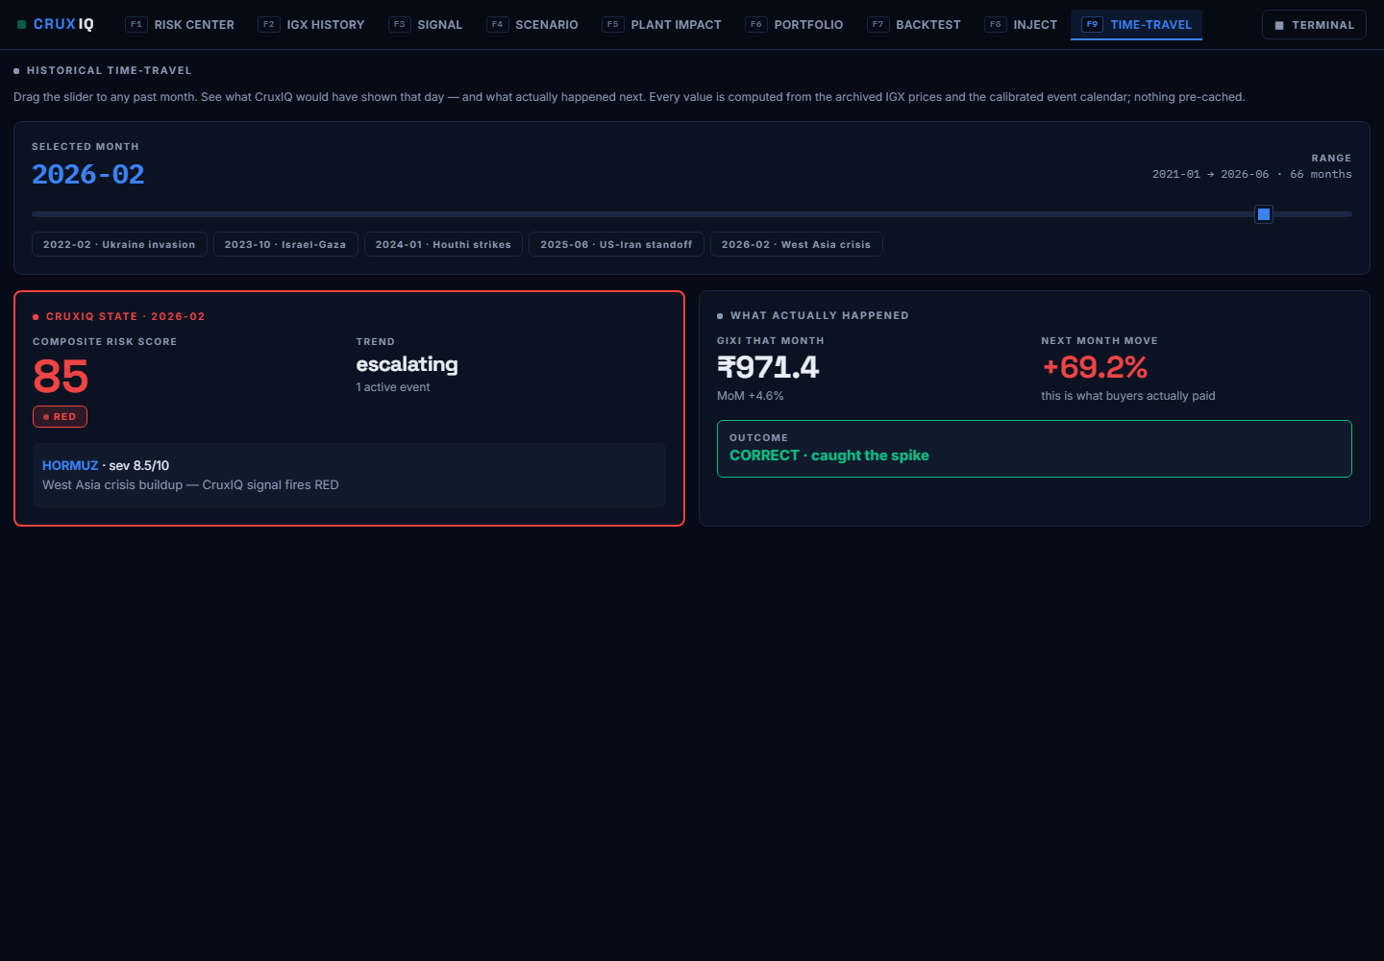
Drag a slider to any month since 2021 and see exactly what CruxIQ would have shown that day — and what actually happened next. This screen is the backtest, made tangible.

5. Architecture
Backend: FastAPI + pandas; Groq (Llama) for event extraction only, with graceful fallback to cached events — the demo never breaks. Frontend: React + Vite + Recharts; the entire visual system is CSS variables, so the Terminal/Boardroom theme switch is one attribute flip. Deploy: Netlify (frontend) + Render (API).

6. Business model
Target: ~2,000 mid-market Indian cement / steel / chemical / glass plants with meaningful gas exposure — too small for a Bloomberg terminal (₹20L+/seat), too exposed to ignore this.
Pricing: ₹30L/plant/year. A single avoided spike (₹10 Cr for the reference plant) pays for 30+ years of subscription. Land and expand: one plant → the group; the 15-plant portfolio view is a ₹4.5 Cr ARR account.

7. Run it yourself
Backend: cd backend && pip install -r requirements.txt && uvicorn main:app --port 8000
Frontend: cd frontend && npm install && npm run dev → http://localhost:5173
The IGX archive ships in the repo — no scraping needed. Without a Groq key, the app runs fully on the cached event set.

