# References on Web Jump out to the interwebby thing

PDF Resources: Designing the Hardware

[1] [Laboratory Exercise 2 Numbers and Displays](ftp://ftp.altera.com/up/pub/Altera_Material/11.1/Laboratory_Exercises/Digital_Logic/DE1/vhdl/lab2_VHDL.pdf)

[2] [Translated manual for Master 21EDA board](http://organicmonkeymotion.files.wordpress.com/2014/01/altera-fpga-development-board-user-manual.pdf)

[3] [Altera DE1 Board](ftp://ftp.altera.com/up/pub/Altera_Material/12.1/Boards/DE1/DE1_User_Manual.pdf)

Tools

[4] [Digital Electronics Education Design Suite](http://www.esng.dibe.unige.it/Deeds/) (DEEDS)

[5] [LogicFriday](http://sontrak.com/)

Contents

References on Web  1

Introduction 2

Part I 4

Part II 10

Part III 10

Part IV 10

Part V 10

Part VI 10

You may now SCREAM!! 10

# Introduction

The **Headings in red** in this document will mirror the headings in the Altera® tutorial Ref [1] so you can easily map between documents. You **WILL NEED** Ref [1] at least as this document is only providing the gotchas when walking through Ref [1]. Additional **Headings in blue** are internal to this document – used to break things up as you would expect headings to do.

Read the previous paragraph again. You are reading this document along with the Altera® tutorial [1].

Remember also from the blog, we are now using Quartus® II version 11.1 – driven by the chip on the board, the 144-pin EP2C5T144C8 Cyclone II. The predominant difference is the transitioning from SPOC to Qsys as system on chip designer. Both are available in 11.1, which suits us because there is a lot of free info on web for SOPC based design.

Legend:

If I have been stumped by something I will use the image to the left to let you know a little investigation was in order.

If an important “Ah Ha!” moment occurred, I will also let you know.

If you’re to go to the web I will give the hint.

STOP, we are swapping tutorials

Now don’t forget something very important. Quartus ® II is clunky. Recall from the blog the crashing. What you will find is you may need to delete project and start again a couple of times so be prepared both spiritually and emotionally. You will find the Altera® tutorial leaves things out (which we will try to catch). You will also find, as I did, the tool may not even crash, but will not react to menu selections etc. Just take a deep breath and SCREAM, get over it and try again. Of course, that was while we were using 10.1, the switch to 11.1 may have changed that – we’ll see … whoops, yes there we are (Figure 1).

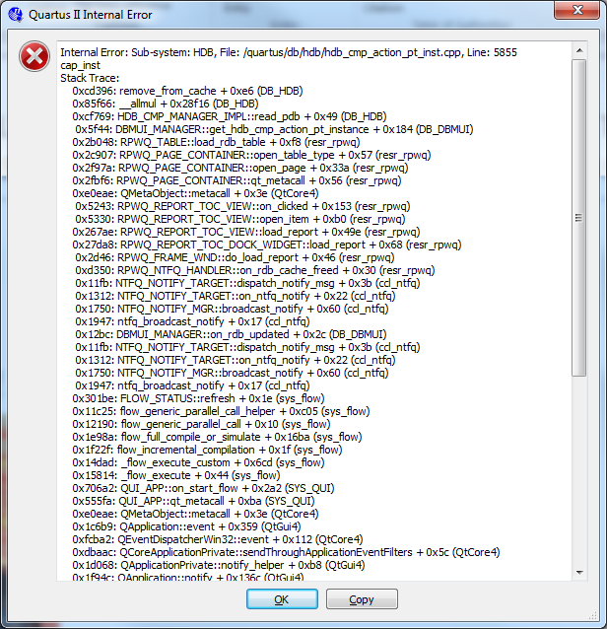

Figure : Same old problem

Don’t forget; as we build projects for each part of the lab remember to set unused pins.

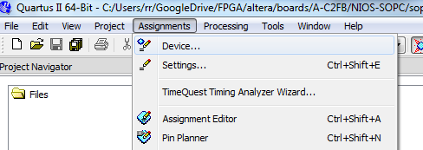

Figure . An important missing step.

Open “Device” dialog (Figure 2) and you will see a button “Device and Pin Options …”, select that (Figure 3). This button doesn’t exist on the dialog when the project is created so you will need to do this as separate step – right now.

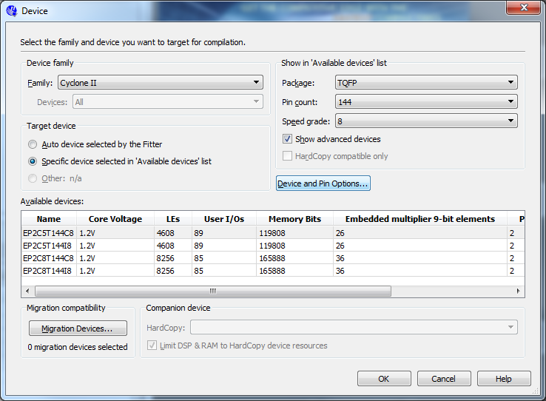

Figure . We need to do something with our unused pins!

Change unused pins to tri-stated inputs (Figure 4).

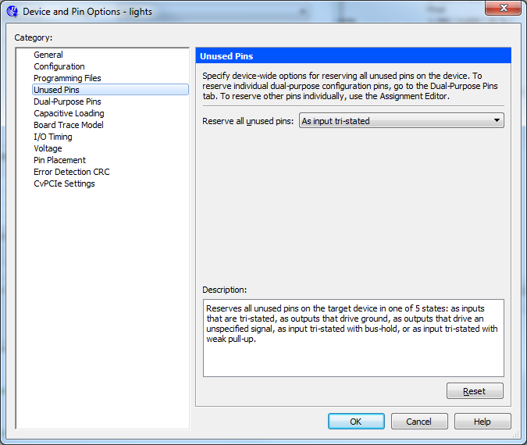

Figure . Tell the pins to be “quiet”

Note also, I will be calling out figures, occasionally, from the Altera® tutorial so I will use Figure x for figures internal to this document and ***Figure y*** when referring to figures in the Altera® tutorial. Similarly, I will use ***Step x***. ***Table x.*** etc. to help remind you to go to the Altera® tutorial.

Ready, set, let’s go.

# Part I

We run straight into a problem with this part of Laboratory 2 as it requires 10 switches so we know we need another way of doing this. As we did in Part V of Digital Labs Part 1, we can use constants to get around the absence of switches. Or, we can opt to drop one of the LED circuits – we have four switches yes and the problem uses four switches per segment. Yes, we’ll do that.

Other than that, we just sketch out our LED segment lighting and then use LogicFriday to build a truth table.

|  |  |  |  |  |  |  |  |  |  |  |  |  |  |  |  |  |  |  |  |  |  |  |  |  |  |  |  |  |  |
| --- | --- | --- | --- | --- | --- | --- | --- | --- | --- | --- | --- | --- | --- | --- | --- | --- | --- | --- | --- | --- | --- | --- | --- | --- | --- | --- | --- | --- | --- |
| |  |  |  |  | | --- | --- | --- | --- | | LED_A | 0 | PIN_93 | 0 | | LED_B | 1 | PIN_92 | 0 | | LED_C | 2 | PIN_87 | 0 | | LED_D | 3 | PIN_86 | 0 | | LED_E | 4 | PIN_55 | 0 | | LED_F | 5 | PIN_58 | 0 | | LED_G | 6 | PIN_79 | 1 |   “1000000” | http://organicmonkeymotion.files.wordpress.com/2014/04/exp72.png1111=>0 |
| |  |  |  |  | | --- | --- | --- | --- | | LED_A | 0 | PIN_93 | 1 | | LED_B | 1 | PIN_92 | 0 | | LED_C | 2 | PIN_87 | 0 | | LED_D | 3 | PIN_86 | 1 | | LED_E | 4 | PIN_55 | 1 | | LED_F | 5 | PIN_58 | 1 | | LED_G | 6 | PIN_79 | 1 |   “1111001” | http://organicmonkeymotion.files.wordpress.com/2014/04/exp72.png1110=>1 |
| |  |  |  |  | | --- | --- | --- | --- | | LED_A | 0 | PIN_93 | 0 | | LED_B | 1 | PIN_92 | 0 | | LED_C | 2 | PIN_87 | 1 | | LED_D | 3 | PIN_86 | 0 | | LED_E | 4 | PIN_55 | 0 | | LED_F | 5 | PIN_58 | 1 | | LED_G | 6 | PIN_79 | 0 |   “0100100” | http://organicmonkeymotion.files.wordpress.com/2014/04/exp72.png1101=>2 |
| |  |  |  |  | | --- | --- | --- | --- | | LED_A | 0 | PIN_93 | 0 | | LED_B | 1 | PIN_92 | 0 | | LED_C | 2 | PIN_87 | 0 | | LED_D | 3 | PIN_86 | 0 | | LED_E | 4 | PIN_55 | 1 | | LED_F | 5 | PIN_58 | 1 | | LED_G | 6 | PIN_79 | 0 |   “0110000” | http://organicmonkeymotion.files.wordpress.com/2014/04/exp72.png1100=>3 |
| |  |  |  |  | | --- | --- | --- | --- | | LED_A | 0 | PIN_93 | 1 | | LED_B | 1 | PIN_92 | 0 | | LED_C | 2 | PIN_87 | 0 | | LED_D | 3 | PIN_86 | 1 | | LED_E | 4 | PIN_55 | 1 | | LED_F | 5 | PIN_58 | 0 | | LED_G | 6 | PIN_79 | 0 |   “0011001” | http://organicmonkeymotion.files.wordpress.com/2014/04/exp72.png1011=>4 |
| |  |  |  |  | | --- | --- | --- | --- | | LED_A | 0 | PIN_93 | 0 | | LED_B | 1 | PIN_92 | 1 | | LED_C | 2 | PIN_87 | 0 | | LED_D | 3 | PIN_86 | 0 | | LED_E | 4 | PIN_55 | 1 | | LED_F | 5 | PIN_58 | 0 | | LED_G | 6 | PIN_79 | 0 |   “0010010” | http://organicmonkeymotion.files.wordpress.com/2014/04/exp72.png1010=>5 |
| |  |  |  |  | | --- | --- | --- | --- | | LED_A | 0 | PIN_93 | 0 | | LED_B | 1 | PIN_92 | 1 | | LED_C | 2 | PIN_87 | 0 | | LED_D | 3 | PIN_86 | 0 | | LED_E | 4 | PIN_55 | 0 | | LED_F | 5 | PIN_58 | 0 | | LED_G | 6 | PIN_79 | 0 |   “0000010” | http://organicmonkeymotion.files.wordpress.com/2014/04/exp72.png1001=>6 |
| |  |  |  |  | | --- | --- | --- | --- | | LED_A | 0 | PIN_93 | 0 | | LED_B | 1 | PIN_92 | 0 | | LED_C | 2 | PIN_87 | 0 | | LED_D | 3 | PIN_86 | 1 | | LED_E | 4 | PIN_55 | 1 | | LED_F | 5 | PIN_58 | 1 | | LED_G | 6 | PIN_79 | 1 |   “1111000” | http://organicmonkeymotion.files.wordpress.com/2014/04/exp72.png1000=>7 |
| |  |  |  |  | | --- | --- | --- | --- | | LED_A | 0 | PIN_93 | 0 | | LED_B | 1 | PIN_92 | 0 | | LED_C | 2 | PIN_87 | 0 | | LED_D | 3 | PIN_86 | 0 | | LED_E | 4 | PIN_55 | 0 | | LED_F | 5 | PIN_58 | 0 | | LED_G | 6 | PIN_79 | 0 |   “0000000” | http://organicmonkeymotion.files.wordpress.com/2014/04/exp72.png0111=>8 |
| |  |  |  |  | | --- | --- | --- | --- | | LED_A | 0 | PIN_93 | 0 | | LED_B | 1 | PIN_92 | 0 | | LED_C | 2 | PIN_87 | 0 | | LED_D | 3 | PIN_86 | 1 | | LED_E | 4 | PIN_55 | 1 | | LED_F | 5 | PIN_58 | 0 | | LED_G | 6 | PIN_79 | 0 |   “0011000” | http://organicmonkeymotion.files.wordpress.com/2014/04/exp72.png0110=9 |
| |  |  |  |  | | --- | --- | --- | --- | | LED_A | 0 | PIN_93 | 1 | | LED_B | 1 | PIN_92 | 1 | | LED_C | 2 | PIN_87 | 1 | | LED_D | 3 | PIN_86 | 1 | | LED_E | 4 | PIN_55 | 1 | | LED_F | 5 | PIN_58 | 1 | | LED_G | 6 | PIN_79 | 1 |   otherwise | http://organicmonkeymotion.files.wordpress.com/2014/04/exp72.png |

The truth table becomes:

Entered by truthtable:

F0 = A' B' C' D' + A' B' C' D + A' B' C D' + A' B' C D + A' B C' D' + A' B C' D + A B' C D + A B C D';

F1 = A' B' C' D' + A' B' C' D + A' B' C D' + A' B' C D + A' B C' D' + A' B C' D + A B' C' D + A B' C D';

F2 = A' B' C' D' + A' B' C' D + A' B' C D' + A' B' C D + A' B C' D' + A' B C' D + A B C' D;

F3 = A' B' C' D' + A' B' C' D + A' B' C D' + A' B' C D + A' B C' D' + A' B C' D + A' B C D' + A B' C' D' + A B' C D + A B C D';

F4 = A' B' C' D' + A' B' C' D + A' B' C D' + A' B' C D + A' B C' D' + A' B C' D + A' B C D' + A B' C' D' + A B' C D' + A B' C D + A B C' D' + A B C D';

F5 = A' B' C' D' + A' B' C' D + A' B' C D' + A' B' C D + A' B C' D' + A' B C' D + A B' C' D' + A B C' D' + A B C' D + A B C D';

F6 = A' B' C' D' + A' B' C' D + A' B' C D' + A' B' C D + A' B C' D' + A' B C' D + A B' C' D' + A B C D' + A B C D;

Factored:

F0 = A' (C' + B') + C (A B D' + B' D);

F1 = B' (C D' + C' D + A') + A' C';

F2 = C' (B D + A') + A' B';

F3 = B' C D + D' (B' C' + B C + A') + A' C';

F4 = A' C' + B' C + D';

F5 = D' (A B + C') + B C' + A' B';

F6 = A B C + C' (B' D' + A') + A' B';

Minimized:

F0 = A B C D' + B' C D + A' C' + A' B' ;

F1 = B' C D' + A' C' + B' C' D + A' B' ;

F2 = B C' D + A' B' + A' C' ;

F3 = A' D' + B C D' + B' C D + B' C' D' + A' C' ;

F4 = A' C' + B' C + D';

F5 = A B D' + A' B' + B C' + C' D';

F6 = A B C + B' C' D' + A' C' + A' B' ;

So coding that up we get Figure 5.

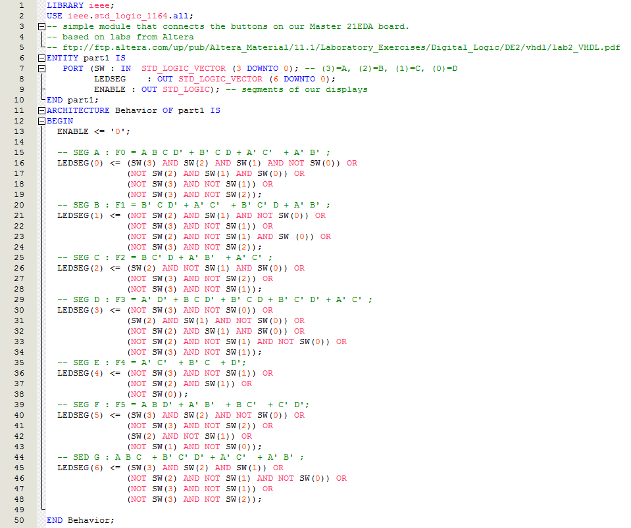

Figure : Voila!

Don’t forget the pin assignments at Figure 6.

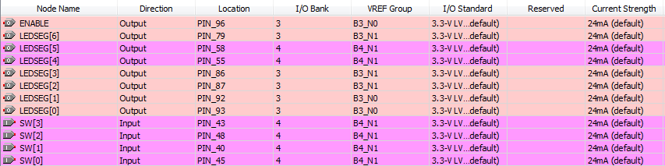

Figure 6

You should get a RTL somewhat like that at Figure 7.

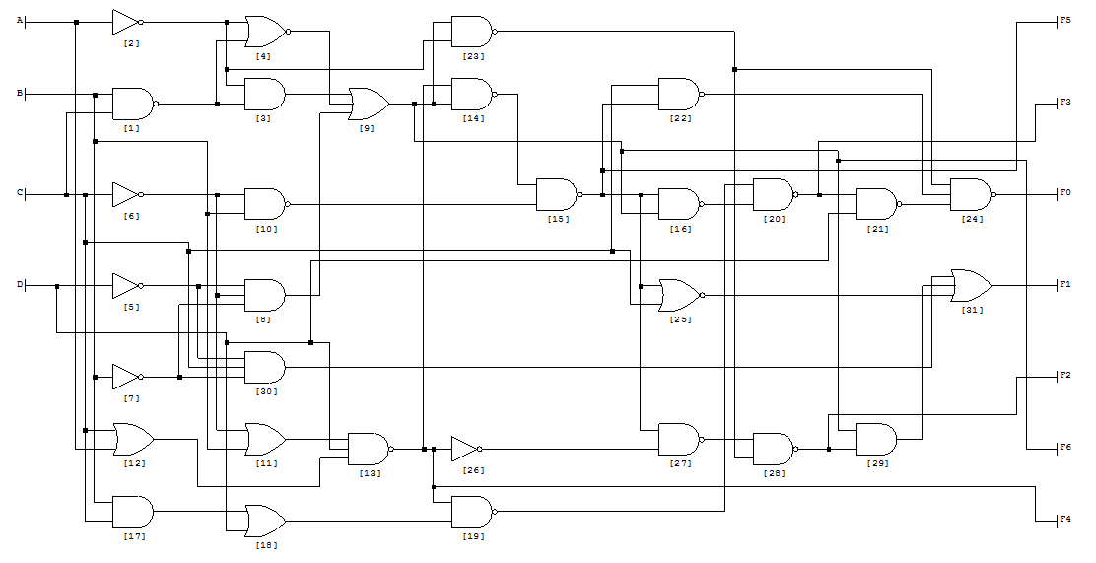

Figure 7

If you bother to code it up in LogicFriday I just used the 8 LED output widget as in Figure 8. If your wire up F0..F6 from Figure 7 then the LED match up with the “0011000” etc. segment enable maps of the logic table so you can interpret them.

So, with everything working you should have the 7-segment display that is enabled off PIN_96 light up as per design.

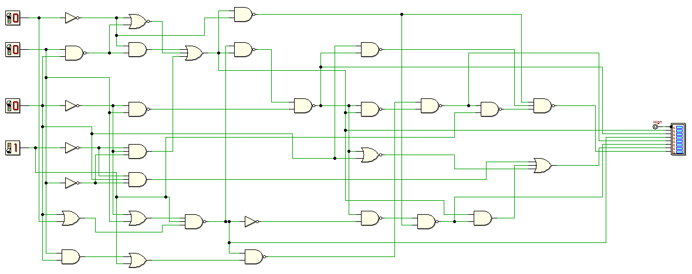

Figure 8

# Part II

# Part III

# Part IV

# Part V

# Part VI

# You may now SCREAM!!

