Software Requirements Specification

SRS

“ORGANIZE IT”

**Document history**

| **Version** | **Status** | **Date** | **Responsible person** | **Reason for change** |
| --- | --- | --- | --- | --- |
| 1.0 | Created | 20 Nov 2023 | Team | Start of the project |
| 1.1 | Edited | 23 Nov 2023 | Team | Meeting for the SRS |
|  |  |  |  |  |

**Glossary**

| spaces | One user’s or multiple different user’s synchronized work area encompassing Tasks (within ToDo-lists) and Notes. |
| --- | --- |
| ToDo-list | Each ToDo-list belongs to a space and can contain multiple tasks. |
| tasks | Tasks can be created by users. Each task belongs to a ToDo-List. |

**Table of contents**

**1. Introduction 1**

1.1. Purpose, Goals and Background 1

**2. Product scope 1**

2.1. Functional requirements 1

2.1.1. Must-criteria 1

2.1.2. Should-criteria 1

2.1.3. Could-criteria 2

2.1.4. Won’t-criteria 2

2.2. Non functional requirements 3

2.3. References 3

**3. General overview 3**

3.1. Description of the initial situation (current state) 3

3.2. Product application 4

3.2.1. Areas of application 4

3.2.2. Target groups, qualification level 4

3.2.3. Operating conditions 4

3.2.4. General restrictions 4

3.2.5. Assumptions and dependencies 4

3.3. Product environment 4

3.3.1. System interface 4

3.3.2. User interface 4

3.3.3. Hardware interface 4

3.3.4. Software interface 4

3.3.5. Communication interface 4

3.3.6. Memory constraints 4

3.3.7. Operational 4

3.3.8. Adaptation of site-specific requirements 4

3.4. Product functionality 5

3.5. User characteristics 5

3.6. Constraints 5

3.7. Assumptions and dependencies 5

3.8. Delays 5

3.9. Requirements for data management 5

3.9.1. General description of the data 5

3.9.2. Archiving 5

3.10. Requirements for the user interface 5

3.10.1. General requirements to the user interface 5

3.10.2. Authorizations 5

3.10.3. Individual adaptation of the user interface 5

3.10.4. Screen layout 5

3.10.5. Checks: field-related and cross-field 5

3.10.6. Print layout, keyboard layout 5

3.10.7. Dialog structure, dialog sequences 5

3.10.8. Help system 5

3.11. Performance requirements 6

3.11.1. Time-related or scope-related product services 6

3.11.2. Performance data, dialog response times 6

3.11.3. Maximum and average data volume or data throughput 6

3.11.4. Accuracy of calculations 6

3.12. Requirements for operation and deployment 6

3.12.1. Safety objectives 6

3.12.2. Operational safety 6

3.12.3. Installation procedure 6

3.12.4. Pilot or trial operation 6

3.12.5. Fault response, warranty, service, "restart" 6

3.12.6. Trainings 6

3.13. Quality requirements 6

3.13.1. Quality characteristics 6

3.13.2. Quality assurance 6

3.13.3. Proof of quality 6

3.13.4. Disclosure of quality control plans 6

3.13.5. Reports, protocols to prove the procedure according to the quality control plans 6

3.14. Requirement for development 7

3.14.1. Design constraints 7

3.14.2. Development environment 7

3.14.3. Project organization 7

3.14.4. Project planning 7

3.14.5. Project monitoring 7

3.14.6. Project control 7

3.14.7. Configuration management 7

3.14.8. Change management 7

3.14.9. Test requirements 7

3.14.10. Reviews, refactoring 7

**4. Appendix 8**

4.1. Glossary, acronyms and abbreviations 8

4.2. Data catalog 8

4.3. Dialog masks 8

4.4. Print masks 8

4.5. Global test scenarios/test cases 8

4.6. Documents to be used 8

4.7. Documentation requirements 8

4.8. List of software supplies 8

4.9. Supplies by the customer 8

4.10. Project organization chart 8

4.11. Project structure plan 8

4.12. Main schedule data 8

**5. Index 8**

# Introduction

## Purpose, Goals and Background

"ORGANIZE IT" is a new multiplatform software designed to streamline task management in today's dynamic digital landscape. With the uprising in remote work and the need for seamless multi- and inter-platform communication, “ORGANIZE IT” addresses the challenges of staying organized and synchronized across various engagements.

This productivity tool offers work spaces for individuals, teams, students, flat share members and other collaborators. Its primary goal is to enhance productivity by providing a unified hub where tasks and notes can be managed, shared and synchronized effortlessly among multiple parties. “ORGANIZE IT” aims to facilitate a smoother and more efficient workflow and allows users to adapt their organizational framework to their unique needs and preferences.

# Product scope

## Functional requirements

### Must-criteria

* The system must provide the user with the ability to create new spaces.
* If a new user is registered, the system must create a default space for that user.
* The system must provide the user with the ability to edit the title of a space.
* The system must provide the user with the ability to delete spaces.
* The system must provide the user with the ability to close and archive spaces.
* The system must provide the user with the ability to create to-do lists.
* The system must provide the user with the ability to edit to-do lists.
* The system must provide the user with the ability to delete to-do lists.
* After clicking on a specific to-do-list the system must provide the user with the ability to create tasks.
* After clicking on a specific to-do-list the system must provide the user with the ability to edit tasks.
* After clicking on a specific to-do-list the system must provide the user with the ability to delete tasks.
* After clicking on a specific to-do-list the system must provide the user with the ability to mark tasks as finished.

### Should-criteria

* The system should provide the user with the ability to register to the service.
* Upon having registered to the service the system should provide the user with the ability to log in with an existing account.
* Upon having registered to the service the system should provide the user with the ability to log into their account on various other devices in order to access their own spaces.
* Upon having registered to the service the system should provide the user to stay logged in on various of their devices at the same time.
* After logging in on a device the system should be able to synchronize the user’s spaces including to-do-lists and notes between logged in devices.

### Could-criteria

* The system could provide the user with the ability to add due-dates to tasks.
* The system could provide the user with the ability to create notes.
* The system could provide the user with the ability to edit notes.
* The system could provide the user with the ability to delete notes.
* After accessing the settings pertaining to a specific space the system could provide the user with the ability to invite other users to collaborate with them on that space.
* Upon joining a space the system could be able to synchronize the space’s content across all of the collaborating user’s various devices.

### Won’t-criteria

* The system won’t provide the user with the ability to select AI generated task suggestions based on the title of a to-do-list.
* If a task has been marked as finished, the system won’t automatically delete the task.
* The system won’t be able to send notifications.
* The system won’t provide the user with the possibility to customize spaces.
* The system won’t provide the user with the possibility to customize to-do-lists.
* The system won’t provide the user with the possibility to customize tasks.

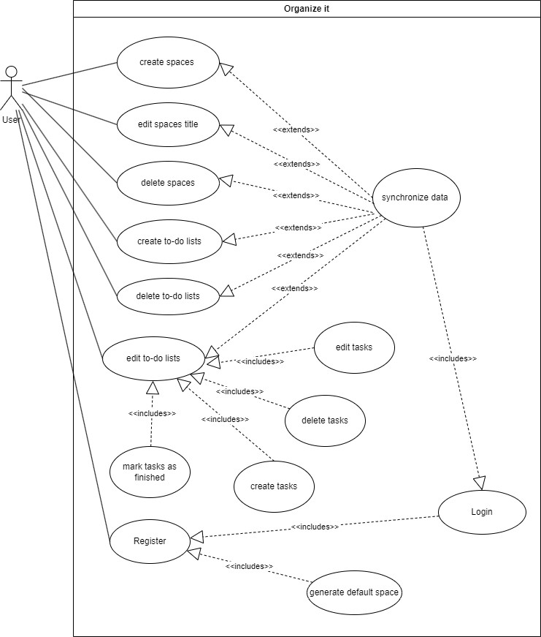

## Non functional requirements

* The app should run on multiple platforms namely: iOS, android, macOS and windows.
* The app should have reasonable (< 20 seconds) loading times.

## References

# General overview

## Description of the initial situation (current state)

## Product application

### Areas of application

The areas of application are very broad: From professional work environments to flat shares, all sorts of organizations or private engagements can make use of this simple productivity tool.

### Target groups, qualification level

“ORGANIZE IT” targets users of all qualification levels alike. The system is intended to be used by professionals in their projects as well as by private people in their daily lives.

Since the “ORGANIZE IT” is planned as an multi-platform app (macOS, Windows, iOS, Android) most users of modern operating systems will be able to use the product.

### Operating conditions

### General restrictions

### Assumptions and dependencies

The only assumption pertaining to the use of Organize IT is that users own some end device (smartphone or desktop computer) with the respective rights and the knowledge in order to install and use the app.

## Product environment

### System interface

### User interface

### Hardware interface

### Software interface

### Communication interface

### Memory constraints

### Operational

### Adaptation of site-specific requirements

## Product functionality

## User characteristics

## Constraints

## Assumptions and dependencies

## Delays

## Requirements for data management

### General description of the data

### Archiving

## Requirements for the user interface

### General requirements to the user interface

### Authorizations

### Individual adaptation of the user interface

### Screen layout

### Checks: field-related and cross-field

### Print layout, keyboard layout

### Dialog structure, dialog sequences

### Help system

## Performance requirements

### Time-related or scope-related product services

### Performance data, dialog response times

### Maximum and average data volume or data throughput

### Accuracy of calculations

## Requirements for operation and deployment

### Safety objectives

### Operational safety

### Installation procedure

### Pilot or trial operation

### Fault response, warranty, service, "restart"

### Trainings

## Quality requirements

### Quality characteristics

### Quality assurance

### Proof of quality

### Disclosure of quality control plans

### Reports, protocols to prove the procedure according to the quality control plans

## Requirement for development

### Design constraints

### Development environment

### Project organization

### Project planning

### Project monitoring

### Project control

### Configuration management

### Change management

### Test requirements

### Reviews, refactoring

# Appendix

## Glossary, acronyms and abbreviations

## Data catalog

## Dialog masks

## Print masks

## Global test scenarios/test cases

## Documents to be used

## Documentation requirements

## List of software supplies

## Supplies by the customer

## Project organization chart

## Project structure plan

## Main schedule data

# Index