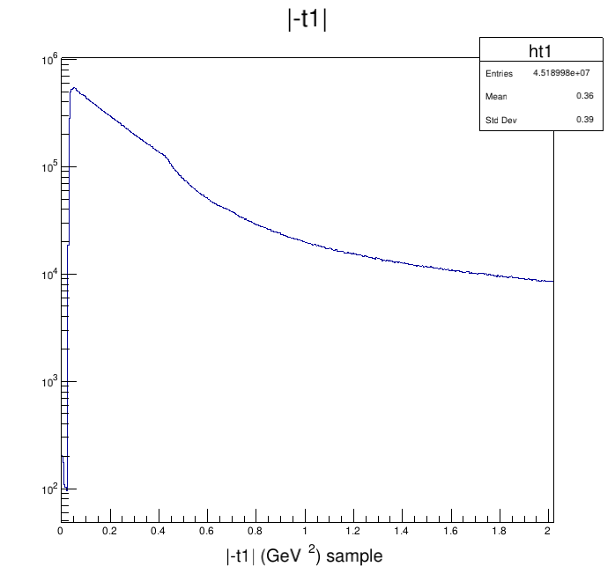

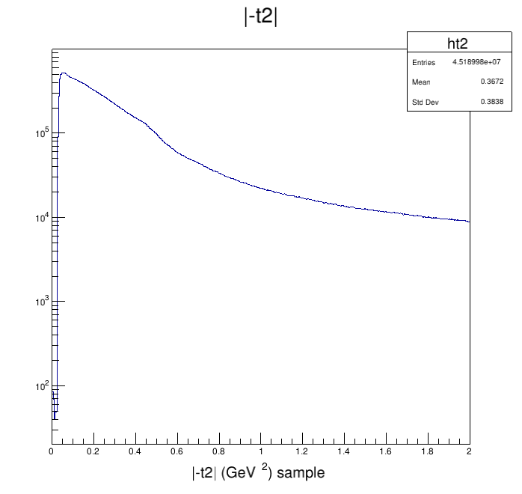

Figure 1: 4-momentum transfer squared for the protons left and right

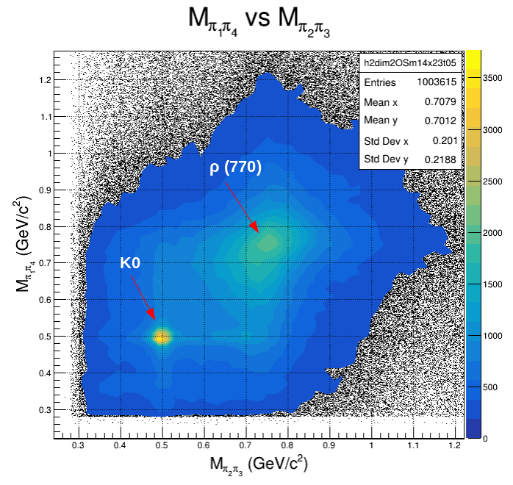

Figure 2: Pion pair scatter plot – full 2018 data

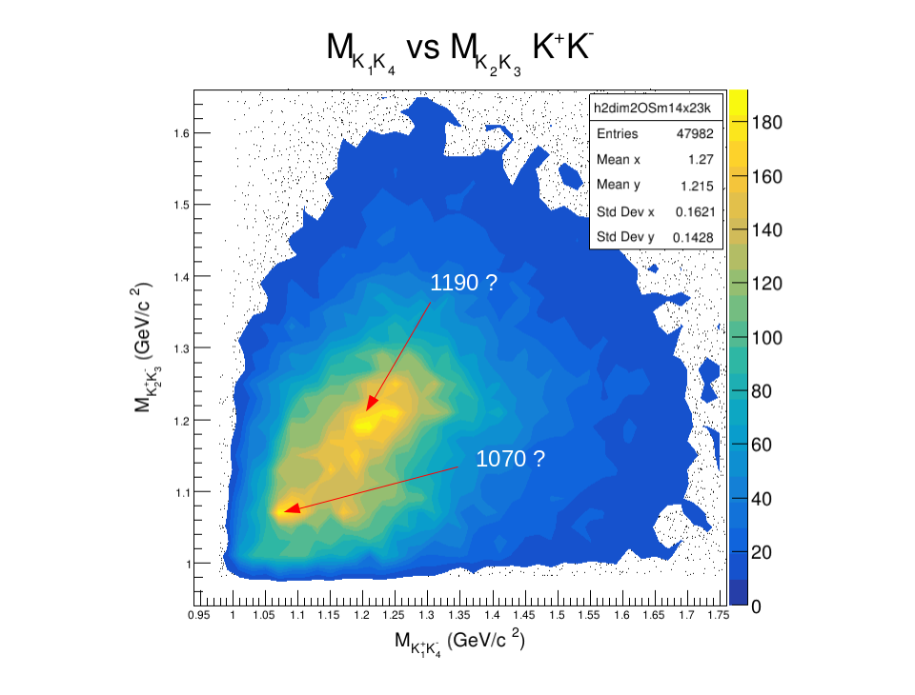

Figure 3: Kaon pair scatter plot – small sample, no PID; notice that
we do not see ϕ(1020)ϕ(1020) events, but they ought to be present;
perhaps we need more statistic
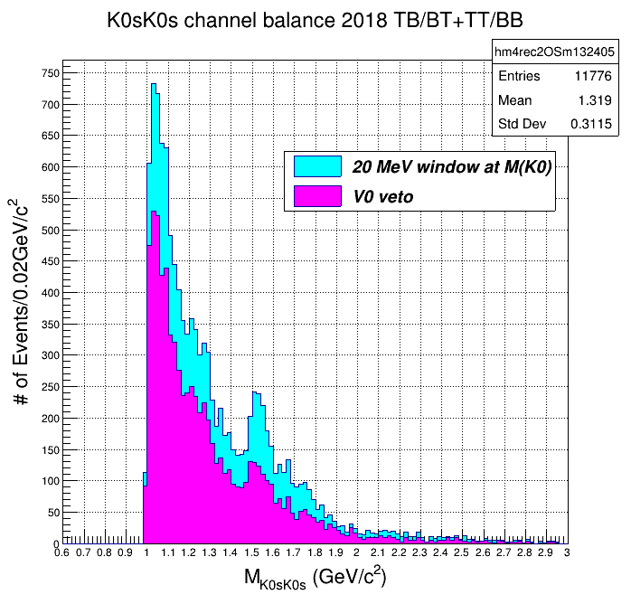

Figure 4: 1540 MeV signal observed on the K0sK0s channel via 20MeV window at M(K0);
V0 veto filters events that are not present in the Kalman’s K0s collection

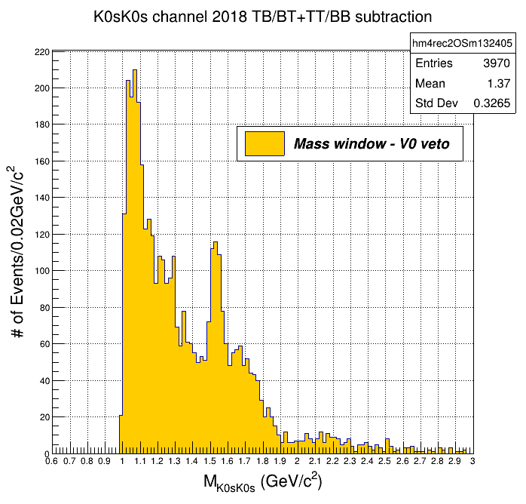

Figure 5: Subtracting the magenta from the cyan events in the previous figure,
we have a set related to the secondary vertices only

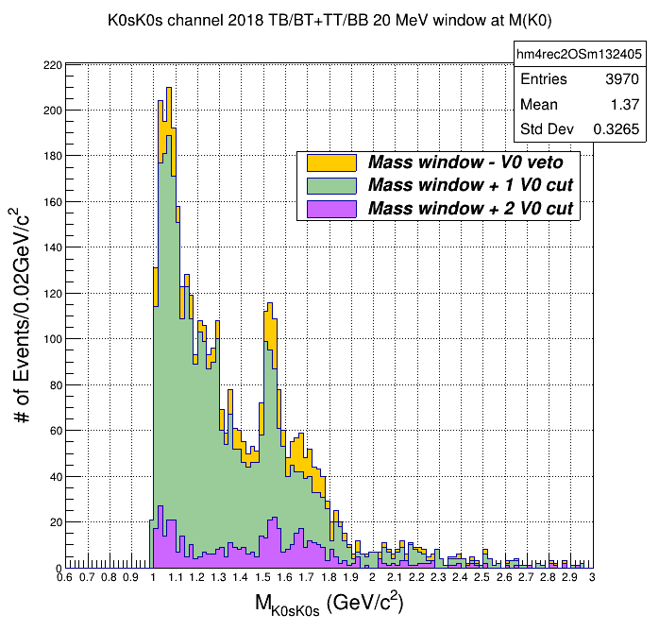

Figure 6: Comparison of 2V0 and 1V0 events present in the yellow set (fig.5)

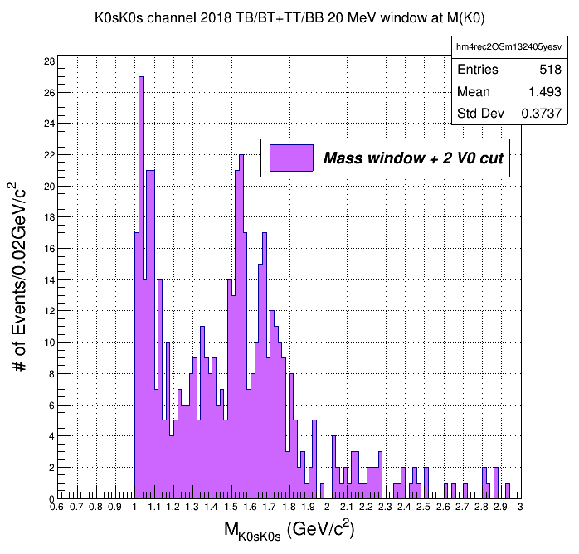

Figure 7: Actual K0sK0s mass distribution produced via the mass window technique;
the shape of the structure is similar to that one obtained from the Kalman filter (fig.8)

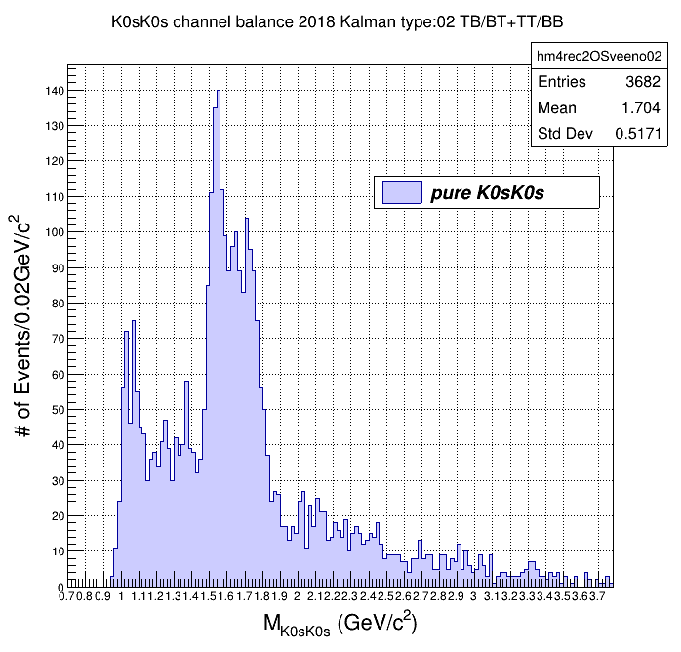

Figure 8: M(K0sK0s) distribution via Kalman filter – full 2018 data;
there is a signal around 1 GeV; could it be ϕ(1020)?

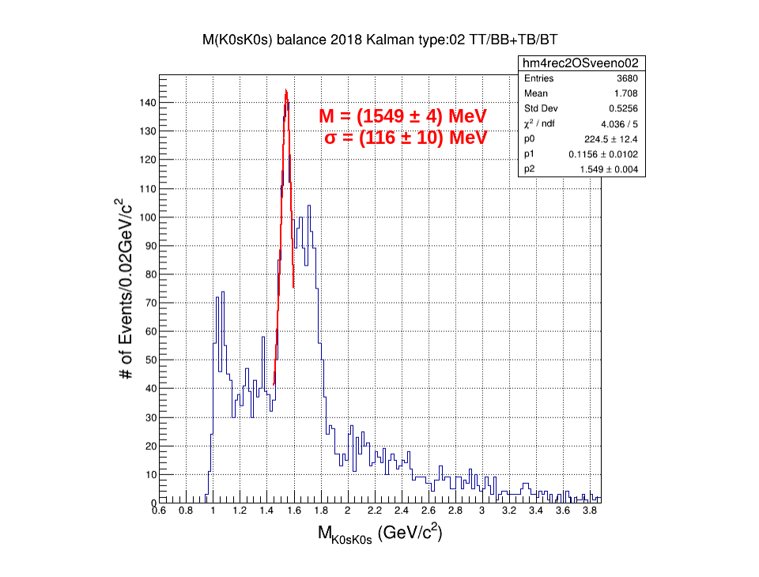

Figure 9: Breit-Wigner fit for the 1549 MeV signal on the K0sK0s channel

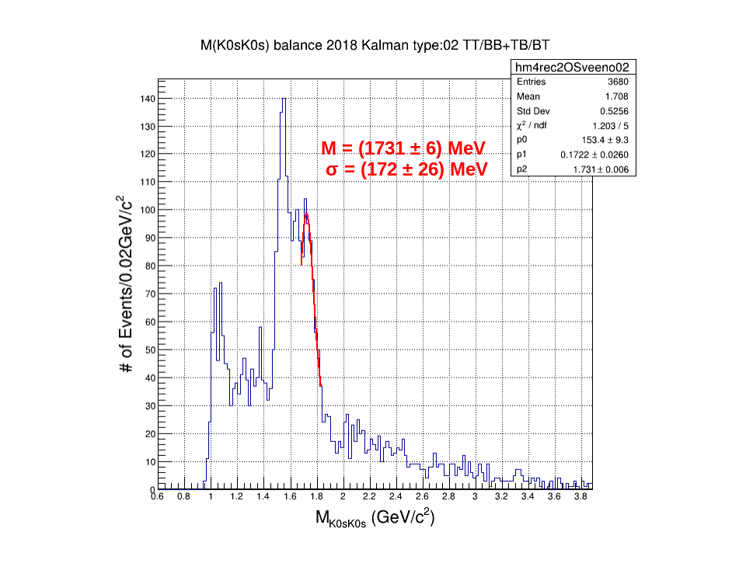

Figure 10: Breit-Wigner fit for the 1731 MeV signal on the K0sK0s channel

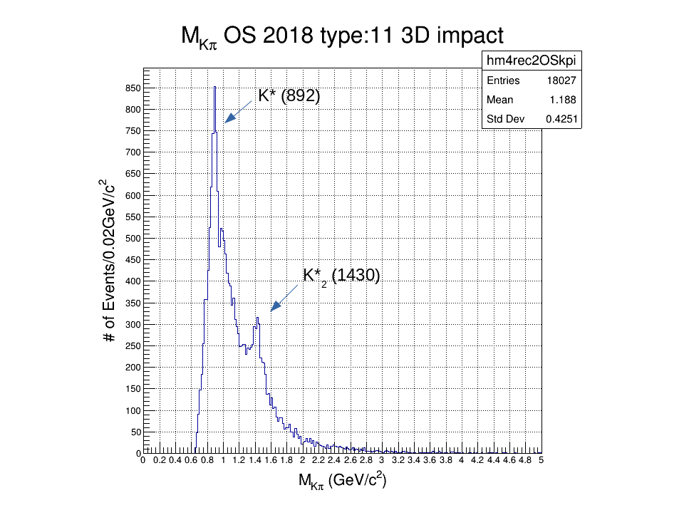

Figure 11: One primary and one secondary vertex, K*-–>K+pi- or K*-–>K-pi+ events

