flex-direction
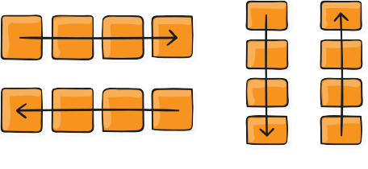
This establishes the main-axis, thus defining the direction flex items are placed in the flex container. Flexbox is (aside from optional wrapping) a single-direction layout concept. Think of flex items as primarily laying out either in horizontal rows or vertical columns.
.container {
flex-direction: row | row-reverse | column | column-reverse;
}
- row (default): left to right in ltr; right to left in rtl
- row-reverse: right to left in ltr; left to right in rtl
- column: same as row but top to bottom
- column-reverse: same as row-reverse but bottom to top

