Mean Absolute Error (MAE): MAE measures the average magnitude of the errors in a set of predictions, without considering their direction. It’s the average over the test sample of the absolute differences between prediction and actual observation where all individual differences have equal weight.

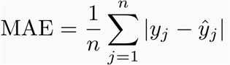

Root mean squared error (RMSE): RMSE is a quadratic scoring rule that also measures the average magnitude of the error. It’s the square root of the average of squared differences between prediction and actual observation.

