Sample Outputs: 06_analysis.sql

Results from running each query in MySQL Workbench. Included encounters only(exclusion_reason IS NULL).

Q1. Baseline
encounters | readmissions | rate_pct | unique_patients
99,343 | 11,314 | 11.39 | 69,990

SQL:

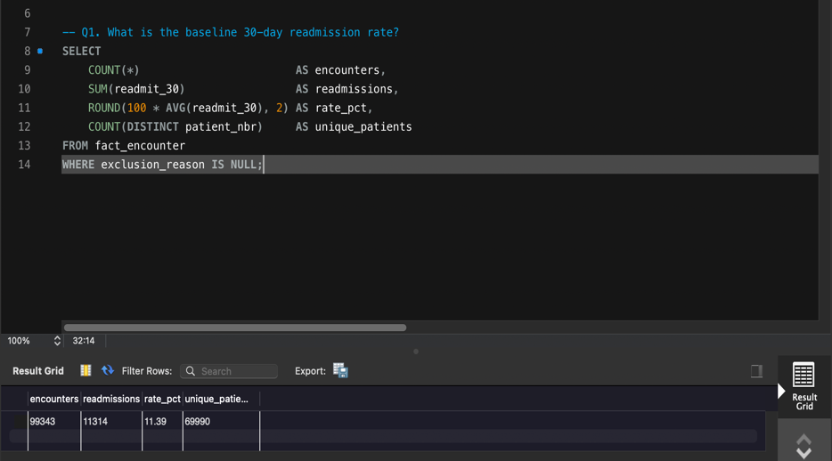

Q2. Are the same patients coming back? (CTE + window function)
patient_group | patients | pct_of_patients | readmissions | pct_of_readmissions
1 encounter | 53,649 | 76.7 | 2,287 | 20.2
2 encounters | 10,218 | 14.6 | 3,108 | 27.5
3 to 4 encounters | 4,587 | 6.6 | 3,046 | 26.9
5 or more encounters | 1,536 | 2.2 | 2,873 | 25.4

SQL:

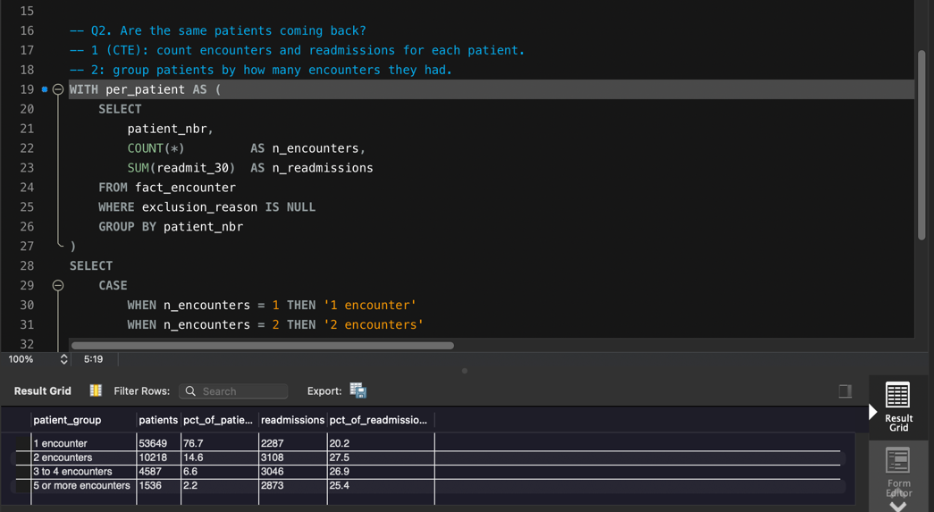

Q3. Prior inpatient visits
prior_inpatient_band | encounters | readmissions | rate_pct
0 | 66,245 | 5,690 | 8.6
1 | 18,984 | 2,516 | 13.3
2 | 7,300 | 1,309 | 17.9
3 | 3,271 | 688 | 21.0
4 | 1,574 | 380 | 24.1
5 | 791 | 253 | 32.0
6+ | 1,178 | 478 | 40.6

SQL:

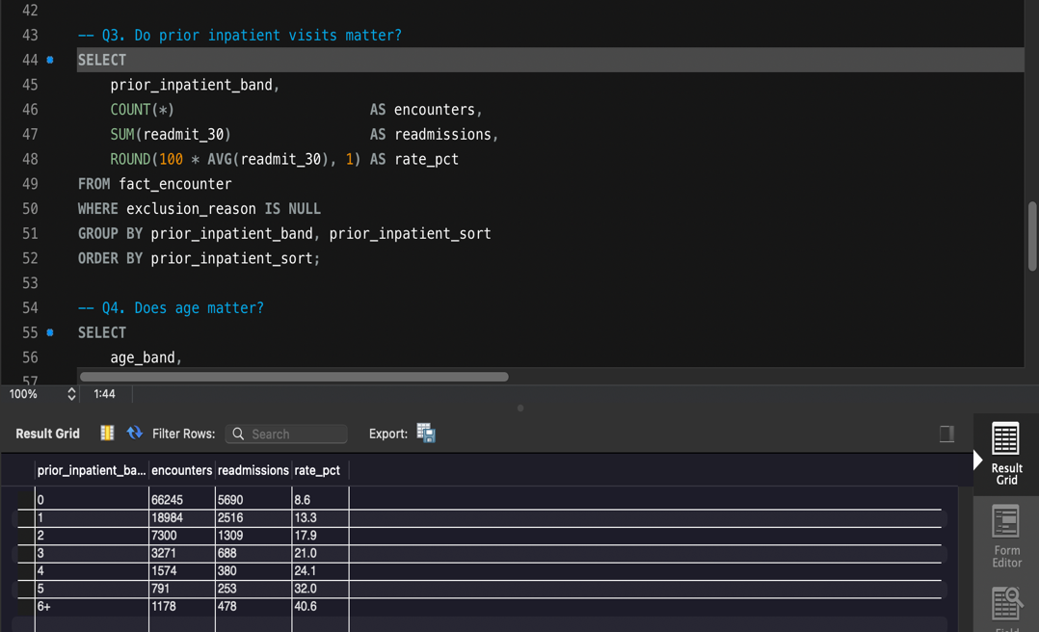

Q4. Age
age_band | encounters | readmissions | rate_pct
0-9 | 160 | 3 | 1.9
10-19 | 690 | 40 | 5.8
20-29 | 1,649 | 236 | 14.3
30-39 | 3,764 | 424 | 11.3
40-49 | 9,607 | 1,024 | 10.7
50-59 | 17,060 | 1,667 | 9.8
60-69 | 22,059 | 2,493 | 11.3
70-79 | 25,331 | 3,054 | 12.1
80-89 | 16,434 | 2,065 | 12.6
90-99 | 2,589 | 308 | 11.9

SQL:

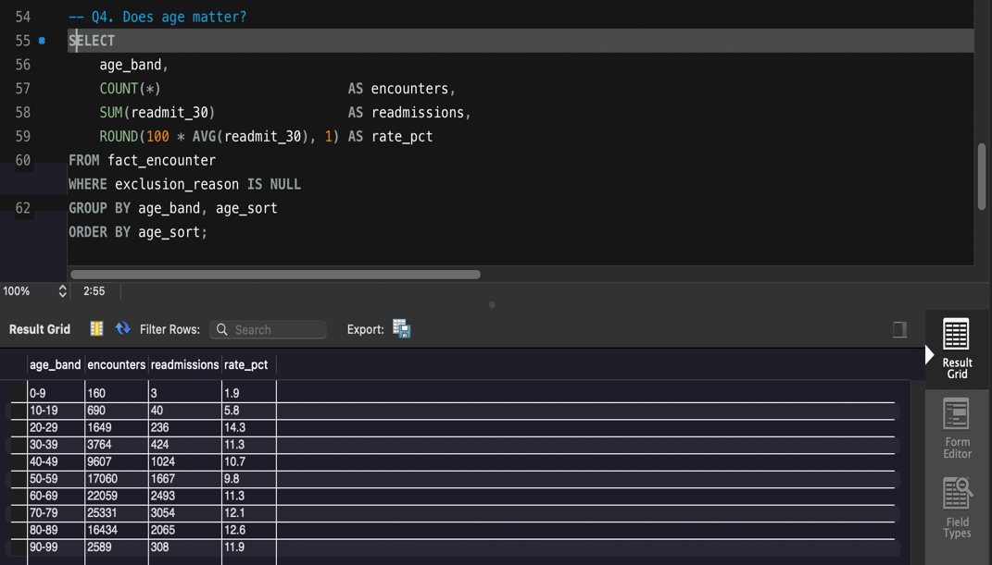

Q5. Primary diagnosis group
diag_group | encounters | readmissions | rate_pct
Diabetes | 8,661 | 1,135 | 13.1
Injury | 6,853 | 850 | 12.4
Circulatory | 29,681 | 3,469 | 11.7
Other | 17,813 | 2,084 | 11.7
Genitourinary | 5,002 | 552 | 11.0
Neoplasms | 3,131 | 341 | 10.9
Digestive | 9,333 | 1,010 | 10.8
Respiratory | 13,934 | 1,402 | 10.1
Musculoskeletal | 4,935 | 471 | 9.5

SQL:

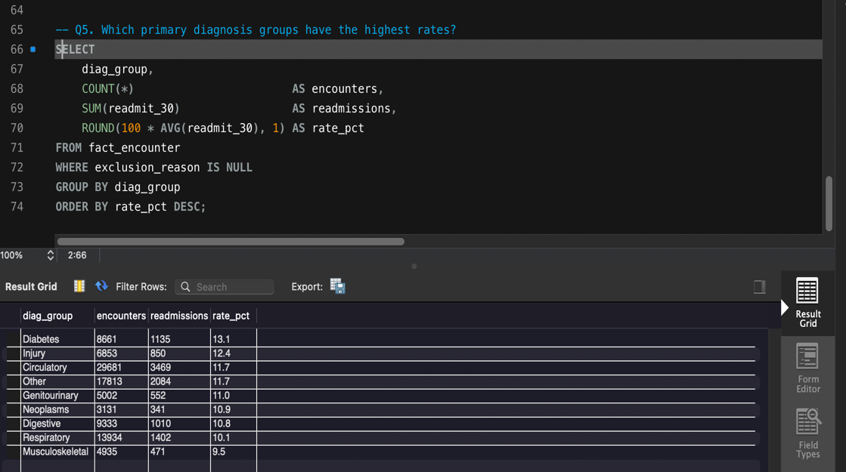

Q6. Admission type (JOIN + COALESCE)
admission_type | encounters | readmissions | rate_pct
Emergency | 52,371 | 6,194 | 11.8
Elective | 18,668 | 1,958 | 10.5
Urgent | 18,132 | 2,058 | 11.4
Not recorded | 5,207 | 583 | 11.2
Not Available | 4,617 | 493 | 10.7
Not Mapped | 320 | 27 | 8.4
Trauma Center | 18 | 0 | 0.0
Newborn | 10 | 1 | 10.0

SQL:

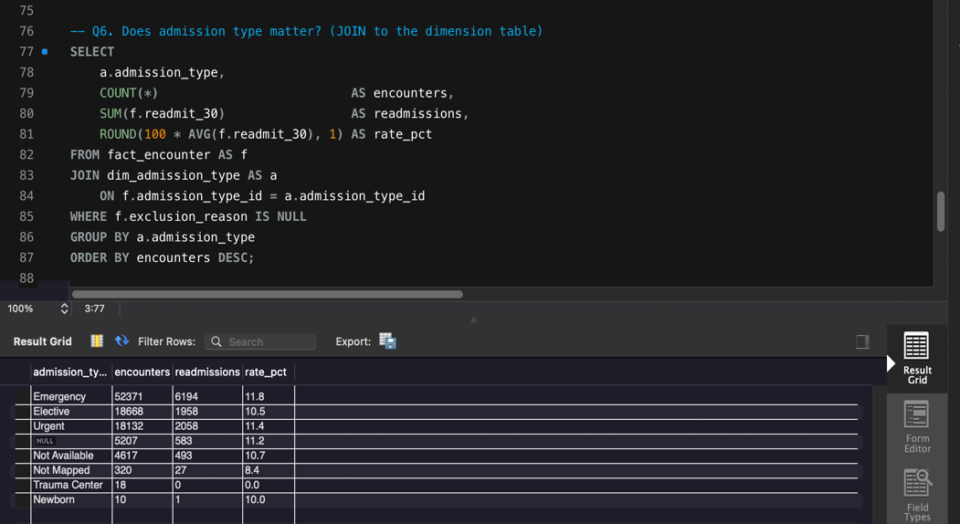

Q7. Discharge destination (CASE)
discharge_group | encounters | readmissions | rate_pct
Transferred to other care | 6,902 | 1,380 | 20.0
Nursing facility | 14,002 | 2,053 | 14.7
Left against advice | 623 | 90 | 14.4
Home with health service | 12,902 | 1,638 | 12.7
Not recorded | 4,680 | 551 | 11.8
Home | 60,234 | 5,602 | 9.3

SQL:

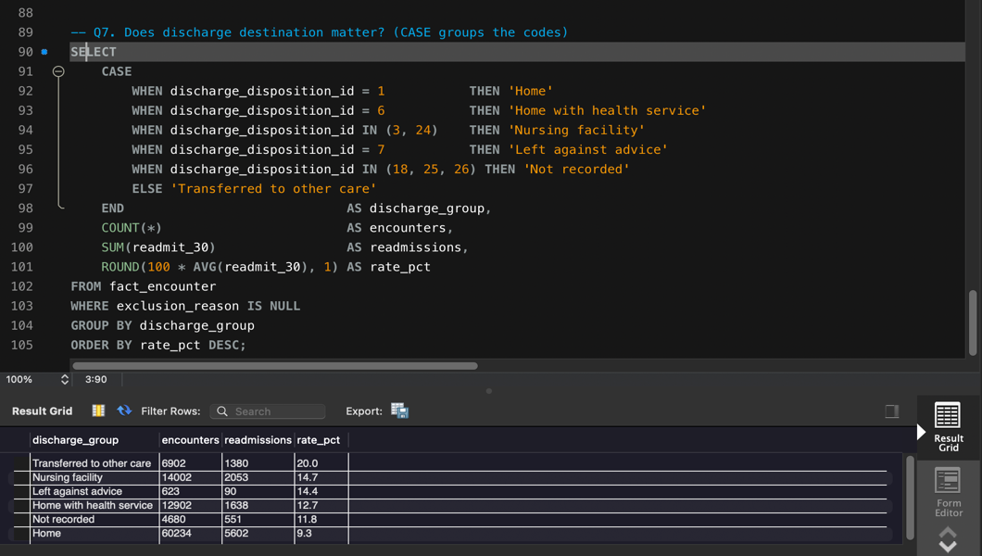

Q8. Medication count
med_band | encounters | readmissions | rate_pct
1-10 | 25,312 | 2,332 | 9.2
11-15 | 28,846 | 3,195 | 11.1
16-20 | 22,096 | 2,743 | 12.4
21-30 | 18,078 | 2,394 | 13.2
31+ | 5,011 | 650 | 13.0

SQL:

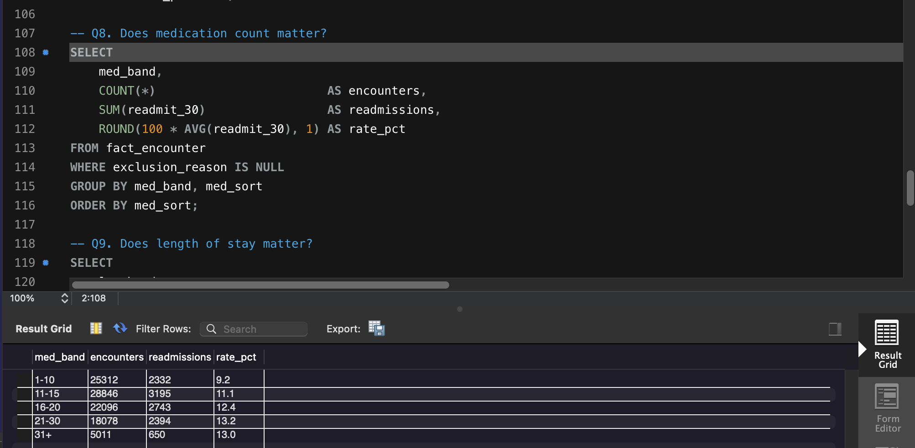

Q9. Length of stay
los_band | encounters | readmissions | rate_pct
1-2 days | 30,715 | 2,864 | 9.3
3-4 days | 31,116 | 3,524 | 11.3
5-7 days | 22,800 | 2,889 | 12.7
8-14 days | 14,712 | 2,037 | 13.8

SQL:

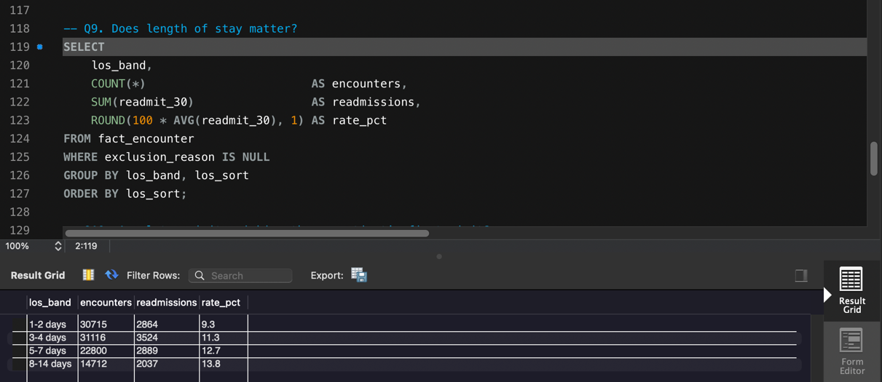

Q10. Visit order (ROW_NUMBER, encounter_id as a date substitute)
visit_order | encounters | readmissions | rate_pct
1st visit | 69,990 | 6,285 | 9.0
2nd visit | 16,341 | 2,314 | 14.2
3rd visit or later | 13,012 | 2,715 | 20.9

SQL:
