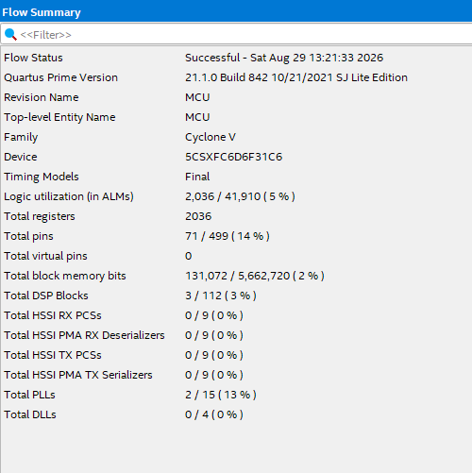
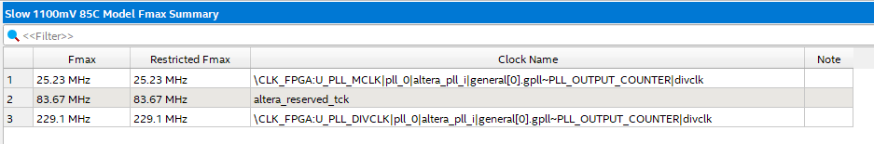
Critical Path:
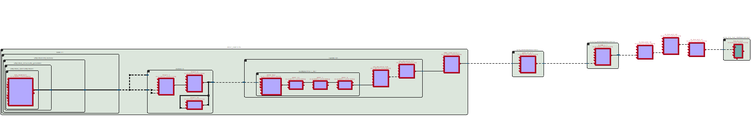
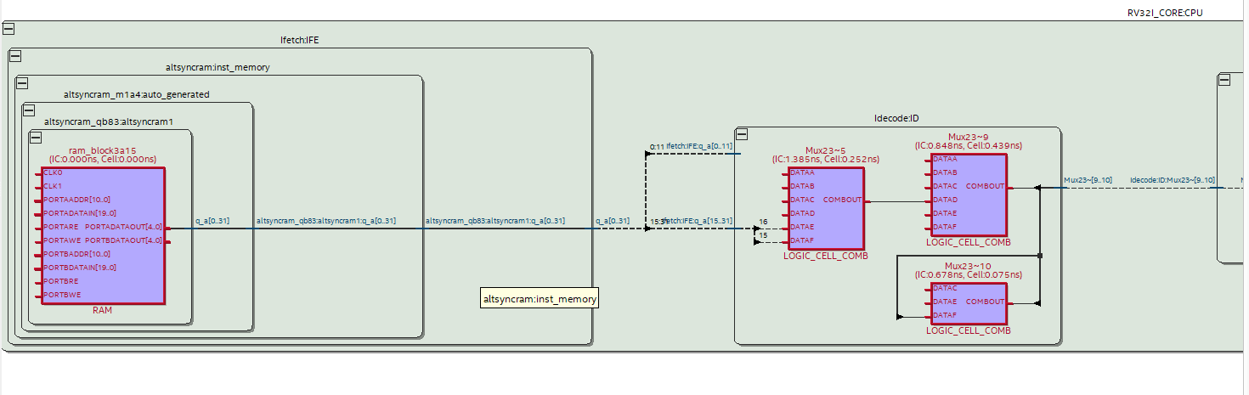
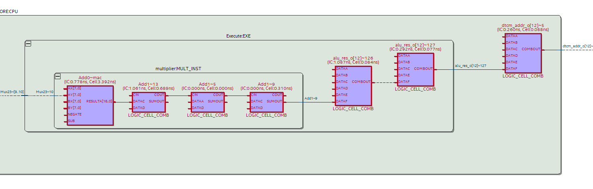
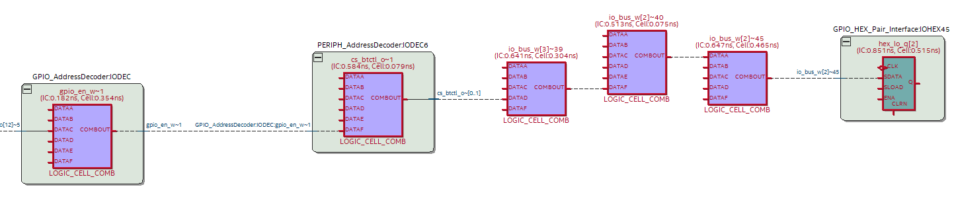
Signal Tap:
Test1
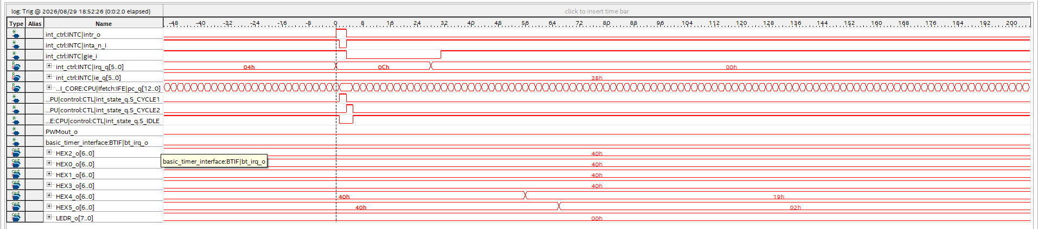
Test2
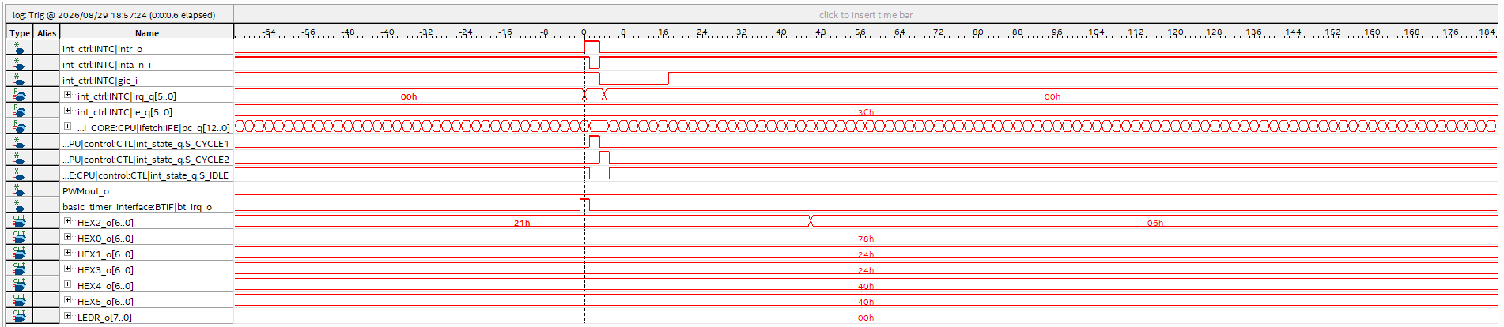
Test3
