ESPnet Hebrew ASR Experiments
Fine-Tuning, Decoding, Results and Discussion

1. Experimental structure
The project separates model training from evaluation. The pretrained XLS-R 300M frontend is fine-tuned on the Hebrew Campus training split. The Hebrew Campus dev split is used as validation data during training. The custom my_test set is used afterward for decoding experiments and does not update model parameters.

2. Common model and data setup
- Training data: hebrew_campus_subset/data/train.
- Validation data: hebrew_campus_subset/data/dev.
- Frontend: S3PRL XLS-R 300M at 16 kHz.
- Preencoder: linear, 1024 -> 256.
- Encoder: 4-block Transformer, output size 256, 4 attention heads, 1024 linear units.
- Decoder: 2-block Transformer, 4 attention heads, 1024 linear units.
- Tokenization: Hebrew character tokens.
- Optimizer: AdamW with weight decay 0.01.
- Batch size: 1 with gradient accumulation of 8; mixed precision enabled.

3. Fine-tuning experiments: what changed
Experiment | Max epochs | Patience | Learning rate | Training CTC weight | Observed epochs
hebrew_xlsr_finetune | 10 | 3 | 1e-5 | 0.5 | 10
hebrew_xlsr_finetune_30ep | 30 | 7 | 1e-5 | 0.5 | 20
hebrew_xlsr_finetune_lr5e5 | 30 | 7 | 5e-5 | 0.5 | 16
hebrew_xlsr_finetune_lr5e5_ctc03 | 30 | 7 | 5e-5 | 0.3 | 30
The progression was controlled: first increase the training horizon, then increase the learning rate, then reduce the training CTC weight from 0.5 to 0.3 so the attention objective receives relatively more influence during training.

4. Note about the lr5e5_ctc03 TensorBoard logs
The TensorBoard directory contains logs from two training sessions with the same lr5e5_ctc03 configuration. These are not two different experiments. For the figures and comparisons in this report, only the later/final session is used. The checkpoint files in the experiment directory show that the final training state selected epoch 29 as both valid.loss.best.pth and valid.acc.best.pth, while latest.pth points to epoch 30.

5. Fine-tuning results from validation data
Run | Epochs | Best valid loss | Best valid acc | Best CTC CER | Best att. CER | Best att. WER
finetune (10 ep) | 10 | 105.032 (ep 10) | 0.249 (ep 9) | 0.230 (ep 10) | 0.756 (ep 5) | 1.405 (ep 2)
finetune_30ep | 20 | 102.609 (ep 12) | 0.251 (ep 18) | 0.166 (ep 20) | 0.753 (ep 5) | 1.404 (ep 20)
finetune_lr5e5 | 16 | 94.269 (ep 8) | 0.324 (ep 16) | 0.107 (ep 15) | 0.733 (ep 16) | 1.212 (ep 13)
finetune_lr5e5_ctc03 | 30 | 65.677 (ep 29) | 0.674 (ep 29) | 0.085 (ep 29) | 0.390 (ep 29) | 0.849 (ep 29)
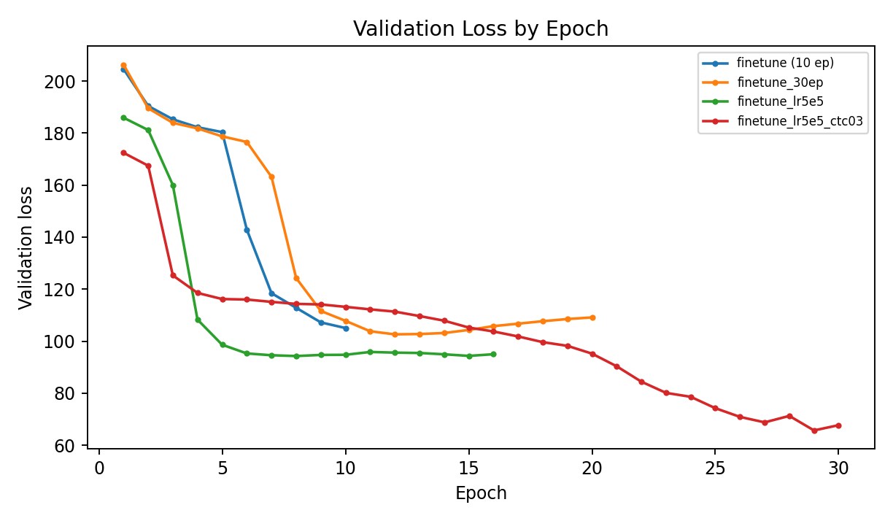
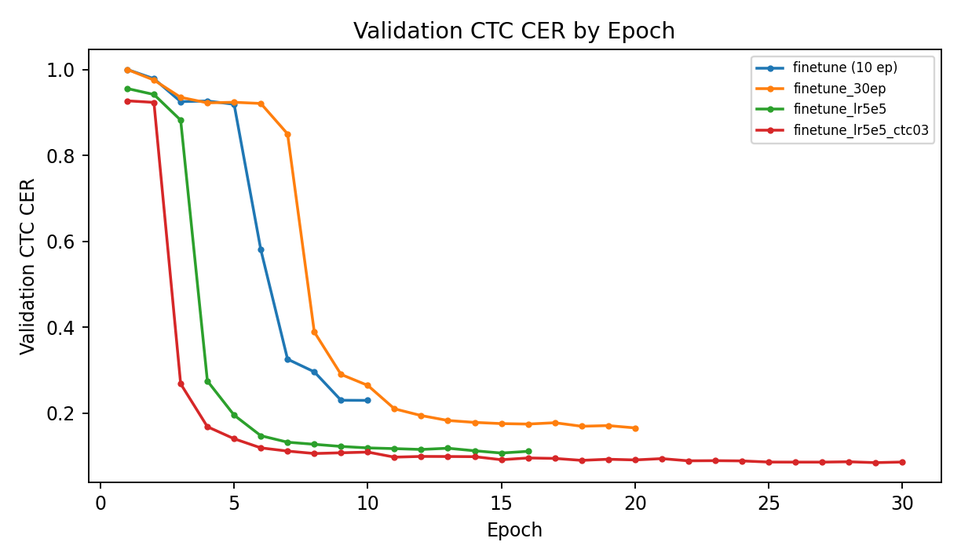

6. Fine-tuning experiment discussion

6.1 hebrew_xlsr_finetune: initial 10-epoch run
This run used lr=1e-5 and training ctc_weight=0.5. Validation loss continued falling through epoch 10, reaching 105.032, while CTC CER improved strongly to 0.230. The attention-side CER remained around 0.76 and WER remained above 1.4. The CTC branch therefore learned useful acoustic/alignment behavior much faster than the attention branch. Because the run ended at its configured maximum while validation loss was still decreasing, extending the training horizon was a reasonable next experiment.

6.2 hebrew_xlsr_finetune_30ep: longer training
The main change was extending max_epoch from 10 to 30 and patience from 3 to 7. Training stopped after 20 epochs. Validation loss reached its minimum at epoch 12 (102.609), then increased, while CTC CER continued improving to 0.166 by epoch 20. The attention CER stayed near 0.75-0.77. This showed that simply training longer mainly strengthened CTC and did not solve the weak attention decoder.

6.3 hebrew_xlsr_finetune_lr5e5: higher learning rate
The learning rate was increased from 1e-5 to 5e-5 while ctc_weight remained 0.5. The best validation loss, 94.269, was reached at epoch 8, and training stopped at epoch 16. CTC CER improved to 0.107, validation attention accuracy reached 0.324, and attention CER improved to 0.733. The higher learning rate therefore accelerated optimization and modestly improved the attention branch.

6.4 hebrew_xlsr_finetune_lr5e5_ctc03: lower training CTC weight
This experiment kept lr=5e-5 but changed the training ctc_weight from 0.5 to 0.3, giving relatively more weight to the attention loss. In the final training session, validation loss reached 65.677 at epoch 29, validation accuracy reached 0.674, attention CER reached 0.390, attention WER reached 0.849, and CTC CER reached 0.085. Epoch 29 was selected as both the best validation-loss and best validation-accuracy checkpoint. This was the first configuration in the sequence where both the CTC and attention branches became substantially useful.

7. What the training sequence demonstrates
- Extending training alone improved CTC but left the attention decoder almost unchanged.
- Increasing the learning rate from 1e-5 to 5e-5 improved convergence speed and modestly improved the attention branch.
- Reducing the training CTC weight from 0.5 to 0.3 coincided with a large improvement in attention accuracy, CER and WER while preserving strong CTC CER.
- The final configuration therefore produced a more balanced CTC-attention model, making it a better candidate for hybrid decoding.

8. my_test decoding experiments
# | Decode experiment | CER | WER | CER no spaces
1 | decode_my_test_ctc | 0.246 | 0.854 | 0.246
2 | decode_my_test_ctc03 | 0.409 | 1.415 | 0.379
3 | decode_my_test_ctc05 | 0.313 | 1.037 | 0.315
4 | decode_my_test_ctc07 | 0.299 | 0.967 | 0.303
5 | decode_my_test_ctc09 | 0.301 | 0.951 | 0.303
6 | decode_my_test_ctc08 | 0.301 | 0.967 | 0.303
7 | decode_my_test_att | 4.894 | 13.862 | 3.034
8 | decode_my_test_hybrid03_lr5e5_ctc03 | 0.162 | 0.573 | 0.162

9. Discussion of my_test decoding
The initial CTC result (CER 0.246, WER 0.854) was the strongest of the early runs. Lower CTC contributions performed worse, while the 0.7-0.9 region was more stable but still did not beat the pure-CTC baseline. Attention-only decoding failed severely (CER 4.894, WER 13.862), which is consistent with the validation evidence that the early attention branch was poorly trained.
The final hybrid experiment using the later lr5e5_ctc03 training configuration achieved CER 0.162 and WER 0.573. Relative to the first CTC baseline, this is about a 34.1% relative CER reduction and a 32.9% relative WER reduction. Both the training configuration and the decoding configuration changed, so the gain should not be attributed to hybrid decoding alone.

10. Training CTC weight versus decoding CTC weight
These are different parameters. The training ctc_weight in model_conf controls how CTC loss and attention loss are combined while model parameters are learned. The decoding --ctc_weight controls how CTC and attention scores are combined during beam search after training. The lr5e5_ctc03 model used training ctc_weight=0.3; the decoding weight used in a later decode experiment is a separate setting.

11. Oral-exam explanation
A concise explanation is: 'I began with a joint CTC-attention fine-tuning setup using a 0.5 CTC training weight. The CTC branch improved quickly, but the attention branch remained weak. Extending training mostly improved CTC. I then raised the learning rate to 5e-5, which converged faster and modestly improved both branches. Finally I lowered the training CTC weight to 0.3, giving relatively more influence to the attention objective. The final run selected epoch 29 as the best validation checkpoint and substantially improved attention accuracy, CER and WER while keeping CTC CER low. On my independent my_test set, the final hybrid system reached CER 0.162 and WER 0.573.'

12. Remaining reproducibility detail
The checkpoint directory confirms that epoch 29 was the best validation-loss and validation-accuracy checkpoint for the final lr5e5_ctc03 run. The decode folder itself does not contain the original decoding command, so the exact filename passed to --asr_model_file cannot be proven from the saved decode outputs alone. If the original shell history or decoding command is available, it can confirm whether valid.loss.best.pth, 29epoch.pth, or an averaged checkpoint was loaded.

