Ori Terletski

G23028954

Homework 4

https://github.com/OriTerletski/STATS-2119

import numpy as np #question 1, Creating an array with the array function of numpy.

numbers = np.array([[1, 2, 3, 4], [5, 6, 7, 8], [9, 10, 11, 12]])

numbers

output:

array([[ 1, 2, 3, 4],

[ 5, 6, 7, 8],

[ 9, 10, 11, 12]])

numbers = np.array([[1, 2, 3, 4], [5, 6, 7, 8], [9, 10, 11, 12]]) #I added this to practice the printing as well

for row in numbers:

for column in row:

print(column, end =' ')

print()

output:

1 2 3 4

5 6 7 8

9 10 11 12

import numpy as np #Question 2

X_Points = np.arange (1, 7)

Y_Points = np.arange (5, 11)

print ("The X points are", X_Points)

print ("The Y points are", Y_Points)

output:

The X points are [1 2 3 4 5 6]

The Y points are [ 5 6 7 8 9 10]

import matplotlib.pyplot as plt #Question 3

import numpy as np

X_Points = np.array([1, 6])

Y_Points = np.array([5, 10])

plt.plot(X_Points, Y_Points)

plt.show()

output:

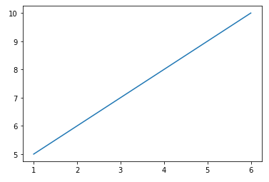

import matplotlib.pyplot as plt #Question 4

import numpy as np

y1 = np.array([1, 2, 3, 4])

y2 = np.array([4, 5, 6, 7])

y3 = np.array([7, 8, 9, 10])

plt.plot(y1)

plt.plot(y2)

plt.plot(y3)

plt.xlabel("X Label")

plt.ylabel("Y Label")

plt.show()

output:

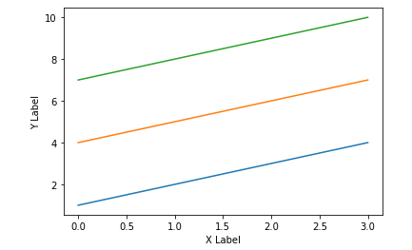

import matplotlib.pyplot as plt #Question 5, creating my own subplot

import numpy as np

x = np.array([7, 10, 4, 1, 10])

y = np.array([45, 1, 8, 34, 4])

plt.subplot(6, 8, 4)

plt.plot(x,y)

x = np.array([9, 21, 43, 2, 2])

y = np.array([1, 32, 24, 47, 7])

plt.subplot(10, 3, 9)

plt.plot(x,y)

x = np.array([25, 21, 10, 3, 2])

y = np.array([1, 5, 9, 2, 4])

plt.subplot(2, 6, 1)

plt.plot(x,y)

plt.show()

output:

