Author: Ori Weiss

Date: 3/15/2018

**Caesar Cipher Trace:**

Key 3,1,7,4,2,5

**Encode (“racecar”)**

Encoded I currentChar Queue nextOffset coded

“” 0 r 3,1,7,4,2,5 - -

“ “ 0 r 1,7,4,2,5,3 3 u

“u” 0 r 1,7,4,2,5,3 3 u

“u” 1 a 1,7,4,2,5,3 3 u

“u” 1 a 7,4,2,5,3,1 1 b

“ub” 1 a 7,4,2,5,3,1 1 b

“ub” 2 c 7,4,2,5,3,1 1 b

“ub” 2 c 4,2,5,3,1,7 7 j

“ubj” 2 c 4,2,5,3,1,7 7 j

“ubj” 3 e 2,5,3,1,7,4 4 i

“ubj” 3 e 2,5,3,1,7,4 4 i

“ubji” 3 e 2,5,3,1,7,4 4 i

“ubji” 4 “ “ 5,3,1,7,4,2 2 “”

“ubji” 4 “ “ 5,3,1,7,4,2 2 “”

“ubji” 4 “ “ 5,3,1,7,4,2 2 “”

“ubji” 5 c 3,1,7,4,2,5 5 h

“ubji” 5 c 3,1,7,4,2,5 5 h

“ubji”h” 5 c 3,1,7,4,2,5 5 h

“ubji”h” 6 a 1,7,4,2,5,3 3 d

“ubji”h” 6 a 1,7,4,2,5,3 3 d

“ubji”hd” 6 a 1,7,4,2,5,3 3 d

“ubji”hd” 7 r 7,4,2,5,3,1 1 s

“ubji”hd” 7 r 7,4,2,5,3,1 1 s

**Decode(“ubji”hds”)**

Encoded I currentChar queue nextOffset coded

 “ “ 0 u 3,1,7,4,2,5 - -

“” 0 u 1,7,4,2,5,3 -3 r

“r” 0 u 1,7,4,2,5,3 -3 r

“r” 1 b 7,4,2,5,3,1 -1 a

“ra” 1 b 7,4,2,5,3,1 -1 a

“ra” 2 j 7,4,2,5,3,1 -1 a

“ra” 2 j 4,2,5,3,1,7 -7 c

“rac” 2 j 4,2,5,3,1,7 -7 c

“rac” 3 I 2,5,3,1,7,4 -4 e

“rac” 3 I 2,5,3,1,7,4 -4 e

“race” 3 I 2,5,3,1,7,4 -4 e

“race” 4 “” 2,5,3,1,7,4 -4 e

“race” 4 “” 5,3,1,7,4,2 -2 “ “

“race ” 5 h 5,3,1,7,4,2 2 “ “

Race c” 5 h 3,1,7,4,2,5 -5 c

Race c 6 d 3,1,7,4,2,5 -5 c

Race ca 6 d 1,7,4,2,5,3 -3 a

Race ca 7 s 1,7,4,2,5,3 -3 q

Race ca 7 s 7,4,2,5,3,1 -1 r

Racecar 8 s 7,4,2,5,3,1 -1 -

**Train Simulation**

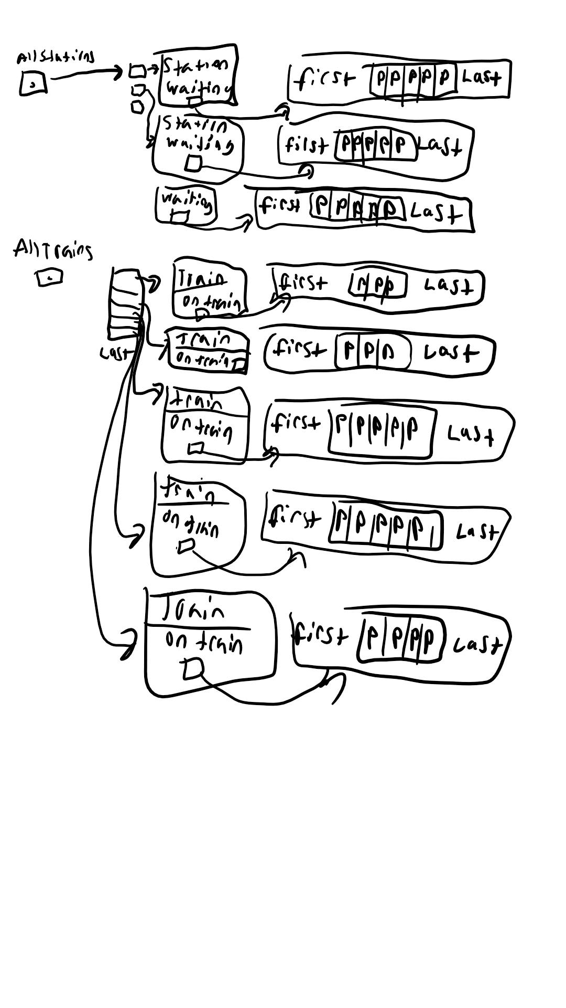

**Job Scheduling Algorithm:**

//create a printing queue

// for the duration of simulation

               //randomly generate a job

               // if there’s no current job and someone is waiting

                              //set someone to current job

                              // remove someone from waiting queue

               //else that is a current job

                              //if currenttime of current job = 0 && queue is !empty

                                             //remove a job from queue and set it to current job

                                             //set current time to TIME SLICE

                              //else queue is empty

                                             //set current job to null

                              //if currenttime > 0

                                             //decrement current time

               //display results