Expression tree:

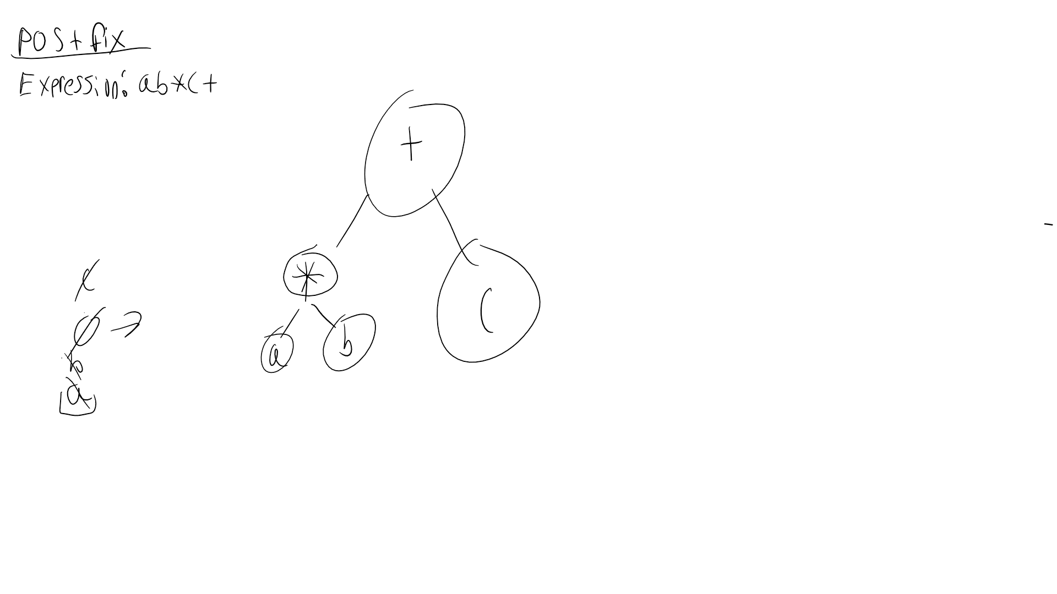

Huffman Code Last Name:

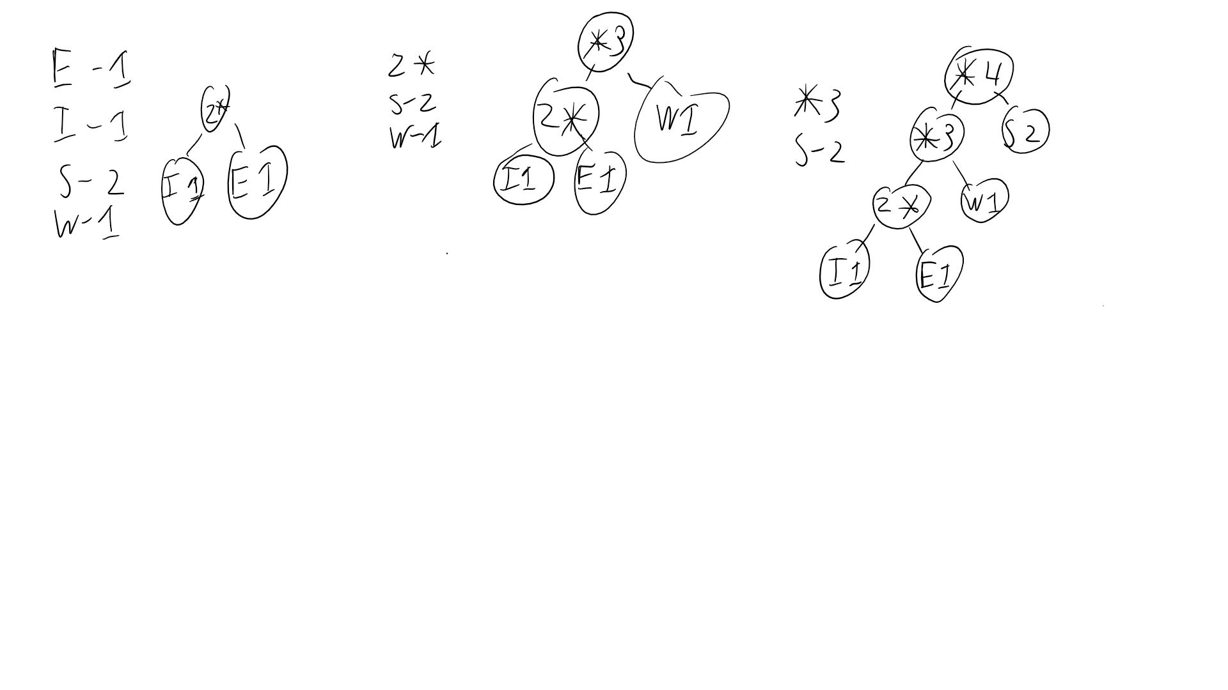

isBST

while(!nodestackIsEmpty or currentNode != null){

while(currentNode != null)

push onto node stack the current node

change current node get left child

if (!nodeStack is empty){

next node = popped node stack

assert nextNode != null

sout nextNode.data

currentNode = nextNode right child

getSmallest(){

create iterator

create smallest variable

while(iterator has next)

if smallest > current node

smallest = current node

iterator.next

buyildBSTfromSortedOrder()

find middle point in array

if right == Left

break

else

attach the point to its parent

left = middle pont/2

right = middle point/2 + middlepoint

buildbst(A,L,M)

builtBST(A,M,R)

prrintBSTInLevelOrder()

while(queue is not empty)

Print root

Queue children

Print the children