בס"ד אורי אשכנזי-205389414
ספיר מדר-207680554
חלק ב
#define _CRT_SECURE_NO_WARNINGS
#include<stdio.h>
#include<stdlib.h>
#include <math.h>

typedef struct Way
{
int Set; // the index int cach
int Tag;

}Way;

typedef struct Command
{
Way way0; //ways
Way way1; //ways
int Priority; // for priority set the Last insert.

}Command;

//functions signture
Command binarytransfer(long long int num, int Tagbit, int Setbit, int Offestbit, int* tmp1, int* tmp2);
void UpdatePrority(Command* Cache, int size);
int Findmax(Command* Cache, int size);
int searchTag(Command* cache, int size, int tag);
int SearchinChace(Command* Cache, int size, int Tag);
void IinitializeP(Command* Cache, int size);

void main(int argc, char** argv)
{
int hits = 0;
int misses = 0;
int Icounter = 0;
int Setbit;
int Tagbit;
int sets;
int index = 0;
int Sizecount = 0;
FILE* fp = fopen(argv[4], "r");
Command temp;
int Offestbit = log(atoi(argv[3])) / log(2);
if (atoi(argv[2]) == 3)
{
Setbit = 0;
Tagbit = 32 - Offestbit;
sets = atoi(argv[1]) / atoi(argv[3]);
}
else
{
Setbit = log(atoi(argv[1]) / (atoi(argv[3]) * atoi(argv[2]))) / log(2);
Tagbit = 32 - (Offestbit + Setbit);
sets = atoi(argv[1]) / (atoi(argv[3]) * atoi(argv[2]));
}
long long int x;
//char c[100];//Array to read from file
int j = 0; // index for the Cache array
int* tmp1 = (int*)malloc(Tagbit * sizeof(int));//array for binary function
int* tmp2 = (int*)malloc(Setbit * sizeof(int));//array for binary function

int* LRU = (int*)calloc(sets, sizeof(int));

if (fp == NULL) {
printf("Error! opening file");
// Program exits if file pointer returns NULL.
exit(1);
}
//Allocate tha Chace Memory
Command* cache = (Command*)malloc(sets * sizeof(Command));
while (!feof(fp))
{
//read from file line by line
if (fscanf(fp, "%lld\n", &x) > 0)
{
Icounter++;
//transfer to binary
temp = binarytransfer(x, Tagbit, Setbit, Offestbit, tmp1, tmp2);
switch (atoi(argv[2]))
{
//One Way
case 1:
if (cache[temp.way0.Set].way0.Tag == temp.way0.Tag)
{
hits++;
}
else
{
misses++;
cache[temp.way0.Set] = temp;
}
break;
// 2 Way
case 2:
if (cache[temp.way0.Set].way0.Tag == temp.way0.Tag)
{
hits++;
LRU[temp.way0.Set] = 0;
}
else if (cache[temp.way0.Set].way1.Tag == temp.way0.Tag)
{
hits++;
LRU[temp.way0.Set] = 1;
}
else
{
misses++;
if (LRU[temp.way0.Set] == 1)
{
cache[temp.way0.Set].way0 = temp.way0;
LRU[temp.way0.Set]--;
}
else
{
cache[temp.way0.Set].way1 = temp.way0;
LRU[temp.way0.Set]++;
}
}
break;
//Fully Associative
default:
int index = SearchinChace(cache, sets, temp.way0.Tag);
IinitializeP(cache, sets);
if (index != -1)
{
hits++;
cache[index].Priority--;
}
else if (index == -1 && Sizecount != sets)
{
misses++;
UpdatePrority(cache, sets);//add prority each command in the cache
cache[Sizecount++] = temp; //find the command most old and replace it;
}
else if (index == -1 && Sizecount == sets)
{
misses++;
cache[Findmax(cache, sets)] = temp; //find the command most old and replace it
UpdatePrority(cache, sets); //add prority each command in the cache
}
break;
}
}
else break;
}
float result = misses / (float)Icounter;
printf("Precentage:%.3f\nHits=%d\nMiss=%d\nInstructions=%d\n", result*100, hits, misses, Icounter);
//free memory
free(tmp1);
free(tmp2);
free(cache);
fclose(fp);

}

int searchTag(Command* cache, int size, int tag)
{
int index = 0;
for (index = 0; index < size; index++)
{
if (cache[index].way0.Tag == tag)
{
return index;
}
}
return 0;
}

// Make it binary number to take the set and offset
Command binarytransfer(long long int num, int Tagbit, int Setbit, int Offestbit, int* tmp1, int* tmp2)
{
long long int y = num;
int size = Tagbit + Setbit;
int power = 0;
Command tmp;
tmp.way0.Set = 0;
tmp.way0.Tag = 0;
tmp.way1.Set = 0;
tmp.way1.Tag = 0;
tmp.Priority = 0;
y = y >> Offestbit;
for (int i = 0; i < Setbit; i++)
{
tmp2[i] = y % 2;
y = y / 2;
}
/*y = y / 2;*/
for (int i = 0; i < Setbit; i++)
{
power = tmp2[i] * pow(2, i);
tmp.way0.Set += power;
tmp.way1.Set += power;

}
for (int i = 0; i < Tagbit; i++)
{
tmp1[i] = y % 2;
y = y / 2;
}
for (int i = 0; i < Tagbit; i++)
{
power = tmp1[i] * pow(2, i);
tmp.way0.Tag += power;
tmp.way1.Tag += power;

}
return tmp;

}

//update Prority in the Cache
void UpdatePrority(Command* Cache, int size)
{
for (int i = 0; i < size; i++)
{
Cache[i].Priority++;
}
}
//find the old command index ( the less use command)
int Findmax(Command* Cache, int size)
{
int max = 0;
for (int i = 0; i < size; i++)
{
if (max < Cache[i].Priority)
max = Cache[i].Priority;
}
return max;
}

//Find int the Cache the command
int SearchinChace(Command* Cache, int size, int Tag)
{
int check = 0;
for (int i = 0; i < size; i++)
{
if(Cache[i].way0.Tag == Tag)
return i;
}
return -1;
}
//Iinitialize Prority
void IinitializeP(Command* Cache, int size)
{
int check = 0;
for (int i = 0; i < size; i++)
{
Cache[i].Priority = 0;
}
}

קונפיגורציה 1 (1024,16)
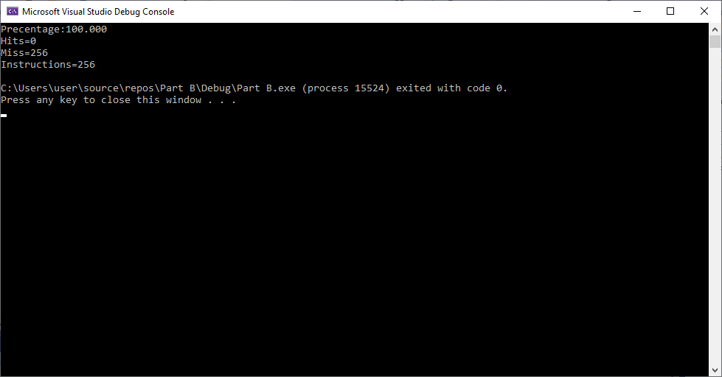

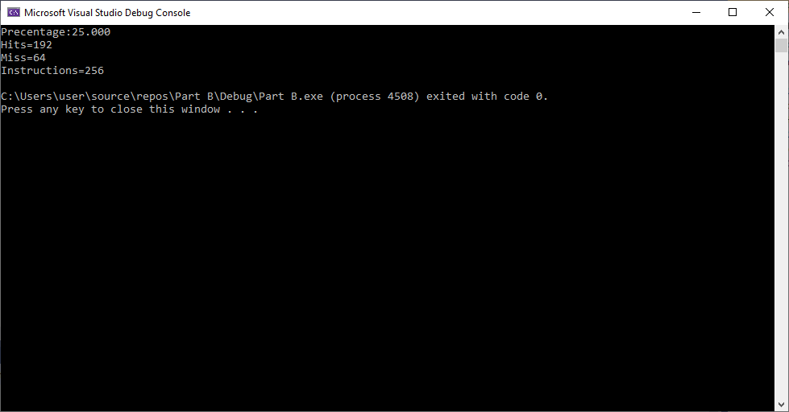

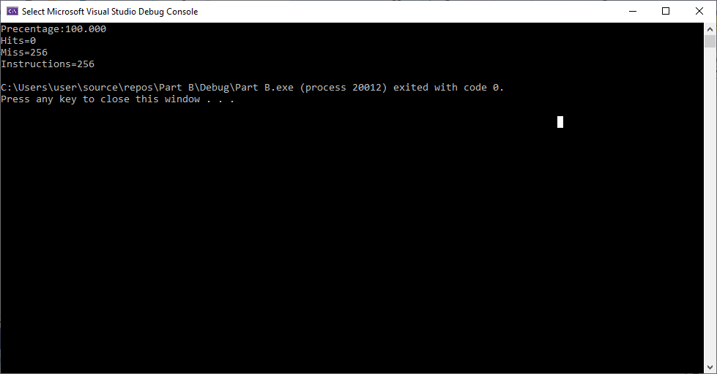

קונפיגורציה 2 (2048,32)

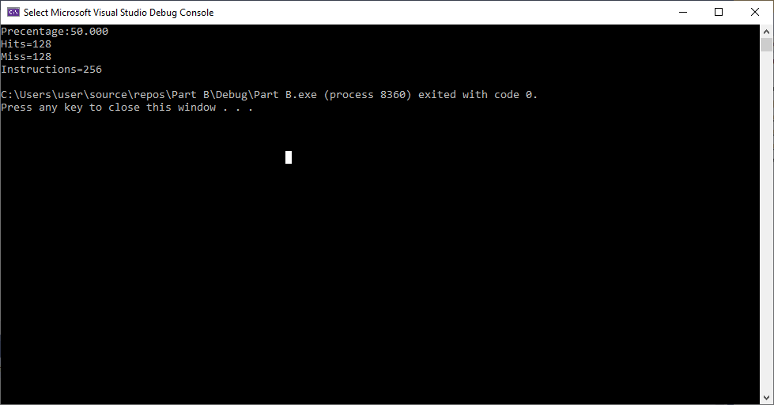

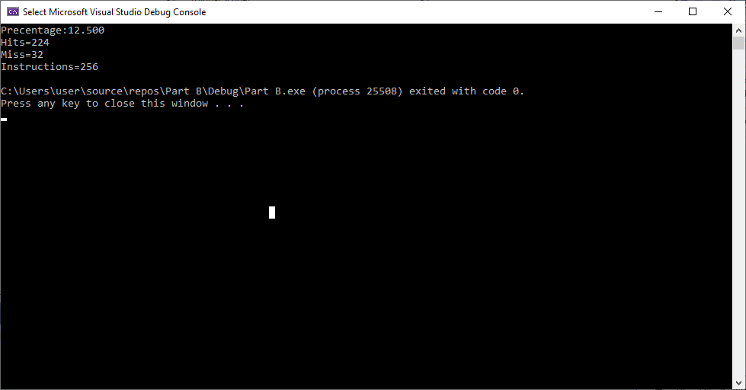

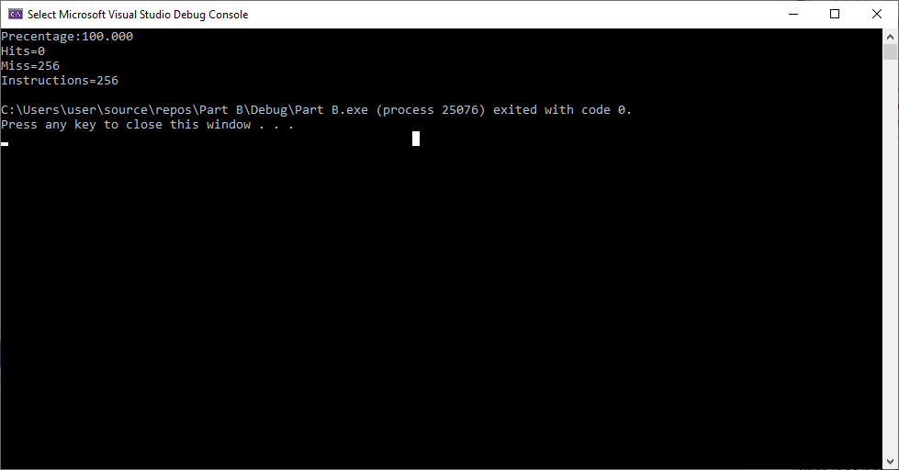

קונפיגורציה 3 (2048,32)

