Question 1:

1. Where is allocated?
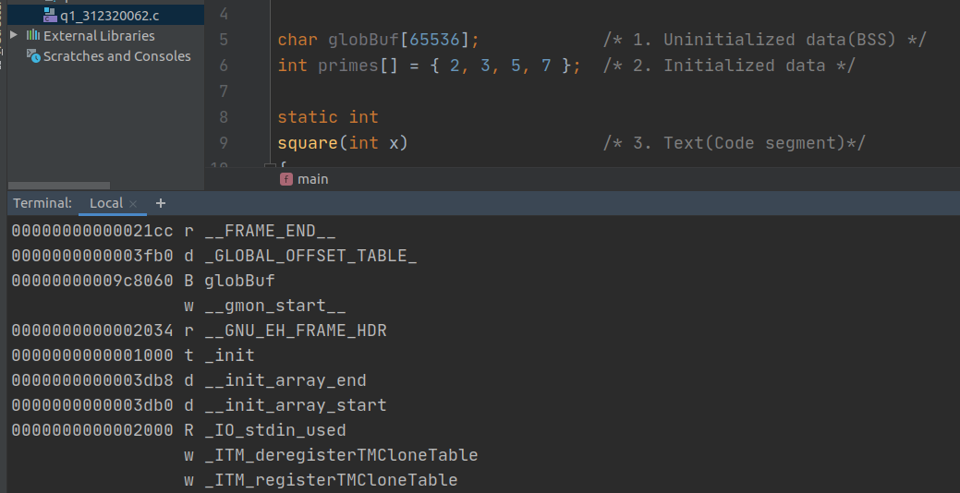
Explanation:
I used the nm command, as we can see globBuf have a symbol type of B which means the globBuf is in Uninitialized data(BSS).
Capital b means that globBuf is global variable.

2. Where is allocated?
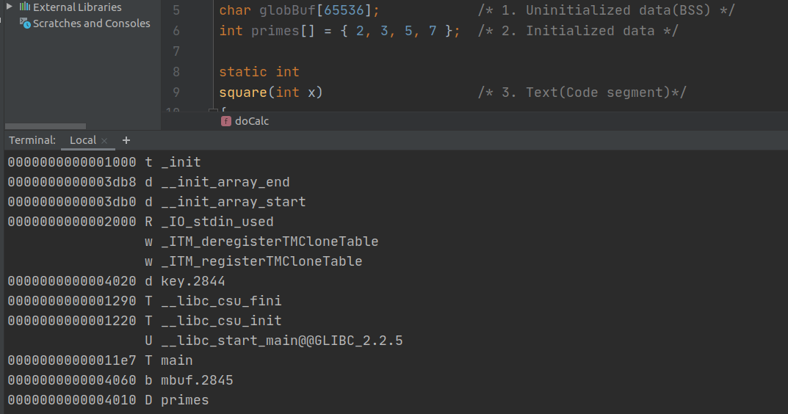
Explanation:
I used the nm command, as we can see primes have symbol type of D , which means that primes is in Initiliazed data.
Capital d means that primes is global variable.

