Question 2.2:
1) Show that server dont get all the signals from the client.

As we can see we sent from the client 1000 signals of SIGINT, but when we sent to the server SIGUSR1 we see that the server got only 487 SIGINT signals.

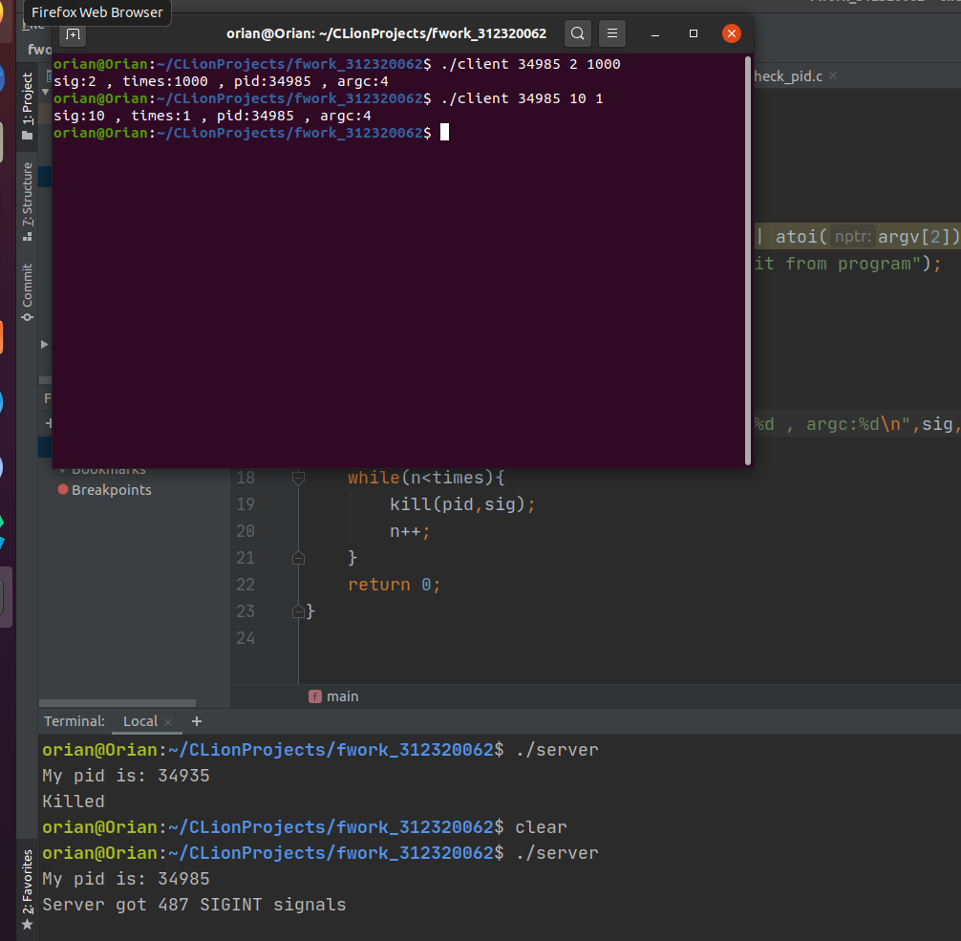

2) Diffrence between Real Time Signals and Signals.

There are few diffrences betweern RT signals and signals,

- More than one RT signal can be queued for the process if it has the signal blocked while someone send it. In standard signals only one of a given type is queued , the rest is ignored.
- Order of delivery of RT signals is guaranteed to be the same as the sending order.
- PID and UID of sending process is written to si_pid and si_uid field of siginfo_t.

