SECUREMIND
Feature Guide
Application overview and feature purposes
Version 1.0 · 29 September 2026
A guide for people who want to understand SecureMind, choose how they use AI, and see how their conversations, models, costs, and sensitive-data findings fit together.
For individual users, project owners, developers, and administrators running their own installation.

1 Purpose and vision
SecureMind brings conversations, documents, and useful context into organized workspaces. Its purpose is to help people use AI with more control over model choice, sensitive information, and estimated cost.
The vision is a personal working space that remains useful as a project develops. It is especially suited to developers and people working on their own projects who want an additional layer of reassurance and transparency around their use of AI.
Model tiers let users reserve more expensive models for more complex questions, while using other models for simpler requests. Memory and Knowledge provide continuity, and Insights makes model usage, estimated costs, and detected sensitive-data concerns visible.
Accessibility also means being able to run your own installation: through Docker on your own machine, or in a cloud environment you configure. Each installation has its own users, settings, and provider connections. SecureMind is not intended to operate one public service holding everyone’s API keys.
An administrator manages provider keys, access, and shared settings. Members use that setup and can have individual estimated spending caps. Stored application data is held within the installation’s environment. Configured external providers can still receive content needed for model responses, transcription, or other processing.

2 How to use this guide
Each section explains what a feature does and why it exists. Start with Workspaces and Chat for everyday use, then explore Knowledge, Memory, Saved, and Insights. Settings and the Admin console explain how the installation is configured and managed.
The Architecture and Technical Guide covers implementation details: processing order, storage, access boundaries, authentication, cost calculations, and the algorithms behind complexity routing.
Guide sections
3 Terms and controls · 4 Connections and credentials · 5 Installation options · 6 Workspaces · 7 Chat · 8 Knowledge · 9 Memory · 10 Saved · 11 Insights · 12 Model settings · 13 Detection policy · 14 My Profile · 15 Appearance · 16 Admin console · 17 Getting started · 18 How the parts fit · 19 Scope and limitations

3 Terms and controls
Term | Meaning
Installation | Your own running copy of SecureMind, with its users, settings, data, and provider connections.
Administrator | Manages accounts, roles, provider connections, detection settings, and estimated spending caps.
Member | Uses the connections and shared settings established by the administrator, without viewing or changing secret keys.
Workspace | Organizes one body of work: its chat, Knowledge, memory, and bookmarks.
Complexity tiers | Max, Plus, Standard, Light, and Micro. Assign a model to each tier. Routing selects a tier for the request.
Fixed model | Use one selected model for replies instead of complexity routing.
Enable | Checks one model that is not in the chat list yet. If it answers, it joins the list.
Test | Runs that same check on a model that is already in the chat list.
Check access | Runs the check once for each listed model on a provider key.
Hide and Show | Hide takes a model off the chat list. Show puts it back. A hidden model can still be the model a tier runs.
Check failed | The last check did not succeed. The label does not explain the cause. Hidden is a separate state.
Provider chip | Shows how many models of that provider, such as Gemini or Anthropic, can be assigned. It is not a request count.
Blue count | How many replies were routed to that tier, for the workspace and date range selected in Insights.
Vendor API key | A provider credential managed by the administrator. Groq and xAI, the provider of Grok, are separate providers.
Cost estimate | An approximate usage cost based on recorded activity and configured provider rates, not an invoice.
Detection | Best-effort identification of sensitive patterns so matched content can be reviewed and redacted.

4 Connections and credentials
Purpose. Connect the model and transcription services available to the installation, with credentials controlled by an administrator.
The administrator adds provider API keys and configures shared connections. Members use those connections without seeing the secret keys or changing them. Vendor keys are stored encrypted. Settings shows a masked hint, not the secret.
Provider connections include Groq, Gemini, OpenAI, Anthropic, and xAI for Grok. Groq and xAI are separate providers.
Amazon Bedrock uses AWS authentication configured for the installation. On a local installation, Bedrock uses the credential chain already on that computer: environment variables, a shared profile or SSO, a container role, or an instance role. SecureMind does not accept pasted AWS access keys. On a cloud installation, Bedrock uses that deployment’s IAM role.
Local Ollama models run through Docker in the local installation. The first boot pulls nomic-embed-text for Knowledge embeddings and llama3.2:3b for local chat. They do not need a vendor API key. Their speed depends on available hardware and may be substantially slower than hosted alternatives. Ollama is not part of the cloud configuration.

Voice transcription
Voice input uses a configured transcription service: Amazon Transcribe or Groq Whisper. The transcript appears in the composer for review before sending. For hosted transcription, audio is sent to the selected service before the resulting text can be scanned.

5 Installation options
Purpose. Let people operate SecureMind in an environment they control.

On your own machine
The local option uses Docker and includes Ollama, as described above. Users can configure external providers when they want hosted models or transcription. Running the application locally does not make external provider calls local.

In your cloud environment
The cloud option runs in the administrator’s own AWS environment. The region is set in the infrastructure configuration. The in-app setup wizard does not ask for a region. Ollama is not part of SecureMind’s cloud configuration. Provider availability and any cross-region processing depend on the services and models configured.
Setup for a local Docker installation and for a deployment in your own AWS account is on the SecureMind website, and linked from the GitHub README.

6 Workspaces
Purpose. Keep the conversations and context for one project or body of work together.
Each workspace contains its own chat, Knowledge, memory, and saved bookmarks. Retrieval stays within the selected workspace. Its name, emoji, and color help you recognize it. They do not select a model or define an AI personality.
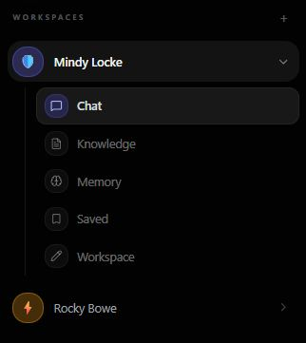
Figure 1. The workspace list. Name, emoji, and color identify it. They do not choose a model.
Switching workspaces opens that workspace’s conversation and context. An unsent queued message is discarded, and the composer is cleared, so the message cannot be delivered into the wrong workspace.

7 Chat
Purpose. Ask questions, review sensitive text, and receive replies using your chosen model configuration.

Review before processing
In the typed-message flow, the draft remains in the browser while detection runs. If sensitive information is detected, the application shows which details will be redacted before the message is processed. The reviewed, redacted text is what continues.
The normal path does not send the original detected value. Detection is best effort: a value that is not detected may remain in the submitted text. A request that skips the browser can also skip this review. The scan is risk reduction, not a guarantee.

Choosing the answering model
Complexity routing selects a tier and calls the model assigned to it. You can assign more expensive models to higher-complexity tiers and use other models for simpler requests. Fixed model uses the single model you select.
The technical guide explains the routing rules, which parts of the conversation influence the decision, and how the application handles an unavailable model. This guide does not restate those rules.

Continuing a conversation
You can type another message while a reply is generating and queue it to send afterward. Stop ends the current response. Attachments remain associated with their queued message.
Documents and images supplied in chat become Knowledge for that workspace and can inform subsequent answers. Replies can cite relevant retrieved sources. A general answer does not imply that a source was used when it was not.
Voice transcription supplies text to the composer using the configured service. Review the transcript, and any detected sensitive information, before sending it.
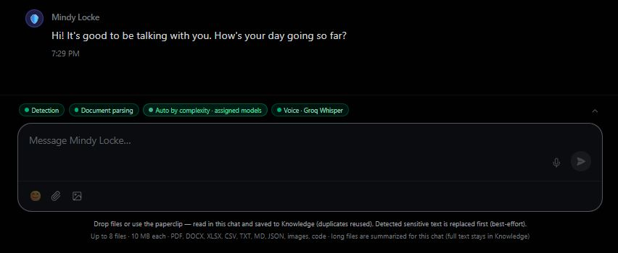
Figure 2. Chat. Status labels sit above the composer. The chevron hides them.

8 Knowledge
Purpose. Let conversations draw on documents and images you provide, with relevant sources available to support answers.
Files uploaded through Knowledge or attached in chat belong to the current workspace. The application extracts usable content, applies sensitive-data detection and redaction to that text, and prepares the redacted text for retrieval.
On a local installation the original file is also stored. Extracted text is scrubbed before it is chunked and embedded. Converting an image to a vector does not make the image safe. The extracted content is redacted before embedding. The hosted data path does not store that original through the same local file step.
When an answer uses retrieved material, it can identify the supporting source or passage. Source references help users inspect the basis of an answer. They do not guarantee that the answer is correct.

9 Memory
Purpose. Show what the application has retained from you, and the context it can use in later conversations.
Memory is a readable view of remembered information and summaries. It makes retained context visible, so later replies are not a guess about what was kept.
Facts come from what you wrote, not from the assistant’s replies. You can correct a fact, pin it, or forget it. Forget hides the fact from later chat and keeps the record so it can be restored. Delete removes the fact. A conversation summary sits alongside the facts.
The vector index used for citations holds document text. It does not hold these fact rows.

10 Saved
Purpose. Bookmark useful places in a long conversation and return to them easily.
Save a message when you want to revisit it. Saved lists those bookmarks. Choosing one returns you to that message in the conversation and highlights it. You can also remove a bookmark.
A bookmark is a navigation aid you curate. It does not become a remembered fact or a Knowledge document.

11 Insights
Purpose. Make model activity, estimated costs, and detected sensitive-data findings visible while you work.
Insights is the right-hand panel beside chat, with Models, Security, and Cost. It is one of SecureMind’s main transparency features. Collapse it when you want more room for the conversation.
Insights follows the workspace you select, and the date range Today, Weekly, Monthly, or All time. Administrator-wide views are available separately through the Admin console.

Models and the full Usage view
Assign a model to each complexity tier, or choose one Fixed model. Provider chips show how many models of that provider can be assigned. The small blue number is the count of replies routed to that tier for the selected workspace and date range.
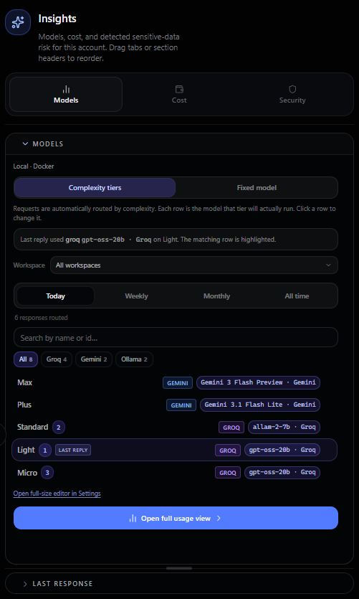
Figure 3. Insights, Models. Each tier shows its model and the blue reply count.
Open the full Usage view for charts and details about input tokens, output tokens, requests by model, routing tiers, citation outcomes, and response times.

Cost
Cost provides an approximate breakdown of model API and Bedrock usage, using recorded activity and provider rates. It is useful for comparing models, observing spending trends, and judging an approximate spending range.
These figures are not billing records. Check the provider’s billing system, or AWS billing for Bedrock, for actual charges. The estimate is not a total cost of ownership for the installation. Local hardware and other infrastructure may cost money outside model usage.
Per-user caps use these estimates as a precaution. When a configured threshold is reached, further billable model calls for that user stop. Ollama calls are not part of that cap. The cap cannot make the provider’s final bill equal the displayed estimate.

Security
Security shows sensitive-data findings for the selected workspace and period. It helps users understand what was detected, where it occurred, and how it was handled. It is not a general vulnerability scanner.
A finding shows the category and what was done with it. It does not show the original sensitive value. A finding can be dismissed or deleted as a log entry. Removing a finding does not restore redacted source content.

12 Model settings
Purpose. Manage connections, available models, transcription, and routing in one place.

Connections
Administrators configure vendor APIs and follow the setup guidance for their keys. In the typed-chat path, detected sensitive text is replaced before the model call. This is best-effort protection. Voice audio and some image processing can leave the installation before that text review.
Amazon Bedrock configuration uses the authentication and region described in section 4. Local installations also expose Ollama. Voice transcription settings select Amazon Transcribe or Groq Whisper and explain when audio leaves the device.

Available models
The available-model list shows the models offered through configured connections. Enable, Test, and Check access are three controls, as defined in section 3. Hide and Show manage the chat list. A hidden model can still be the model a tier runs. Check failed means the last check did not succeed.
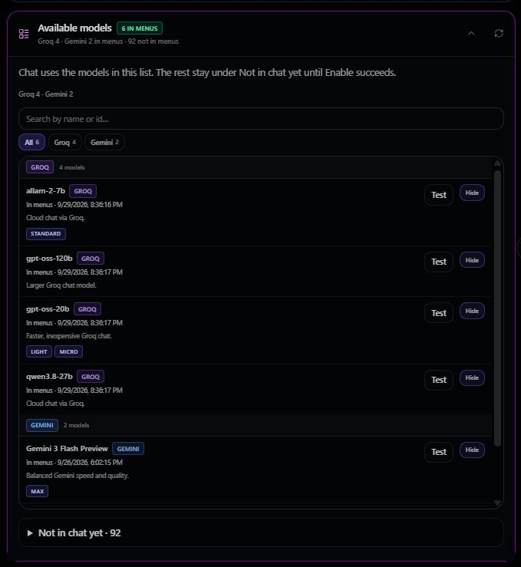
Figure 4. Available models. The models already in chat, each with Test and Hide.

Complexity tiers and Fixed model
The larger tier editor provides the same assignment controls as Insights, with more room to browse and filter models. Assign a model to Max, Plus, Standard, Light, and Micro, or select one Fixed model.

13 Detection policy
Purpose. Set the sensitivity of future sensitive-data detection across the installation.
The administrator manages this policy under Settings, Detection. Balanced is the default and covers the usual pattern families. High adds passport and national-ID patterns that Balanced does not include. Low narrows detection. For example, Low does not include the street-address and IP patterns that Balanced includes.
Changes apply going forward. Switching from Low to High does not rescan or scrub older messages or documents accepted under Low.
Safe terms let an administrator exempt a known non-sensitive value, such as a domain or a literal the installation should keep. Secrets, Social Security numbers, and card numbers cannot be exempted.

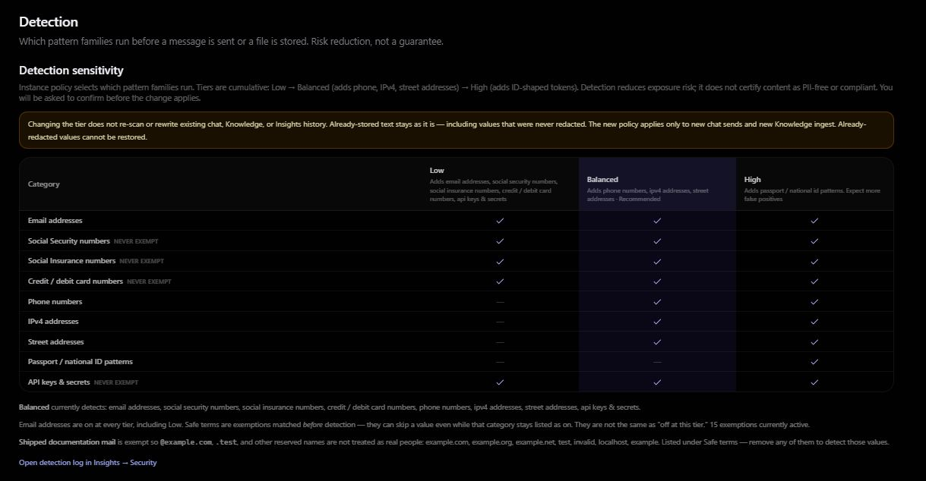
Figure 5. Settings, Detection. Sensitivity

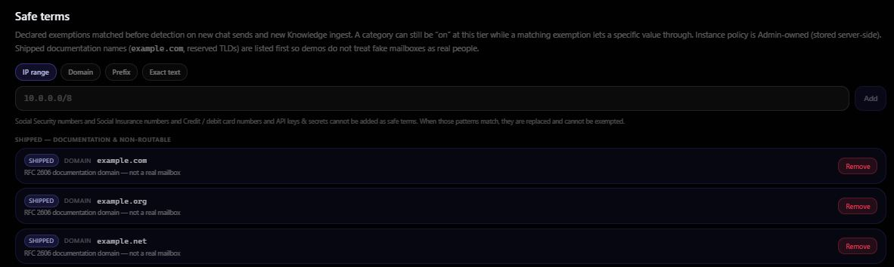
Figure 6. Safe terms

14 My Profile
Purpose. Manage how you are identified in the application and maintain your account details.
My Profile lets you set a profile image, change your display name, and add a description about yourself. The photo is available to a signed-in session. It is not a public link. Where the installation uses its sign-in service, password controls let you change your password.

15 Appearance
Purpose. Choose a comfortable display theme.
Open Settings and choose Appearance to switch between light and dark. The choice is saved on the device. It does not change other users’ screens. Dark is the default until a choice is saved.

16 Admin console
Purpose. Manage the people using the installation and oversee their usage and estimated spending.
Administrators can view users’ email addresses, monthly estimated costs, and Insights for the installation or for one person. They can set a per-user cost cap.
The administrator creates accounts, assigns roles, sets passwords, and can suspend an account. Members use the shared connections and cannot view or change provider secret keys.
Cost caps are precautionary limits based on estimated use. The application blocks covered billable requests when the estimate reaches the cap. Administrators should still review actual charges with the provider. These limits are not provider-enforced billing budgets.
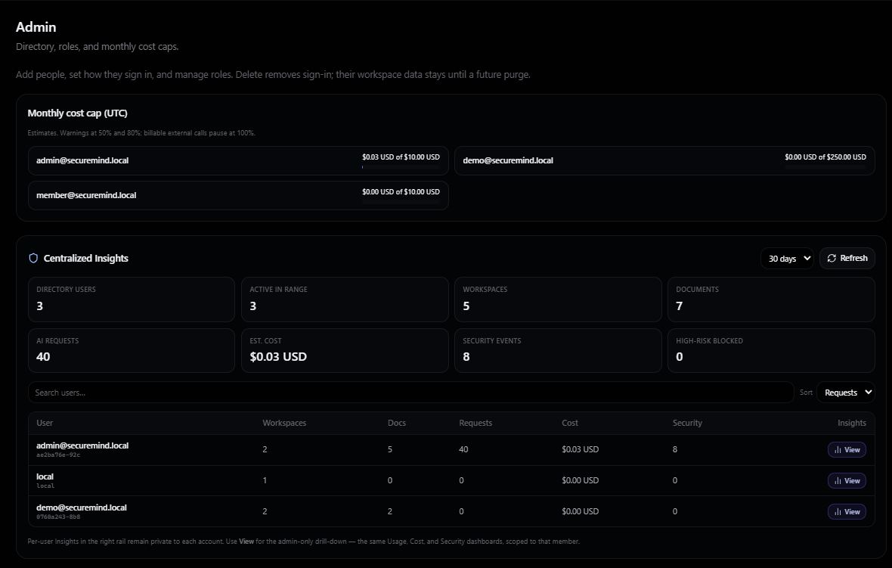
Figure 7. Admin, users
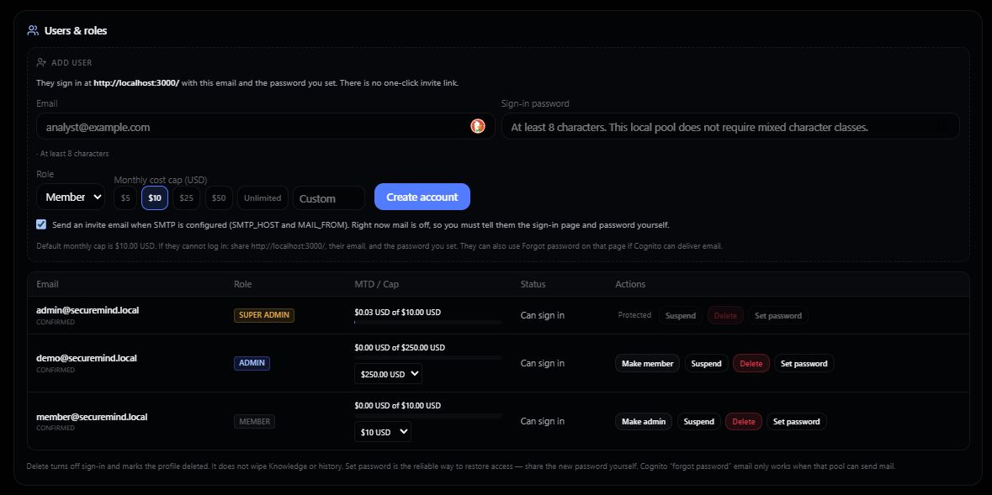
Figure 8. Users and roles. Create an account, assign a role, and set a cap

17 Getting started
Purpose. Help a new user reach a working model and understand how to begin.
Getting started appears while chat is not ready. It points toward Settings, Setup, and Models: connect a model source, make a model available, and send a first message. Sensitive-data review and Insights are part of that introduction. The full setup steps are on the website, as described in section 5.

18 How the parts fit
Start with your own installation. The administrator connects services, configures detection, creates accounts, and sets estimated spending limits. Members then work in a workspace using that configuration.
Chat reviews typed text before processing. Knowledge supplies uploaded content. Memory retains what you wrote. Saved returns you to a message. A complexity tier or a fixed model determines which model answers. Insights shows the activity, the estimated cost, and the findings.

Installation instructions
Setup covers a Docker installation on your own machine and a deployment in your own AWS account. Those steps are on the SecureMind website and linked from the GitHub README. The cloud region is set in the infrastructure configuration, as described in section 5. The technical guide describes provider regions and processing destinations.

19 Scope and limitations
SecureMind is an additional layer of control, reassurance, and transparency for people using AI in their own environment. It is not a compliance program, a certification, or a replacement for an organization’s required security controls.
Detection is best effort. A value that is not detected may be processed or stored. Browser review is the path inside the application. It is not protection against a request that bypasses that path.
Costs and caps rely on estimates, not invoices. Actual billing comes from the provider. A locally hosted application may still send content to external services when those services are configured.
Each installation is independently operated. SecureMind is not intended to run a shared public service that holds every customer’s API keys. A region set for the deployment does not, by itself, mean that every connected service processes data only there.
SecureMind does not accept pasted AWS access keys. Local Bedrock uses the credential chain in section 4. Raw audio sent for hosted transcription is processed before the transcript can be reviewed and redacted.

