# Overview

This mobile app simulates basic features provided by an online shopping cart:

* Retrieve a list of items that are available in backend system
* Add/Remove items
* Increase/Decrease quantities of each item
* Calculate a total with tax and discount
* Submit an order to backend service

# Pre-requirements to run a test

* A Windows desktop/laptop computer with following software installed
  + Node.js (download from <https://nodejs.org/en/> )
    - Run following command after Node.js installation has been completed

**npm install –g expo-cli**

**npm install –g vue-native-cli**

* + Android Studio (<https://developer.android.com/studio>): it’s only required if you don’t have a android phone for testing.
  + Github Desktop (<https://desktop.github.com/> )
* An android phone: it’s only required if you don’t have Android Studio installed

# Mobile App Testing Steps

## Step 1: Verify the backend service, that support this mobile app, is up and running

|  |  |
| --- | --- |
| URL | Expected Result |
| <https://uoftcsc301.herokuapp.com/> | Hello World! |
| <https://uoftcsc301.herokuapp.com/getCatalogue> | {"catalogue":[{"id":0,"price":2,"quantity":1,"title":"Apple"},{"id":1,"price":3,"quantity":1,"title":"Orange"}]} |

Open a web browser and enter following URL listed in the following table

Note: the backend service hosted by Heroku. If no traffic hits the server at <https://uoftcsc301.herokuapp.com/>, it will be in sleep mode. In other words, a response time of first request might be slower.

## Step 2: Clone Git repository of this mobile app to your local machine

1. Open a browser and navigate to <https://github.com/csc301-fall-2020/assignment-1-25-Origami-rice-xinyuan0801-mobile/tree/mobile>
2. Click “Code” drop down list and choose “Open with GitHub Desktop”

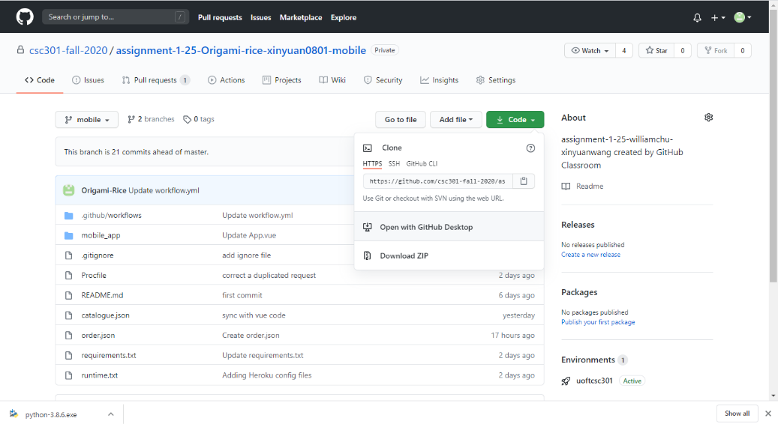

1. Click “Open GitHubDesktop.exe” on a pop-up window

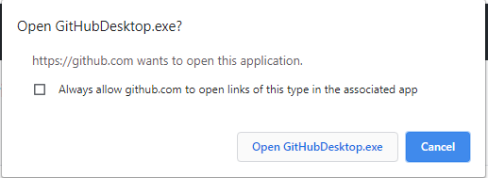

1. Specify a “Local path” where you want to store the cloned repository.

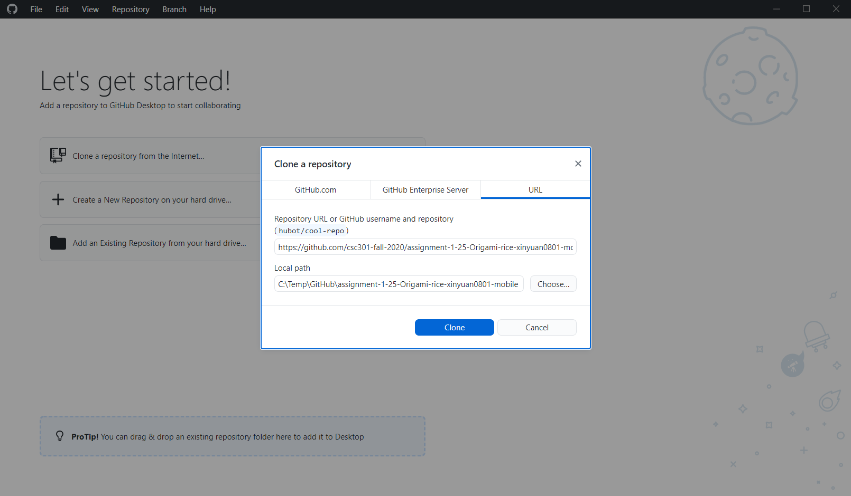

1. Once the repository is cloned and make you are connected to “mobile” branch



## Step 3: Create a Android emulator or connect you Android phone to your desktop/laptop via USB cable with “USB debugging” option enabled

You only need one of following settings:

* Create an emulator: please refer to <https://docs.expo.io/workflow/android-studio-emulator>
* Enable “USB debugging”: please search a solution for your phone

## Step 4: Deploy a Vue Native mobile app on your Android phone or an Android emulator

1. Open a CMD window as an administrator
2. Change working directory to the mobile app project root directory

<local installation folder>\assignment-1-25-Origami-rice-xinyuan0801-mobile\mobile_app\calculator-app

1. Run command: npm start
2. Once the following screen showup, you can choose option “a”. The process will automatically find your emulator or Android phone (not both!!)

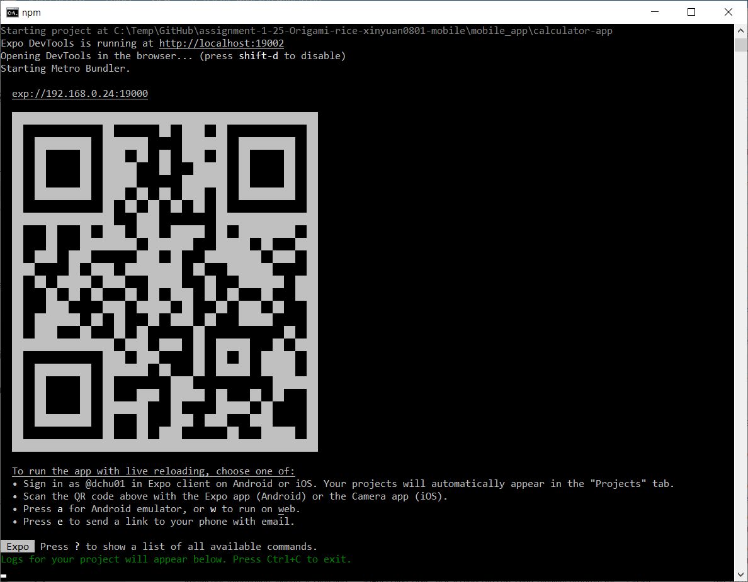

1. Once you see following console window, the mobile app – calculator is supposed to be installed and running on your phone or emulator. (Please ignore the warning messages)

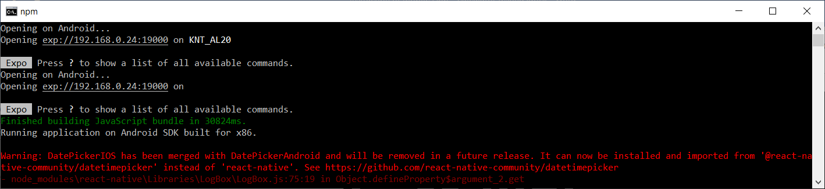

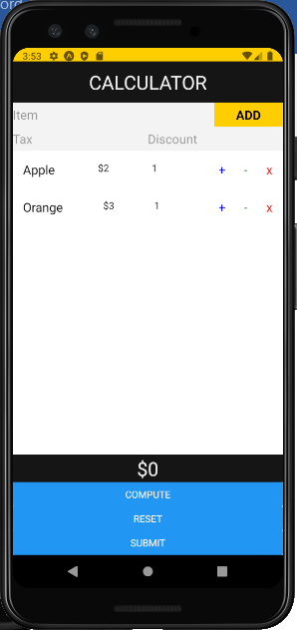

1. The first page shows a list of items that’s available in backend system. Functions of all buttons and icons on the page are described in following table

|  |  |
| --- | --- |
| Name | Fuction |
| + | Increase quantity |
| - | Decrease quantity |
| x | Delete an item |
| “Item” text input + “ADD” | Add a new item to the shopping cart |
| “Tax” text input | Specify tax |
| “Discount” text input | Specify discount percentage |
| “COMPUTE” | Calculate total amount of an order |
| “Reset” button | Clean shopping cart with initial items |
| “Submit” button | Submit an order to backend system  -----------------------------------------  Note: clicking this button will trigger server to store an order on server side as a JSON file. When backend server runs on a local server, it works. When backend server hosted on uoftcsc301.herokuapp.com, it might not work. Because Heroku might not allow the server app to store anything on hosting server. Anyway, try following URL to confirm if your order are saved on backend side: <http://uoftcsc301.herokuapp.com/getOrder> |

# CI-CD Configuration Testing Steps

## Overview

Two sets of CI-CD configuration have been setup for this assignment. One uses GitHub Actions; One uses Heroku application setting.

## GitHub Actions (doesn’t work because of class room spending limits)

The GitHu Action defined in .github/workflows do following two things:

1. Run a Python command: python mobile_app/backend/main_test.py to complete a unit testing
2. Deploy and release backend service to Heroku container

The workflow will be triggered, when any changes have been pushed/pulled from branch: mobile

## Heroku Application

A Heroku application is created to monitor a “push” event at the repository (<https://github.com/csc301-fall-2020/assignment-1-25-Origami-rice-xinyuan0801-mobile/tree/mobile> ) in GitHub.

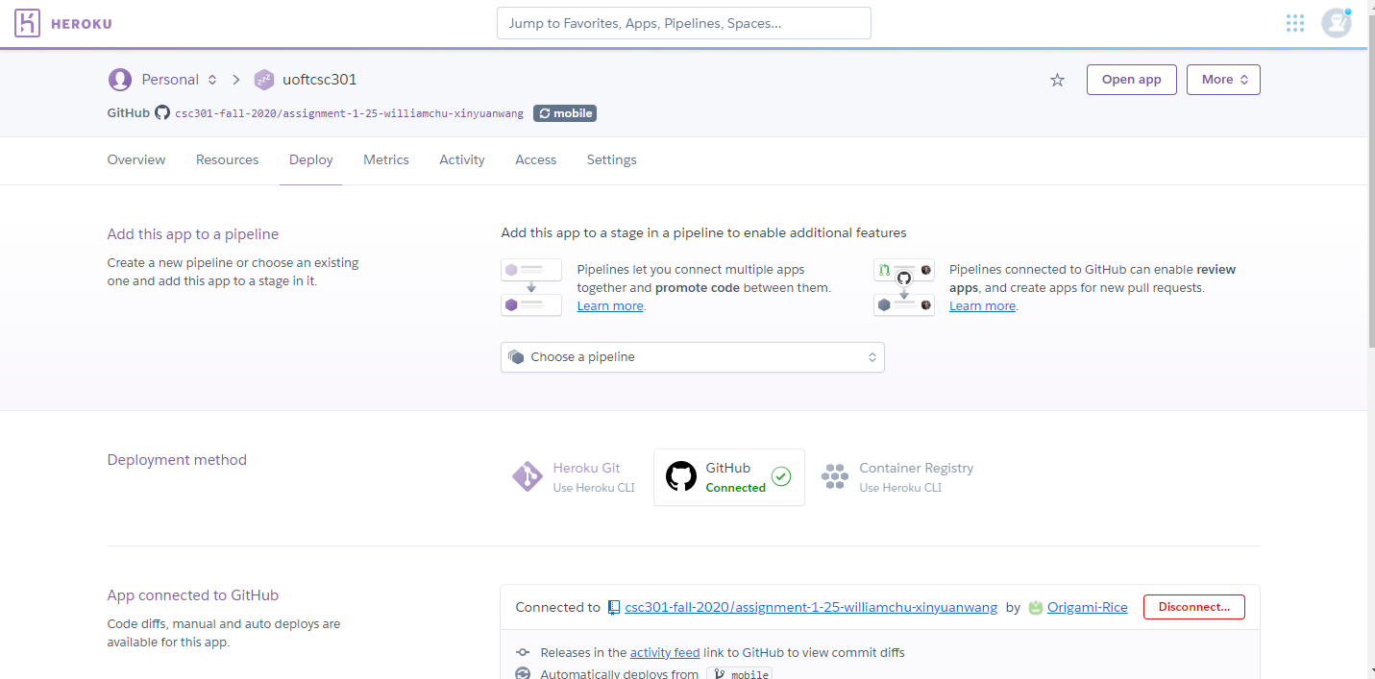

### Testing Steps

1. Open a browser and enter URL address: <https://uoftcsc301.herokuapp.com/>

You will receive “Hello World!” on a response

1. Modify the backend Python file: main.py (at: assignment-1-25-Origami-rice-xinyuan0801-mobile\mobile_app\backend)

Replacing ‘Hello World!’ With ‘Your Greeting!’

|  |
| --- |
| from flask import Flask, jsonify, request  from flask_cors import CORS  import json  app = Flask(__name__)  CORS(app)  @app.route('/getCatalogue', methods=['GET'])  def get_catalogue():  with open('mobile_app/backend/catalogue.json') as f:  catalogue = json.load(f)  f.close  return jsonify(catalogue)  @app.route('/', methods=['GET'])  def get_hello():  return 'Hello World!'  @app.route('/getTotal/<int:price>/<int:quantities>', methods=['GET'])  def get_total(price, quantities):  return str(price * quantities)  @app.route('/submit', methods=['POST', 'GET'])  def post_order():  print('it is called!')  jsonData = request.get_json()  with open('order.json', 'w') as outfile:  json.dump(jsonData, outfile)  return jsonify(jsonData)  @app.route('/getOrder', methods=['GET'])  def get_order():  with open('order.json') as f:  order = json.load(f)  f.close  return jsonify(order)  if __name__ == "__main__":  app.run(debug=True) |

1. Save, Commit and Push main.py to GitHub, it will automatically trigger Heroku application to test, deploy and release. You might wait for 5 min and visit <https://uoftcsc301.herokuapp.com/> again. You will see “Your Greeting!” in the response