**Tasks To Be Performed:**

1. Setup Ansible cluster with 3 nodes

2. On slave 1 install Java

3. On slave 2 install MySQL server

Do the above tasks using Ansible Playbooks

**Procedure: -**

First we need to set up the machine.

Create master, slave1 and slave2 machine.

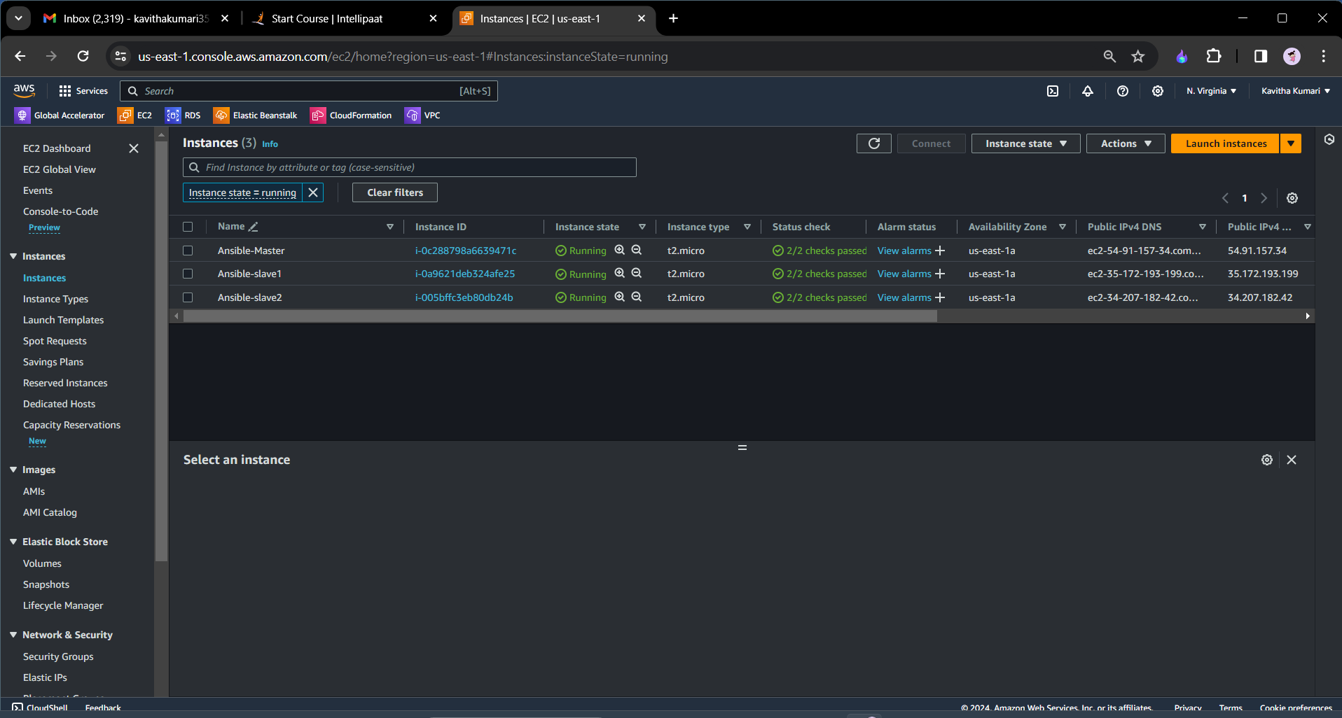

First we need to give the ssh key access to the master server for the slave1 and slave2.

I have not create the key pair therefore I will generate the keypair through the command **ssh-keygen** and press enter until the keypair is generated.[pic]

=>Then we need to go to the folder of ssh and find the location of the public key generated that is **id_rsa.pub**

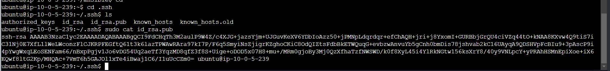

* We need to paste this key to the slave1 and slave2 at the location authorized_keys.

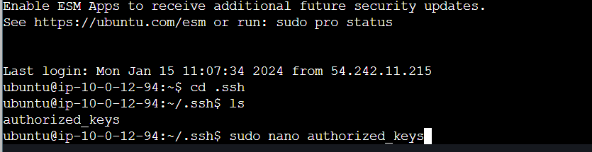

* Paste the key and save and exit from the file.
* Now when we try to ssh the slave machine from the master machine with the command **ssh ubuntu@pub-address** we will be able to ssh sucessfully.

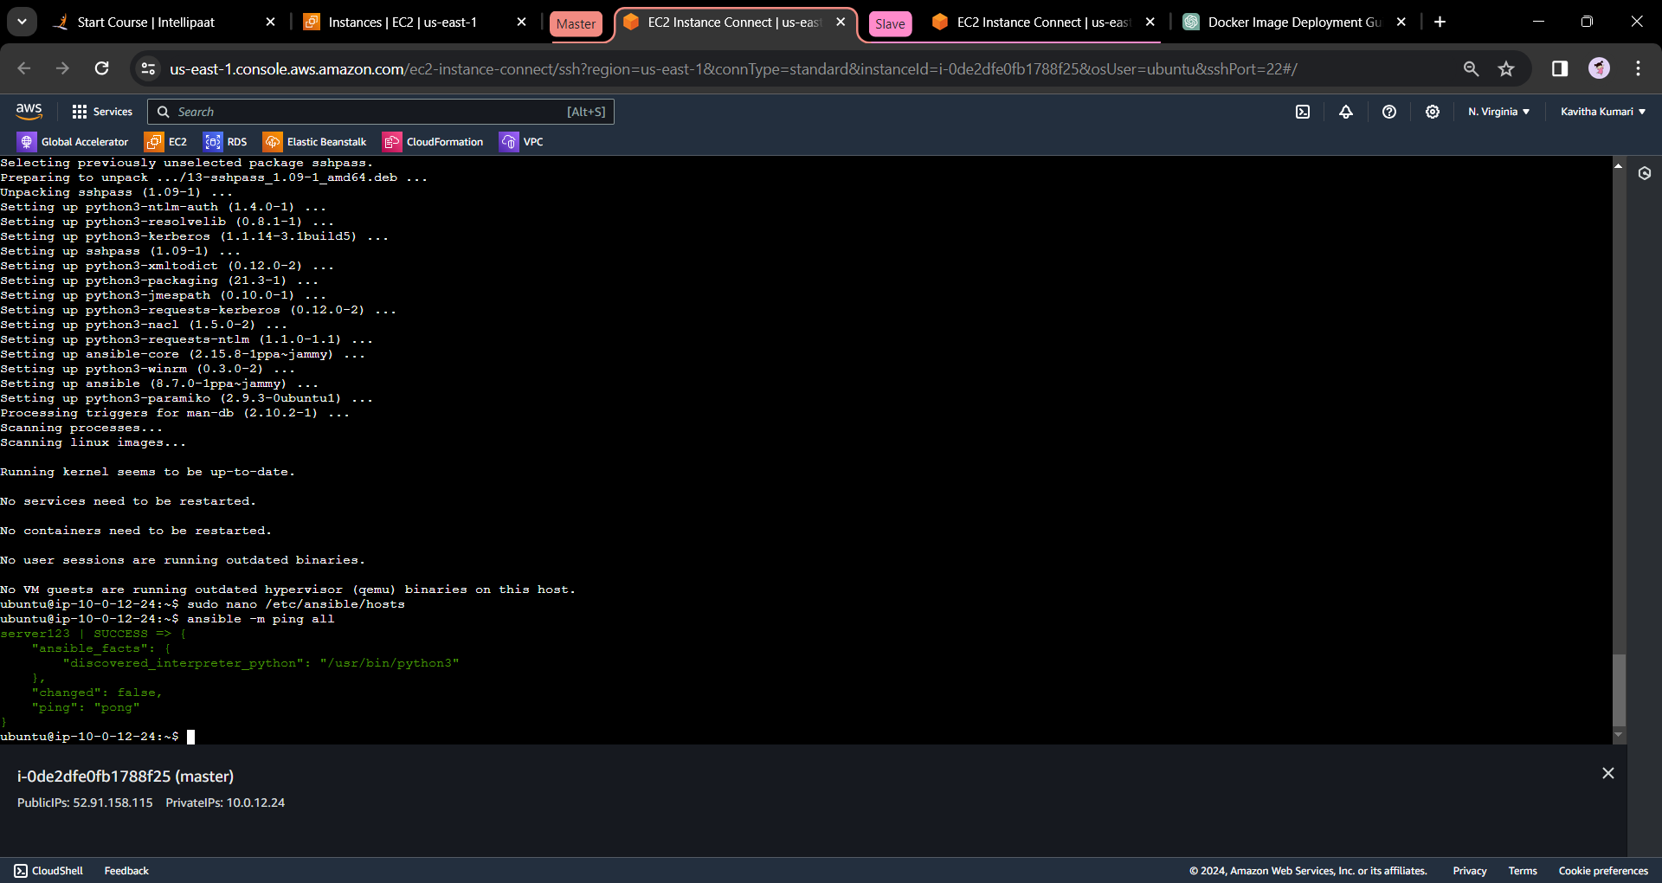

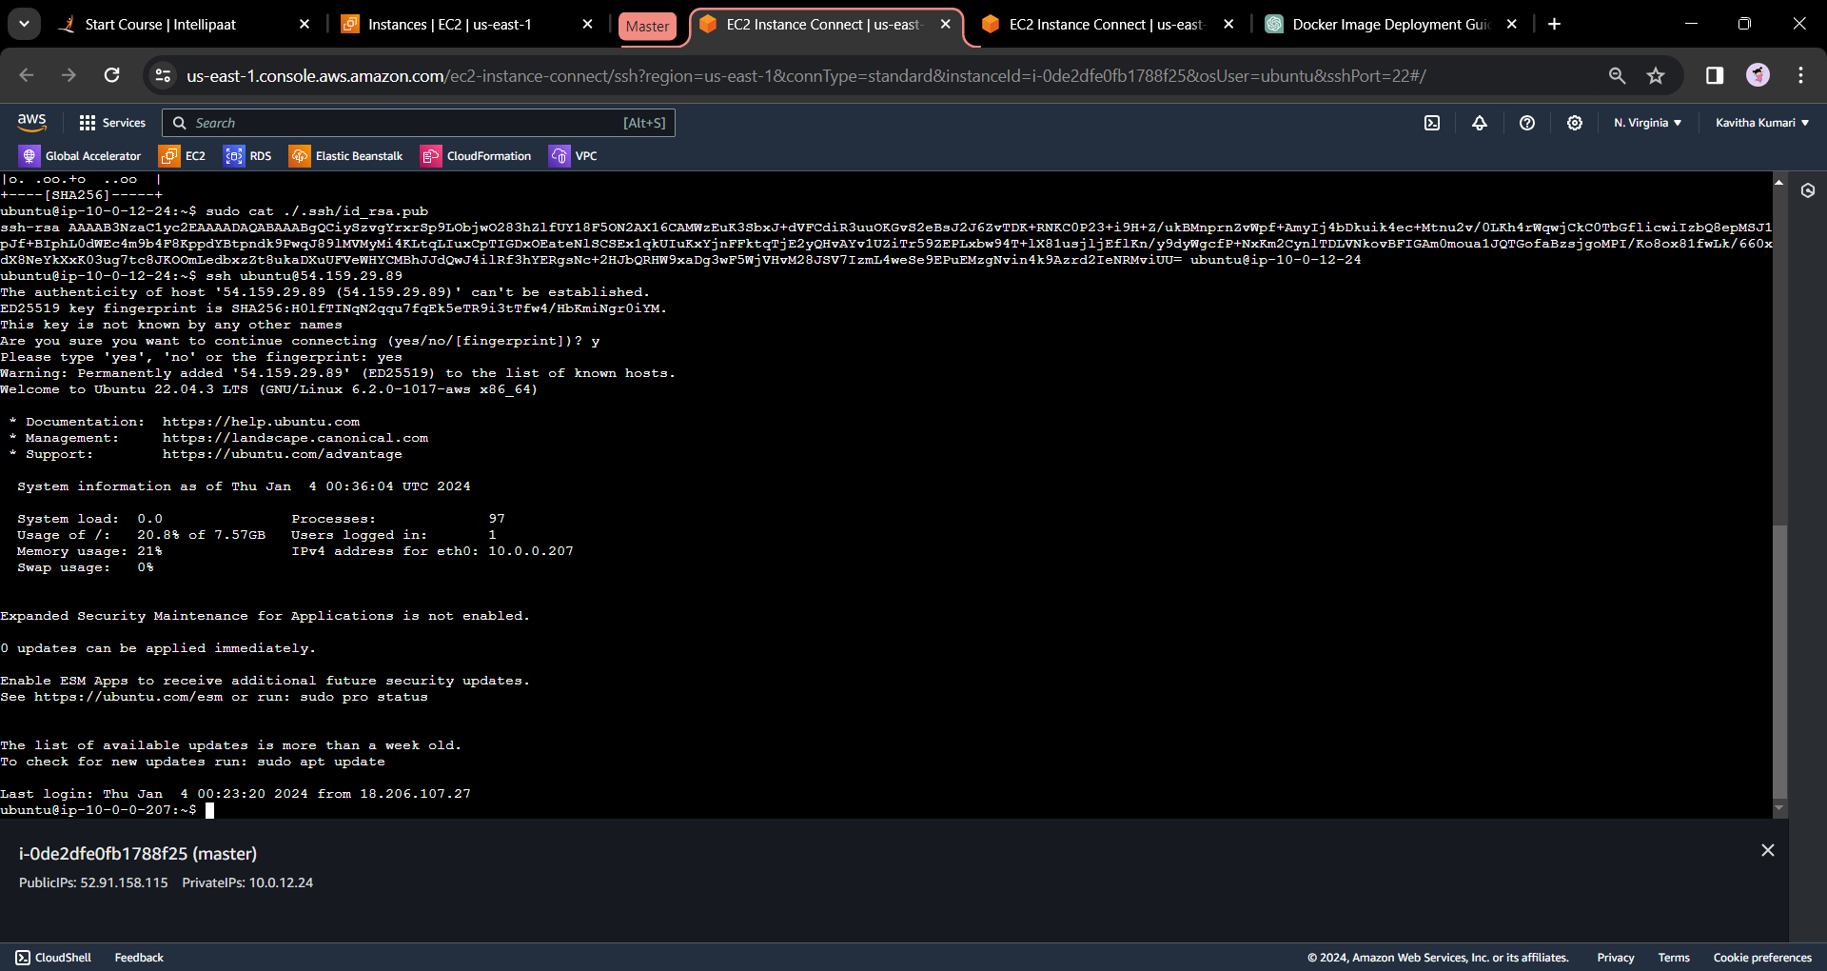

* After this we need to run the following commands on the master server.
* **sudo apt update**
* **sudo apt install software-properties-common**
* **sudo apt-add-repository –yes –update ppa:ansible/ansbile**
* **sudo apt install ansible**
* Now we must configure the slave1 and slave2 file by creating host file in the master. To edit the file, pass the following command.
* sudo nano /etc/ansible/hosts

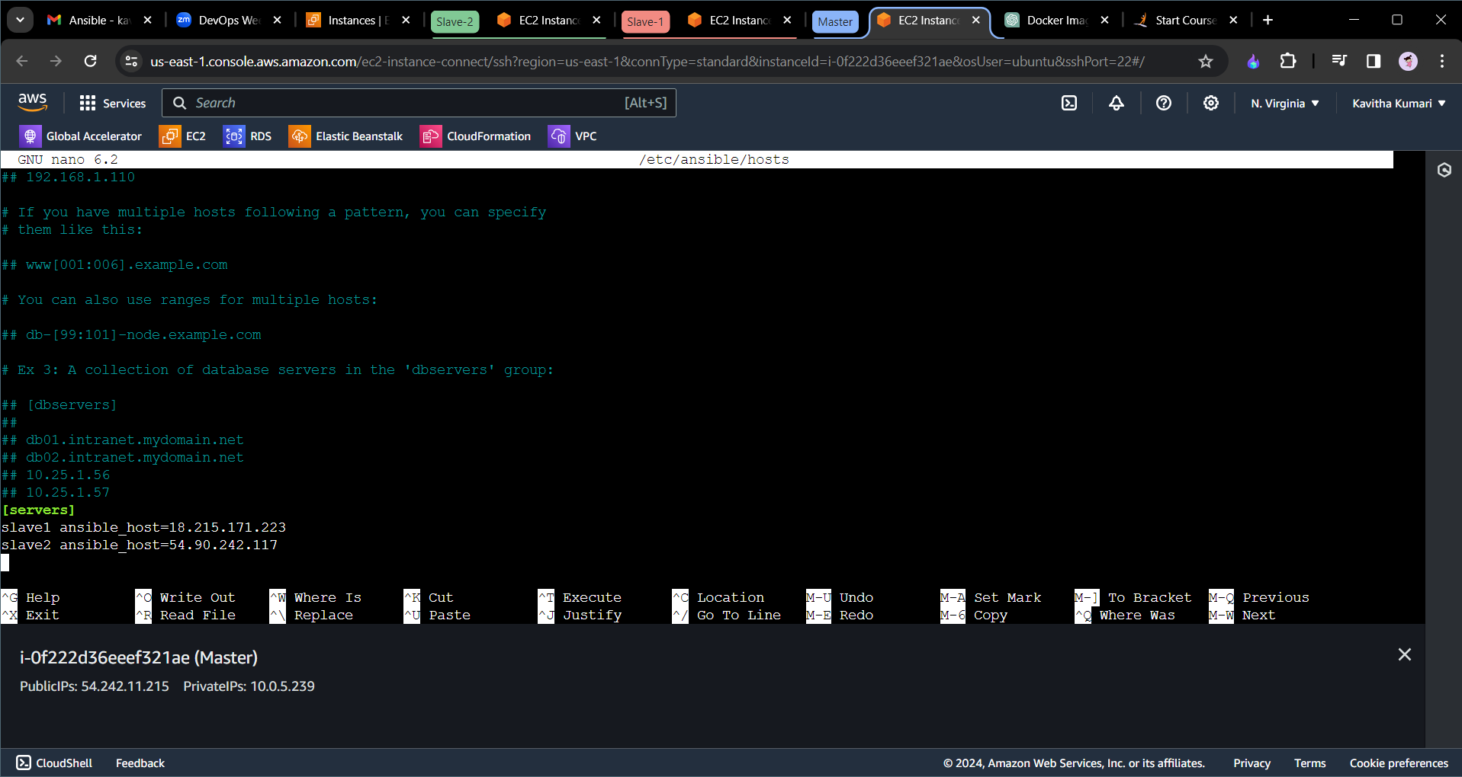

* we need to include the both the slave1 and slave2 file in the [servers] group mention the public ips the tag server can be given any name and also slave1 and slave2.
* After doing this if we run **ansible -m ping all**  we will see the following output.

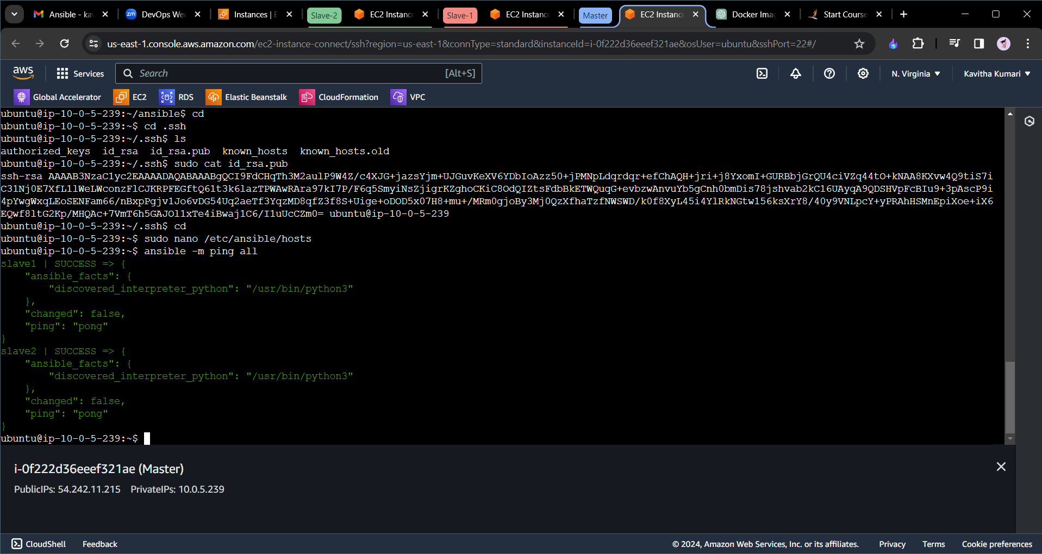

* Now we will create a folder called ansible and in that we will create the playbook play1.yaml and play2.yaml. In play1.yaml we will install java with the version 11 and in the play2.yaml we will install mysql server.
* We need to run the following commands.
* **mkdir ansible**
* **cd ansible**
* **sudo nano play1.yaml**
* In the play1.yaml we need to include the following command.

---  
- name: Install Java 11  
 hosts: [your_target_group]  
 become: yes # Run tasks with sudo (root) privileges  
  
 tasks:  
 - name: Update apt cache  
 apt:  
 update_cache: yes  
  
 - name: Install OpenJDK 11  
 apt:  
 name: openjdk-11-jdk  
 state: present # Ensure that the package is installed

* Save and exit from the file and run the following command.
* **ansible-playbook play1.yaml**

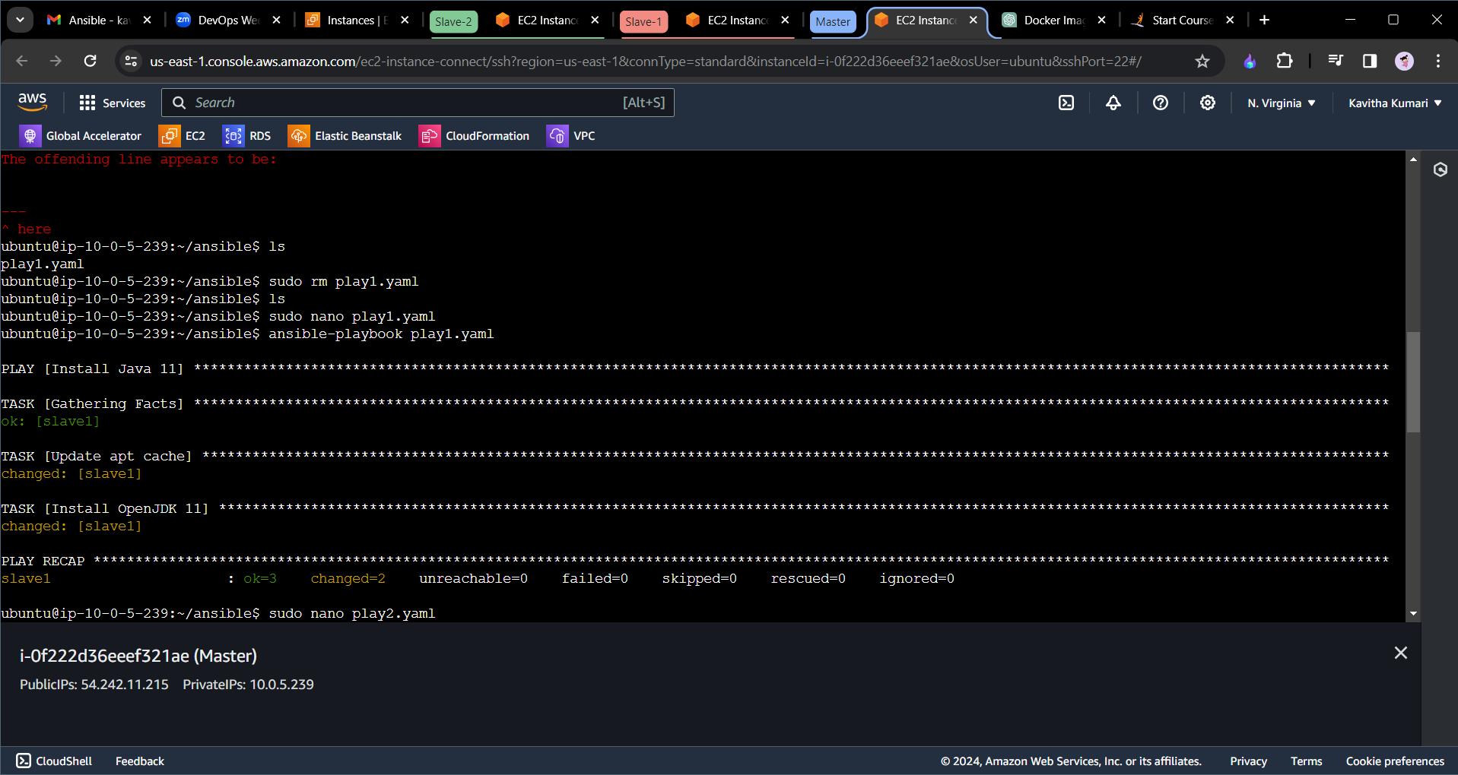

* In the similar way we will create the play2.yaml with the following confirguration.

---  
- name: Install MySQL  
 hosts: your_mysql_servers  
 become: yes  
  
 tasks:  
 - name: Update apt cache  
 apt:  
 update_cache: yes  
  
 - name: Install MySQL Server  
 apt:  
 name: mysql-server  
 state: present  
  
 - name: Install MySQL Client  
 apt:  
 name: mysql-client  
 state: present

=>ansible-playbook play2.yaml

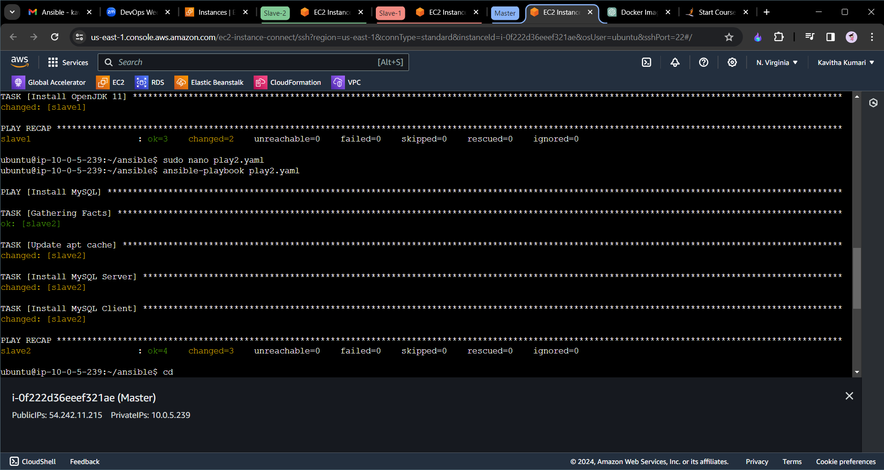

**These playbooks assume you're using Ubuntu or a similar distribution that uses the `apt` package manager. If you're using a different distribution, adjust the package names accordingly (e.g., `yum` for CentOS/RHEL).**