**Tasks To Be Performed:**

1. Create 2 Ansible roles

2. Install Apache2 on slave1 using one role and NGINX on slave2 using the other role

3. Above should be implemented using different Ansible roles

**Procedure:**

* For this we need to create Master, Slave1 and Slave2 servers in AWS with the ubuntu image and security inbound rules as all traffic.
* We need to install ansible and confirgue the servers.
* Ansible roles are created into the “**/etc/ansible/roles”** directory.
* Therefore, run the following command **cd /etc/ansible/roles**
* Run the following command **sudo ansible-galaxy init apace-role**
* I have installed the tree which makes us easy to view the files and folders in the tree manner.

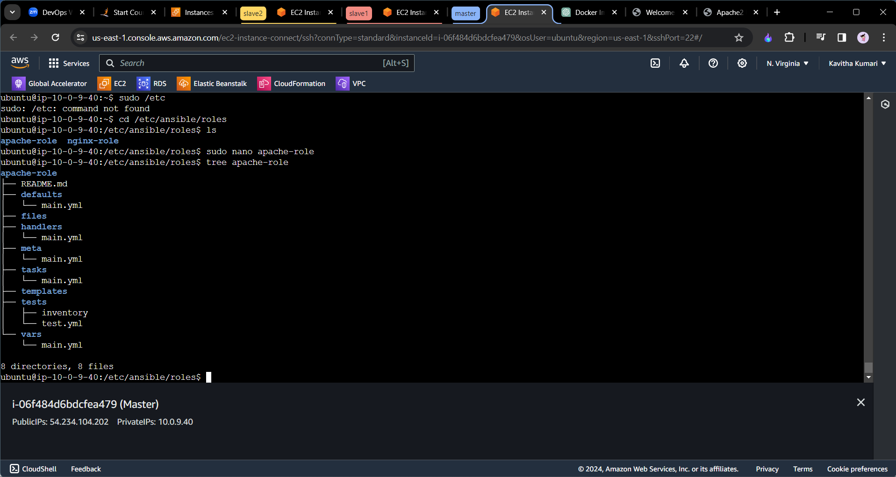

* To view the tree like structure of the apache-role write the command **tree apache-role**
* To create the role to install the apach2 on to the server we need to edit the main.yml which is present in the tasks folder.
* Therefore, we need to go to that file **sudo nano apache-role/tasks/main.yml.** Include the following code in it.

---  
# roles/apache_role/tasks/main.yml  
  
- name: Update apt cache  
 apt:  
 update_cache: yes  
  
- name: Install Apache2  
 apt:  
 name: apache2  
 state: present  
  
- name: Start Apache2 service  
 service:  
 name: apache2  
 state: started  
 enabled: yes

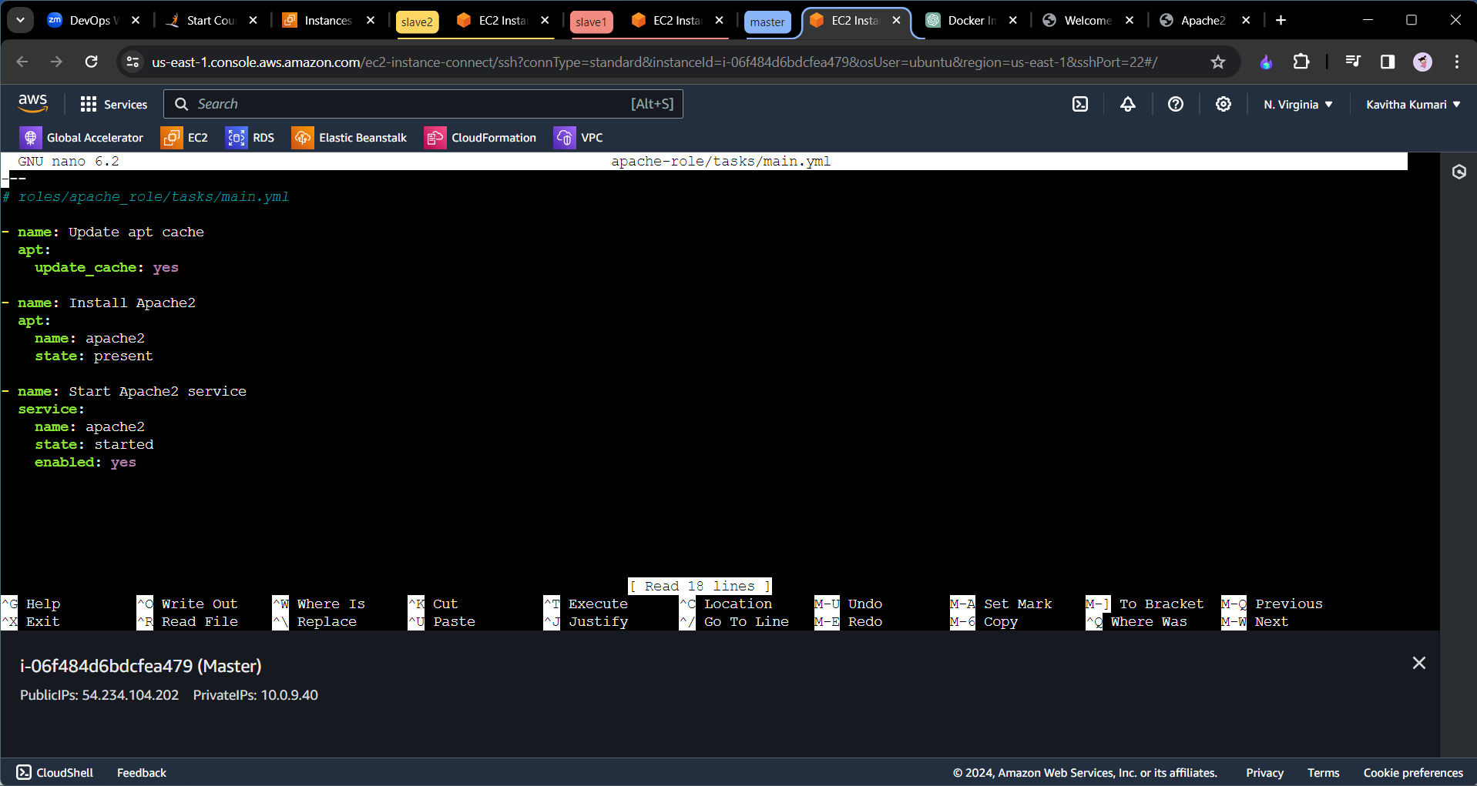

* In the similar manner we will also create the ngin-role with the following code in it.

---  
# roles/nginx_role/tasks/main.yml  
  
- name: Update apt cache  
 apt:  
 update_cache: yes  
  
- name: Install NGINX  
 apt:  
 name: nginx  
 state: present  
  
- name: Start NGINX service  
 service:  
 name: nginx  
 state: started  
 enabled: yes

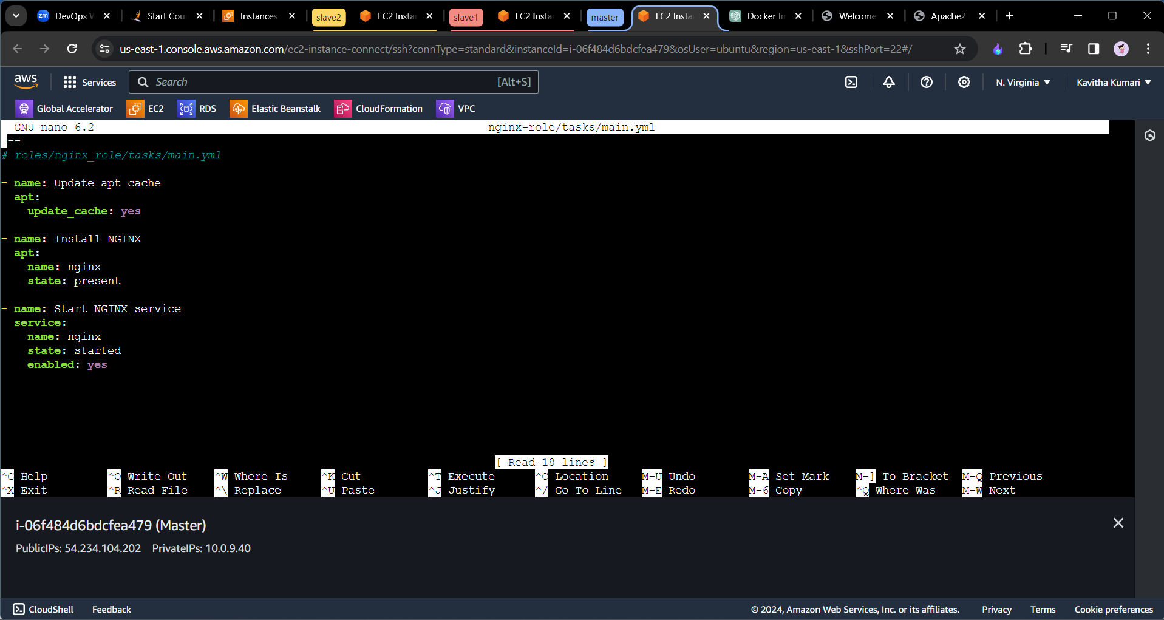

* Now we comeback to our original folder and we will create the playbook named apach.yaml and ngin.yaml which will use the roles and install apache2 and nginx server on both the servers respectively.
* Create the folder called ansible **mkdir ansible.**
* Get into that folder and create **sudo nano apach.yaml and include the following code.**

---  
- name: Start Apache with Role  
 hosts: slave2  
 become: yes  
  
 roles:  
 - apache-role

* Similarly create the ngin.yaml and include the following code.

---  
- name: Start nginx with Role  
 hosts: slave1  
 become: yes  
  
 roles:  
 - nginx-role

* Run the following command.
* ansible-playbook apach.yaml
* ansible-playbook ngin.yaml

Now we can open this browser with the help of the public ips of the slave1 and slave2 machines.

