**Tasks To Be Performed:**

1. Use the previous deployment of Ansible cluster

2. Configure the files folder in the role with index.html which should be replaced with the original index.html

All of the above should only happen on the slave which has NGINX installed using the role

**Procedure:**

* In the previous tasks we created roles and with the help of roles we install apach2 and nginx on both the slave machines and the default page was running.
* Here we need to replace those files with the default page created by us.
* First, we will start with the nginx that is slave1 machine where the nginx server is the default.
* In the path /etc/ansible/roles/apache-role/tasks we will create the new file called copy. yaml

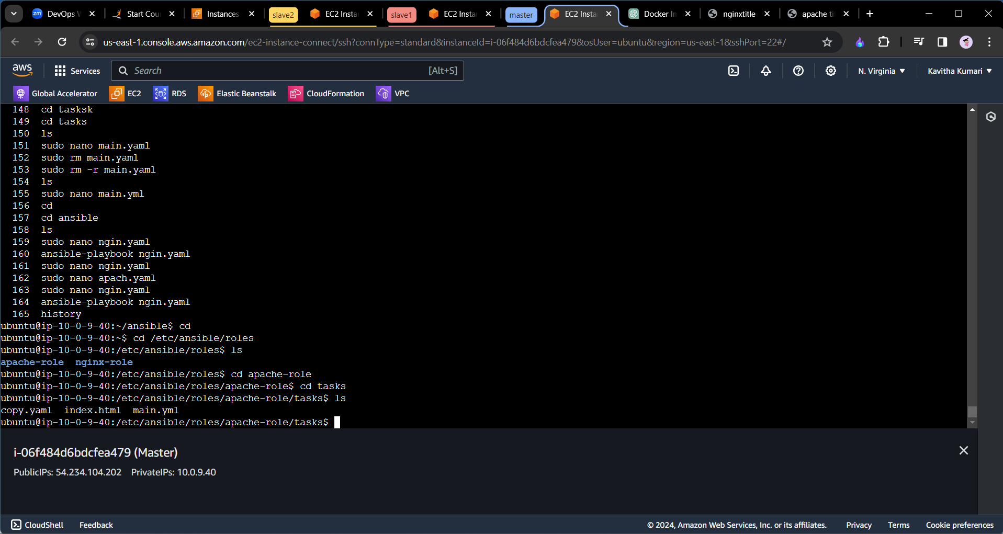

---  
 - name: replacing the original file  
 copy: src=/etc/ansible/roles/apache-role/tasks/index.html  
 dest=/var/www/html/

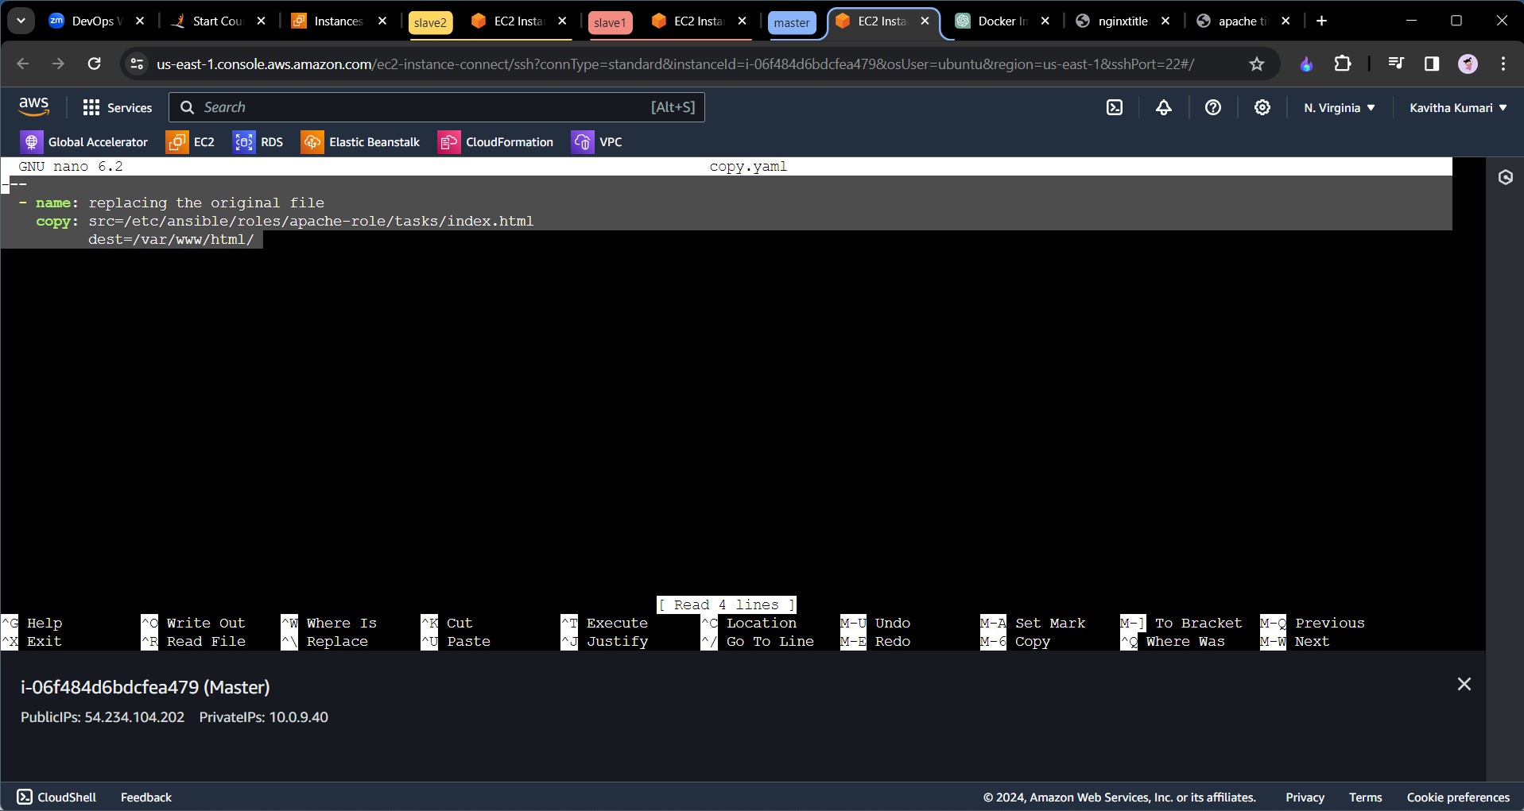

* Save and exit from the file.
* Now go to the main.yml and include this tasks as follows.

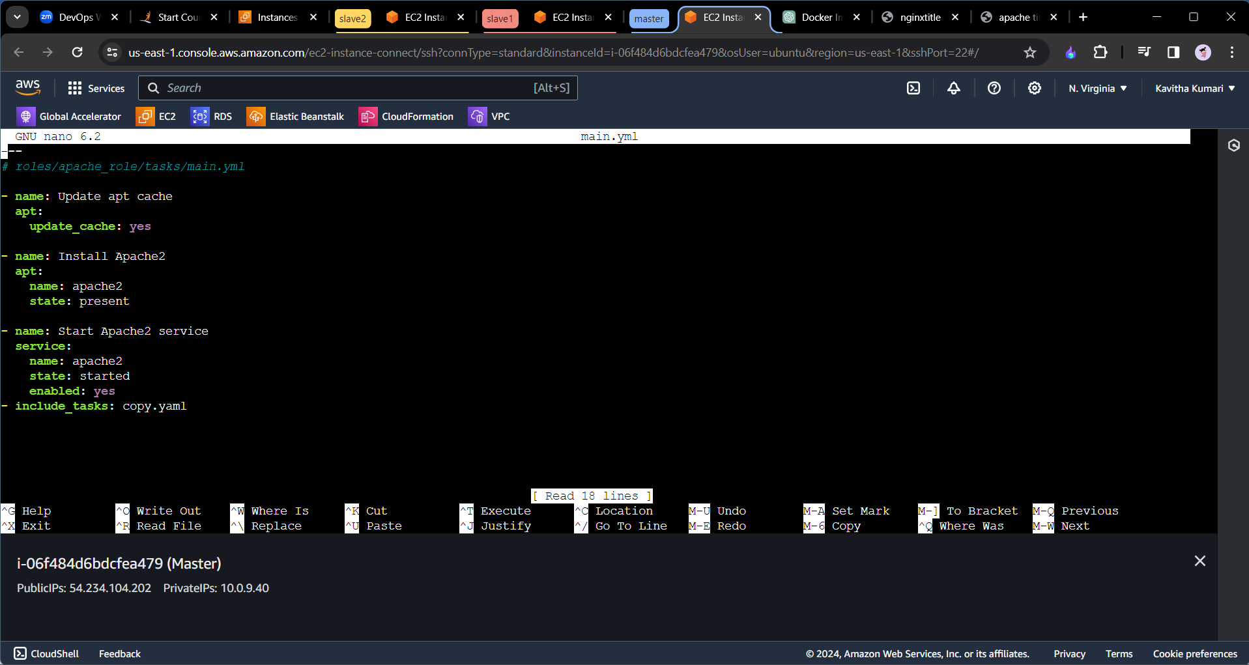

=>create the new file called index.html

=>and paste the html code in it and save and exit. And in the ansible folder run the playbook once.

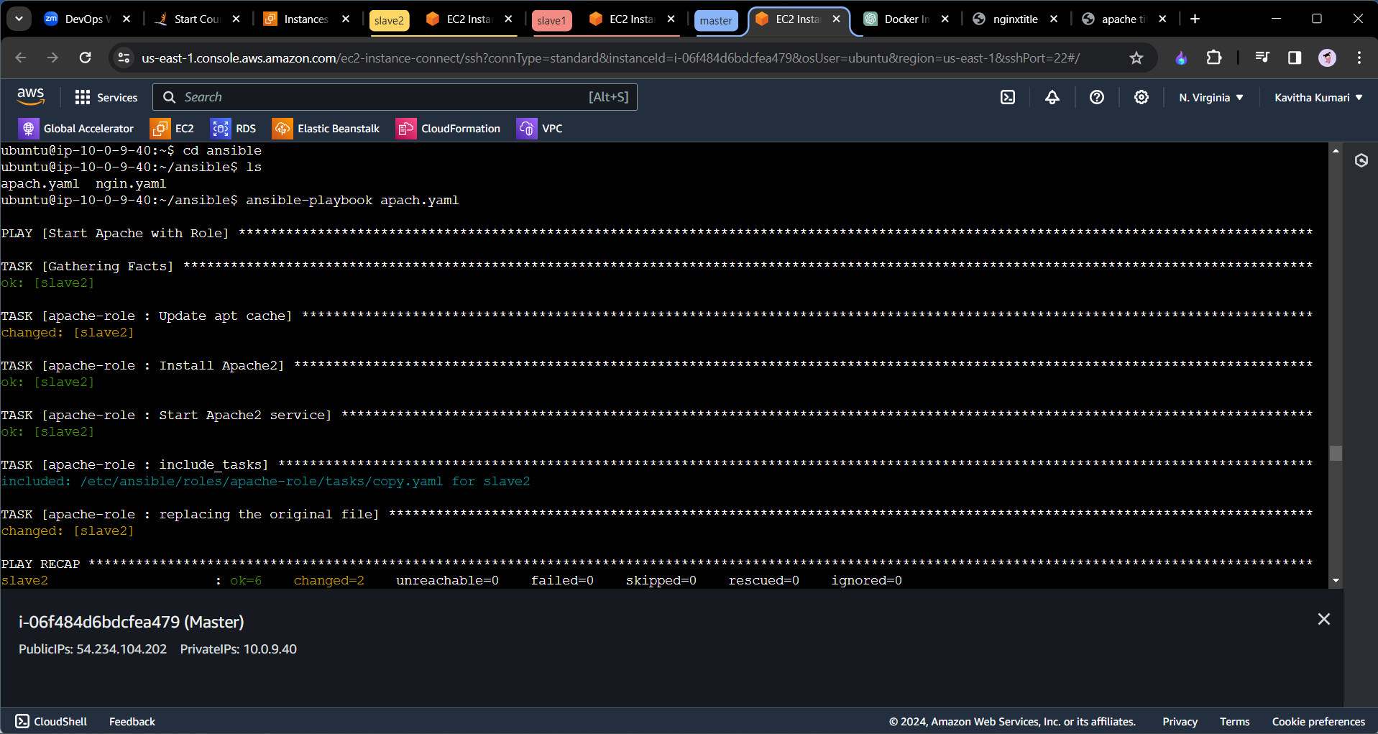

=> In the similar manner we will do with the nginx server as well.

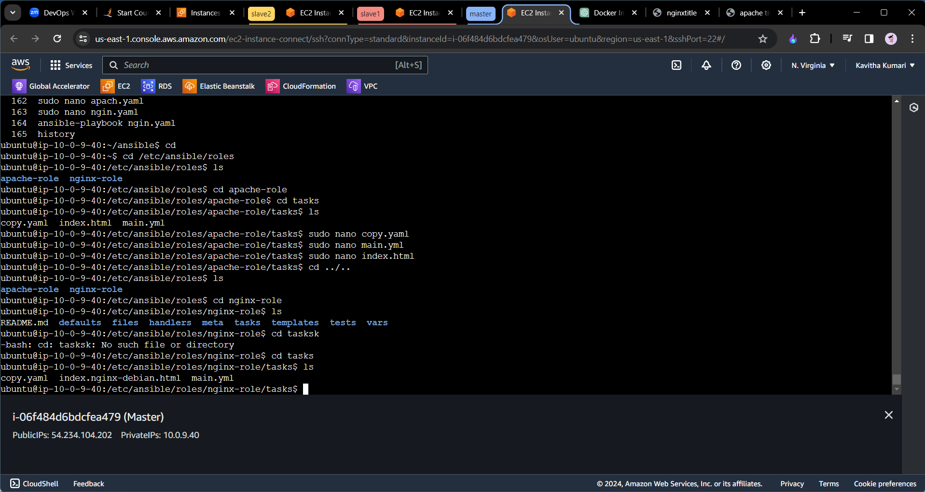

---  
 - name: copy the original nignx file to the new which we have created  
 copy: src=/etc/ansible/roles/nginx-role/tasks/index.nginx-debian.html  
 dest=/var/www/html/  
 become: true

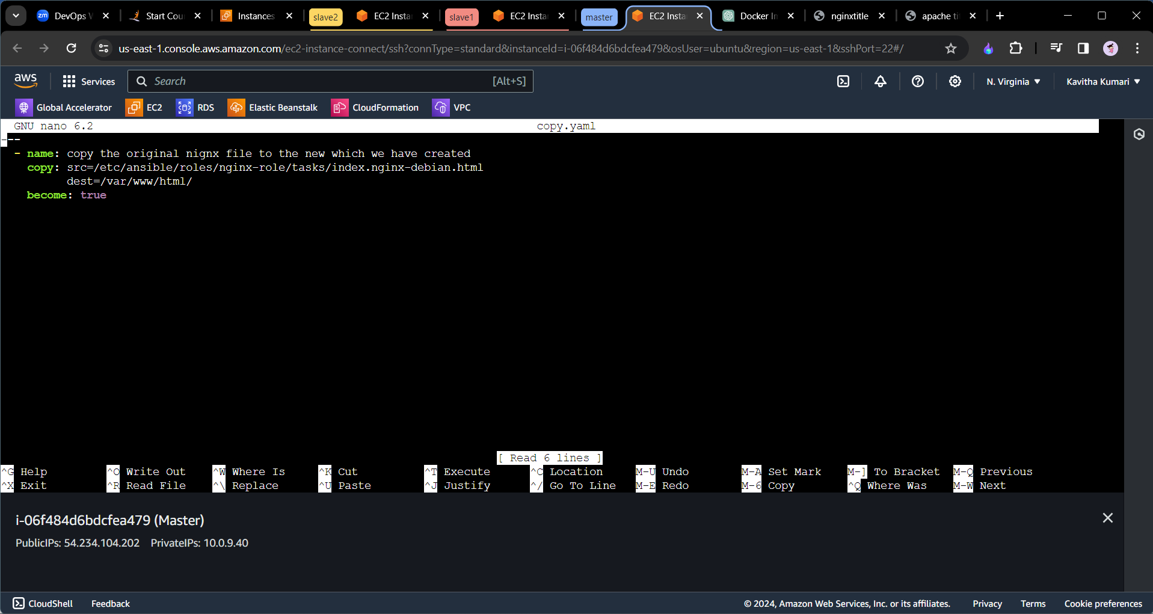

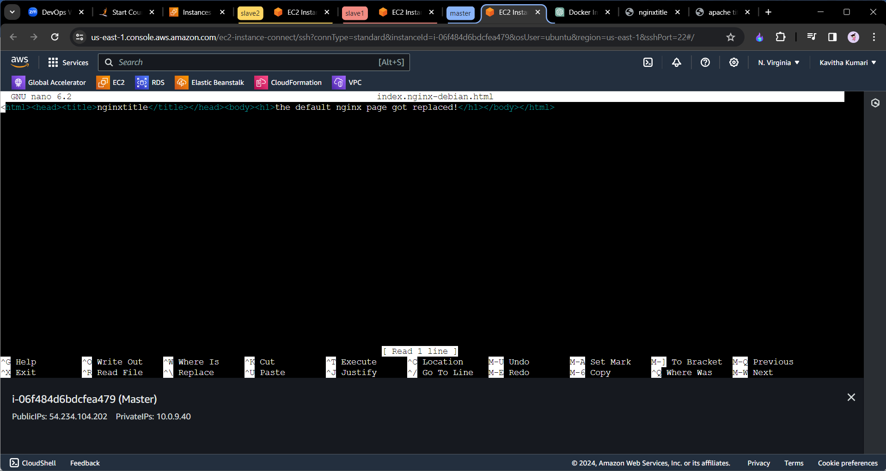

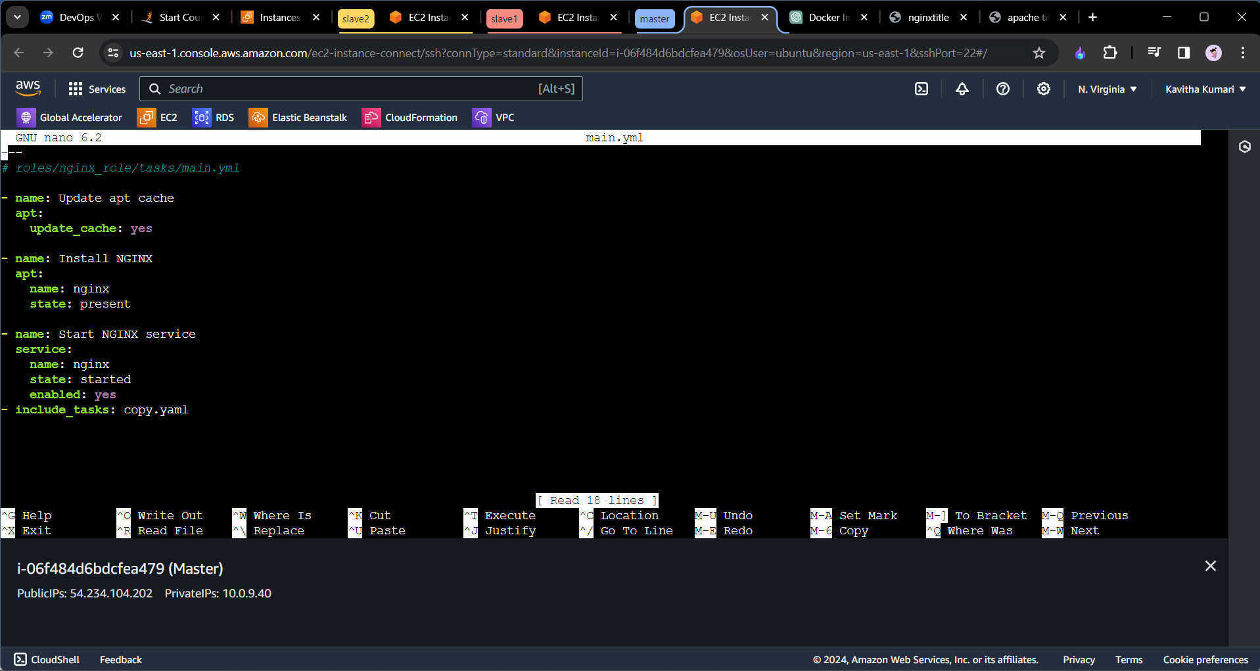

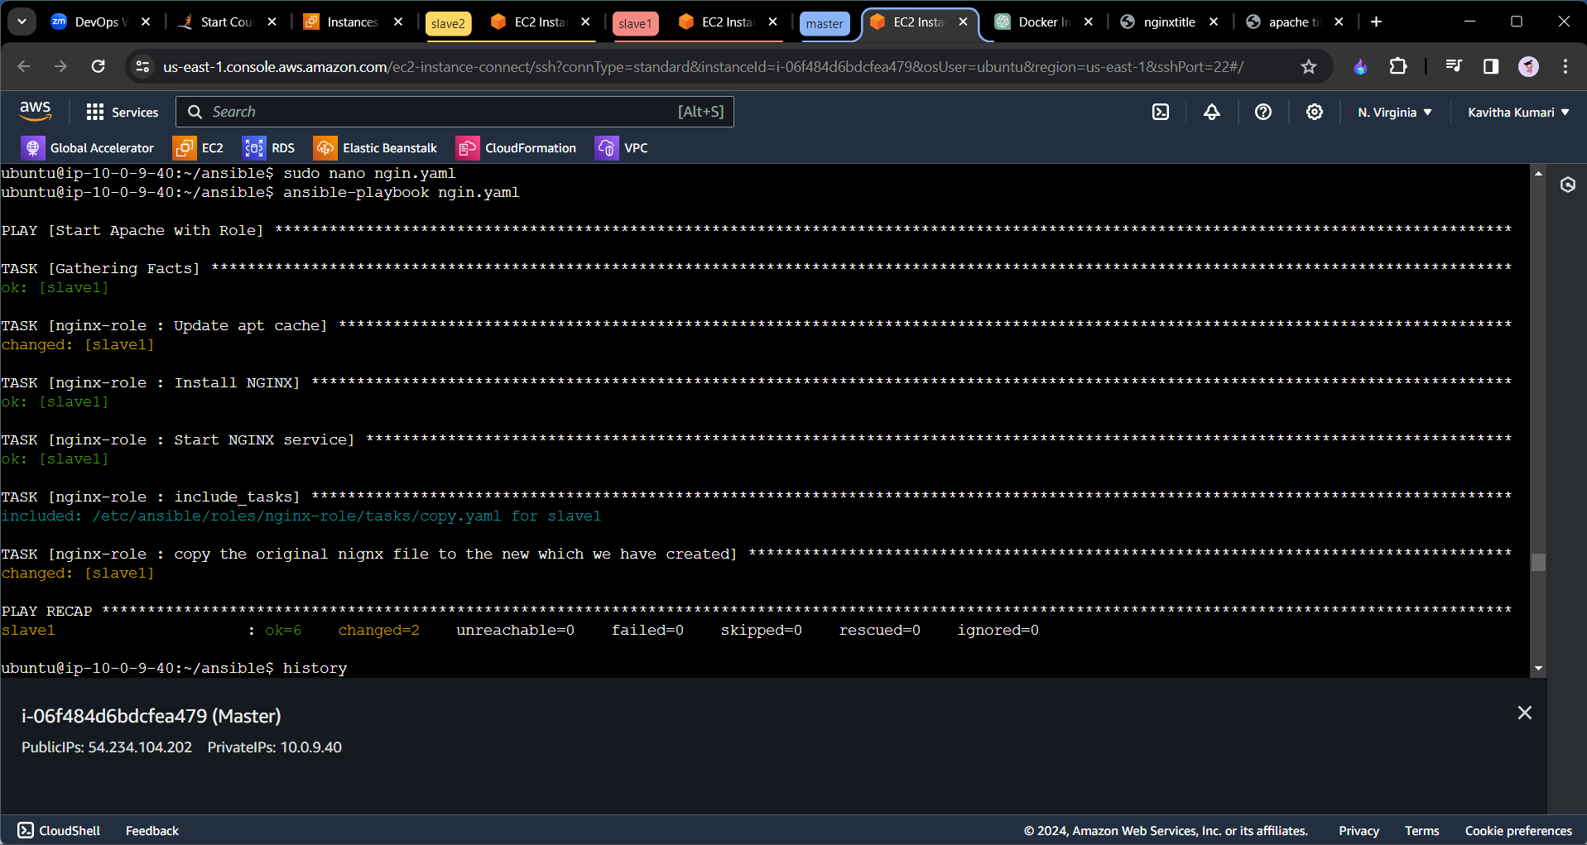

=>Now we will be able to see the default page runnning which was created by us on the browser.

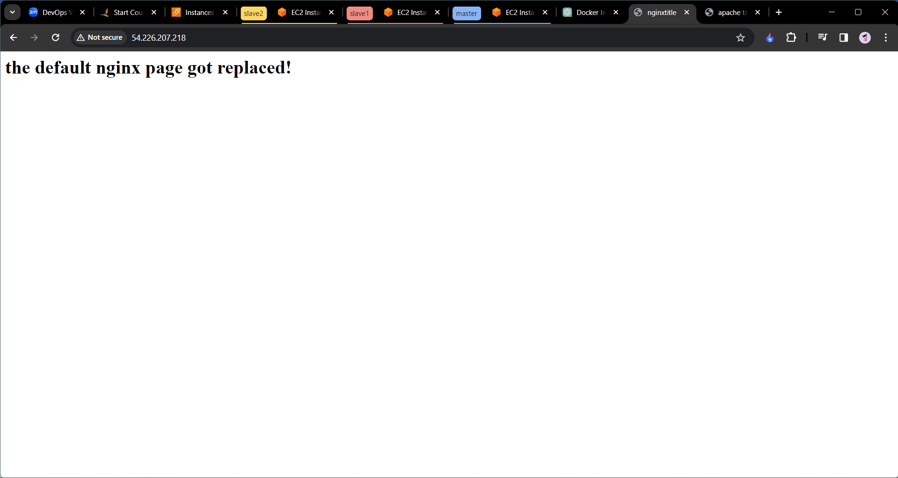

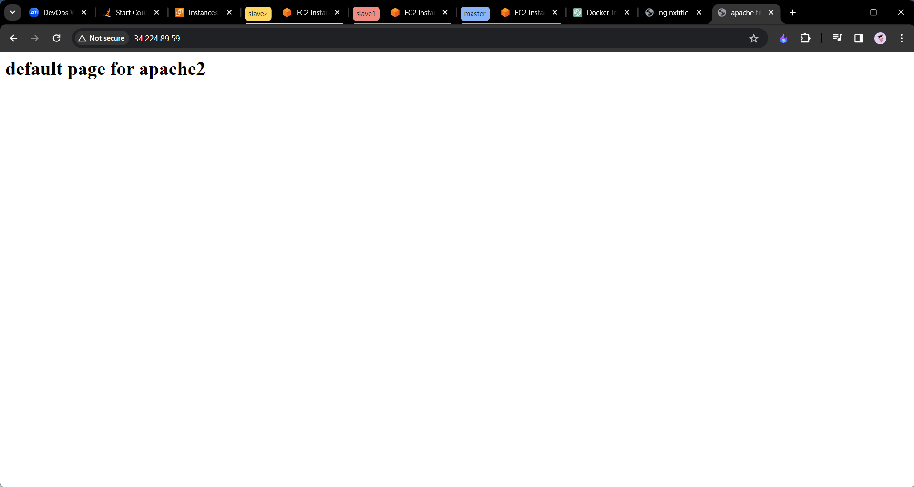

End========================================