Tasks To Be Performed:

1. Create a new deployment of Ansible cluster of 5 nodes

2. Label 2 nodes as test and other 2 as prod

3. Install Java on test nodes

4. Install MySQL server on prod nodes

Use Ansible roles for the above and group the hosts under test and prod.

Procedure: -

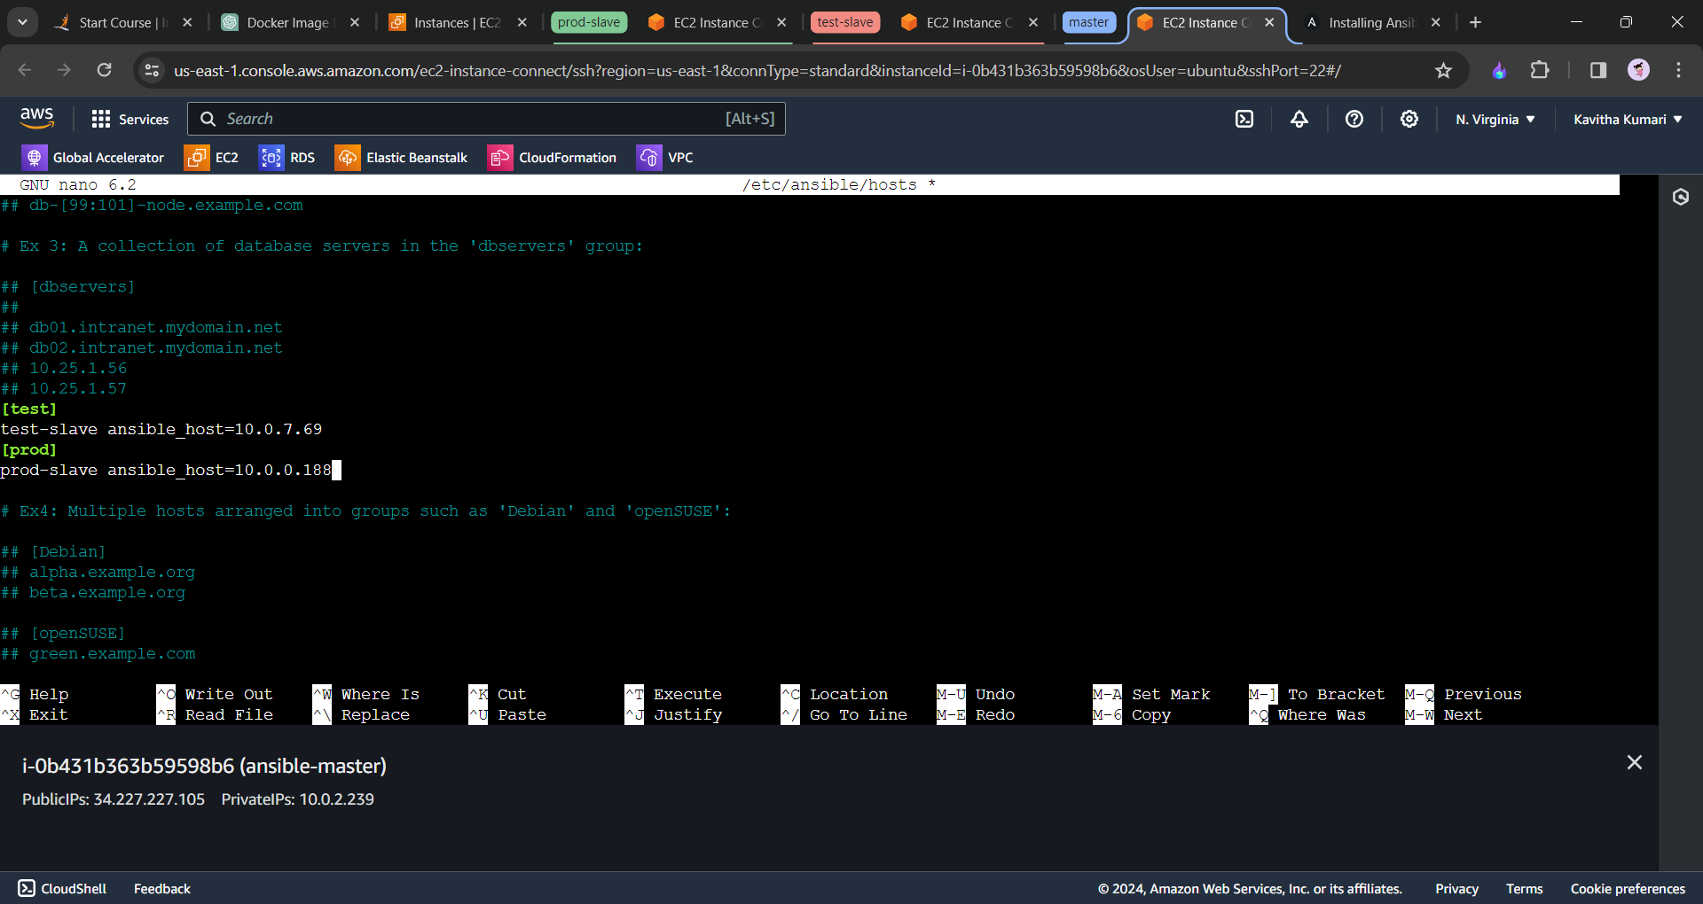

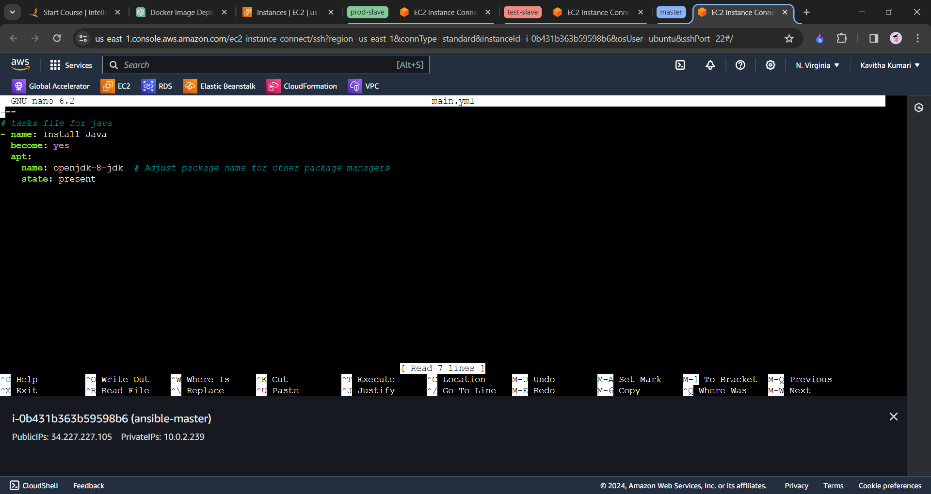

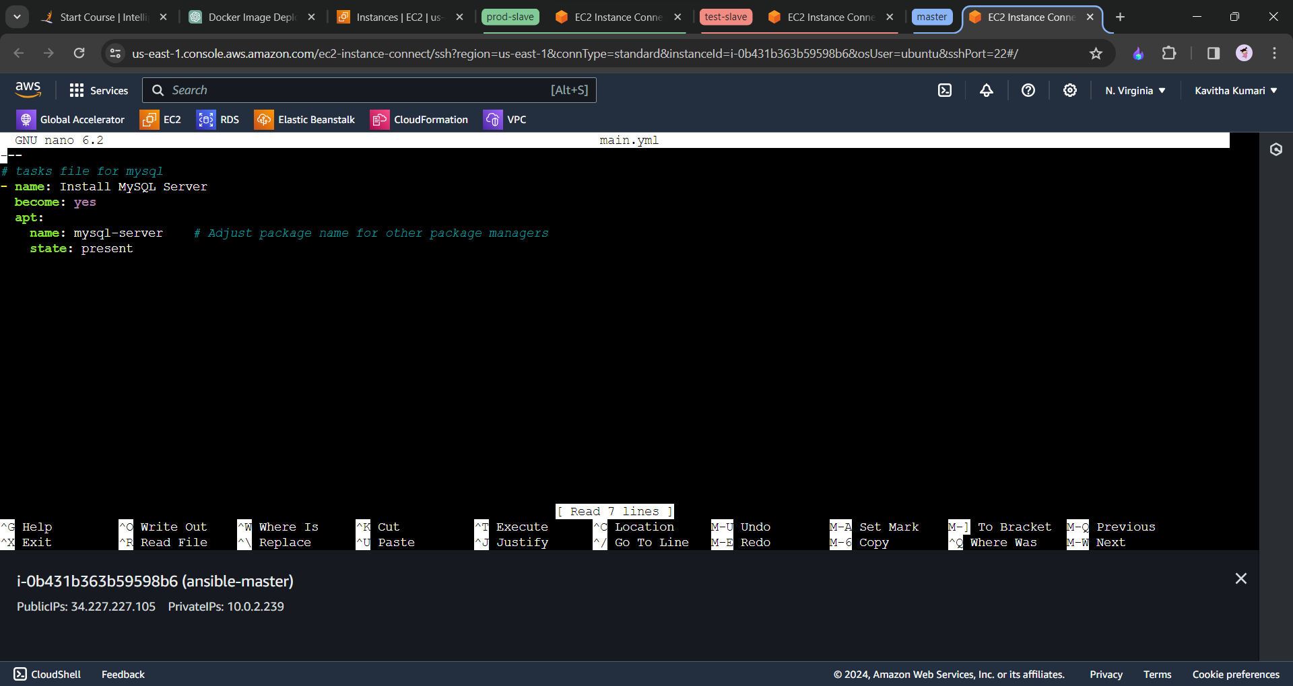

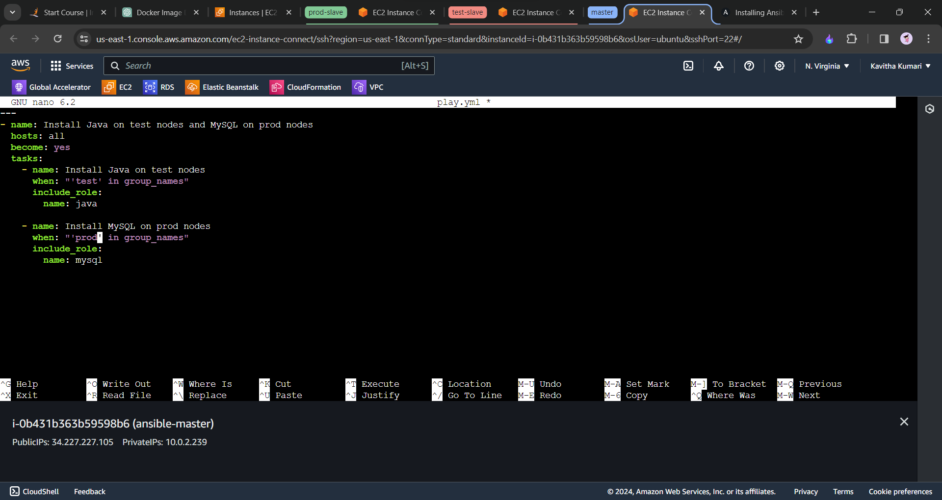

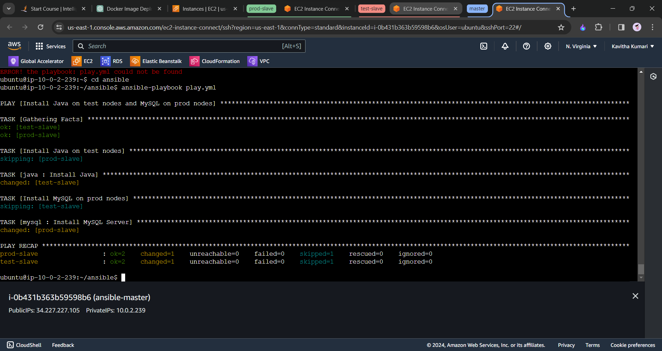

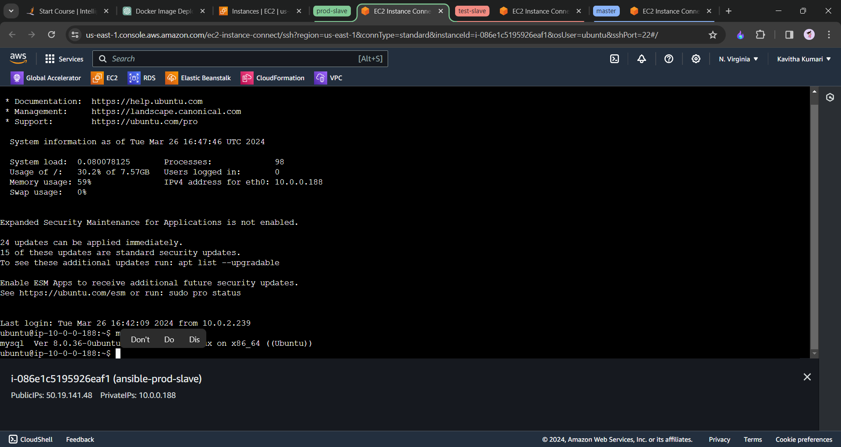

With this the java and mysql is installed to the respective slave machine.

-------end-------