Tasks To Be Performed:

1. Create 5 custom container with 5 different default pages

2. Using Docker Compose deploy these 5 containers on port 81, 82, 83, 84 and 85 respectively

Procedure: -

<**html**>  
<**head**>  
<**title**>hostfile</**title**>  
<**style**>  
*{  
**margin**:0;  
**padding**:0;  
**box-sizing**: border-box;  
}  
**body** {  
**height**:100vh;  
**display**: flex;  
**justify-content**: center;  
**align-items**: center;  
}  
</**style**>  
</**head**>  
<**body**>  
<**h1**>Hello There. I am in container </**h1**>  
</**body**>  
</**html**>

--------------------------------------------------------------------

# Dockerfile for container1  
  
# Use a base image  
FROM nginx:latest  
  
# Copy the default page into the container  
COPY index.html /usr/share/nginx/html/

We need to install the docker compse for this please refer the official documentation of the docker compose

1 sudo apt update  
 2 for pkg in docker.io docker-doc docker-compose docker-compose-v2 podman-docker containerd runc; do sudo apt-get remove $pkg; done  
 3 sudo apt-get update  
 4 sudo apt-get install ca-certificates curl  
 5 sudo install -m 0755 -d /etc/apt/keyrings  
 6 sudo curl -fsSL https://download.docker.com/linux/ubuntu/gpg -o /etc/apt/keyrings/docker.asc  
 7 sudo chmod a+r /etc/apt/keyrings/docker.asc  
 8 echo "deb [arch=$(dpkg --print-architecture) signed-by=/etc/apt/keyrings/docker.asc] https://download.docker.com/linux/ubuntu \  
 9 $(. /etc/os-release && echo "$VERSION_CODENAME") stable" | sudo tee /etc/apt/sources.list.d/docker.list > /dev/null  
 10 sudo apt-get update  
 11 sudo apt-get install docker-ce docker-ce-cli containerd.io docker-buildx-plugin docker-compose-plugin  
 12 docker --version  
 13 sudo docker run hello-world  
 14 curl -SL https://github.com/docker/compose/releases/download/v2.24.6/docker-compose-linux-x86_64 -o /usr/local/bin/docker-compose  
 15 sudo curl -SL https://github.com/docker/compose/releases/download/v2.24.6/docker-compose-linux-x86_64 -o /usr/local/bin/docker-compose  
 16 sudo ln -s /usr/local/bin/docker-compose /usr/bin/docker-compose  
 17 docker-compose.exe version  
 18 sudo docker-compose.exe version  
 19 docker compose --version  
 20 docker compose version  
 21 mkdir c1 c2 c3 c4 c5  
 22 ls  
 23 cd c1  
 24 sudo nano index.html  
 25 sudo nano Dockerfile  
 26 docker build -t c1 .  
 27 sudo docker build -t c1 .  
 28 cd   
 29 sudo docker ps  
 30 sudo docker images  
 31 cd c2  
 32 sudo nano index.html  
 33 sudo nano Dockerfile  
 34 sudo docker build -t c2 .  
 35 cd   
 36 cd c3  
 37 sudo nano index.html  
 38 sudo nano Dockerfile  
 39 sudo docker build -t c3 .  
 40 cd   
 41 cd c4  
 42 sudo nano index.html  
 43 sudo nano Dockerfile  
 44 sudo docker build -t c4 .  
 45 cd   
 46 cd c5  
 47 sudo nano index.html  
 48 sudo nano Dockerfile  
 49 sudo docker build -t c5 .  
 50 cd   
 51 sudo nano docker-compose.yml  
 52 sudo docker-compose up  
 53 docker-compose up  
 54 sudo su  
 55 history

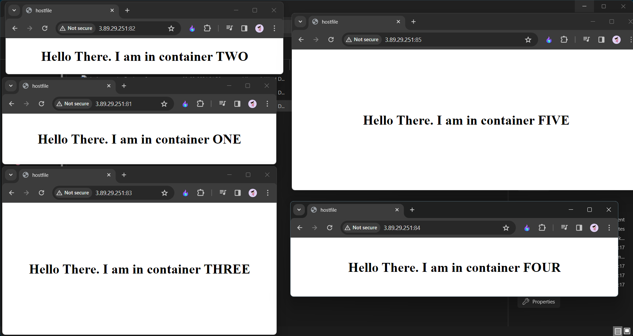

These are the five containers running on ports 81,82,83,84,85.

Thank you.