Tasks To Be Performed:

1. Create a Docker swarm cluster with 3 nodes

2. Deploy an Apache container with 4 replicas

Procedure: -

Run the following command in the masternode:

1 sudo apt update  
 2 sudo curl -L https://github.com/hshar94/docker-compose/raw/master/docker-compose-Linux-x86_64 -o /usr/local/bin/docker-compose  
 3 sudo chmod +x /usr/local/bin/docker-compose  
 4 docker-compose --version  
 5 mkdir docker  
 6 cd docker  
 7 sudo nano docker-compose.yml  
 8 sudo rm docker-compose.yml  
 9 ls  
 10 sudo nano docker-compose.yml  
 11 docker-compose up -d  
 12 sudo nano docker-compose.yml  
 13 docker-compose up -d  
 14 sudo nano docker-compose.yml  
 15 docker-compose up -d  
 16 sudo systemctl status docker  
 17 cd   
 18 docker-compose up -d  
 19 ls  
 20 cd docker  
 21 sudo docker-compose up -d  
 22 cd   
 23 sudo systemctl status docker  
 24 sudo systemctl start docker  
 25 cd docker  
 26 docker-compose --version  
 27 sudo systemctl status docker  
 28 sudo rm docker-compose.yml  
 29 ls  
 30 cd   
 31 sudo rmdir docker  
 32 ls  
 33 sudo apt install docker.io  
 34 sudo systemctl start docker  
 35 sudo systemctl enable docker  
 36 sudo systemctl status dockerk  
 37 sudo systemctl status docker  
 38 docker swarm init  
 39 sudo docker swarm init  
 40 docker node ls  
 41 sudo docker node ls  
 42 ls  
 43 sudo nano docker-compose.yml  
 44 sudo docker stack deploy -c docker-compose.yml apache_stack  
 45 sudo docker service ls  
 46 docker service ps apache_stack_apache  
 47 sudo docker service ps apache_stack_apache  
 48 history

This below command is also for the creating the service with the replica 5

docker service create --name nginx_service --replicas 3 -p 81:80 nginx

sudo docker service scale **nginx_service**=5

The below is the docker-compose.yml file

**version**: '3.8'  
  
**services**:  
 **apache**:  
 **image**: **httpd**:latest  
 **deploy**:  
 **replicas**: 4  
 **restart_policy**:  
 **condition**: any  
 **ports**:  
 - "80:80"

Below the commands should be run on the worker node.

1 sudo apt update  
 2 sudo apt install docker.io  
 3 sudo systemctl start docker  
 4 sudo systemctl enable docker  
 5 sudo systemctl status docker  
 6 getent group docker  
 7 sudo usermod -aG docker $USER  
 8 newgrp docker  
 9 docker run hello-world  
 10 docker swarm join --token SWMTKN-1-5imy0udz9l0x21gvp6xdfl7xohn3pgo5buhisfnt1hyj5zavjb-77ss89jkbdt04touwt9c781x9 10.0.15.66:2377 //we will get this through the master machine when we run the docker swarm init  
 11 history

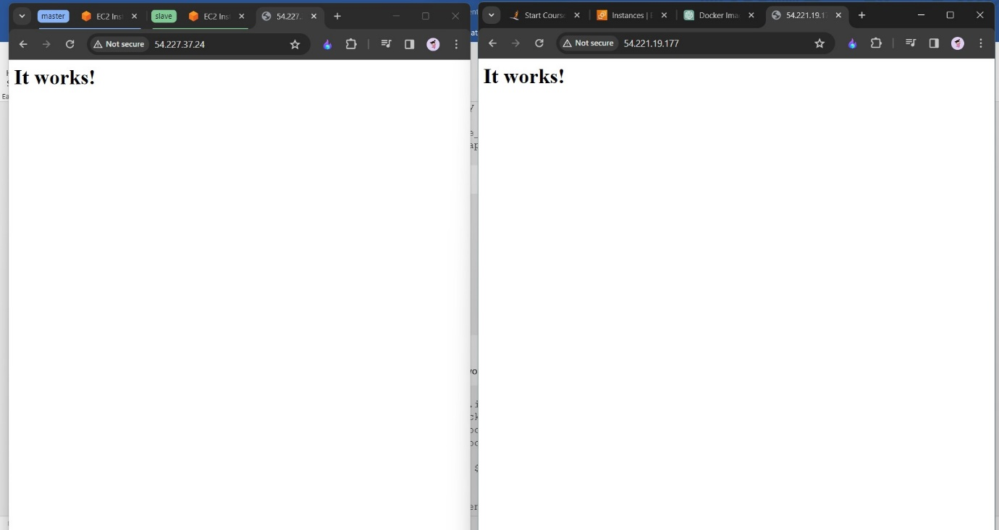

This can be runned on both the public ip address of the machine.