Tasks To Be Performed:

1. Use the previous assignment’s deployment

2. Deploy any 2 containers in a overlay network

3. Try pinging each of the containers from within the containers

Procedure:

Note that we have two containers namely kabi and kabis created.

sudo docker run -d --name kabi -p 80:80 nginx  
sudo docker run -d --name kabis -p 81:80 nginx

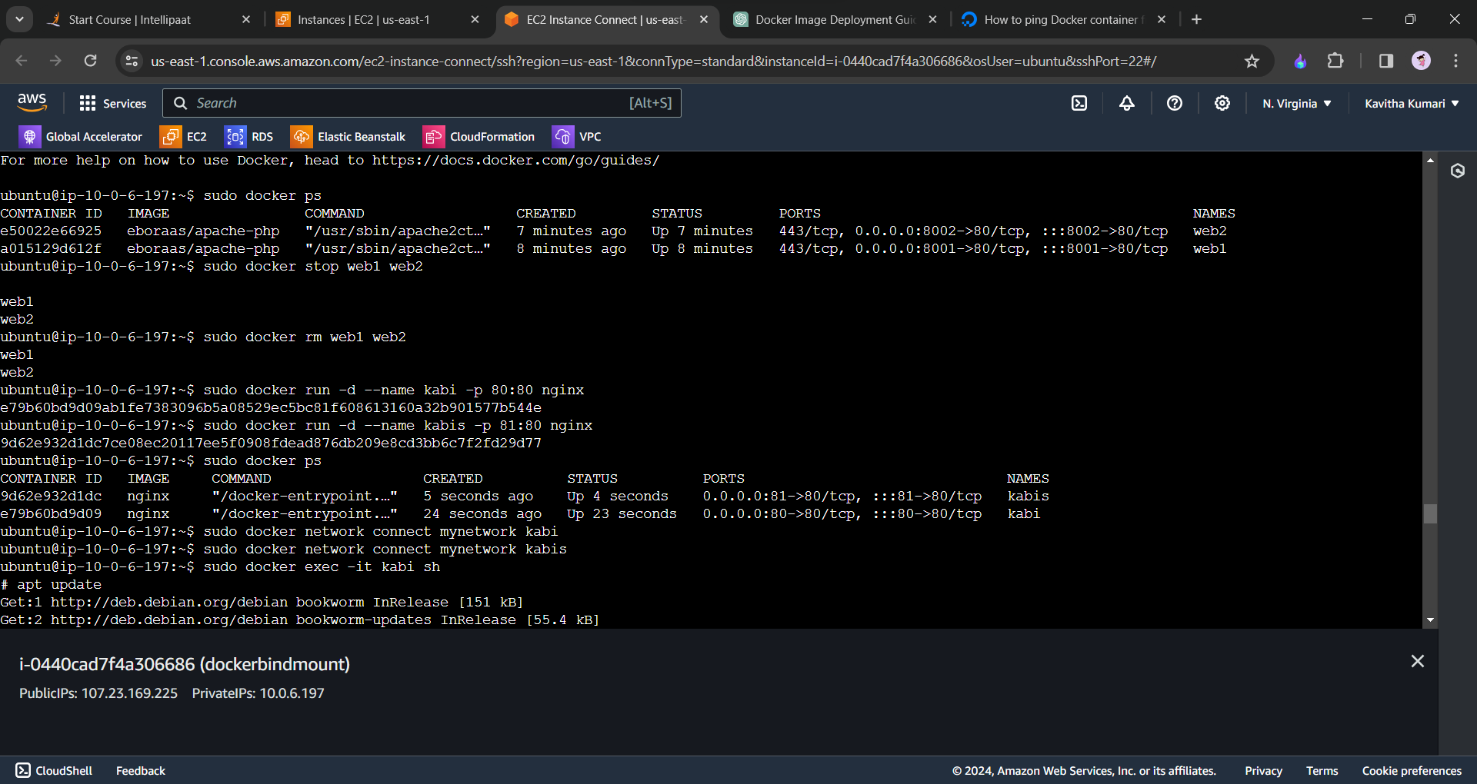

In the next step we will create out own network and we will connect our two container with the network.

sudo docker network create mynetwork  
sudo docker network connect mynetwork kabi  
sudo docker network connect mynetwork kabis

After this get into each shell with the command sudo docker exec -it container-name/id sh

Write the following command.

apt install  
apt install iputils-ping  
ping othercontainer-name

The following will be the output in each container.

