**Tasks To Be Performed:**

1. Pull Ubuntu container

2. Run this container and map port 80 on the local

3. Install Apache2 on this container

4. Check if you can access the Apache page on your browser.

dckr_pat_n3aJEuiIUadnKsZvOAu5x8jqlSI

**Procedure:**

1. Launch an EC2 Instance with Ubuntu AMI:

2. Ensure that your security group allows inbound traffic on port 80.

2. Connect to the EC2 Instance:

1. Connect to your EC2 instance using connect:

3. Install Docker on the EC2 Instance:

1. Update the package index:

sudo apt update

2. Install Docker:

sudo apt **install** docker.io -y

3. Start the Docker service:

```bash

sudo systemctl start docker

```

4. Enable Docker to start on boot:

sudo systemctl enable docker

4. Pull Ubuntu Container and Run with Port Mapping:

1. Pull the Ubuntu container:

sudo docker pull ubuntu

2. Run the Ubuntu container and map port 80:

sudo docker run -itd --name my_apache_container -p 80:80 ubuntu

5. Install Apache2 in the Docker Container:

1. Connect to the running container:

sudo docker exec -**it** my_apache_container /bin/bash

2. Install Apache2 inside the container:

apt update

apt install apache2

service apache2 status

service apache2 start

6. Access Apache Page:

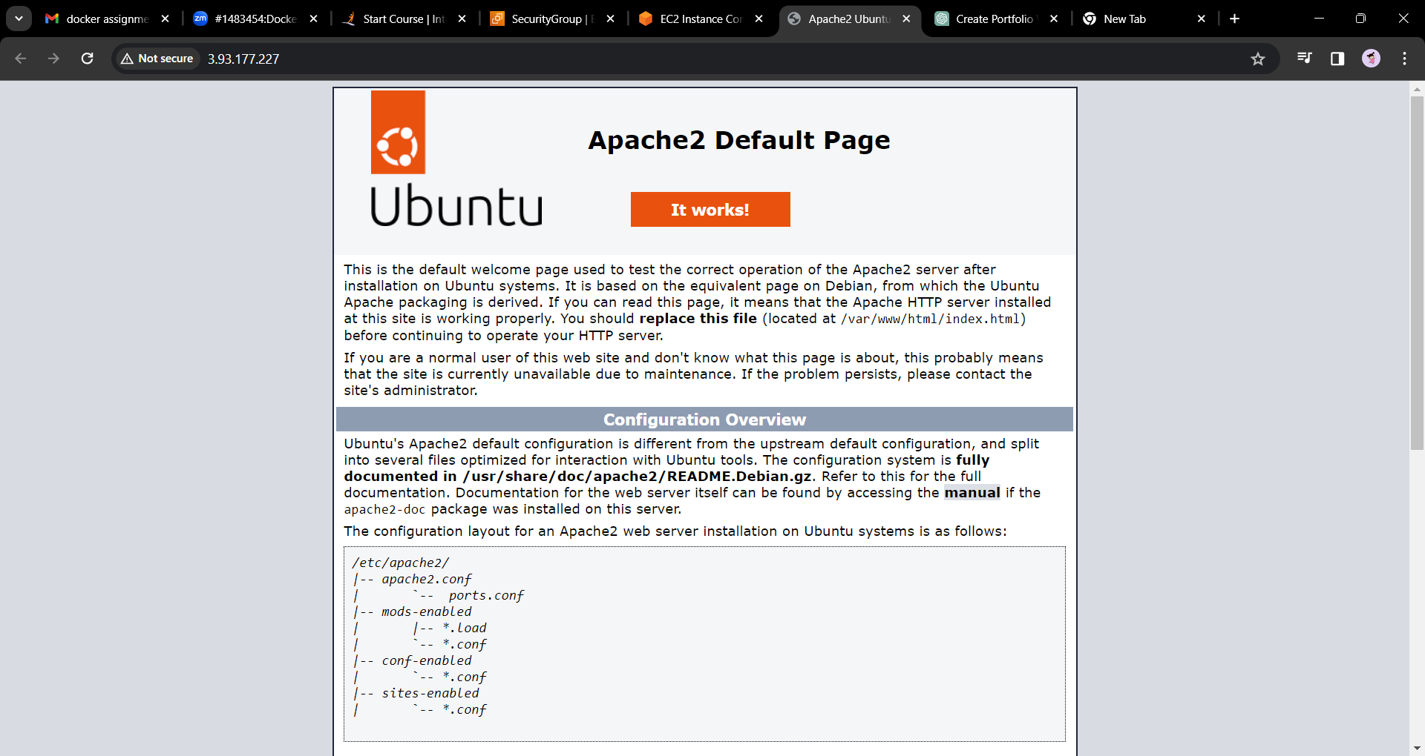1. Open your browser and navigate to your EC2 instance's public IP address or DNS name. You should see the default Apache page.