Tasks To Be Performed:

1. Save the image created in assignment 1 as a Docker image 2. Launch container from this new image and map the port to 81

3. Go inside the container and start the Apache2 service

4. Check if you can access it on the browser

**Procedure:**

* My previous container ubuntu has apache2 service enabled in it.
* We can convert it in the image with the following command.

sudo docker **commit** **container**-**name** image-**name**

docker tag image-name:latest image-name:v1

* Now we can launch the container from the new image.

docker run -d -p 81:80 --name new-container my-ubuntu-image:v1

* This command does the following :
* ‘-d’: Runs the container in detached mode.
* ‘-p 81:80’: Maps port 81 on the host to port 80 in the container.
* ‘—name new-container’: Names the container ‘new-container’
* ‘my-images:v1’: Specifies the image you create in step1

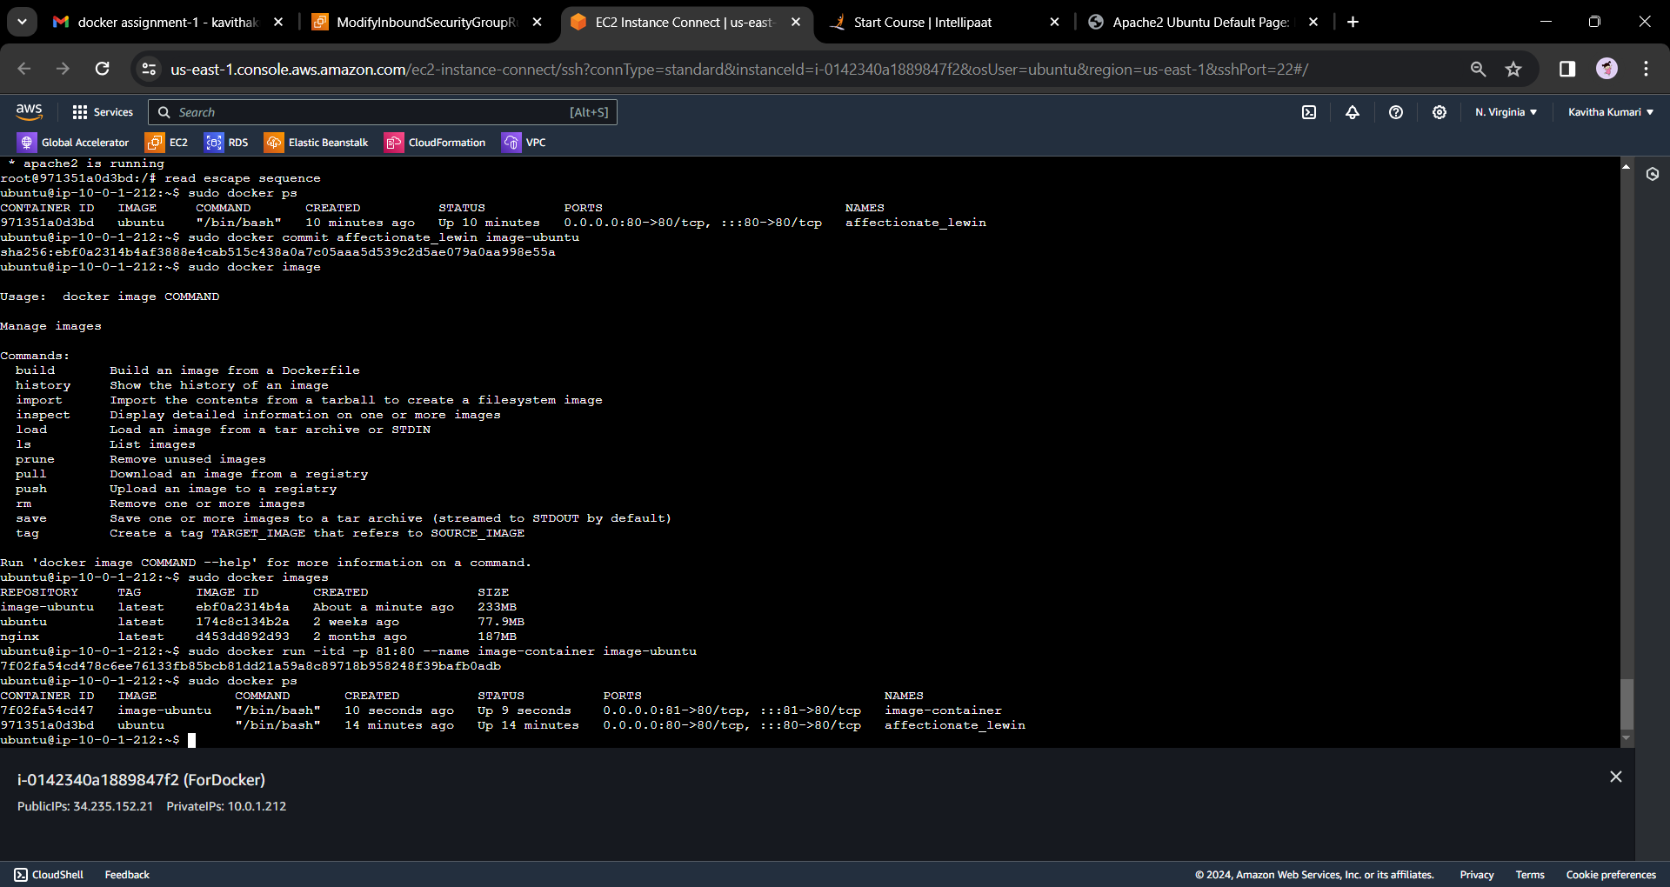

* Now we can go inside the container and start apache2

sudo docker exec -it new-container bash  
service apache2 start

* exit

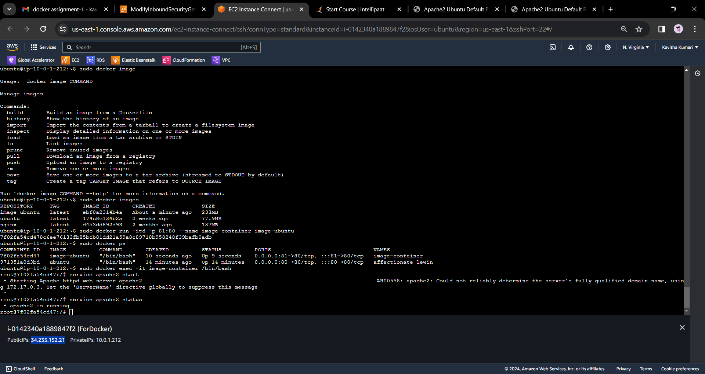

* These commands enter the running container’s shell, start the Apache2 service, and then exit.
* Now we can check whether the Apche is running on the browser. With the help of the current-Public-IP:81

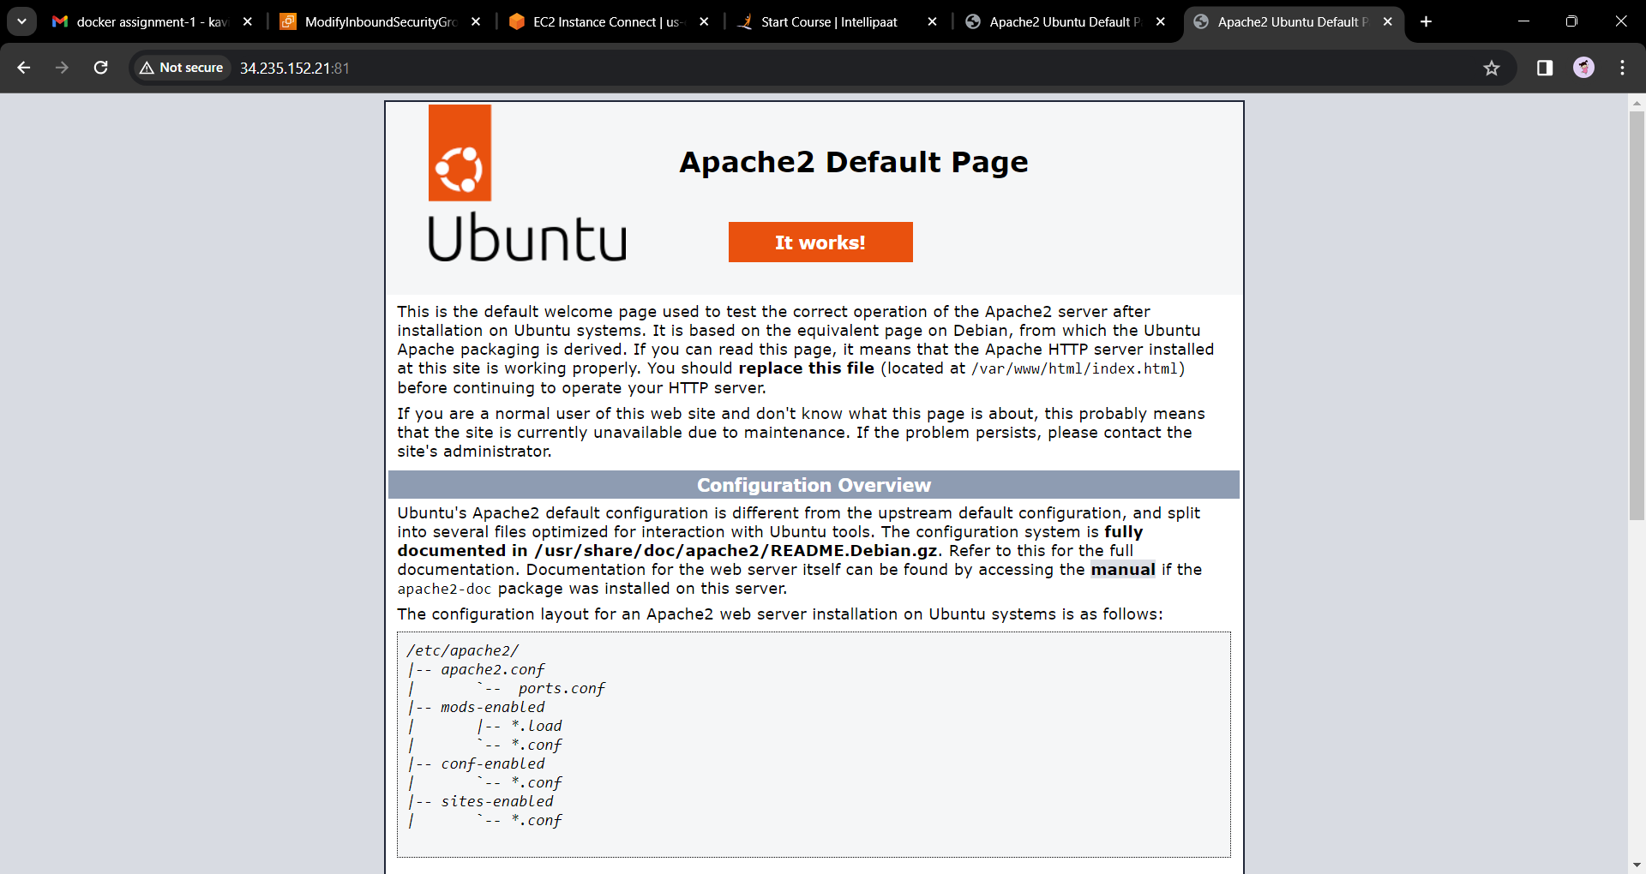

---end---