**Tasks To Be Performed:**

1. Use the saved image in the previous assignment

2. Upload this image on Docker Hub

3. On a separate machine pull this Docker Hub image and launch it on port 80

4. Start the Apache2 service

5. Verify if you can see the Apache2 service

**Procedure:**

**Below are the steps you can follow to achieve the tasks you've mentioned:**

**1. Use the saved image in the previous assignment:**

docker **tag** **image-ubuntu**:latest kavithakumari062001/dockerdemo-2023-december:latest

**2. Upload this image on Docker Hub:**

**Before pushing the image to Docker Hub, you need to log in to your Docker Hub account using the following command:**

**docker login**

**```After logging in, you can push your image to Docker Hub:**

**```bash**

docker push kavithakumari062001/dockerdemo-2023-december:tagname**```**

**### 3. On a separate machine, pull this Docker Hub image and launch it on port 80:**

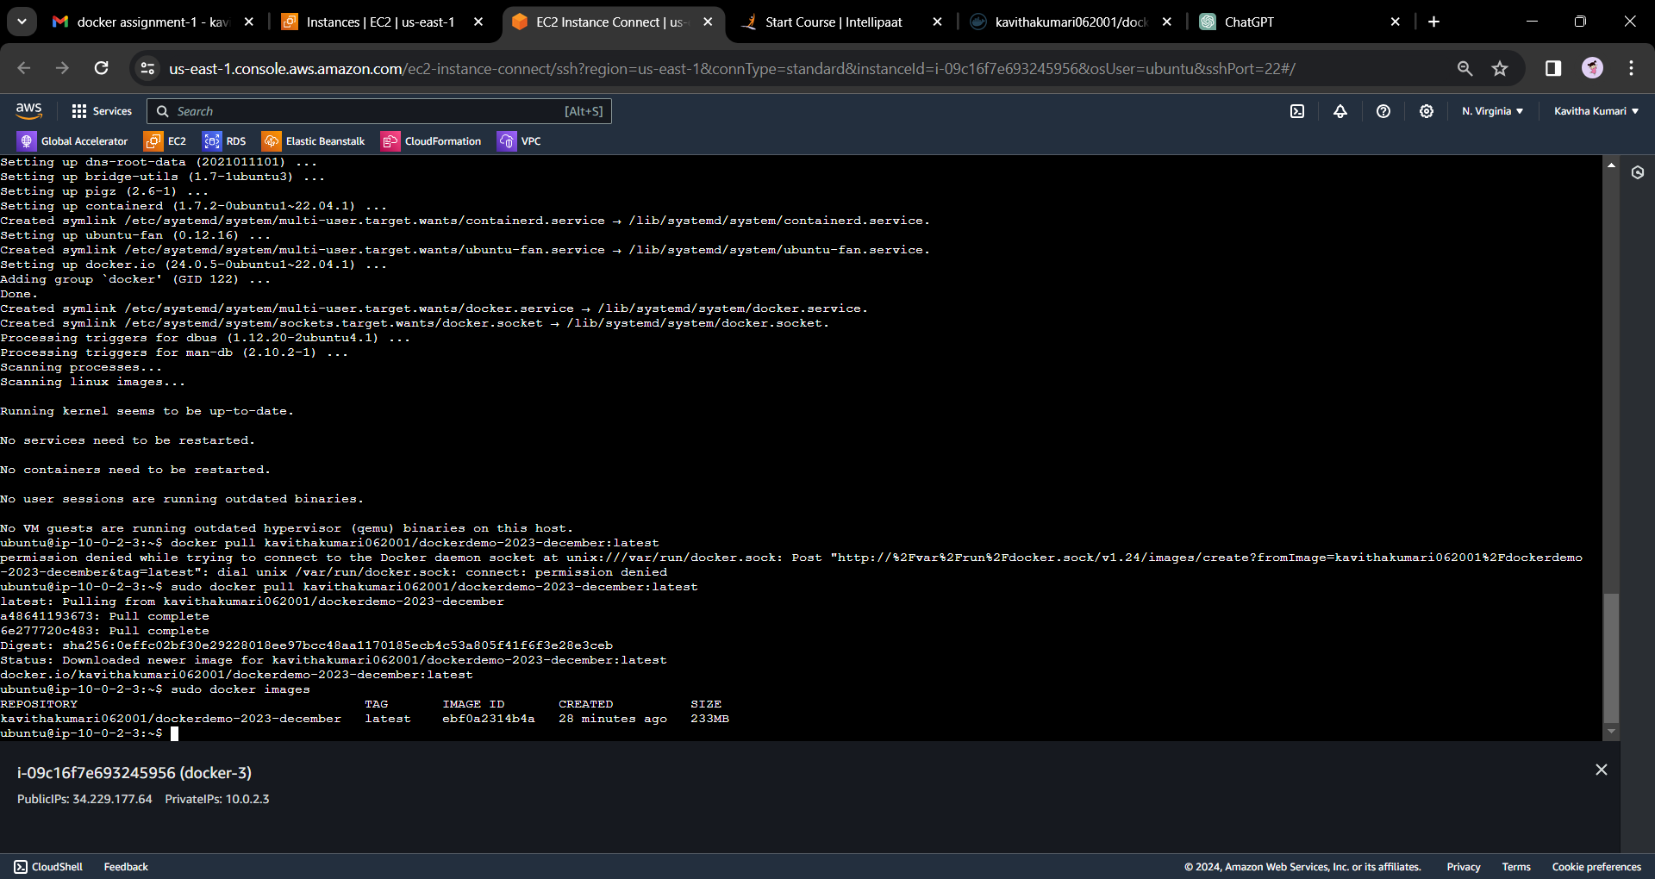

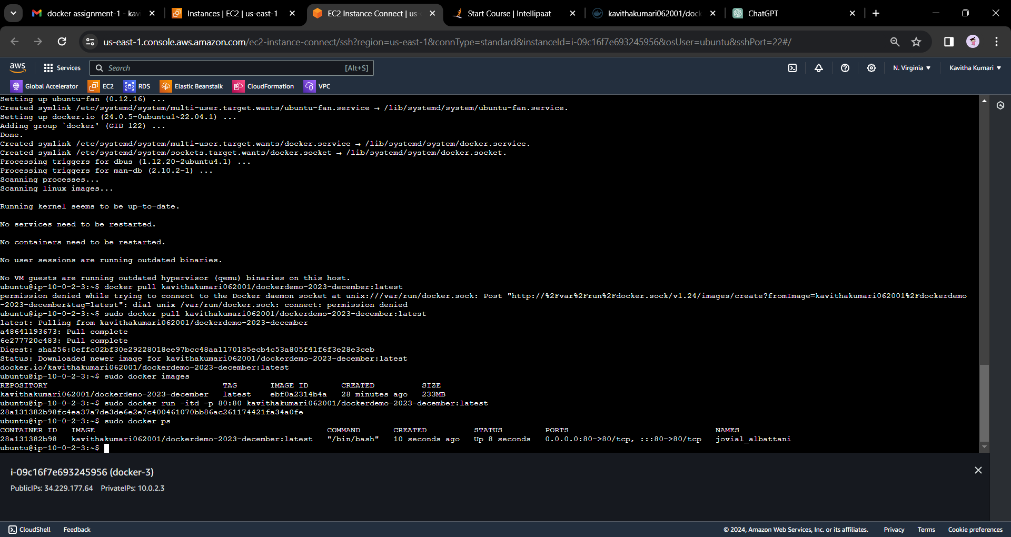

**On the separate machine, you need to have Docker installed. Use the following commands to pull the image and run it on port 80:**

**```bash**

**docker pull kavithakumari062001/dockerdemo-2023-december:latest**

sudo docker run -itd -p 80:80 kavithakumari062001/dockerdemo-2023-december:latest

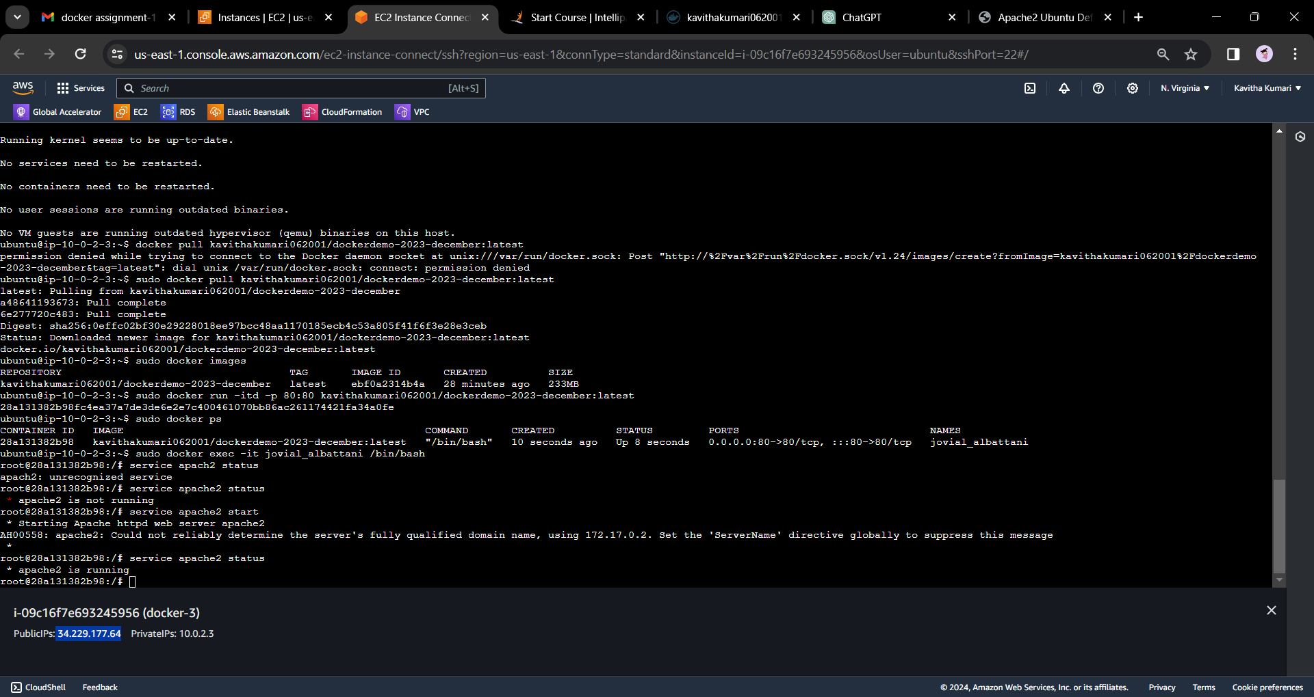

**### 4. Start the Apache2 service:**

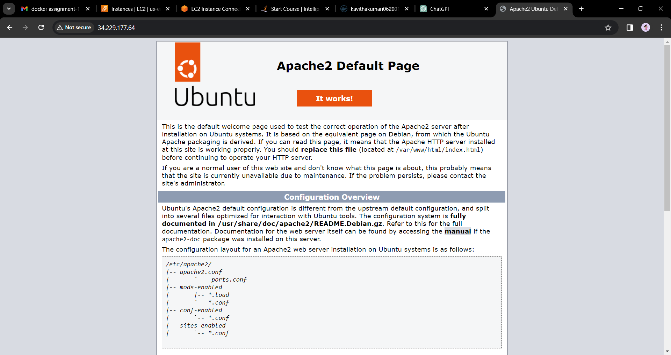

**You can execute commands inside the running container to start the Apache2 service. Use the following command to get into the container:**

**```bash**

docker exec -**it** container_id /bin/bash

**```**

**Replace `container_id` with the actual ID of your running container. Once inside the container, start the Apache2 service:**

**```bash**

service apache2 start

**```**

**### 5. Verify if you can see the Apache2 service:**

**Open a web browser and navigate to the IP address or domain of the machine where you launched the Docker container, specifying port 80 (e.g., `http://your_machine_ip:80`). If everything is set up correctly, you should see the Apache2 service.**

**Make sure to replace placeholders like `<image_name>`, `<tag>`, `yourusername`, `container_id`, and `your_machine_ip` with your actual values.**