**Tasks To Be Performed:**

1. Create a Dockerfile with the following specs:

● Ubuntu container

● Apache2 installed

● Apache2 should automatically run once the container starts

2. Submit the Dockerfile for assignment completion

**Procedure: -**

**Below is a sample Dockerfile that meets your specifications:**

**```Dockerfile**

**# Use the official Ubuntu base image**

**FROM** **ubuntu**:latest

**# Update the package list and install Apache2**

RUN apt-get update && apt-get install -y apache2

**# Automatically start Apache2 when the container starts**

**CMD** ["apache2ctl", "-D", "FOREGROUND"]

**# Expose port 80 to make it accessible outside the container**

EXPOSE 80

**```**

**Save this content in a file named `Dockerfile`. This Dockerfile:**

**To build an image from this Dockerfile, navigate to the directory containing the Dockerfile and run:**

docker build -t **my**-apache-image .

**This assumes you are in the same directory as the Dockerfile, and it will tag the image as `my-apache-image`. Adjust the tag (`-t`) and the image name accordingly.**

**Once built, you can run the container with:**

**```bash**

docker run -itd -p 81:80 my-apache-image

**//I have used port 81 here because on 80 the other conainer was running.**

**```**

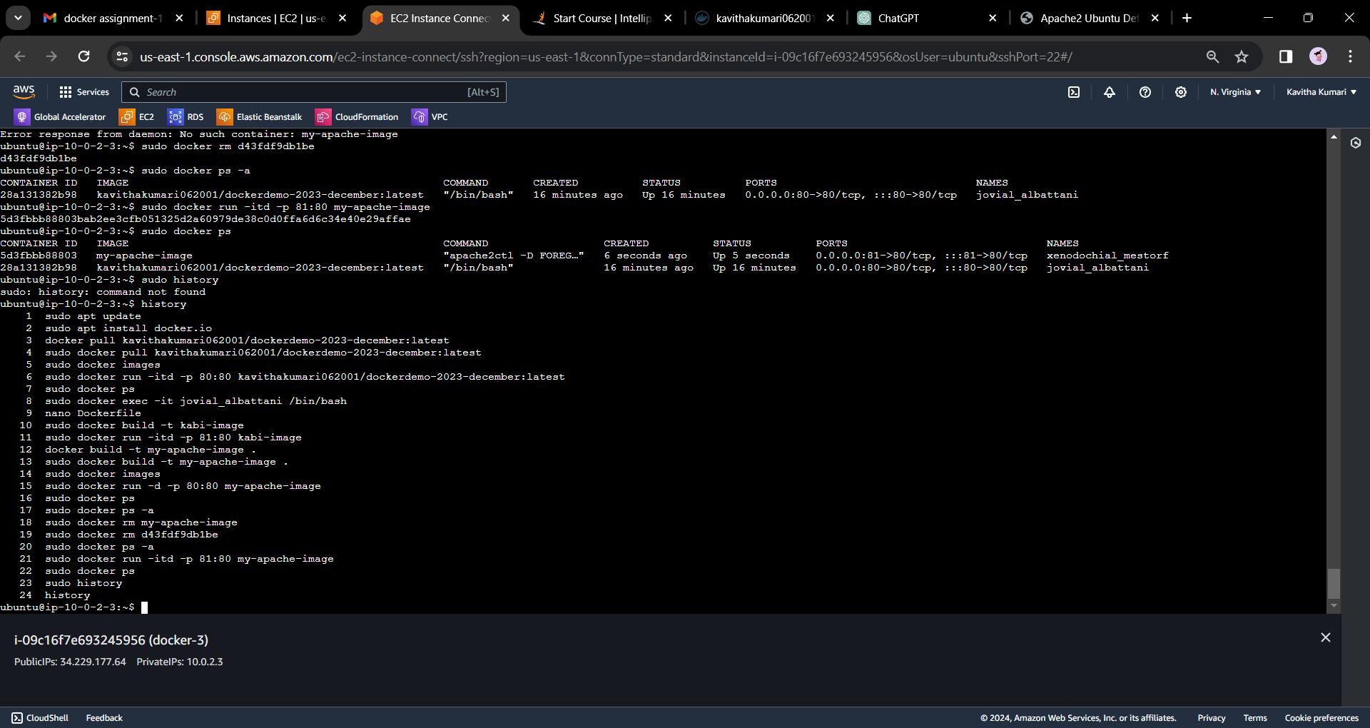

**This will start the container in detached mode, mapping port 80 on the host to port 80 in the container.**

**Remember to adapt the image name and tag as needed for your project.**

