**Tasks To Be Performed:**

1. Create a sample HTML file

2. Use the Dockerfile from the previous task

3. Replace this sample HTML file inside the Docker container with the default page

**Procedure: -**

**To achieve this, follow these steps:**

**1. Create a sample HTML file:**

**Create a simple HTML file, for example, `index.html`:**

**Save this file in the same directory as your Dockerfile.**

**2. Use the Dockerfile from the previous task:**

**Assuming you have the Dockerfile created in the previous task, ensure that it's in the same directory as your sample HTML file.**

**3. Replace this sample HTML file inside the Docker container with the default page:**

**Modify your Dockerfile to copy the `index.html` file into the Apache default document root. Update your Dockerfile to look like this:**

**Dockerfile**

**# Use the official Ubuntu base image**

**FROM** **ubuntu**:latest

**# Update the package list and install Apache2**

RUN apt-get update && apt-get install -y apache2

**# Copy the sample HTML file into the container**

**COPY** **index**.html /**var**/www/html/**index**.html

**# Automatically start Apache2 when the container starts**

**CMD** ["apache2ctl", "-D", "FOREGROUND"]

**# Expose port 80 to make it accessible outside the container**

EXPOSE 80

**```**

**This Dockerfile now includes a `COPY` instruction to copy the `index.html` file to the default document root of Apache.**

**4. Build and run the Docker container:**

**Build the Docker image:**

**bash**

docker build -t **my**-apache-image

**```Run the Docker container:**

**```bash**

docker run -itd -p 82:80 my-apache-image

**```**

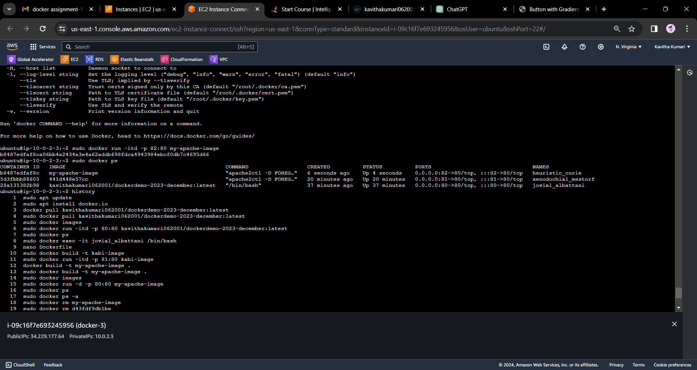

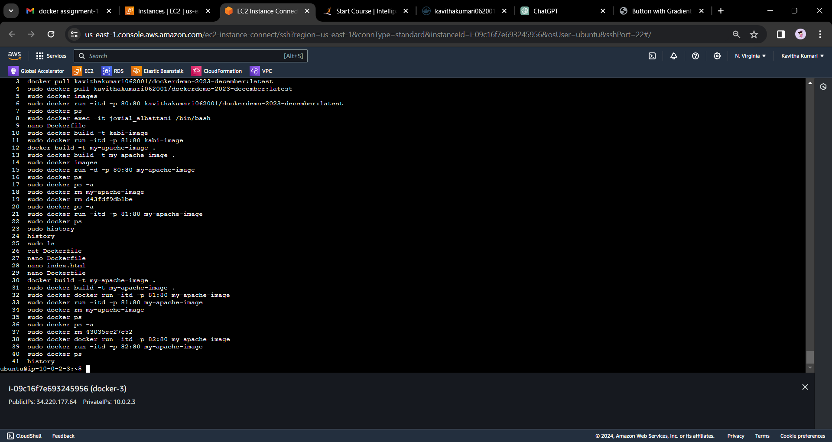

**Now, when you access your EC2 instance or Docker container's IP address, you should see the content of the `index.html` file as the default page.**

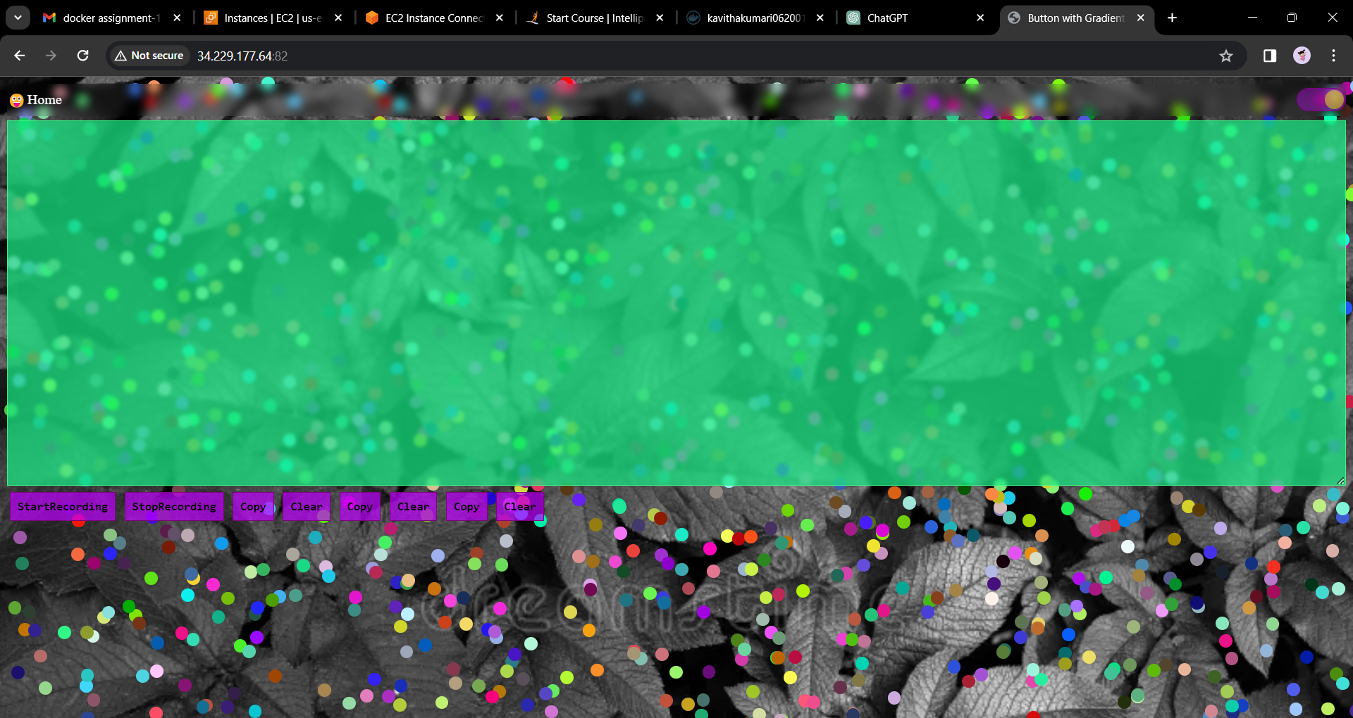

**------end-------**