Research Records
Part I Using BERT & RoBERTa finetuning on document classification system
- Introduction
There are numerous methods for classifying documents. In traditional machine learning, NLP preprocessing steps, such as tokenization and stemming, are employed in conjunction with supervised learning algorithms, including SVM, Naive Bayes, KNN, and decision trees [1]. We use and refine large language models (LLMs) in this study. LLMs can help deal with various tasks and learn from the datasets efficiently. Our document classification system utilizes BERT (Bidirectional Encoder Representations from Transformers) [2] and RoBERTa (a robustly optimized BERT approach) [3], which have been refined and integrated for enhanced performance. Taichung Veteran General Hospital provides the dataset, which is subjected to preprocessing, data engineering, training, experiments, and class balancing. Data imbalance is a significant problem because some department classes only have one or two samples [4]. This paper discusses and addresses this problem along with some suggested solutions.
- Related Work
  - Traditional Approaches to Document Classification
NLP (Natural Language Processing) is one of the oldest tasks because document classification was a very active area in the past, with the early approaches based on classical machine learning algorithms such as Naive Bayes, Support Vector Machines (SVM), Decision Trees and other algorithms, many of them used TF-IDF and Bag-of-Words as silver-bullet feature extraction techniques. [5]
  - BERT for Document Classification
Deep learning was a significant achievement for the field in the long term. Transformers, with the first foundational model BERT (Bidirectional Encoder Representations from Transformers) [6], a word-level pre-trained BERT, have been used for document classification in NLP, for example, BERT. Adhikari et al. [2] presented DocBERT, stating that fine-tuning BERT for document-level input yields advanced results across various datasets, including IMDb, Yelp, and Amazon reviews. Cons: Transformer-based models provide better results than those from national CNNs and now RNNs on longer textual inputs.
  - RoBERTa for Document Classification
Roberta, another high-quality retraining implementation of BERT [7], improved classification results with larger batches and more extended sequences, and removed the NSP (Next Sentence Prediction) objective. Bohara et al. [3] trained RoBERTa from scratch on the arXiv dataset and demonstrated that it outperforms a BERT model designed explicitly for scientific paper abstracts in document classification. They stated that their experiments highlight the necessity of hyperparameter fine-tuning, particularly for length and batch size, during the fine-tuning process.
  - Handling Data Imbalance in Classification
The primary bottleneck for document categorization is class imbalance, which significantly reduces the model's performance in cases where the number of samples from some classes is minimal, particularly for underrepresented categories. Hasanin et al. [8] presented state-of-the-art techniques for handling imbalanced data in large-scale datasets, including sampling SMOTE (Synthetic Minority Oversampling Technique), random sampling, and ensemble approaches.
Transformer-based models, such as BERT and Roberta, have been shown to perform better in document classification. However, it is crucial to address class imbalance in training to ensure the production of high-quality models or robust/fairness-consistent training in real-world applications where the label distribution is naturally imbalanced.
- Methodology
  - Data Preprocessing
The hospital provided 23,191 data records, including columns for document ID, hospital department, document sending authority, content type, sending date, and ending processing date. There are personal privacy problems we would like to deal with when filtering the dataset for sexual harassment, domestic violence, and medical disputes. Then, we must do data filtering for our dataset. Given that the dataset contains real Chinese names, we should apply name anonymization processing using NER [9] to cover these names in our data, thereby preventing the exposure of sensitive information.

3.1.1 Chinese Name Anonymous Processing
Initially, we attempted to scan each Chinese name and replace it with "XXX"; instead of manually covering the names, we will use LLM models to assist us. The benefit is that it’s a highly efficient process and works quickly.
Process patterns | Techniques | Used tools／Model | Tech type | Accuracy
1 | HaNLP NER | MSRA_NER_BERT | Transformer NER | 85%
2 | Stanza Chinese NER | stanford/stanza | BiLSTM + CRF | 60%
3 | spaCy Transformer | zh_core_Ib_trf | Transformer NER | 90%
Table 1. Name anonymous methods comparison

We will use the methods from Table 1 to determine which method is best suited for anonymous processing. We must scan each Chinese name and replace it with "XXX." As shown in Table 1, our first approach involves detecting Chinese names in the data using HaNLP + NER. However, the accuracy, completeness, and results are unsatisfactory with the MSRA_NER_BERT model. The second method involves using Stanza from Stanford University, which also supports Chinese NER. Although this model generally performs better in entity detection, its process coverage is not yet complete. Similar to the HaNLP model, we were unable to cover the entire dataset for our task, and in some cases, it was insufficient for our needs due to the requirement for comprehensive coverage of personal names. Thus, we employ method three, relying on SpaCy Transformer and NER to perform name anonymization. The accuracy of this method is significantly higher than that of the other two, but it requires a longer runtime. The following loads the dataset into a data frame using method 3. On Spacy, load the model "zh-core_Ib_trf," which is used for Chinese text understanding, and save it in an NLP variable. This model is then used in the function to detect Chinese characters. I will define a function to detect Chinese names and replace these names with "XXX." The last step is setting the processing batch; here, I put it to process 1000 data points at a time. The final output of the data will be stored in a new worksheet named "anonymous_with_spacy" from our Excel dataset, and will later be used. Here is the final output. The name of the anonymous data will be shown as Fig 1:

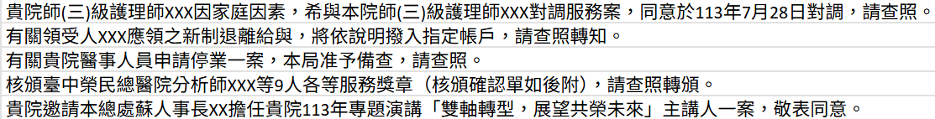
Fig. 1. Name the anonymous processing output result

3.1.2 Data Splitting
We used Google Colab as our environment, and our programming language is Python 3.11. We utilized a T4 GPU as our tool for processing the pre-trained models.
First, we will load our dataset and clean our data using Pandas. We will then drop the columns we won’t use, leaving only “contents” and “departments” as our training data and labels. For training purposes, we renamed the column contents "instruction" and the departments on our labels. We will also remove the department class with only one supporting data point, as this could affect the training results and cause the model to learn unbalanced patterns. We will allocate 80% of the data for training, 10% for testing, and 10% for validation. Scikit-Learn’s train_test_split module will split the data into training and testing sets. The split data will be saved as train.jsonl and test.jsonl in the Google Cloud project file.

3.1.3 Data Augmentation
When we were doing the first phase of training, we discovered a data unbalancing problem in our dataset due to the supporting data each department has; some departments only have 2 to 3 supporting data, and some departments have enough data to train; this would affect the value of the evaluation metric macro avg, causing our model to learn from the department classes that have many supporting data and cause data imbalance. Here, we can see that the data is insufficient for training. Therefore, we will utilize ChatGPT to generate sample data for this part. We send some samples to ChatGPT and ask it to create similar samples to complete our dataset. ChatGPT will generate 3 to 5 more samples to ensure there are enough for training. We filter the data to identify and remove these outliers. If a class has fewer than three samples, we exclude it and use GPT to generate additional samples. We organize the generated data into a list called augmented_samples, then use Hugging Face’s Dataset module to combine them with the training set for further processing by using Hugging Face’s Dataset module HFDataset to turn the list into a Hugging Face object for the later use of throwing into Hugging Face’s Trainer and use concatenate_dataset function to join the generated data and the training dataset together.
  - Data Engineering

3.2.1 Labeling
In this section, the training and testing data labels are compiled into a list. Next, the textual labels are encoded into numbers using Scikit-learn's Label Encoder. The encoded label file is then saved as 'label_encoder' in the Google Cloud project file for inference.

3.2.2 Tokenization and Model Selection
We must convert Chinese text into numeric vectors for models using numerical input. After tokenization, we obtain two key parts: input_ids (token indices in the model’s vocabulary) and attention_mask (indicates real tokens vs padding). We truncate long texts and pad short ones to ensure equal input lengths. Special tokens [CLS] (start) and [SEP] (end) are added.
We use the BERT-base-chinese and HFL/chinese-roberta-wwm-ext tokenizers, which are pre-trained on Chinese corpora. These tokenizers preserve linguistic structure and are suitable for formal documents, such as government texts. Each input sample is a dictionary:
{'input_ids': [...], 'attention_mask': [...], 'label': label}
This format enables the model to distinguish between tokens and padding and assign the correct label.
The tokenizer function processes the text by truncating to a max length of 512 tokens and padding shorter inputs. The result is stored in a PyTorch tokenized_dataset, which is then fed to the model. A typical input looks like:
Input = {[CLS], token1, token2, ..., tokenN, [SEP]}

3.2.3 Class Balancing
Our dataset, comprising 23,191 data samples, has been joined with the generated data samples. To balance the learning weight of our model, we apply two methods.
In training phase 1, we applied PyTorch’s Weight Random Sampler module. We use this method because it doesn't alter the dataset itself. It eliminates the need for manual oversampling or undersampling. Instead, it adjusts how samples are drawn during training, making minority-class and majority-class samples less frequent. In an imbalanced dataset, the model tends to overfit the majority classes and ignore the minority classes. The sampler increases the visibility of a few sample classes, enabling the model to learn more effectively about those features. This method also preserves the dataset size. Unlike oversampling, which duplicates data, and undersampling, which discards data, this method maintains the same dataset size. Every epoch still has the same number of samples, but they are sampled differently. We first will collect all the labels from the training dataset into a list and then calculate how many times each label appears in the training set; the example output will be like this: {0: 300, 1: 50, 2: 150}, and then we will count the total number of training samples. Next, we will assign a weight to each sample; samples with rare classes will get higher weights; for example, if class 1 is rare, only 50 samples, then each of its samples receives a weight of 1/50 = 0.02; if class 0 is standard about 300 samples, then its samples get a smaller weight 1/300 ≈ 0.0033, this means rare classes are more likely to be sampled during training. We will count the weights using this code line: sample_weights = [1.0 / label_freq[label] for the label in label_list]. The final step is to create a sampler that draws samples with replacement, favoring underrepresented classes according to their weights. The sampler will be applied: sampler = WeightedRandomSampler(sample_weights, num_samples=len(sample_weights), replacement=True). The weight balancing formula below was used:
$w_{i}​=\frac{1}{f_{yi}}​ ( SEQ "equation" \backslash n \backslash * MERGEFORMAT 1)$
$f_{yi}$ is the frequency of labels in the training set. Samples are drawn with probability proportional to their weight, enabling rare-class oversampling and majority-class undersampling during training.
After completing the first method, we found that the macro avg metric's training result showed only a slight improvement, so we explored alternative approaches to enhance class balancing. To ensure the model learns in a more balanced and stable manner, we apply loss-level weighting using PyTorch, without disrupting the batch structure. This approach explicitly instructs the model to prioritize underrepresented classes by assigning them higher importance. We achieve this by passing a class_weights parameter directly into PyTorch’s CrossEntropyLoss. This method is chosen because Hugging Face’s built-in Trainer does not support passing class_weights directly into the loss function. We would have to subclass the Trainer and override the loss computation function to implement class weighting using Hugging Face's framework. Therefore, in this project, we manually define a custom WeightedLossTrainer using PyTorch to apply the class-weighted loss. This loss-level balancing strategy helps control the influence of gradients, increasing the chances that minority classes are properly learned. In classification tasks, larger losses result in larger parameter updates; therefore, without weighting, the model tends to overlook classes with few samples. This weighting method is particularly suitable for large-scale training, where class imbalance is more severe.
Weights calculation used: Inverse-frequency normalized weights
$w_{i}=\frac{\frac{1}{count\left(i\right)}}{\frac{1}{count\left(j\right)} }×N ( SEQ "equation" \backslash n \backslash * MERGEFORMAT 2)$
$w_{i}$ is the normalized class weight for class $ⅈ$, $count(i)$is the number of training samples, $count(j)$is the number of training samples which are also the most frequent sample classes in the training data. Here, we used the Python function code count() to count the number of samples of $i$ and $j$. $N$ is the total number of classes. This formula normalizes the weight by comparing the inverse frequency of each class to the reference class j, then scales it by the total number of classes N, ensuring that the sum of all weights remains consistent during loss computation.
First, we extract the labels from each sample in the training dataset and count the number of occurrences for each class. These counts are stored in a dictionary called label_counts, and we then calculate the total number of classes. Next, we calculate the class weights, assigning higher weights to classes with fewer samples. The weights are calculated using the formula 1/frequency; the fewer samples a class has, the larger its weight will be for that few-sample class. These weights will be converted into a PyTorch tensor, allowing them to be used in the loss function. To ensure consistency, we normalize the weights so that the total sum of all weights is scaled to the number of classes. Finally, we define a custom class by inheriting from Hugging Face’s Trainer and overriding its loss computation method. We pass the calculated weights into CrossEntropyLoss, focusing on errors from minority classes during training. The weights are also moved to the GPU for computation to ensure efficient processing.

3.3 Training Procedure and Hyperparameters Setup
In this section, we utilize Hugging Face’s Trainer module to fine-tune our model, developing a custom WeightedLossTrainer to address class imbalance. The key hyperparameters we tune include the number of epochs, batch size, warmup steps, and optimizer. Selected BERT and RoBERTa as our pre-trained models due to their strong performance on Chinese text. BERT is used as our baseline model (bert-base-Chinese) for its effectiveness in general Chinese NLP tasks. It learns contextual embeddings through masked token prediction, utilizing both left and right contexts, making it suitable for sentence-level classification.
RoBERTa improves on BERT by removing the Next Sentence Prediction (NSP) task, using larger batch sizes, and dynamic masking. We use hfl/chinese-roberta-wwm-ext, which supports whole word masking and better handles Chinese word segmentation. Compared to BERT, RoBERTa generally achieves better performance in classification tasks due to its more extensive pretraining. The base structures of BERT and RoBERTa are shown in the diagram in Fig 2:

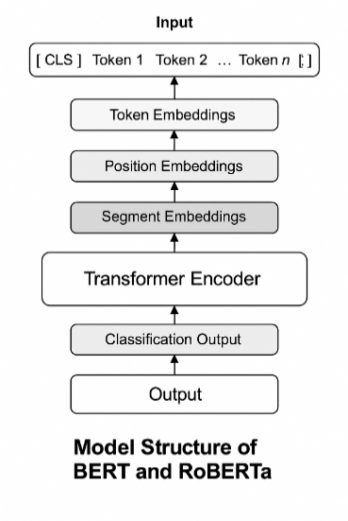
Fig. 2. Model structure of BERT and RoBERTa[6]
From Fig 2, we can see that BERT and RoBERTa share a typical basic structure. Each layer contains 12 transformer encoder layers, comprising 12 heads of multi-head attention and an FFN (Feedforward Neural Network), followed by layer normalization and dropout. Their structure is based on the Transformer architecture, which computes contextual embeddings with a self-attention mechanism:
$Attention\left(Q, K, V\right)=softmax\left(\frac{QK^{T}}{\sqrt{d_{k}}}\right)V ( SEQ "equation" \backslash n \backslash * MERGEFORMAT 3)$
Here, $Q$ represents the query matrix, $K$ is the key matrix, $V$ is the value matrix, and $d_{k}$ represents the dimension of the key vectors. This equation computes the scaled dot-product attention used in each transformer encoder layer. It allows the model to weigh the importance of different tokens in the sequence by comparing the similarity between queries and keys, determining how much focus each token should give to others.
We have finetuned 2 times for BERT to increase the model’s understanding of each content of a document; we can see the hyperparameters we’ve finetuned in the organized table:
Table 2. Hyperparameters Set Up
Parameter | Value
Model name | BERT-base Chinese ~ RoBERTa Chinese
Batch size | 8
Epochs | 5~10
Learning rate | 0.00002
Max length | 512
Warmup strategy | Warmupsteps=500 ~ warmup_ratio = 0.1
LR scheduler | Cosine (added in the second phase)
Early stopping | patience = 3 (added in the second phase)
Optimizer | AdamW
Loss function | Cross-Entropy with class weights (applied in the second phase)

Table 2 shows the hyperparameters we used in the fine-tuning process. In the first training phase, we ran five epochs with a batch size of 8 and a learning rate of 0.00002 for stable convergence. The input sequence length was set to 512 tokens. We applied 500 fixed warmup steps to gradually increase the learning rate at the start, helping reduce loss fluctuations.
We used the AdamW optimizer and non-weighted Cross-Entropy Loss to establish a baseline performance.
In the second phase, we increased the number of epochs to 10 and introduced data augmentation. Since the dataset size changed, we replaced the fixed warmup steps with a warmup ratio of 0.1, allowing the warmup period to scale with the total steps.
We added a cosine learning rate scheduler to avoid local minima and stabilize convergence. This also addressed the gradient issues and overfitting observed earlier. Early stopping with a patience of 3 was used to prevent over-training.
A custom trainer was initialized with a weighted loss function for class imbalance and a data collator to apply dynamic padding within each batch. Finally, we integrated class weights into training arguments and saved the final model to our Google Cloud project file. The training workflow is summarized in Fig 3:

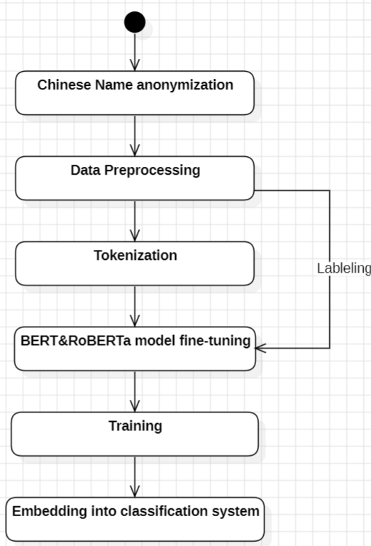
Fig. 3. Training Procedure Diagram
- Results & Discussion
Data augmentation and data balance are important problems that we all have to pay attention to because they affect how the model learns and how accurate the model can be; we can see the data changing from before to after data augmentation:
Table 3. BERT first phase training result
Accuracy | Precision | Recall | F1-score | Macro Avrg
87.04% | 86.22% | 87.04% | 86.27% | 50.87%

The data in Table 3 represents the first time I trained and fine-tuned BERT. Notably, before data augmentation, the Macro Avg metric stood at 50.87%, indicating that the model had not learned in a balanced manner; instead, it only recognized classes with the most data. However, despite using a weight random sampler for random sampling, the results were unsatisfactory. Nevertheless, the metric numbers increased slightly.
Table 4. BERT second phase training result
Accuracy | Precision | Recall | F1-score | Macro Avrg
88.19% | 87.56% | 88.19% | 87.68% | 56.61%

Table 4 represents the second training iteration for BERT. It shows a slight increase in evaluation metrics due to weight random sampling, which helps balance the data's learning; however, it still appears insufficient. First phase during training of BERT the validation loss increases from epoch five, however it’s not enough to determine how it performs when running, so I also tried epoch 10 in the next phase training to see how it performs and added early stopping in the training argument as the buffer of 3 so when the validation loss goes too high 3 times, it will stop learning.Fig 4 shows the final phase of the training process for BERT:

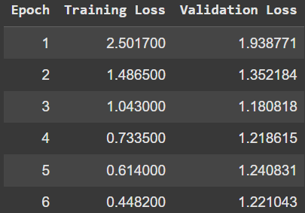
Fig. 4. BERT training circumstance
From Fig 4, the epoch stops at 6, preventing overfitting. The same training method was employed in the Roberta training process, and we will compare the differences when both models use the same training and fine-tuning methods.
Fig 5 is the RoBERTa training process:

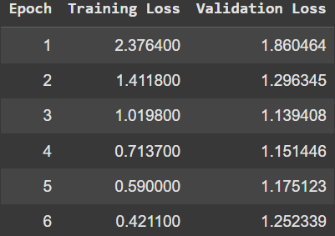
Fig. 5. RoBERTa training circumstances
Fig 5 is the first phase procedure of Roberta. We can observe that the training loss becomes increasingly steady throughout each training epoch. This time, we can see that the validation loss increases from epoch 4; however, the early stopping function prevents overfitting by stopping at epoch 6. In the future, we will explore additional methods to fine-tune the model’s hyperparameters, aiming to decrease the validation loss of RoBERTa further.
Model | Accuracy | Precision | Recall | F1-Score | Macro Avrg
BERT | 83.87% | 85.21% | 83.87% | 84.00% | 59.51%
RoBERTa | 84.32% | 85.76% | 84.32% | 84.58% | 59.17%
Table 5. Final training result for BERT and RoBERTa

Table 5 presents the final training results for BERT and RoBERTa, showing an increase in the macro average, which indicates improved class balance with data augmentation and class balancing. Under the same training and fine-tuning setup, RoBERTa outperforms BERT, as shown by higher training accuracy. This suggests that Roberta learns Chinese sentences better. From Table 5, we can also observe how data balancing affects the metrics during training.

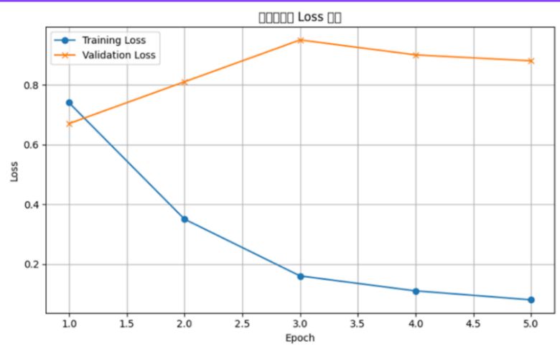
Fig. 6. Model training and validation loss
Fig 6 shows how steadily our models learn, as indicated by the steadily changing values throughout the training process. When the validation or training loss increases, the early stopping technique will halt the training to prevent overfitting. Our model easily overfits after epoch 3, so we will improve the method by fine-tuning the model’s hyperparameters in the future.
- Conclusion & Future Work
In the future, we plan to explore larger-scale models, such as LLaMA 7B, to compare their performance with that of BERT and Roberta. We will choose the best fine-tuned model to embed into the system. For evaluation, we intend to use additional metrics, including the confusion matrix, ROC curves, and micro and macro-AUC scores, to provide more comprehensive performance metrics. Through experiments, we observed that RoBERTa outperforms BERT when employing techniques such as class-weighted loss and data augmentation. Class imbalance is a significant challenge for large datasets, particularly for departments with limited training data. We employed strategies such as applying weight loss functions and generating samples using GPT for several classes to address this issue. This process provided us with experience in model training, fine-tuning, and utilizing PyTorch’s loss functions. In the future, the chosen fine-tuned model will be implemented in our document classification system.

References
- Chowdhury, S., Schoen, M.P.: Research Paper Classification using Supervised Machine Learning Techniques. Proceedings of the 2020 Intermountain Engineering, Technology and Computing Conference (IETC) 1, 1–6 (2020).
- Adhikari, A., Ram, A., Tang, R., Lin, J.: DocBERT: BERT for Document Classification. arXiv preprint arXiv:1904.08398 (2019).
- Bohara, K., Shakya, A., Pande, B.D.: Fine-Tuning of Roberta for Document Classification of ArXiv Dataset. In: Udgata, S.K., Chaki, R., Favorskaya, M.N. (eds.) Mobile Computing and Sustainable Informatics, Lecture Notes in Networks and Systems, vol. 166, pp. 243–255. Springer, Singapore (2023).
- Kulkarni, A., Chong, D., Batarseh, F.A.: Foundations of Data Imbalance and Solutions for a Data Democracy. arXiv preprint arXiv:2108.00071 (2021).
- Ranjan, N.M., Prasad, R.S.: A Brief Survey of Text Document Classification Algorithms and Processes. International Journal of Computer Applications 182(43), 1–6 (2019).
- Devlin, J., Chang, M.W., Lee, K., Toutanova, K.: BERT: Pretraining of Deep Bidirectional Transformers for Language Understanding. In: Proceedings of the 2019 Conference of the North American Chapter of the Association for Computational Linguistics: Human Language Technologies (NAACL-HLT), vol. 1, pp. 4171–4186. ACL, Minneapolis, USA (2019).
- Liu, Y., Ott, M., Goyal, N., Du, J., Joshi, M., Chen, D., ... & Stoyanov, V.: Roberta: A Robustly Optimized BERT Pretraining Approach. arXiv preprint arXiv:1907.11692 (2019).
- Hasanin, T., Khoshgoftaar, T.M., Leevy, J.L., Bauder, R.A.: Severely Imbalanced Big Data Challenges: Investigating Data Sampling Approaches. Journal of Big Data 6, 1–25 (2019).
- Liu, P., Guo, Y., Wang, F., Li, G.: Chinese Named Entity Recognition: The State of the Art. Neurocomputing 473, 37–53 (2022).

Part II Using Llama3 finetuning on document classification system using different kind of methods comparing to traditional LLM models

